Job Introductions: What is a Librarian?
Learning Objectives:
Students will be introduced to new jobs in their community. They will become familiar with what each job entails.
Materials & Preparation:
- What is a Librarian? power point (included)
- Matching activity (multiple levels included)
- Comprehension questions (included)
- Writing picture prompt (included)
- YouTube video: search “What is a Librarian?” If the video is no longer posted, there are many that will work, just preview before showing your students!
- Scissors & glue
- ***Our school library lets our students take the due date stickers off of returned books OR remove the due date cards, as a job. If you are able to talk to your librarians and set this up, it’s an awesome way to introduce the lesson and set up an in school job site/skill for your students!
Instruction:
- There are many important jobs in our community. There are also many jobs in a school. Can you tell me a few? What do these people do?
- What is a Librarian? power point
Full Class Activity:
- Removing library stickers/due date cards from books
- Tour the library, if you have time! Students can meet with your librarian and maybe even get a book read to them.
- YouTube clip
Independent Working Time:
- Comprehension questions
- Matching activities
- Writing picture prompt
Wrap up/Closing:
- Review what a job as a librarian looks like.

Other Ideas for Activities:
- I made a chart in my classroom with each student’s name on it, each day I would rotate tasks so they all got to do each at least once a week (folding towels, laundry, vacuuming, sweeping, wiping tables, etc.).This is also something I did with vocational tasks as well (laminating, making copies, mail delivery, taking stickies off of library books etc.) Worked great, totally applicable, and less planning!
- Print each slide and cut the sentences off, have students match the sentence to the picture.
- If possible, make weekly or monthly trips to your school library. Get students accustomed to this area and to your school librarian or the assistants. This is a GREAT place for in school job sites. I have had my students perform a range of skills/tasks in the library (depending on their functioning level): fixing computer stations, pushing chairs in, watering plants, putting books back, sorting fiction/nonfiction based on stickers etc.
- Another great job site for our older students is going to the elementary libraries to perform similar tasks or even read books to the younger students, if they are capable.

Name _____________________________________ Date ___________________________
Draw a line to match the same pictures.



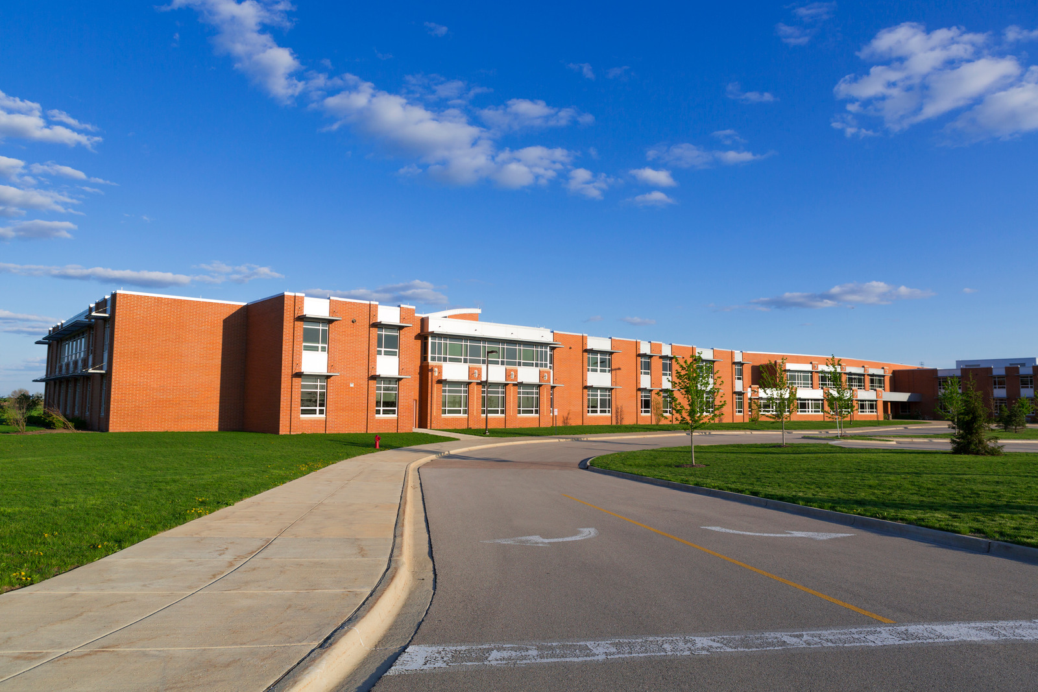




Name ___________________________________________ Date _____________________
Match the pictures to the words.
Bookshelves

Librarian scanning books

Putting books back

Helping students

School

Name __________________________________________ Date______________________
Answer the questions about being a Librarian.

- Where does a librarian work?
- Pool
- Library
- Office

- What can a librarian help you find?
- Books, magazines
- Baseball cards
- Blankets

- What does the librarian put on or in your book when checking it out?
- A smiley face
- A due date sticker or card
- Nothing

- A librarian also makes sure that:
- Everyone has had lunch
- Schools have pizza parties
- Books are put back in the correct place

- What are some library rules?
- Shhh, inside voices
- You can yell and talk as loud as you want
- Listening to loud music is okay
BONUS: Who is your school librarian?

____________________________________________________________________________

Score: _____/5 = ______%

Name _____________________________________ Date ___________________________
Write 3 sentences about the picture.

________________________________________________________________________________________________________________________________________________________________________________________________________________________________________________________________________________________________________________________________________________________________________________________________________________________________________________________________________________________________________________________________________________________________________________________________________________________________________________________________________

