HIP SERIES ~ 6 directions of movement with traction
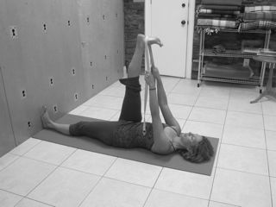
1. Supta Padangusthasana
With the right hand, hold onto the big toe of the right foot or place a strap around the right foot. Keep the left knee bent and the left foot on the floor. Slowly straighten the right leg. Slowly straighten the left leg as much as possible, pressing the left heel away from you as you pull the pit of the abdomen toward your head. Engage the quadriceps as you move the outer hip away from your head. Keep the head and right shoulder on the floor. Wait for up to nine breathes, and then switch sides. Figure 1.
Figure 1

2. Parvritta Supta Padangusthasana
Set up as in #1. Hold both sides of the strap in your right hand, and place the “L” of the index finger and thumb of the left hand into your hip crease; press your hip away from your head and down towards the ground. Extend through both heels. Gently take your left leg over to the right. Keep the sole of the left foot parallel to the floor and your foot in line with your right shoulder. Lift the POA. Hold for 9 breaths, and then switch sides. Figure 2.

3. Parsva Supta Padangusthasana
Set up as in #1. Hold both sides of the strap in your left hand and place your right hand on top of your right hip to keep in anchored to the floor. Press through both heels and lift the POA. Pull your left leg out to the left, leading with the left heel. Keep your right hip on the floor as you extend out through your left heel. Keep the outside of your left foot parallel with the floor. Hold for 9 breaths, and then switch sides.
Figure 2

Figure 3.

Figure 3

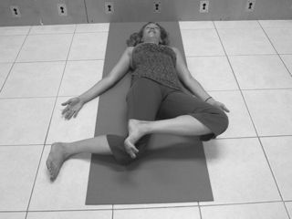4. Internal Hip Rotation
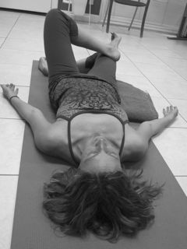Lay on your back with your feet on the floor and knees bent at a 90-degree angle. Step your right foot over to the right one shin length. Flex both feet, and then fold your right knee toward your left foot. If there is any pain in the right knee, place a block or blanket underneath for support. If there is no pain, continue by placing your left ankle across your right distal thigh and allow your left knee to open to the left. Allow your buttocks to move away from the floor as you lengthen your thighbone away from your head and pull the POA toward your head. Hold for 9 breaths, and then switch sides. Figure 4.
Figure 4

5. External Hip Rotation (Supta Janu Padasthilasana)
Lie on your back with your feet on the floor and your knees bent at a 90-degree angle. Move both feet together over to the left one shin length. Flex both feet but keep your heels on the ground. Move your right knee to the right, then place your left ankle across your right thigh and open your left knee to the left. You may place a blanket under your right buttock if needed. Lengthen out and down through your thigh bones and lift the POA towards the head. Hold for 9 breaths, and then switch sides.
Figure 5.

6. Eka Pada Supta Virasana
Figure 5

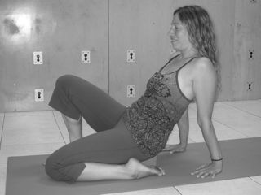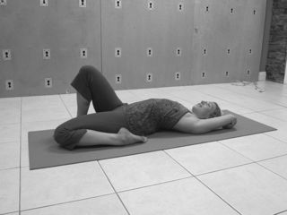Begin on your hands and knees. Bring your knees together and your heels out wider than your hips to sit into Virasana. Bring your left foot forward to the floor. Place a block beneath your right side bone. Keep your right knee in line with your right hip. Place your hands behind you and push down to lift your hips. Lift the POA to extend the tailbone forward. Place your right sit bone back onto the block and press your right inner knee to the floor as you continue lifting the POA. If you are comfortable here, you can remove the block and rest on elbows or lay all the way onto your back. Hold for 9 breaths, and then switch sides. Figure 13 & 14.
Figure 14

Figure 13

