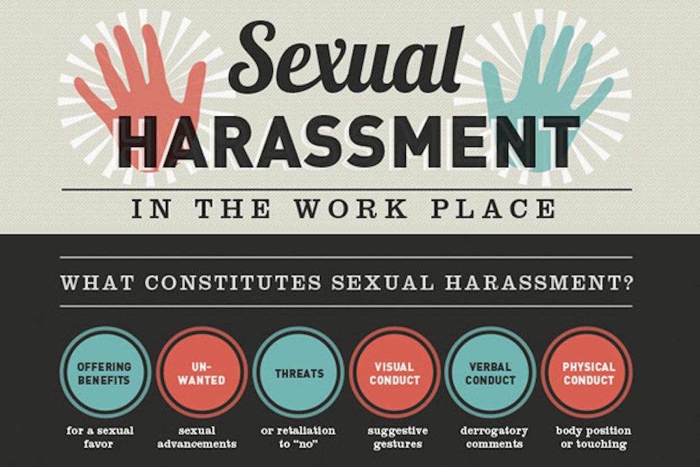

This policy guideline applies to all employees and contractors of the company. All employees are required comply with this procedure, in respect of fellow employees as well as clients, suppliers and contractors of the company.

- Introduction
(Insert company name) believes that:-

(a) All employees and job applicants have the right to be treated with dignity and respect.
(b) Employees are required to respect one another's integrity, dignity, privacy and their right to equity in the workplace.
(c) Sexual harassment in the workplace will not be permitted or condoned and the purpose of this policy is to adopt a zero tolerance approach towards sexual harassment in the workplace.
(d) Persons who have been subjected to sexual harassment in the workplace have a right to lodge a grievance, and to expect that the Company will take appropriate action.

- Preamble

The purpose of the policy guideline is to entrench fundamental human rights.

Sexual harassment is a violation of the fundamental human rights of men and women and is a violation of the right to equality, human dignity, privacy, security of person and fair labour practices. Sexual harassment undermines the basic integrity of the employment relationship and is a direct violation of (Insert company name) values and Code of Conduct.

The organization commits itself to the timeous handling of cases of alleged sexual harassment and to ensure that fair procedures and appropriate action is taken to minimize and deal with matters of sexual harassment as soon as instances of alleged sexual harassment are brought to its attention.

The organization views sexual harassment in any form extremely seriously and disciplinary action, including summary dismissal, may result.

In turn however, false and malicious claims of sexual harassment that cannot be substantiated will also be viewed in a serious light, and disciplinary action including dismissal may result.

Sexual harassment may be committed against both male and female persons by persons of the same or opposite sex without regard to the employee's or the perpetrator's sexual orientation.

- Definition
Sexual attention becomes sexual harassment if:-
(a) The behaviour is persisted in, although a single incident of harassment can constitute sexual harassment; and / or
(b) The recipient has made it clear that the behaviour is considered offensive; and / or
(c) The perpetrator should have known that the behaviour is regarded as unacceptable.

- Behaviour constituting sexual harassment
Sexual harassment includes, but is not limited to the following types of behavior:-

4.1 Verbal behavior of a sexual nature, such as
(a) Unwelcome innuendoes, suggestions and hints.
(b) Unwelcome sexual advances.
(c) Unwelcome comments with sexual overtones.
(d) Unwelcome sex related jokes or insults.
(e) Unwelcome graphic comments about a person’s body made in their presence or directed toward them.
(f) Unwelcome and in-appropriate enquiries about a person’s sex life.
(g) Unwelcome whistling directed at a person or group of persons.
(h) Unwelcome jokes that cause awkwardness or embarrassment.
(i) Comments about a person’s sexual habits.
(j) Verbal threats or abuse.
(k) Unwelcome telephone calls with sexual overtones.

4.2 Gestures and other non-verbal behaviour
(a) Unwelcome gestures.
(b) Indecent exposure.
(c) The unwelcome display of sexually explicit/undesirable pictures and objects.
(d) Persistent and unwelcome flirting.

4.3 Visual sexual harassment
(a) A public display of pornographic or other offensive, derogatory and/or sexually explicit pictures, photographs, cartoons, drawings, symbols and other material.
(b) Showing of pornographic or sexually explicit movies or slides.
(c) Indecent exposure of private parts in view of others.
(d) Displaying / sourcing offensive material / jokes on PC’s and / or e-mailing such material to other employees.

4.4 Physical behavior
(a) All unwanted physical contact, ranging from touching to sexual assault and rape, and includes a strip search by or in the presence of the opposite sex.
(b) Attempted or actual kissing or fondling.

4.5 Psychological sexual behavior
(a) Repeated unwanted social invitations for dinner, drinks or movies.
(b) Sexual favors.
(c) Requiring / requesting an employee to wear sexy, revealing, or suggestive clothes.

4.6 Quid pro quo harassment
When an employer, supervisor, member of management or co-employee undertakes or attempts to influence the process of employment, promotion, training, discipline, dismissal, salary increment or other benefit of an employee or job applicant, in exchange for sexual favors.

4.7 Sexual favoritism
Sexual favoritism exists where a person who is in a position of authority rewards only those who respond to his/her sexual advances, whilst other deserving employees who do not submit themselves to any sexual advances are denied promotions, merit rating or salary increases.

4.8 Behavior which does not constitute sexual harassment
The following would not normally constitute sexual harassment:-
- Occasional compliments.
- Flirtatious banter when it is mutually acceptable.
- Forms of greetings that are deemed acceptable according to Company culture and behavior.
- Occasional jokes or other behaviors whereby the intent is not meant to be offensive, except where the perpetrator should have known that the behavior is regarded as unacceptable.

- Procedure
Sexual harassment allegations need not follow the normal Grievance Procedure and will remain as confidential as possible. Any employee who believes that he or she has been the subject of sexual harassment should report the alleged complaint immediately in accordance with the following procedure. All information disclosed pursuant to this procedure will be held in strictest confidence, and will only be disclosed on a need-to-know basis in order to investigate and resolve the matter.

Because the immediate supervisor or line manager may be alleged to be involved, the complainant may contact anyone from Human Resources, their employee representative or the Employee Assistance Programme Coordinator to investigate an allegation. This investigation must be done in consultation with Human Resources or by a management assigned investigator.

The investigator would assure the complainant that the allegation details and the complainant’s identity will remain as confidential as possible.

The investigator and the complainant should try to agree whether the complainant wishes the matter to be resolved informally or prefers formal disciplinary action to be taken. Pressure should not be put on the complainant to either drop or proceed with the complaint/grievance.

5.1 The Informal Procedure
If the complainant prefers informal action, the assigned investigator will call the accused to a private meeting, advise them of the details of the complaint lodged. The investigator will assure the accused that their identity will remain as confidential as possible until the matter is resolved. The investigator must give the accused an opportunity to state their case; explain the outcome that the complainant requests (an informal settlement) and advise the accused of the possible consequences if proved guilty of sexual harassment in a formal disciplinary hearing.

The investigator shall again meet with the complainant, advise him/her of the accused’s response and, if the complainant is satisfied, invite both parties to meet to consider resolving and settling the matter without the need for formal discipline action.

The investigator will assess what support and assistance the complainant may require after settlement.

The role of the investigator is that of mediator. On being appraised of the allegations, the investigator may of their own accord initiate the formal procedures set out in 5.2 below.

5.2 The Formal Procedure
If the matter is not settled, or if the complainant or accused wants formal disciplinary action the investigator will investigate the allegation sensitively, interview witnesses, if any, and get written statements, if possible. If the allegations are substantial and serious, and there are reasonable prospects of proving the allegations against the accused on a balance of probability, the normal Disciplinary Procedures in respect of a formal disciplinary hearing, shall then follow.

The above procedure may differ in two important respects:-
- If the complainant wishes, the formal discipline hearing will take place in camera, i.e. in private, only the persons directly involved, should attend; and the names of the parties shall remain as confidential as possible.
- (Insert company name) usual disciplinary measures apply, as well as the normal rules regarding appeals.

It is a disciplinary offence to victimize or retaliate against an employee who in good faith lodges a grievance of sexual harassment, or to pressurize a complainant to drop a complaint of sexual harassment.

In turn it is a disciplinary offence to lay unfounded or unjustified complaints against a fellow employee with the intent to cause malicious harm to them or their reputation. The legal rights of the victim are reserved and are in no way limited.

- Confidentiality
(a) Employers and employees must ensure that grievances about sexual harassment are investigated and handled in a manner that ensures that the identities of the persons involved are kept as confidential as possible.
(b) In cases of sexual harassment, management, employees and the parties concerned must endeavor to ensure confidentiality as far as possible in the disciplinary inquiry. Only appropriate members of management as well as the aggrieved person, representative, alleged perpetrator, witnesses and interpreter if required, must be present in the disciplinary inquiry.
(c) The Company is required to disclose to either party or to their representatives, such information as may be reasonably necessary to enable the parties to prepare for any internal or external civil or criminal proceedings.

- Employee Assistance Programme
A complainant or an alleged perpetrator of sexual harassment, who has been found to be innocent or unjustly accused, may apply for assistance in terms of the (Insert company name) Employee Assistance Programme for remedial assistance, including the provision of special leave or trauma counselling where such proceedings have impacted on the employee's work performance or psychological well-being.

