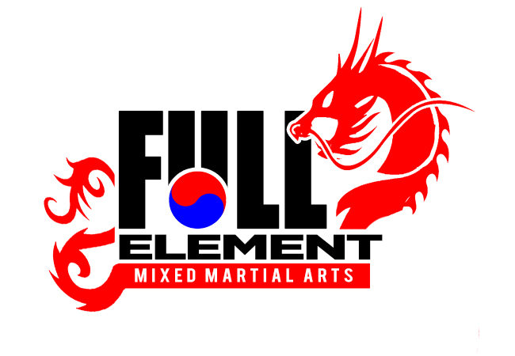

**Welcome to Full Element Martial Arts**

**Laid out here are your beginning stages of your journey.**

 **Make sure to join our SECRET**

**GROUPS**



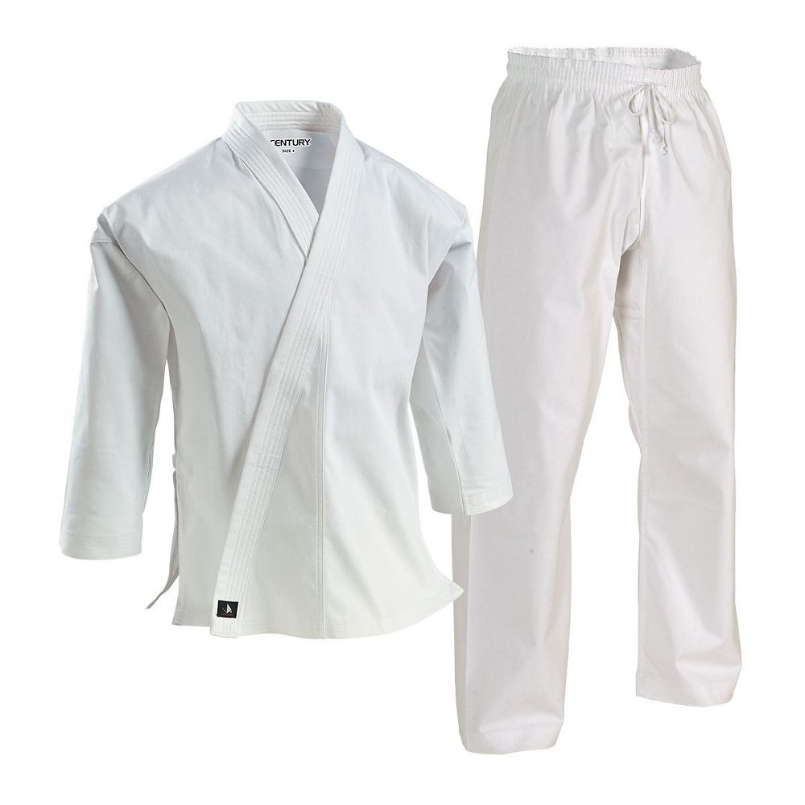





1. Congratulations on your signing up for our 6 Week Special Introductory Offer at $69.99. By this stage you have received your either Traditional White Uniform or your Summer Uniform (Seasonal). Your uniform is valued at $49.99 but is given to you for free.





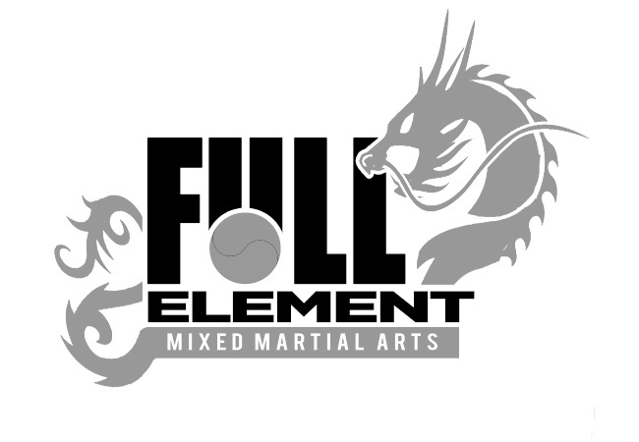2. Other items you will need to purchase are boxing gloves, which you purchase through the school and costs $24.99.





3. The White Belt has to be earned, and can be earned during the six week trial. You will be informed of it via a formal Testing Letter that will be handed to you at the ending and in front of the entire school. The Belt Graduation Fee is $60, which needs to be submitted prior to the testing. When testing is completed, you will receive your White Belt and White Belt Certificate.





4. In either Week Four or Five, we consider this to be decision week, where when you are satisfied with the program, you would commit and enroll to our Program and become an official member at the Base Tuition, which is $139.99. Our agreements are for One Year long only and can be broken at anytime for $75.