August 2014

 | UNIQUE VISITORS | NEW MEMBERS | POSTS | KUDOS | SOLUTIONS
08/2014 | 67,447 (+12%) | 1,736 (+38%) | 1,356 (+24%) | 158 (+51%) | 278 (+83%)
08/2013 | 59,322 | 1,454 | 1,024 | 76 | 46
DISCUSSION VIEWS | USERS BY RANK
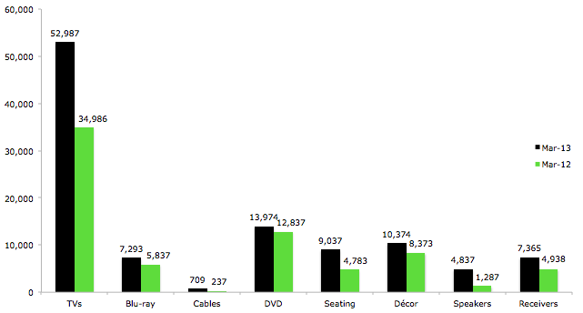 | Elite Contributor | 1
 | Master Contributor | 4
 | Experienced Contributor | 2
 | Super Contributor | 7
 | Regular Contributor | 6
 | Frequent Contributor | 28
 | Contributor | 20
 | Occasional Contributor | 125
 | New Contributor | 708
 | Member | 367
 | New Member | 1,847
 | TOTAL | 3,115
HOT TOPICS | FEATURED MEMBER
Looking for a great TV. Any Advice? – Many users have chimed in here to provide their thoughts and expertise on choosing the best TV for a home theater. Many of the replies contain information about TVs at various pricing levels.  Broken Sub Woofer. Help! – Some great insights have been posted in this thread about diagnosing and fixing a broken sub woofer. A full parts list was provided by one user as well.  Post your home theater! – This topic is filled with photos and video walkthroughs of member home theater setups. Many of them have mentioned that they wouldn’t mind if we featured some of them on our website. |  | John_Doe24  Super Contributor  Expert (Home Theater)
 | Got started in my dad’s basement in the early 70’s and have loved it ever since. Proud owner of the best home theater on my block!
 | Posts: 468 |  | Solutions: 102
COMMUNITY CALENDAR
