Work Book
21 Day Rejuvenation Challenge
Pilates For Smarties: by Robyn Alvarez

- Checklists
- Gratitude
- Recipes
- Affirmations
- Eulogy
- De-Cluttering
- Bucket List
On the App :
Complete Program
Daily meditations
Daily Pilates classes




Before you Start-Plan your 21 Days -print off
In your own personal diary plan your next 21 days. Write in your work schedule, family time, commitments Look for the white space in your day. Allocating an hour for yourself preferably first thing in the morning. As soon as you wake up is best to go for your walk /meditation it sets your mind up for the rest of the day. You can do this rejuvenation challenge anyway you like for example you might contact an old friend that you’ve not seen for years to go for a bushwalk to a waterfall (you’ve completed 3 tasks from the Getting out of your comfort zone) 1. Be Kind 2. 10 Km Hike 3Find a Waterfall

Daily Checklist These activities need to be completed daily for maximum benefit
Challenge | Day 1 | Day  2 | Day 3 | Day 4 | Day 5 | Day 6 | Day 7 | Day  8 | Day  9 | Day  10 | Day  11 | Day  12 | Day  13 | Day  14 | Day  15 | Day  16 | Day  17 | Day  18 | Day  19 | Day  20 | Day  21
Wake up 5.30/6am
Walk outside
Drink Celtic salt water
Write my Gratitude
Affirmations
10min Meditation
Pilates Exercises
2-3 Lts Water
16hour Fasting
Cold Shower
Eating Clean
Sleep 8 hours
Self reflection

Getting out of your Comfort Zone checklist: These activities must be completed at least once during the 21 days
BODY
Grounding/Sun Gazing | 1-7 days | 8-14  days | 15-21  days
24 Hour Fast | 1day | 2day | 3day
Walking 10km | 1-7 days | 8-14  days | 15-21  days
MIND
De Clutter your environment exercise -completed | 10 items | 20 items | All
Learn something new
Ice Bath
Social Media De-tox | 1-7 days | 8-14  days | 15-21  days
HEART
Write your Eulogy
Be Kind exercise
Find a waterfall and Swim in it
Write a Bucket List

Week 1 Workbook
Day 1
Write down 3 things you are grateful for:

1.

2.

3.

Write with your non-dominant hand today's affirmation: I love myself enough to take excellent care of my body, mind and soul and it responds by giving me vibrant good health
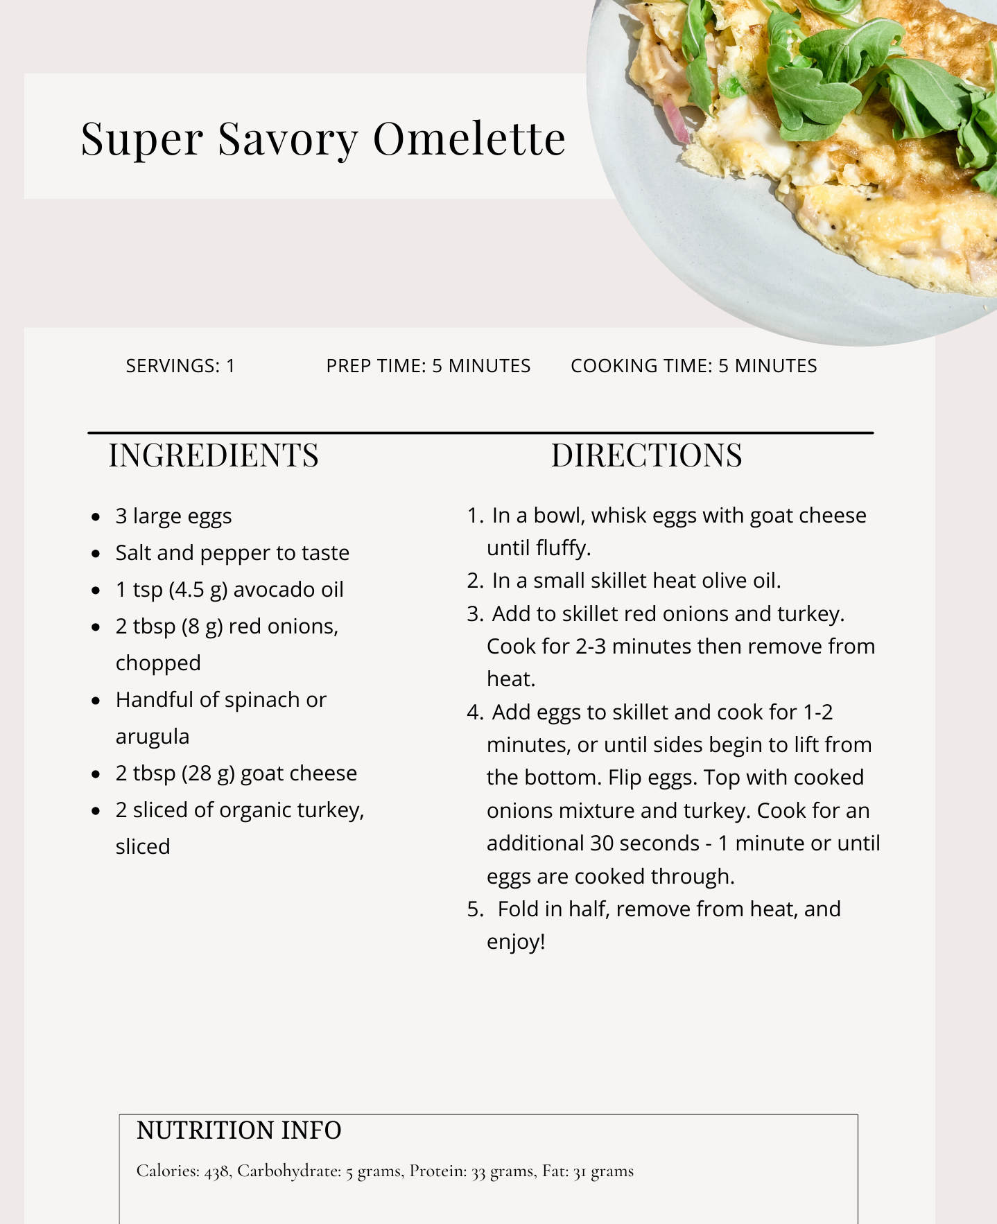
Breakfast
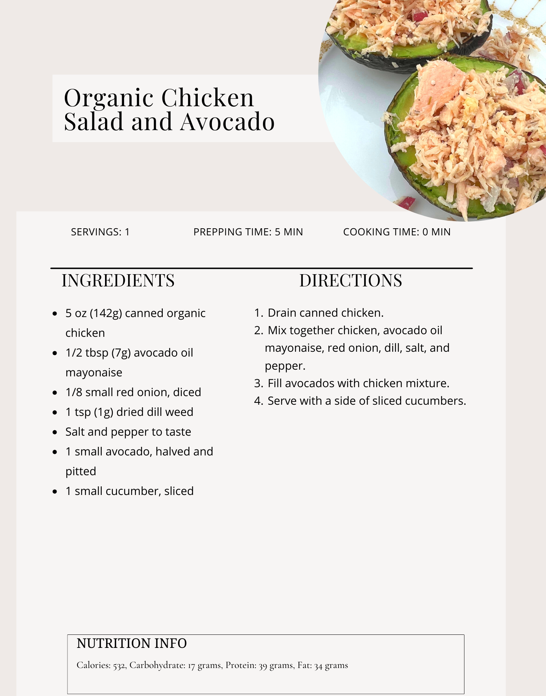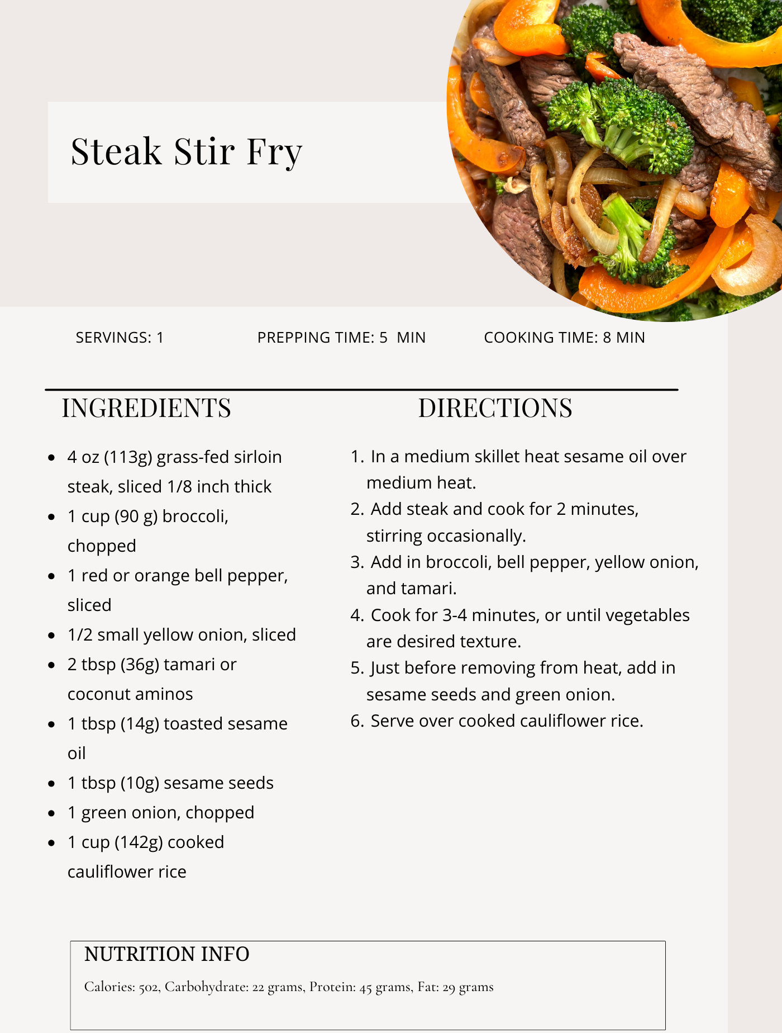
Dinner-save leftovers for tomorrow
Lunch
Note what time you finish dinner =Intermittent Fasting :16 hours after your last meal
Self Reflection: What Did I do Well today?

Day 2
Write down 3 things you are grateful for: Find 3 new things you are grateful for

1.

2.

3.
Write with your non-dominant hand today's affirmation: With every breath I take, I am getting Healthier and Healthier
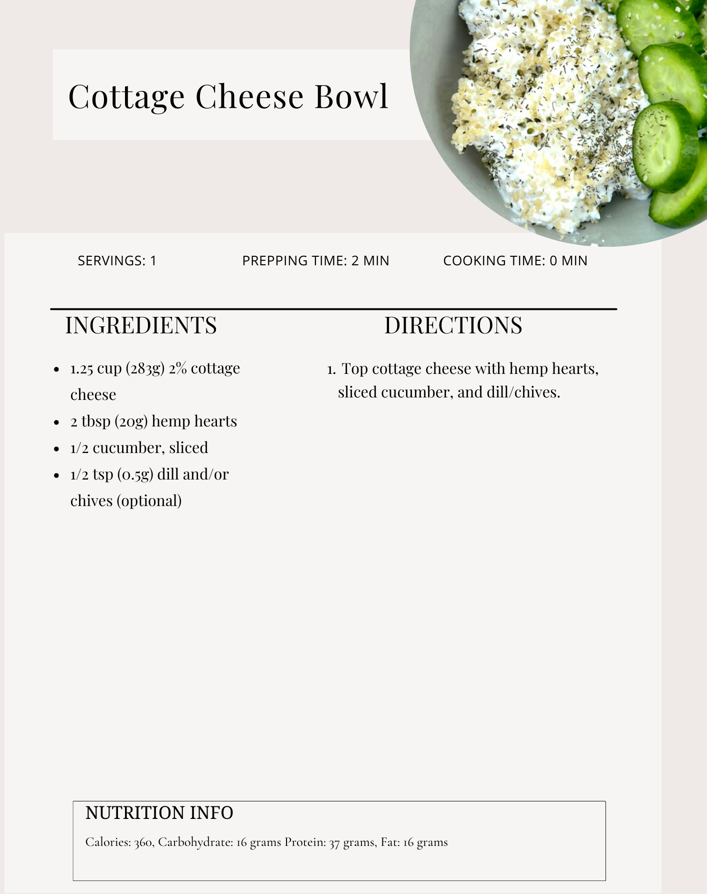
Breakfast
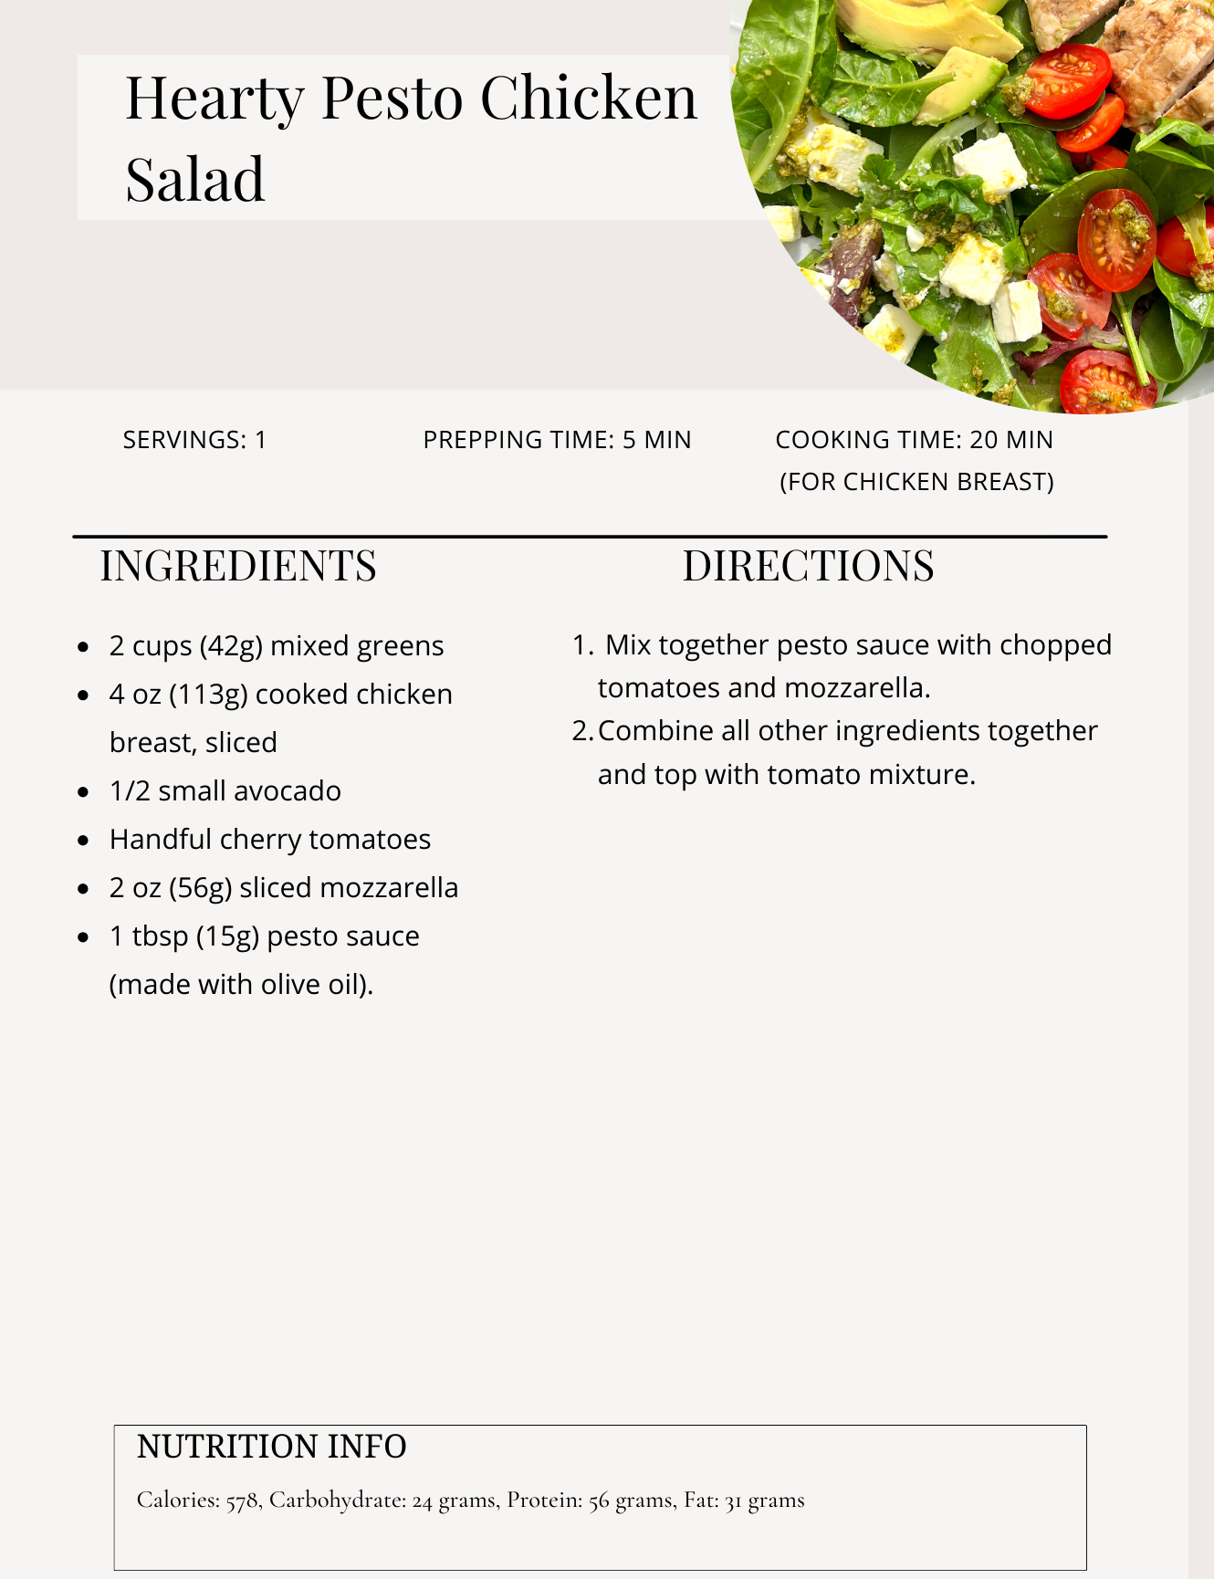
Lunch

Dinner : Left overs from the night before
Note what time you finish dinner =Intermittent Fasting :16 hours after your last meal
Self Reflection: What Did I do Well today?

Day 3
Write down 3 things you are grateful for: Find 3 new things you are grateful for

1.

2.

3.

Write with your non-dominant hand today's affirmation: Throughout the day, I check in on my Body's tension Level. I sit quietly, Breathe deeply and let the tension go.

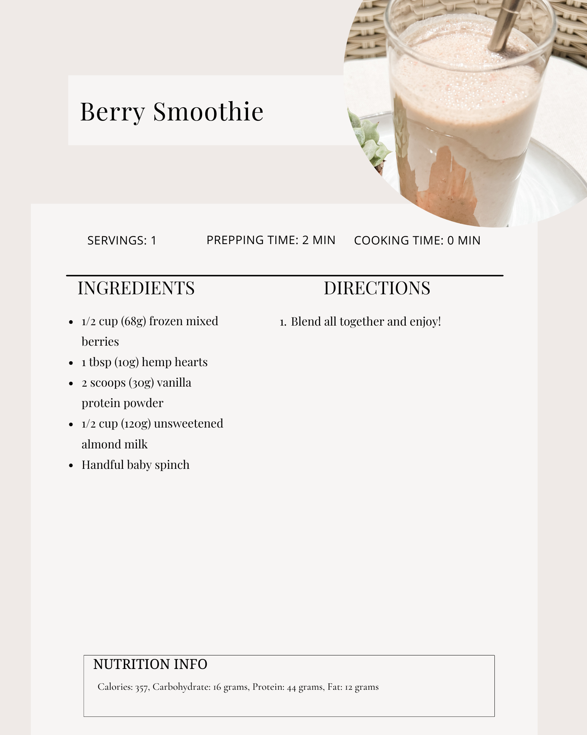
Breakfast
Lunch
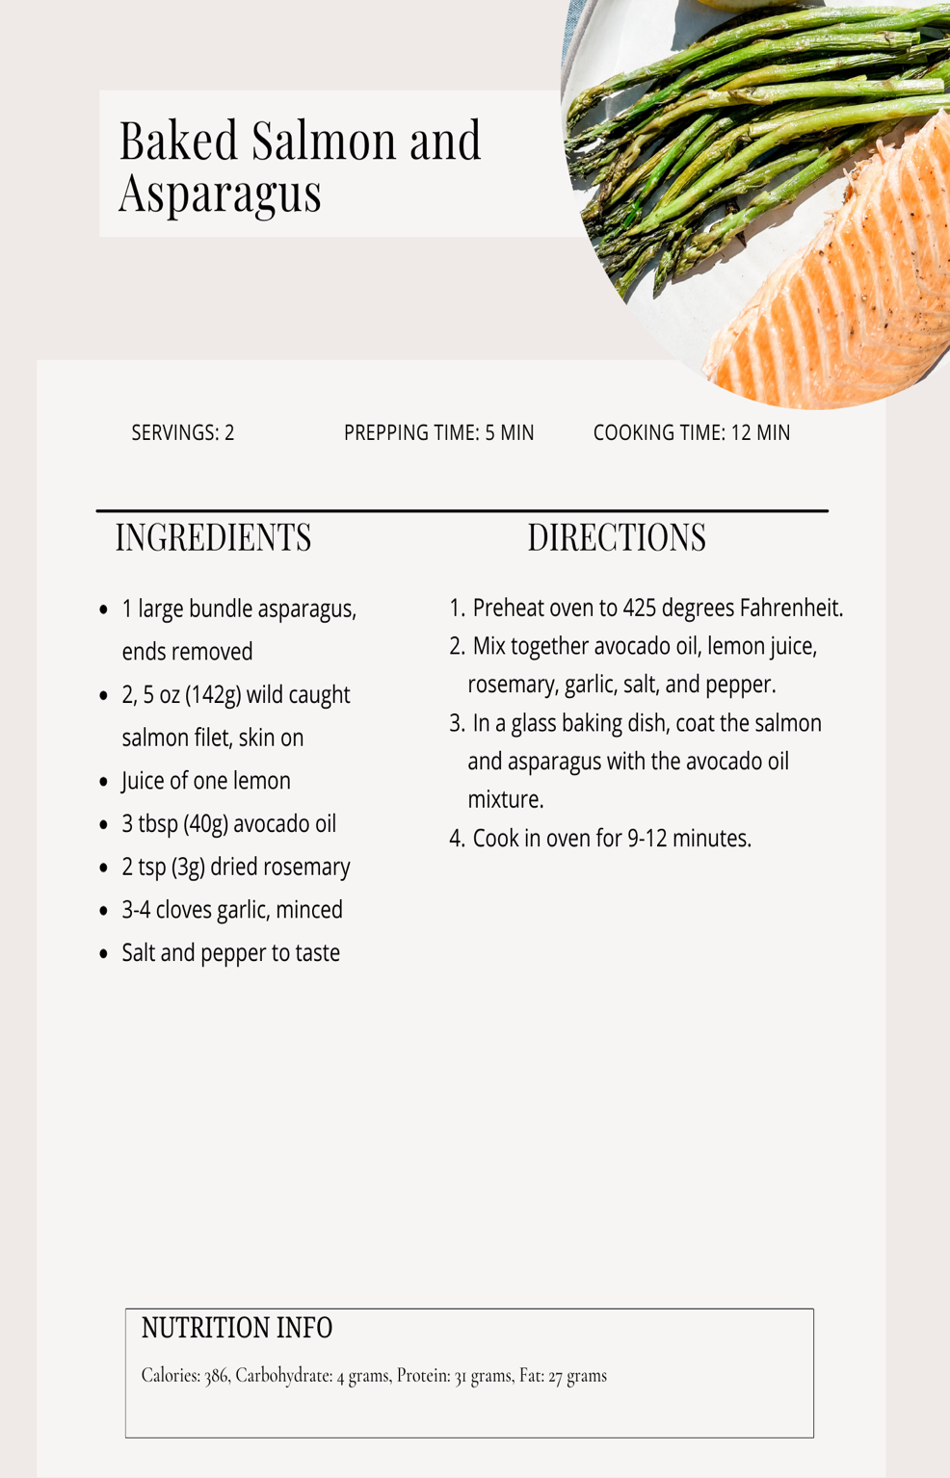
Dinner
Note what time you finish dinner =Intermittent Fasting :16 hours after your last meal
Self Reflection: What Did I do Well today?

Dinner-save for leftovers for tomorrows dinner

Day 4
Write down 3 things you are grateful for: Find 3 new things you are grateful for

1.

2.

3.

Write with your non-dominant hand today's affirmation: Today I do a mental housecleaning, making room for new positive thoughts.

Breakfast
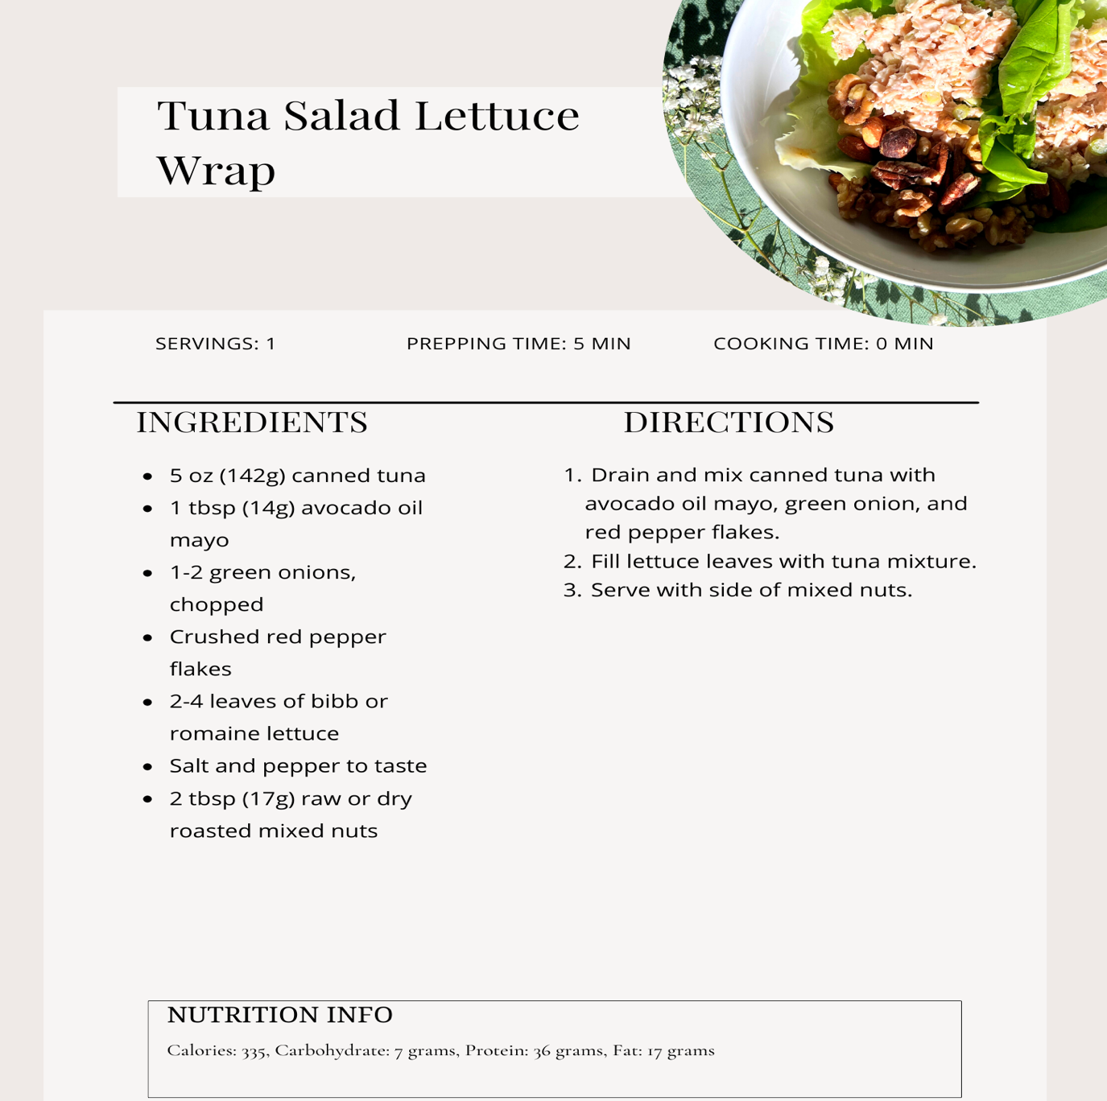
Lunch

Dinner: Left overs from the night before

Note what time you finish dinner =Intermittent Fasting :16 hours after your last meal

Self Reflection: What Did I do Well today?

Lunch

Day 5

Write down 3 things you are grateful for:

1.

2.

3.

Write with your non-dominant hand today's affirmation: The more I accept life exactly as it is, the more I get to experience true harmony and perfection.

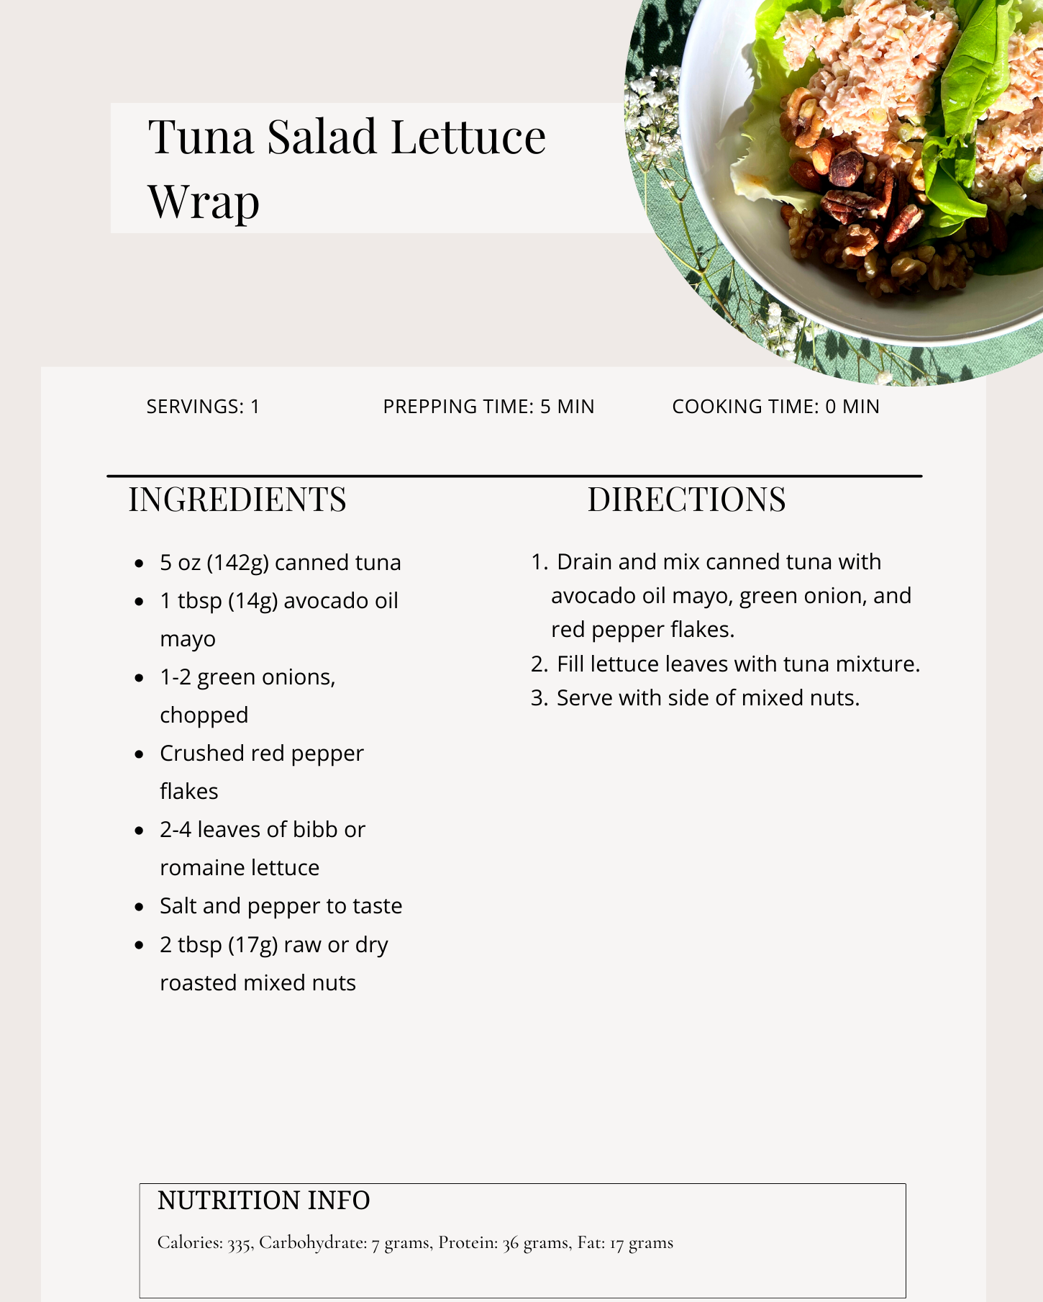
Lunch
Breakfast

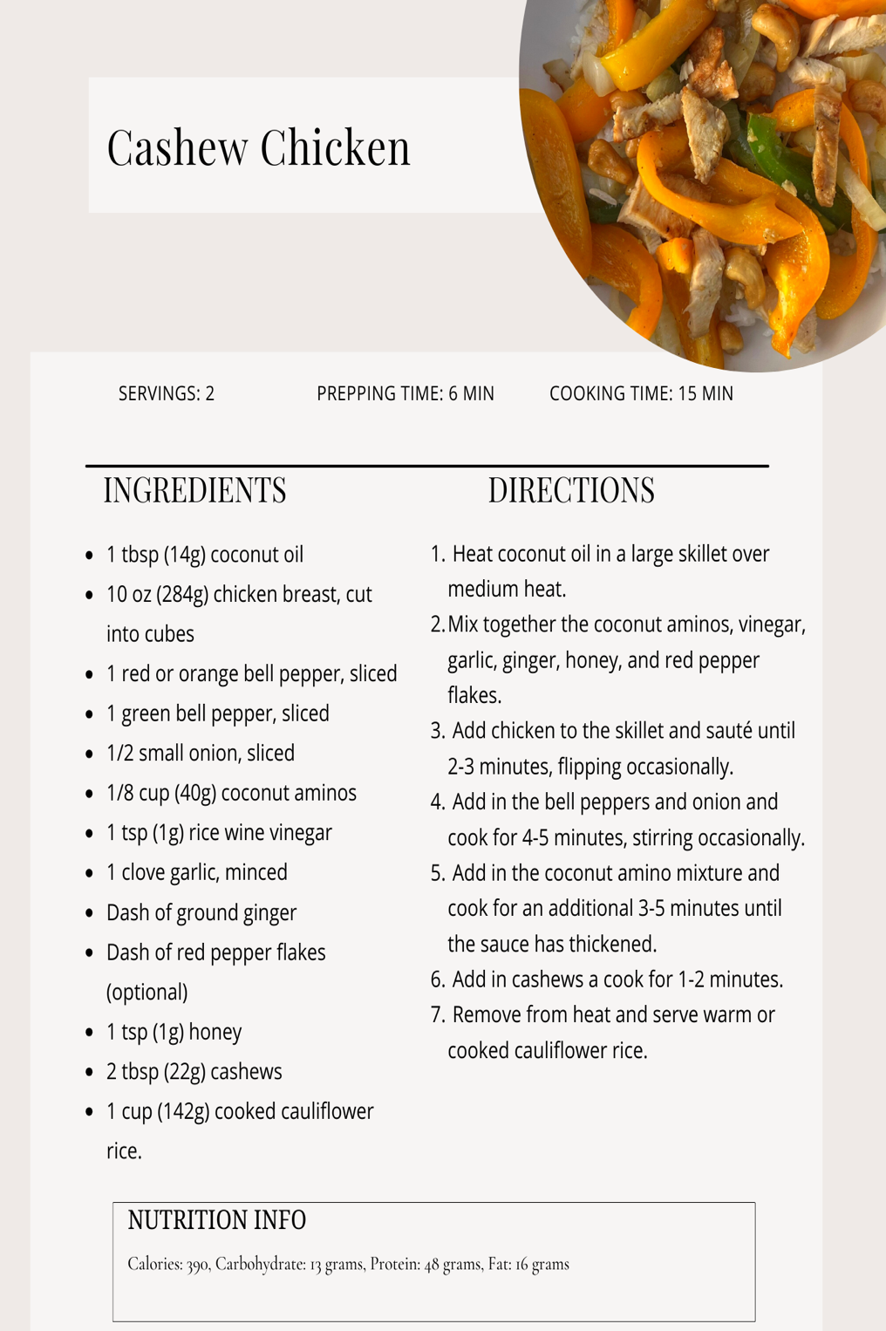
Dinner
Note what time you finish dinner =Intermittent Fasting :16 hours after your last meal
Dinner save leftovers for tomorrow night dinner

Self Reflection: What Did I do Well today?

Day 6

Write down 3 things you are grateful for:

1.

2.

3.

Write with your non-dominant hand today's affirmation: My inner vision is clear and unclouded

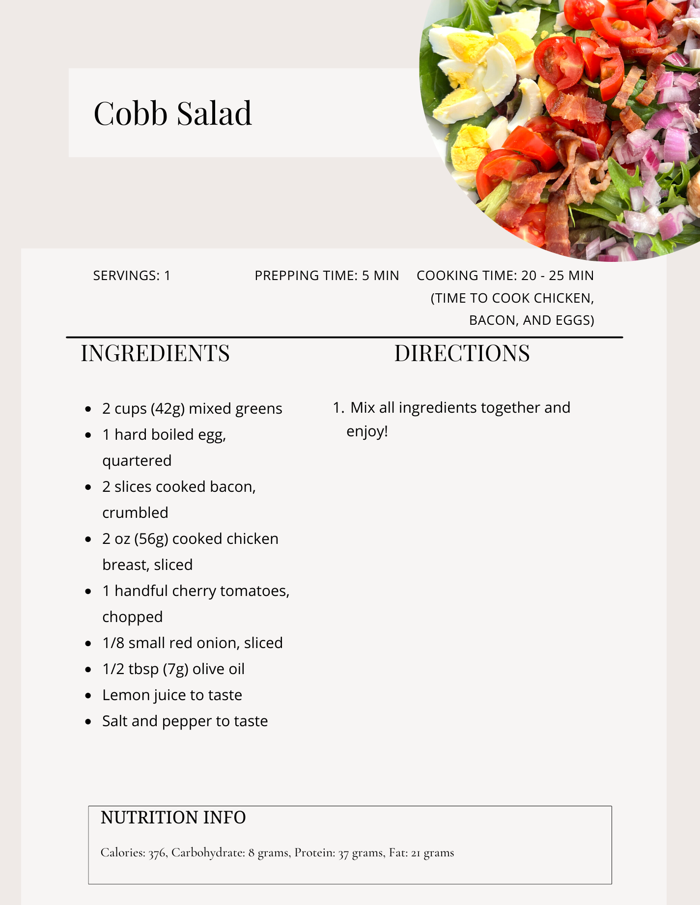
Breakfast
Lunch

Dinner: Left overs from the night before- Note what time you finish dinner =Intermittent Fasting :16 hours after your last meal
Self Reflection: What Did I do Well today?

Day 7

Write down 3 things you are grateful for:

1.

2.

3.

Write with your non-dominant hand today's affirmation: I am open and receptive to receiving all the gifts that life has to give me .

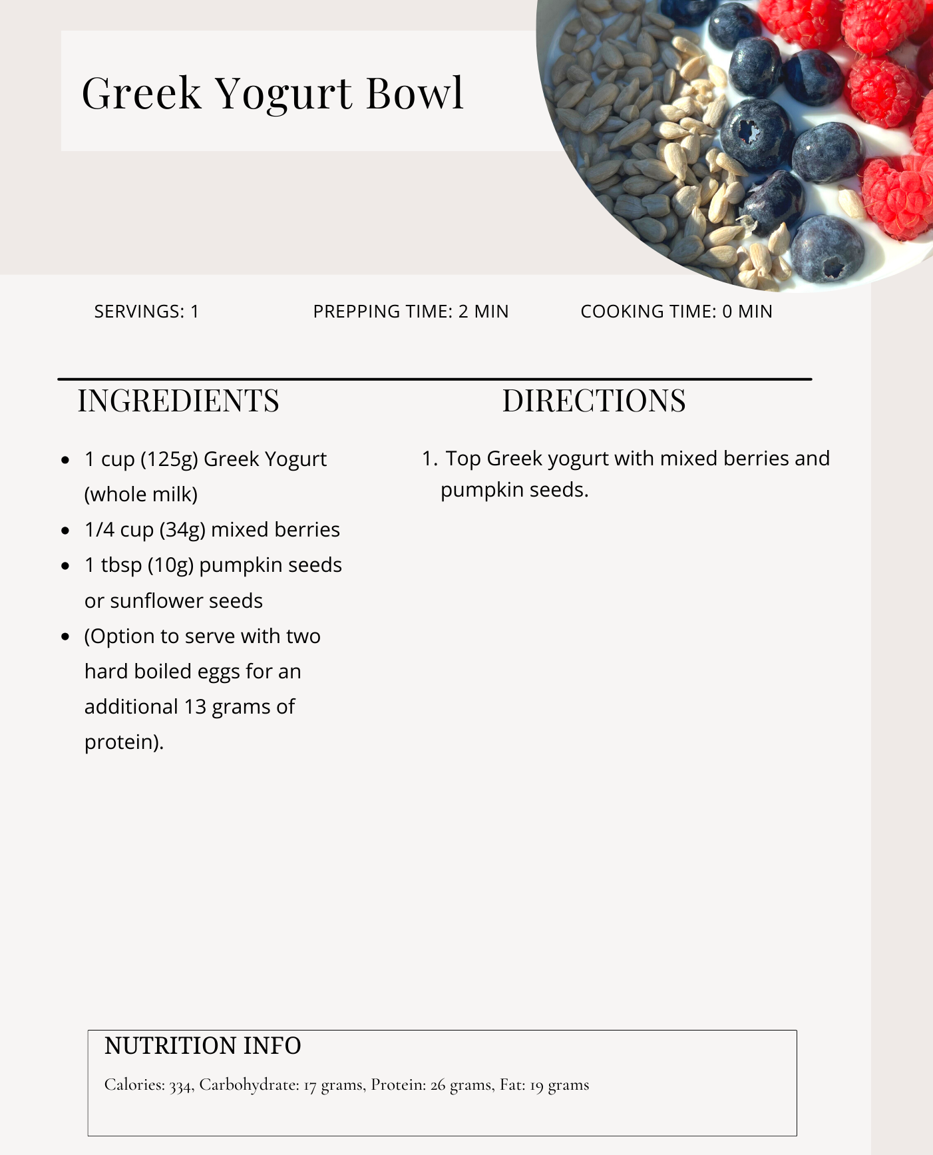
Lunch
Breakfast
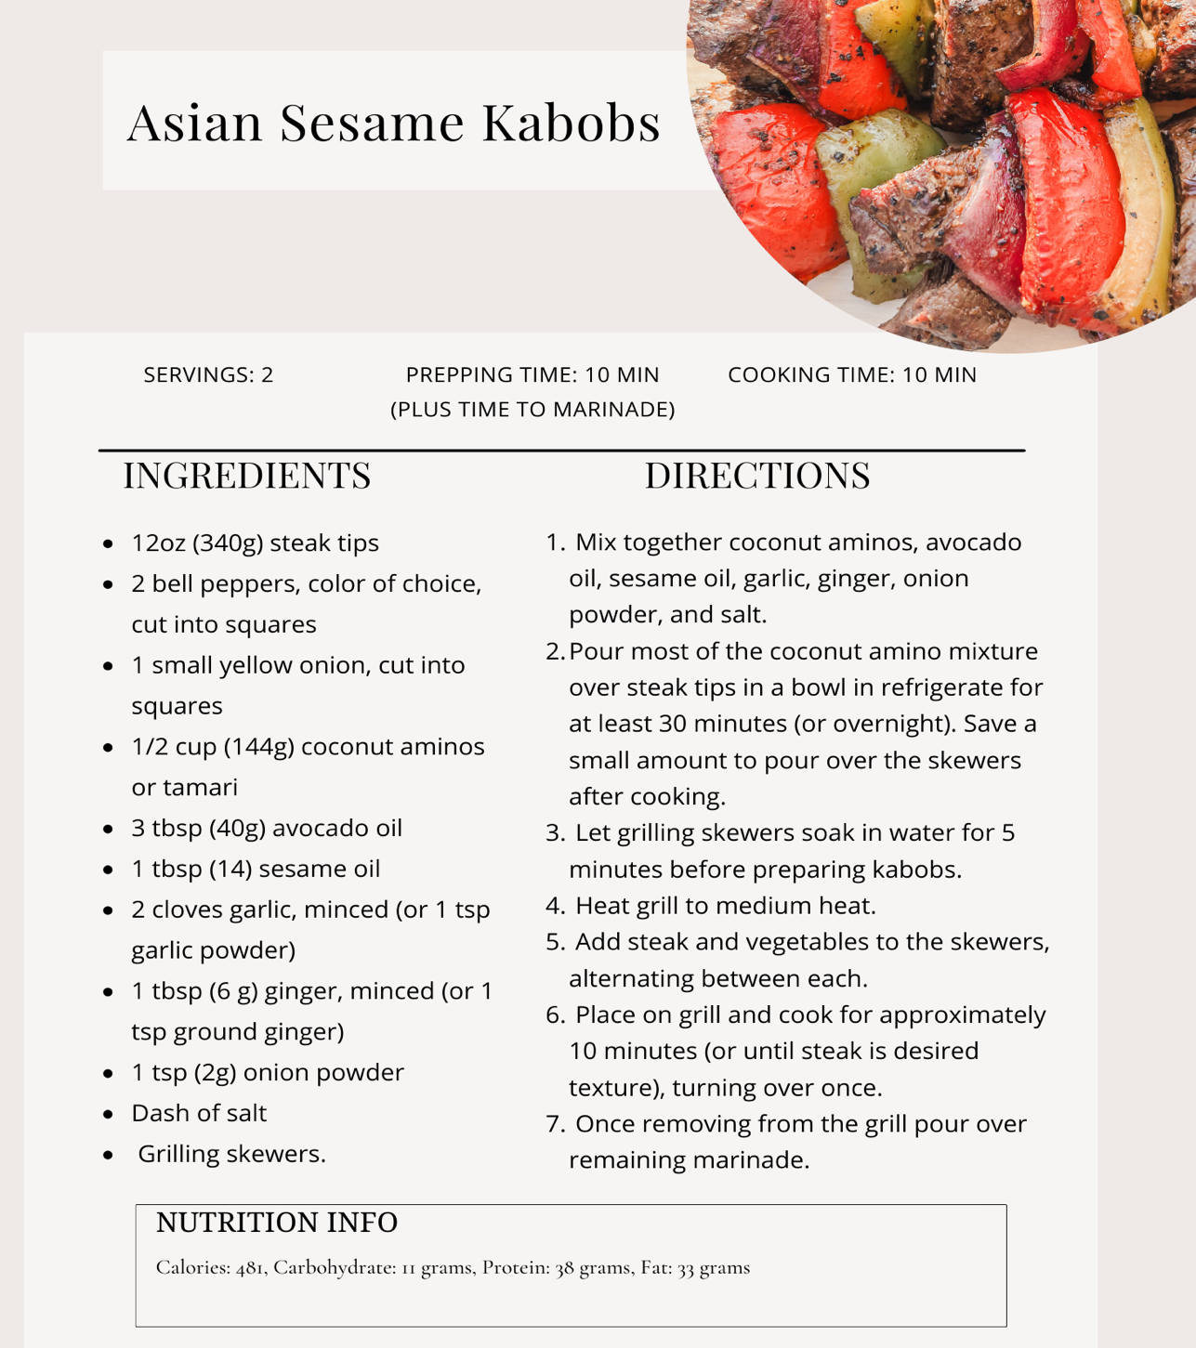
Dinner
Note what time you finish dinner =Intermittent Fasting :16 hours after your last meal

Self Reflection: What Did I do Well today?
Dinner

Getting out of your Comfort Zone Challenge Activity
De-Clutter your Environment
The connection between mental clutter and physical space is well-recognized. A cluttered environment often reflects a cluttered mind, and vice versa. The scenario you described, where unfinished tasks and to-dos play in the background of your subconscious, can indeed lead to stress and a sense of procrastination.Here is an exercise to help you get started . Try to get through some of your to-do list through the next 21 days.
- Create a To-Do List for each room of the house. Go into each room and write down everything you see even the big jobs like painting the walls.
  - Write down tasks on a to-do list, categorizing them by priority.
  - Break down larger tasks into smaller, more manageable steps.For example if you need to paint a wall you might have to get quotes from 3 painters or if you are doing it yourself buy the paint and equipment.
Organizing tasks room by room is a practical approach to manage your to-do list effectively. Here's a template to help you list tasks for different rooms in your home:
Room | Task | Breakdown into bite size Tasks
Room | Task | Breakdown into bite size Tasks

Getting out of your Comfort Zone Challenge Activity
Write your Eulogy
The idea of writing one's own eulogy may seem unconventional and, perhaps, a bit morbid at first glance. However, this powerful exercise in self-reflection can be a transformative and enlightening experience. By articulating your life story, values, and accomplishments, you gain a profound understanding of the legacy you wish to leave behind. In this article, we will explore the process of writing your own eulogy, its significance, and the valuable insights it can offer. How to Write Your Own Eulogy:
- Reflect on Your Life:
  - Consider key life events, relationships, and experiences that have shaped you. Reflect on moments of joy, sorrow, and personal growth.
- Identify Core Values:
  - What principles have guided your decisions and actions throughout your life? Identify the core values that define you.
- Acknowledge Achievements and Challenges:
  - Celebrate your achievements and acknowledge the challenges you've overcome. This balanced perspective provides a holistic view of your journey.
- Consider Relationships:
  - Highlight significant relationships and the impact they've had on your life. Express gratitude for the people who played a pivotal role.
- Express Your Hopes for the Future:
  - Share your hopes and aspirations for the future, both for yourself and for those you leave behind. This adds a forward-looking dimension to your eulogy.
Euology space

Getting out of your Comfort Zone Challenge Activity
Write a bucket list
Creating a bucket list is a wonderful way to set intentions, dream big, and make the most of your life's journey. Here's a brief guide on how to write a bucket list:
1. Reflect on Your Passions and Interests:
- Begin by reflecting on your passions, interests, and the experiences you've always dreamed of having. Consider activities that bring you joy, fulfillment, and a sense of purpose.
2. Identify Short-Term and Long-Term Goals:
- Categorize your bucket list into short-term and long-term goals. Short-term goals might be things you can achieve within the next year, while long-term goals could span several years or even a lifetime.
3. Be Specific and Concrete:
- Be specific about the experiences you want to have. Instead of vague goals like "travel more," specify destinations you want to visit, such as "explore the streets of Tokyo" or "experience the Northern Lights in Iceland."
4. Include a Variety of Experiences:
- Ensure diversity in your list by including a mix of travel, personal development, adventure, and leisure activities. This variety will keep your list exciting and well-rounded.
5. Challenge Yourself:
- Don't be afraid to include challenging or adventurous goals. Pushing your boundaries can lead to personal growth and unforgettable experiences.
6. Consider Your Values:
- Align your bucket list with your values. Include activities that resonate with what matters most to you and contribute to your sense of fulfillment.
7. Keep It Flexible:
- While it's good to have a list, allow flexibility for spontaneous opportunities. Sometimes, the best experiences are the ones you didn't plan for.
8. Prioritize and Set a Timeline:
- Prioritize your bucket list items based on importance to you. Consider setting a timeline for each goal to keep yourself accountable and motivated.
9. Share Your List:
- Share your bucket list with friends or family. This not only makes the experience more enjoyable but also opens up opportunities for shared adventures.
10. Celebrate Achievements:
- As you tick off items from your bucket list, take time to celebrate your achievements. Reflect on the experiences, lessons learned, and memories created.
11. Update and Evolve:
- Your bucket list is not set in stone. Allow it to evolve as your interests, priorities, and circumstances change. Regularly revisit and update your list to reflect your current aspirations.
Creating a bucket list is a personal and introspective process. It's about envisioning a life filled with meaningful experiences and taking intentional steps to turn those dreams into reality. Enjoy the journey of crafting your list, and let it inspire you to live life to the fullest.

Week 2
Day 8
Write down 3 things you are grateful for:

1.

2.

3.

Write with your non-dominant hand today's affirmation The greatest gift I can give myself is unconditional love

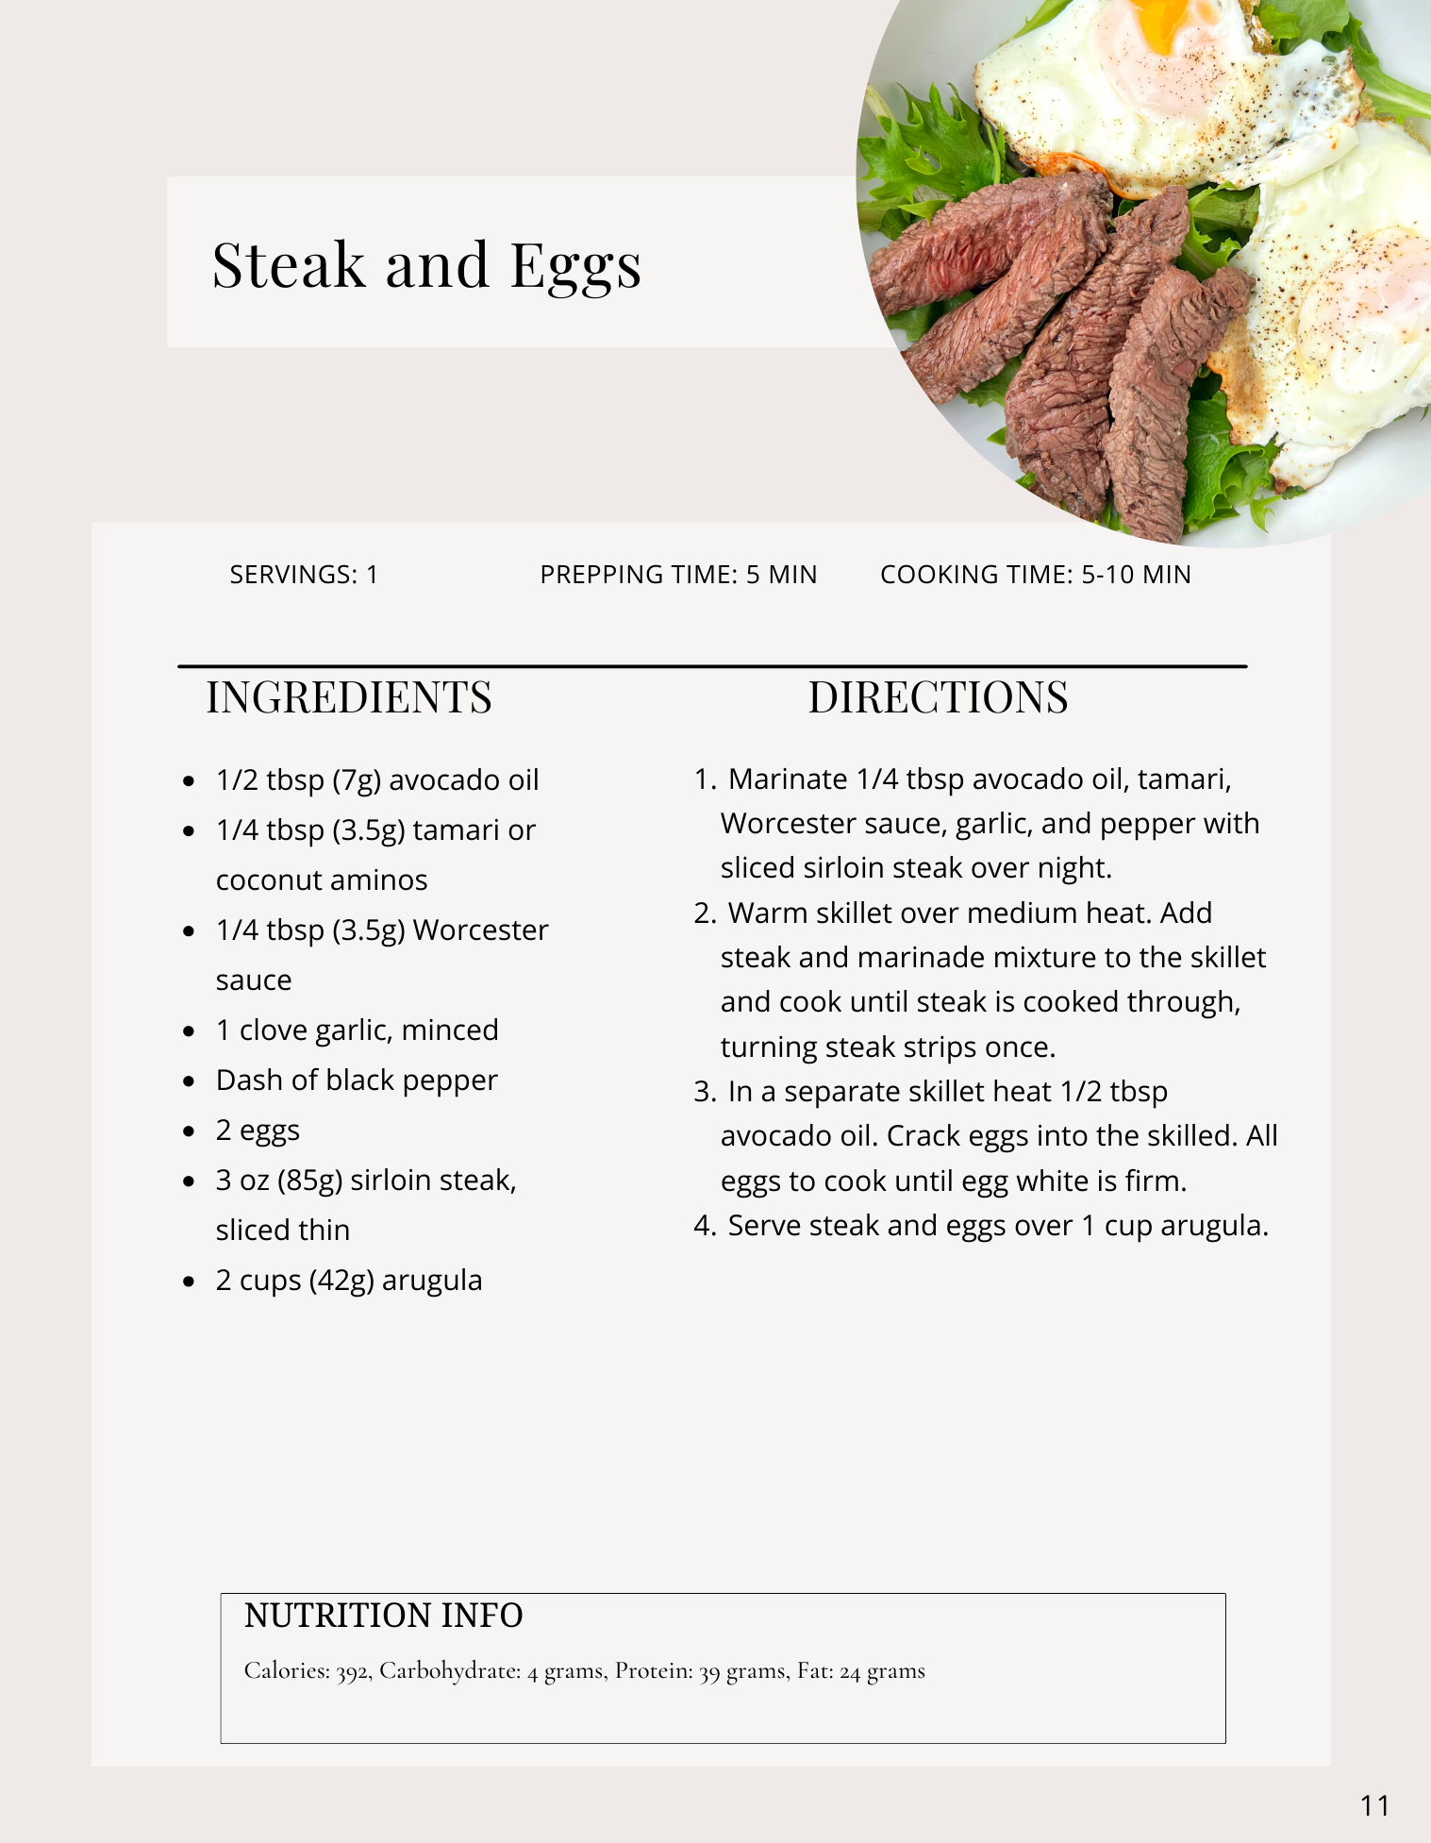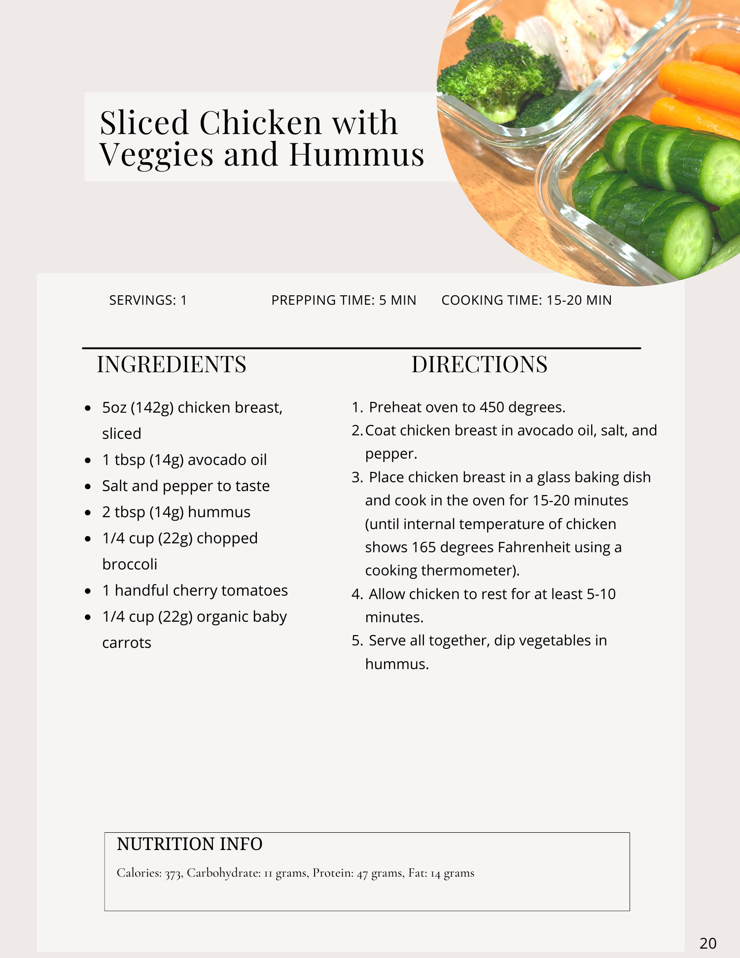
Lunch
Breakfast
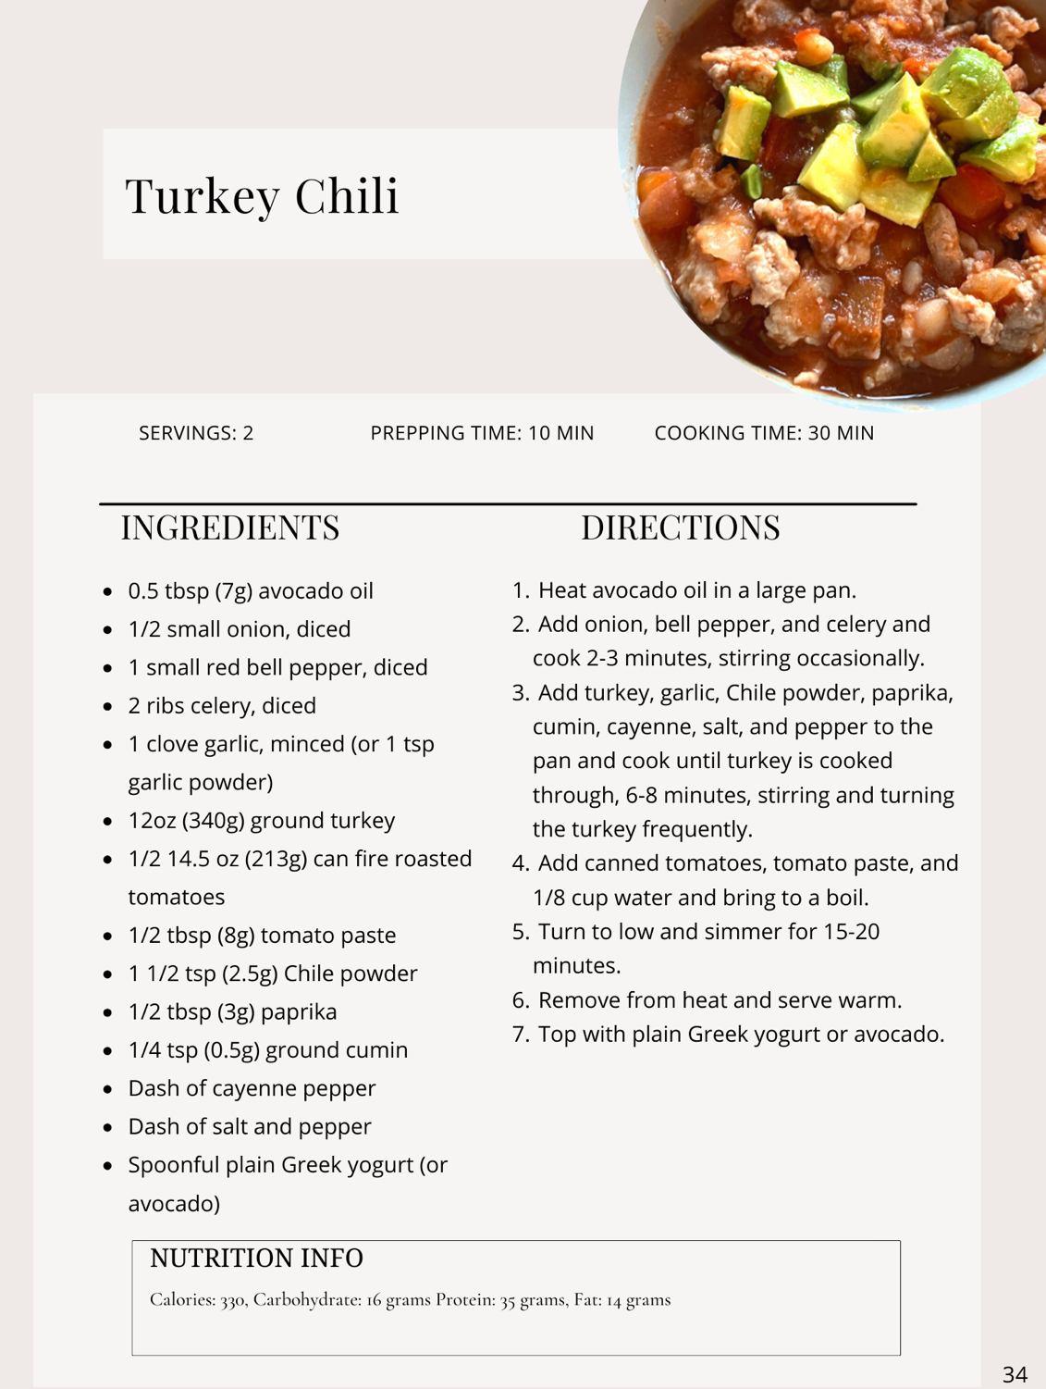
Note what time you finish dinner =Intermittent Fasting :16 hours after your last meal
Dinner

Self Reflection: What Did I do Well today?
Dinner-save leftovers for tomorrows dinner

Day 9
Write down 3 things you are grateful for: Find 3 new things you are grateful for

1.

2.

3.

Write with your non-dominant hand today's affirmation: I maintain my body at the highest level of health , giving it what it needs at every level
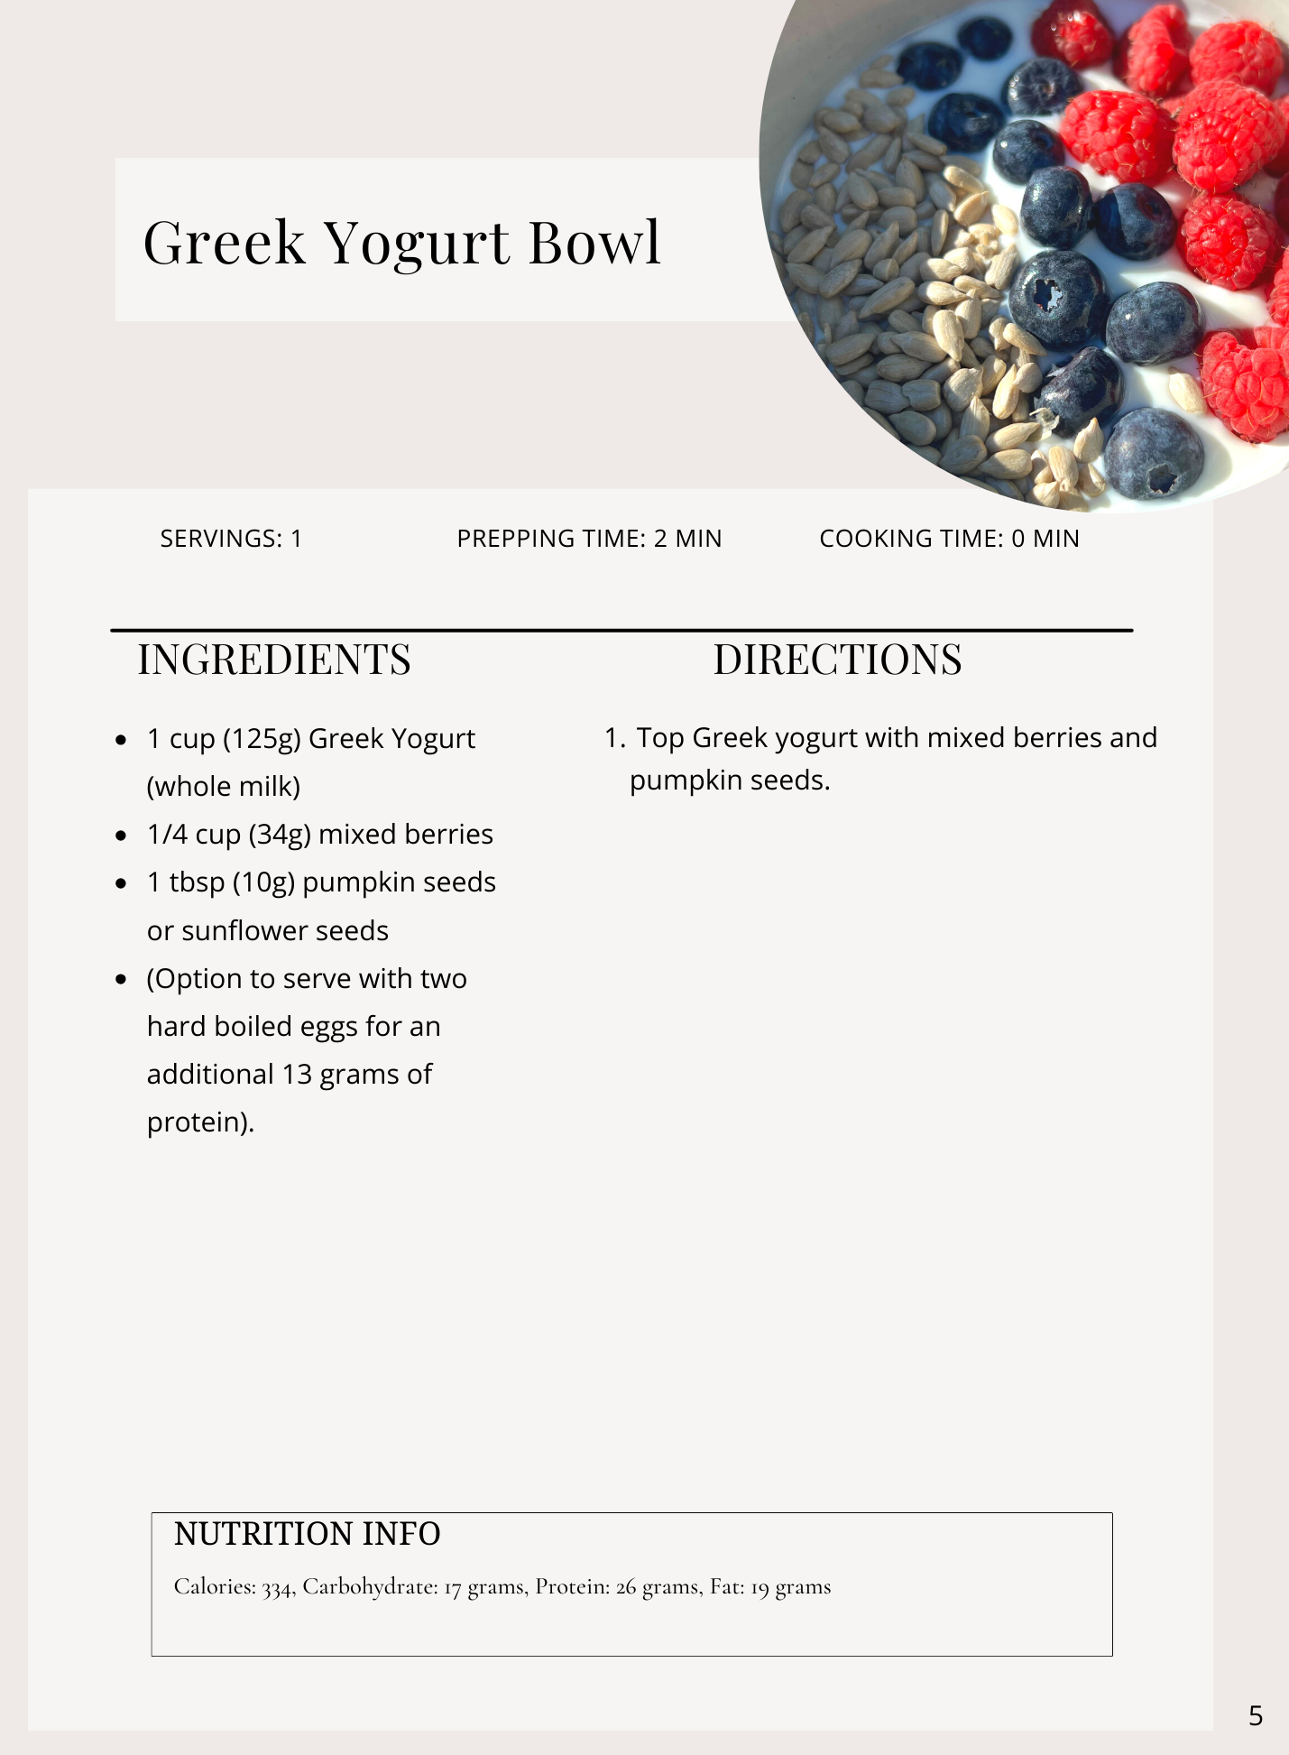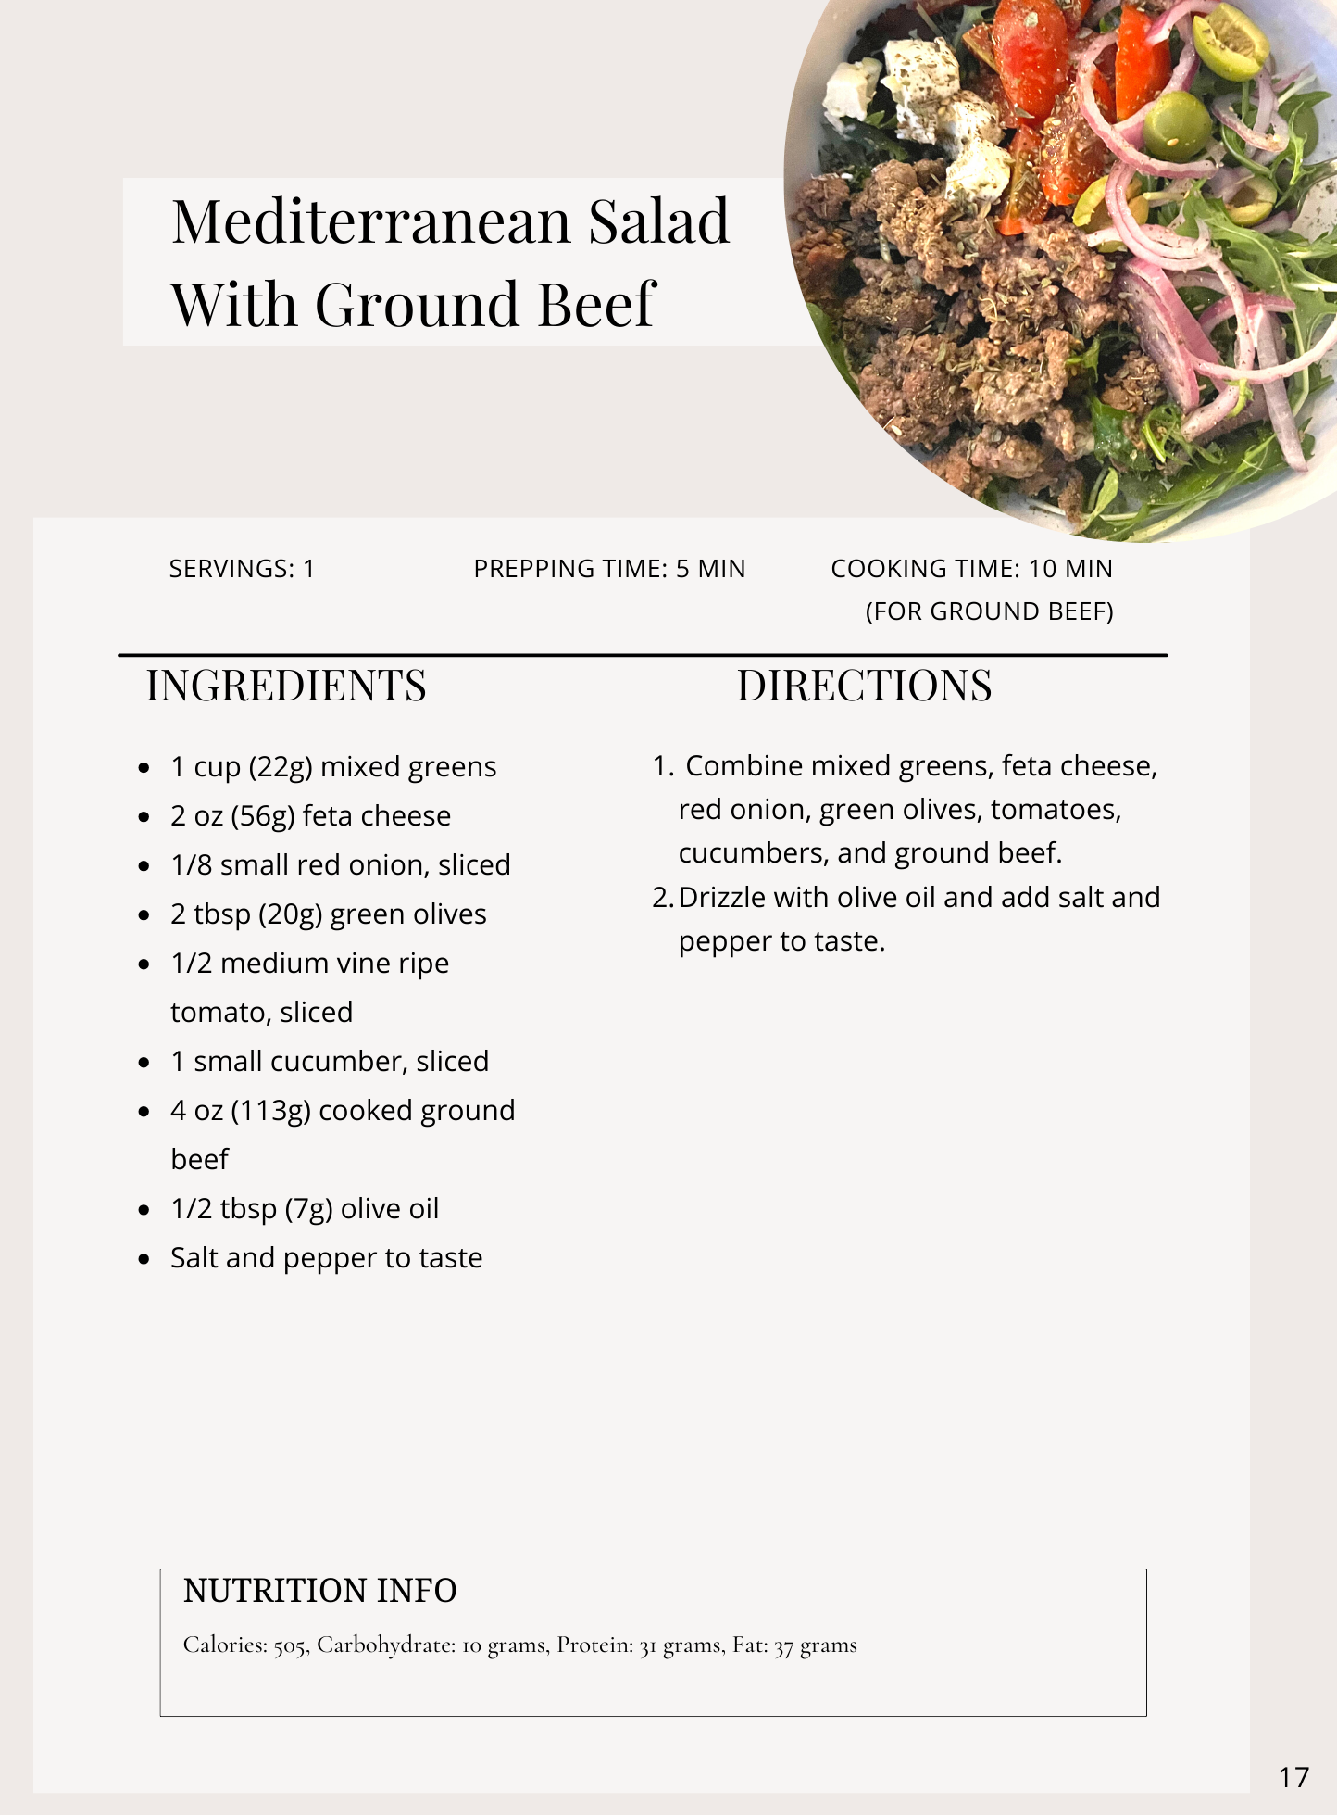
Lunch
Breakfast
Dinner- Leftovers from night before Note what time you finish dinner =Intermittent Fasting :16 hours after your last meal
Self Reflection: What Did I do Well today
Day 10
Write down 3 things you are grateful for: Find 3 new things you are grateful for

1.

2.

3.

Write with your non-dominant hand today's affirmation: No one else gets to choose for me. I make my own choices.
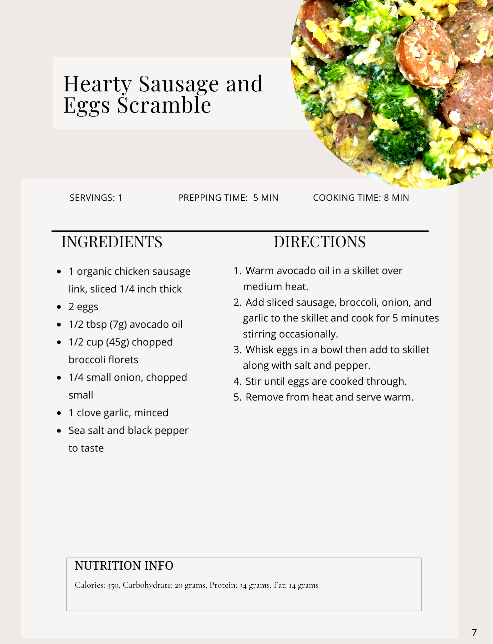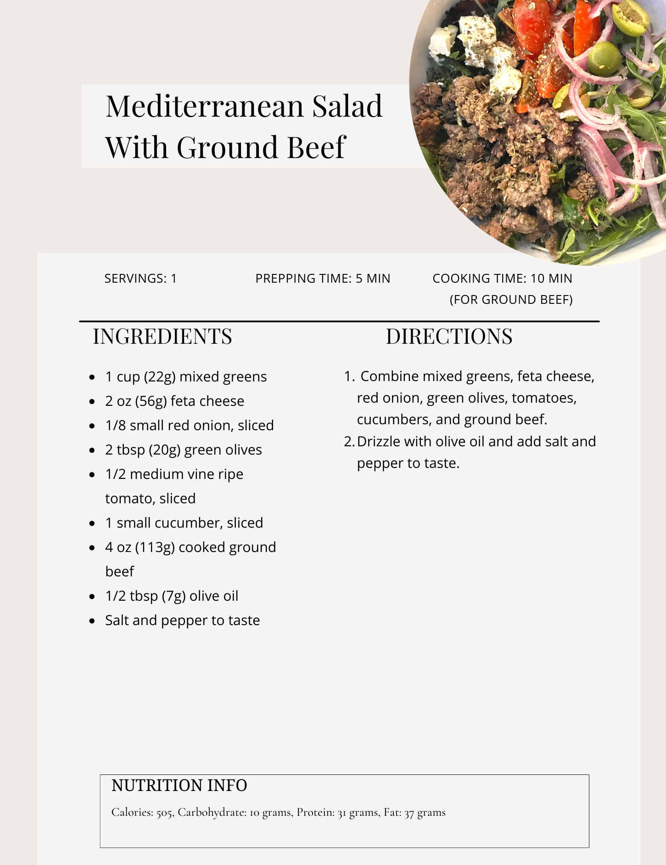
Lunch
Breakfast
Dinner
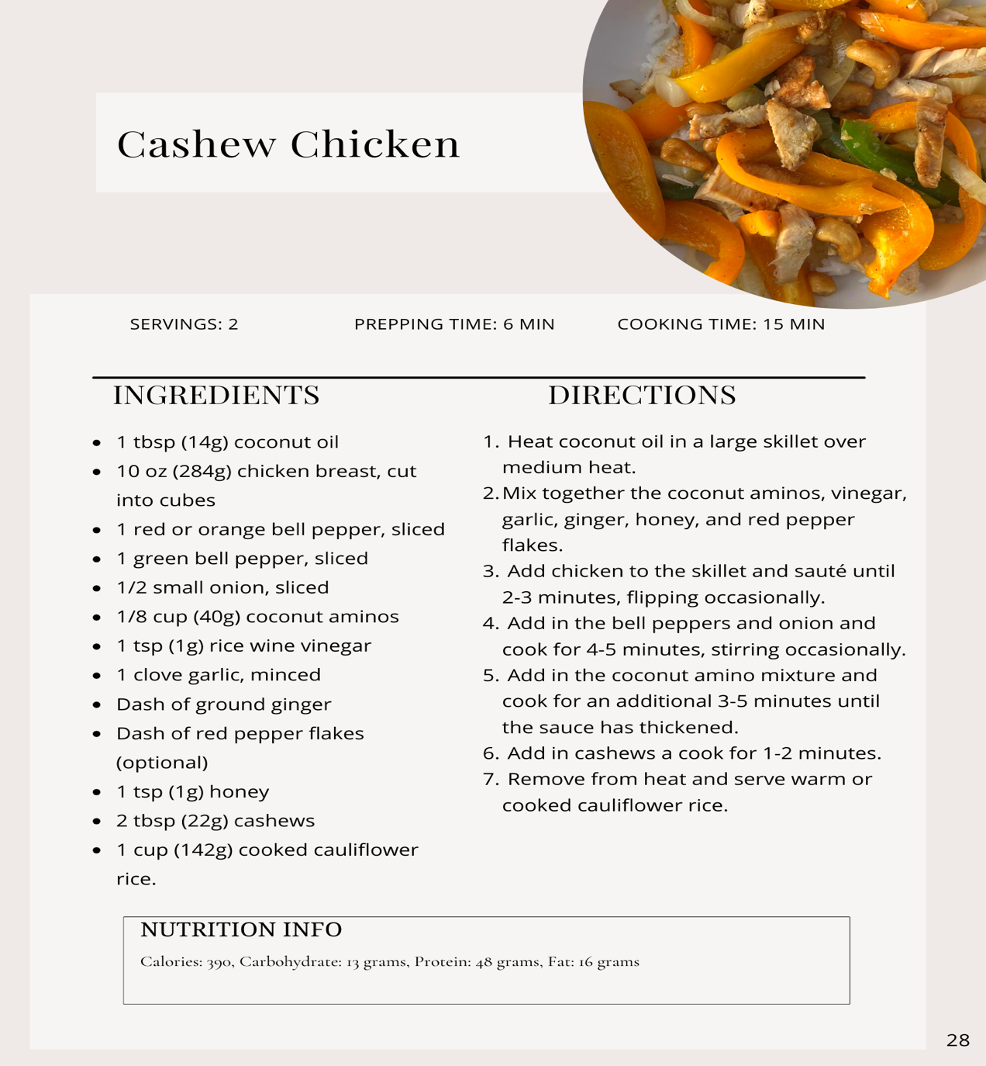

Note what time you finish dinner =Intermittent Fasting :16 hours after your last meal

Self Reflection: What Did I do Well today?

Dinner save leftovers for tomorrow

Day 11
Write down 3 things you are grateful for: Find 3 new things you are grateful for

1.

2.

3.

Write with your non-dominant hand today's affirmation I take the time today to bask in the love and light of my life. What a glorious day!
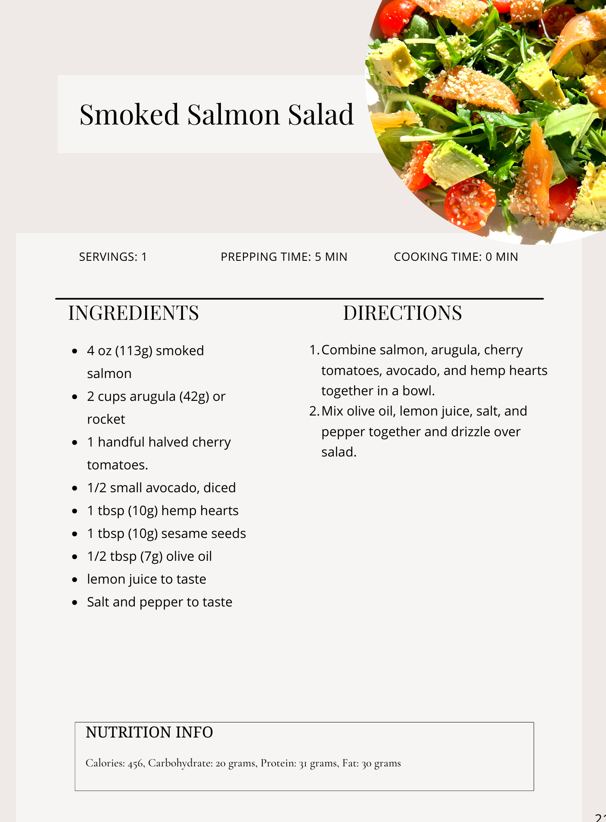 Dinner-left overs from night before Note what time you finish dinner =Intermittent Fasting :16 hours after your last meal
Lunch
Breakfast

Self Reflection: What Did I do Well today
Day 12
Write down 3 things you are grateful for: Find 3 new things you are grateful for

1.

2.

3.

Write with your non-dominant hand today's affirmation I joyfully help wherever I can, easing the load of others .
Lunch
Breakfast
Dinner
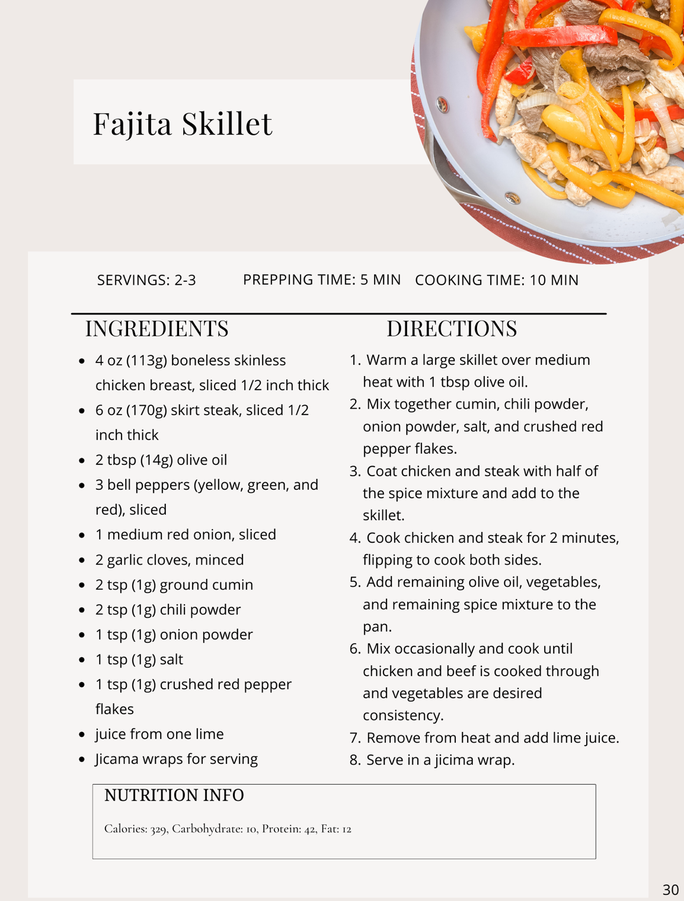
Note what time you finish dinner =Intermittent Fasting :16 hours after your last meal

Self Reflection: What Did I do Well today?

Dinner save leftovers for tomorrows dinner

Day 13
Write down 3 things you are grateful for: Find 3 new things you are grateful for

1.

2.

3.

Write with your non-dominant hand today's affirmation Limitations are merely opportunities to grow. I use them as stepping- stones to success.
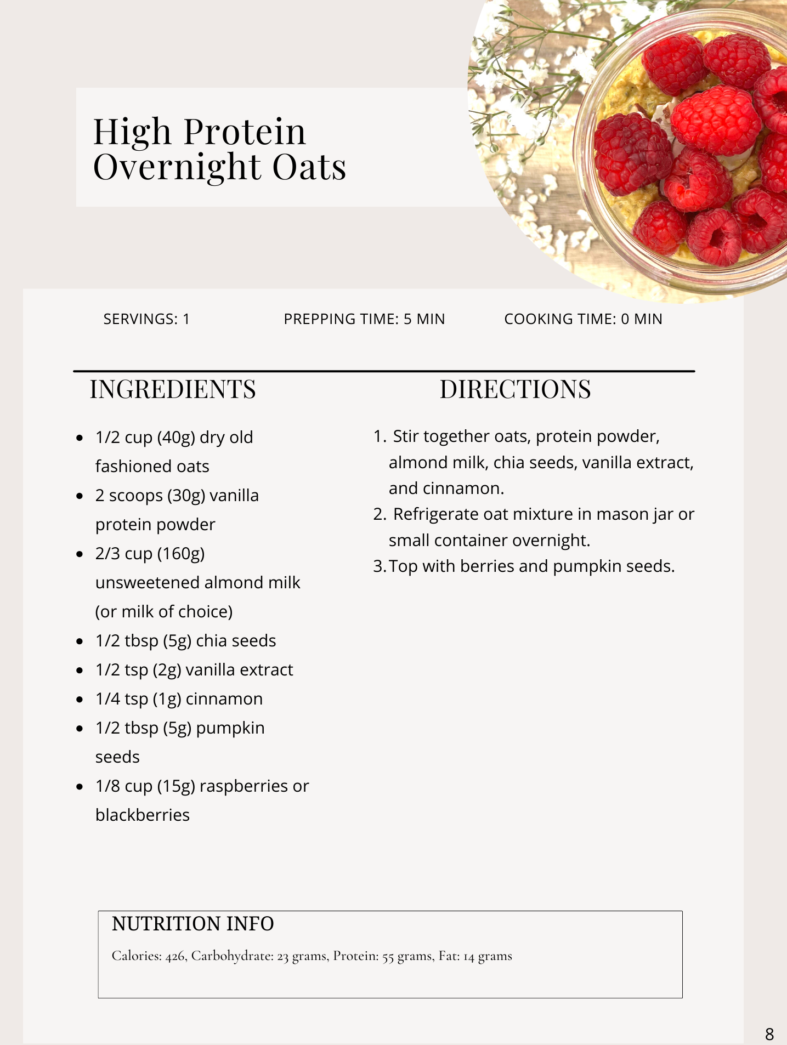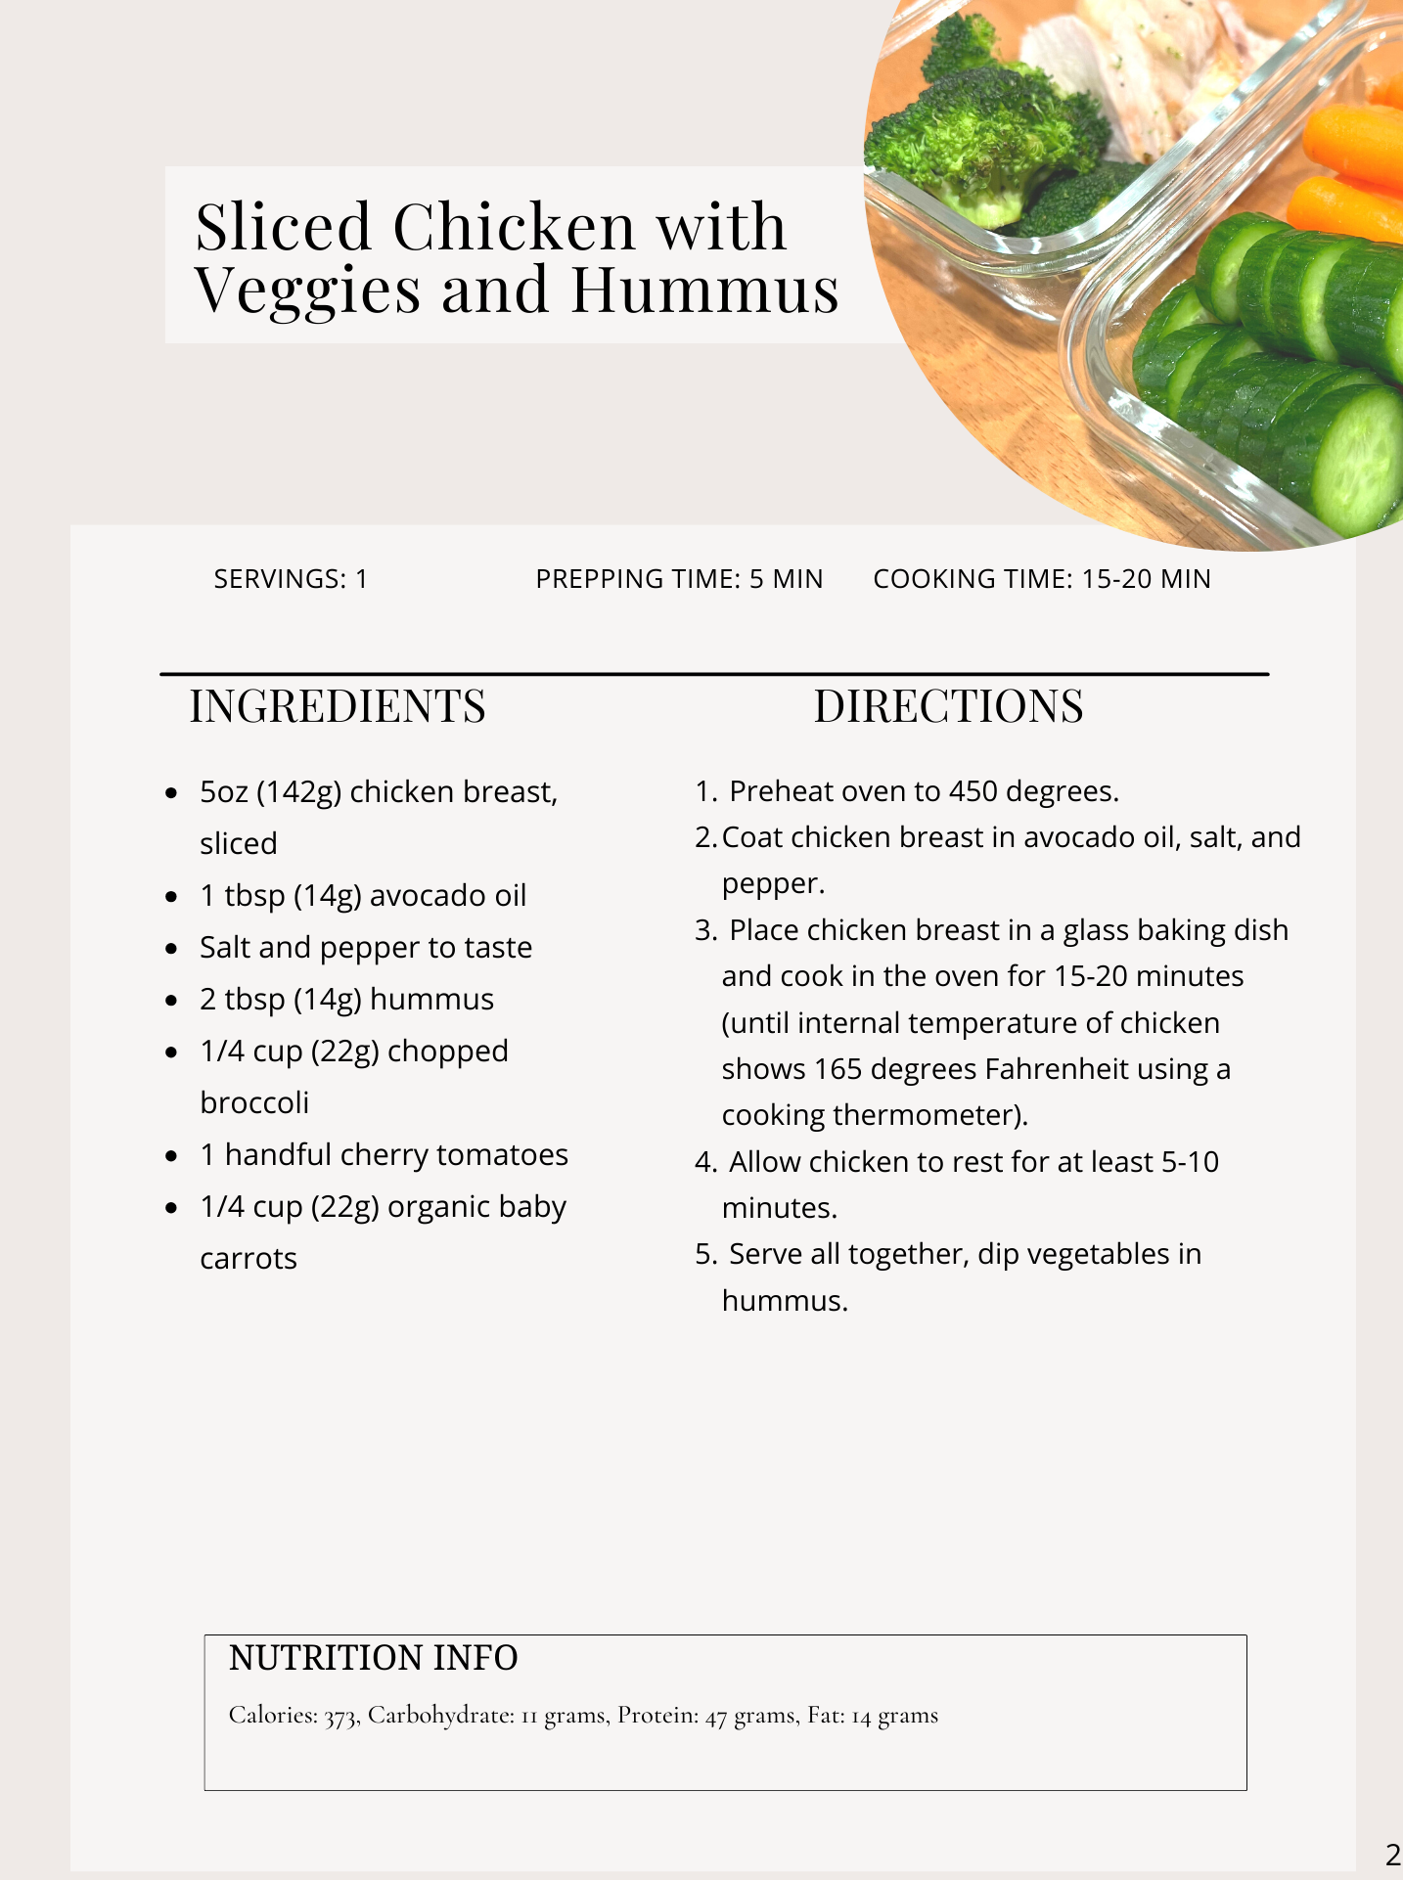
Lunch
Breakfast
dinner-left over from night before- Note what time you finish dinner =Intermittent Fasting :16 hours after your last mea
Self Reflection: What Did I do Well today
Day 14

Write down 3 things you are grateful for: Find 3 new things you are grateful for

1.

2.

3.

Write with your non-dominant hand today's affirmation Love flows through my body, healing all dis-ease.
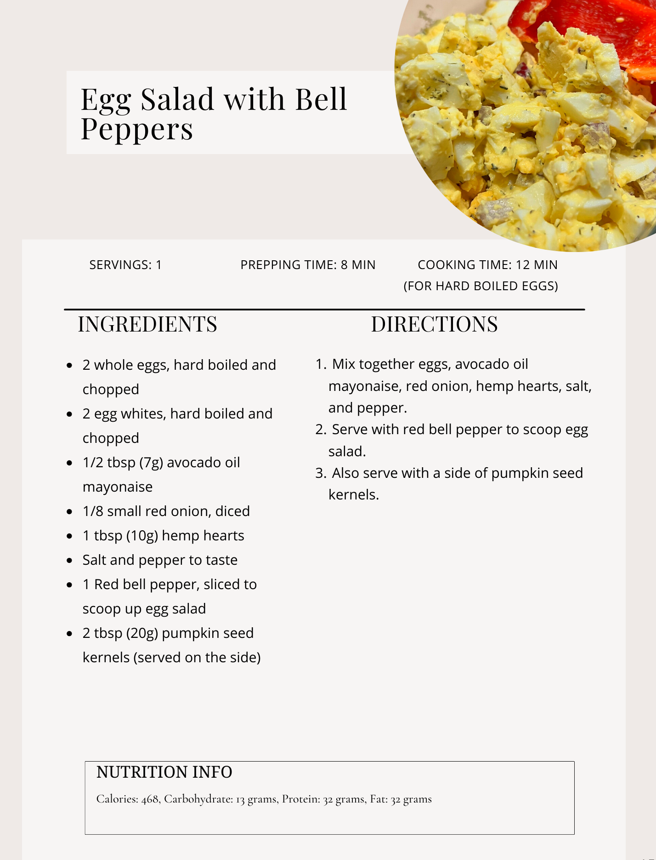
Breakfast
Lunch
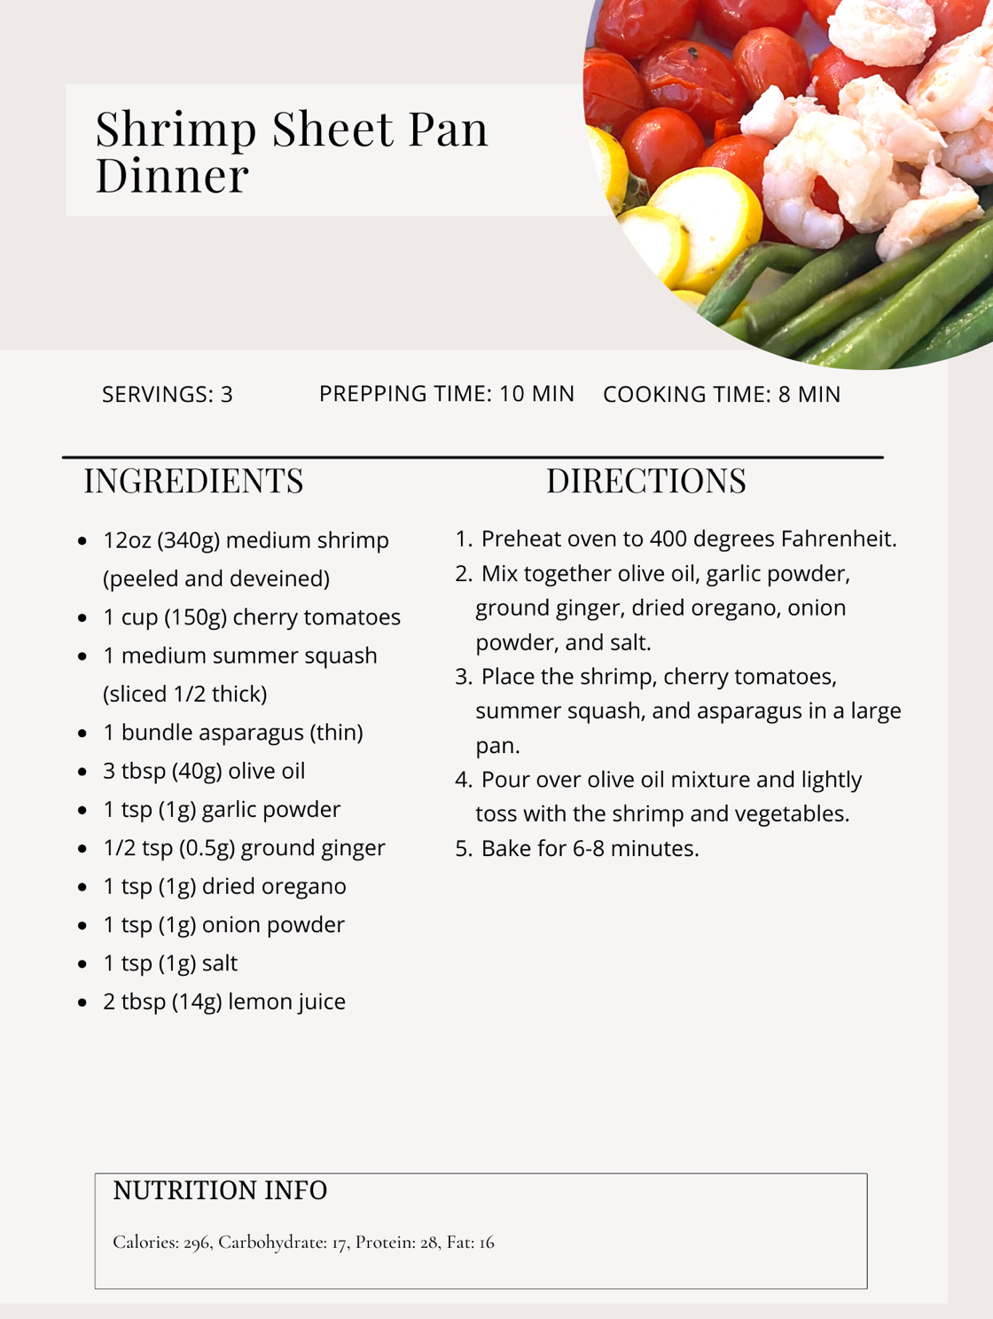
Intermittent Fasting :16 hours after your last meal

Self Reflection: What Did I do Well today?
Dinner

Dinner

Week 3
Day 15
Write down 3 things you are grateful for:

1.

2.

3.

Write with your non-dominant hand today's affirmation Everyone I meet today has my best interests at heart.

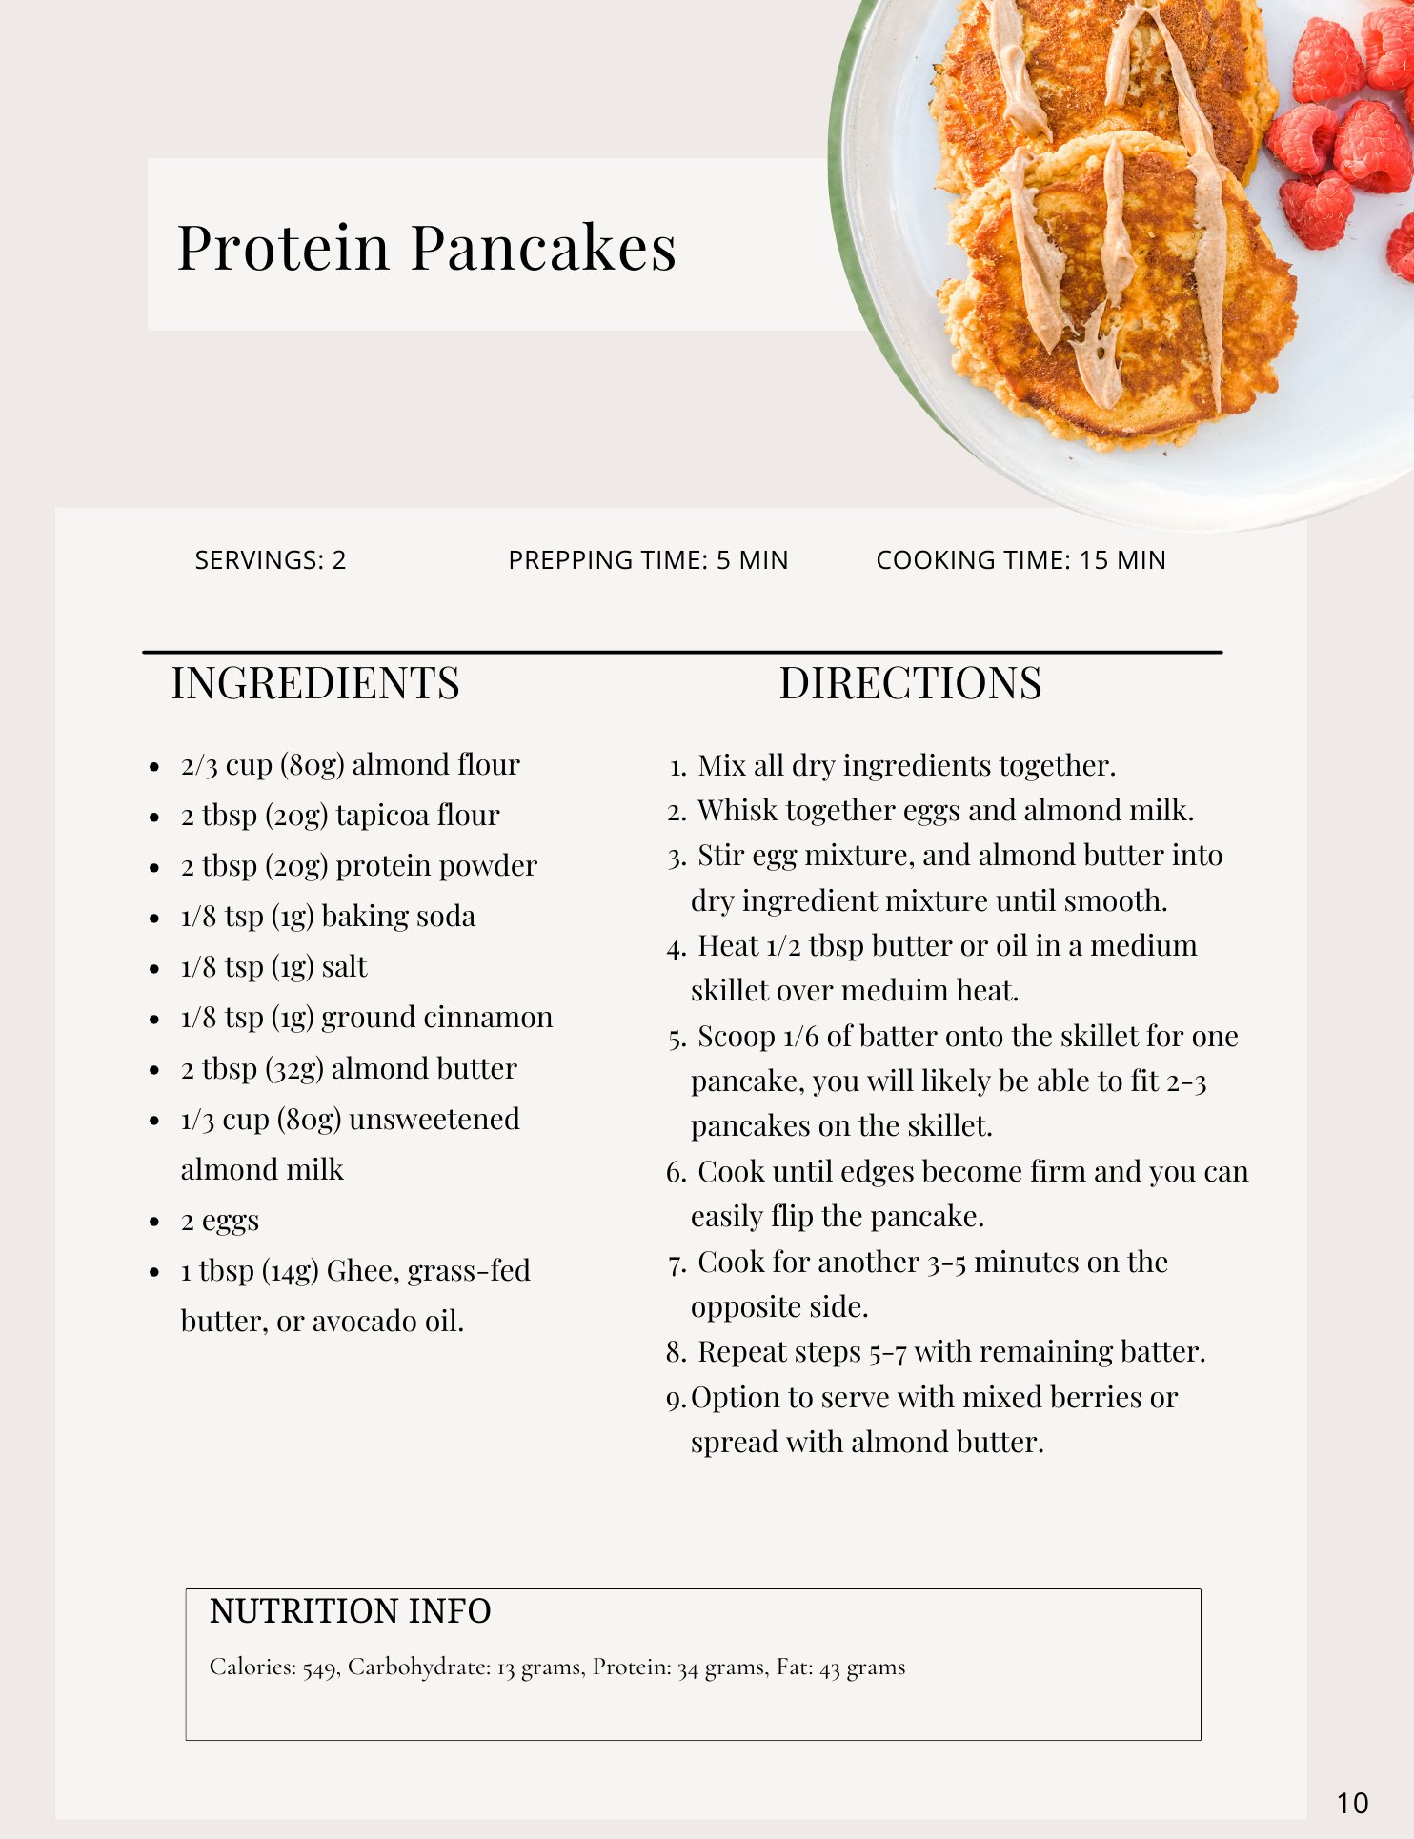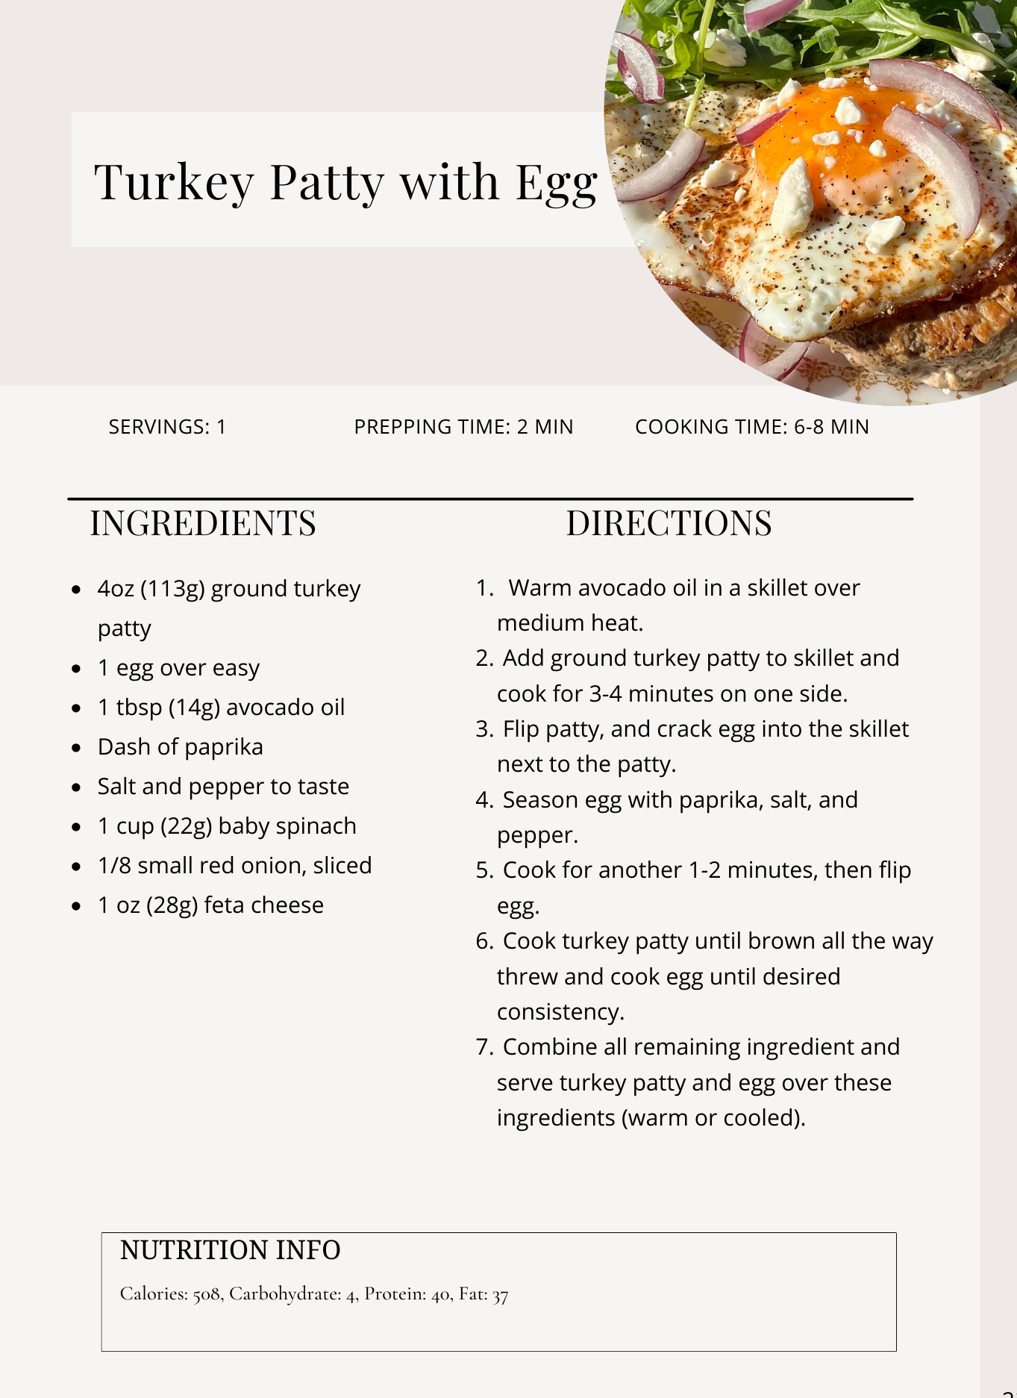
Lunch
Breakfast
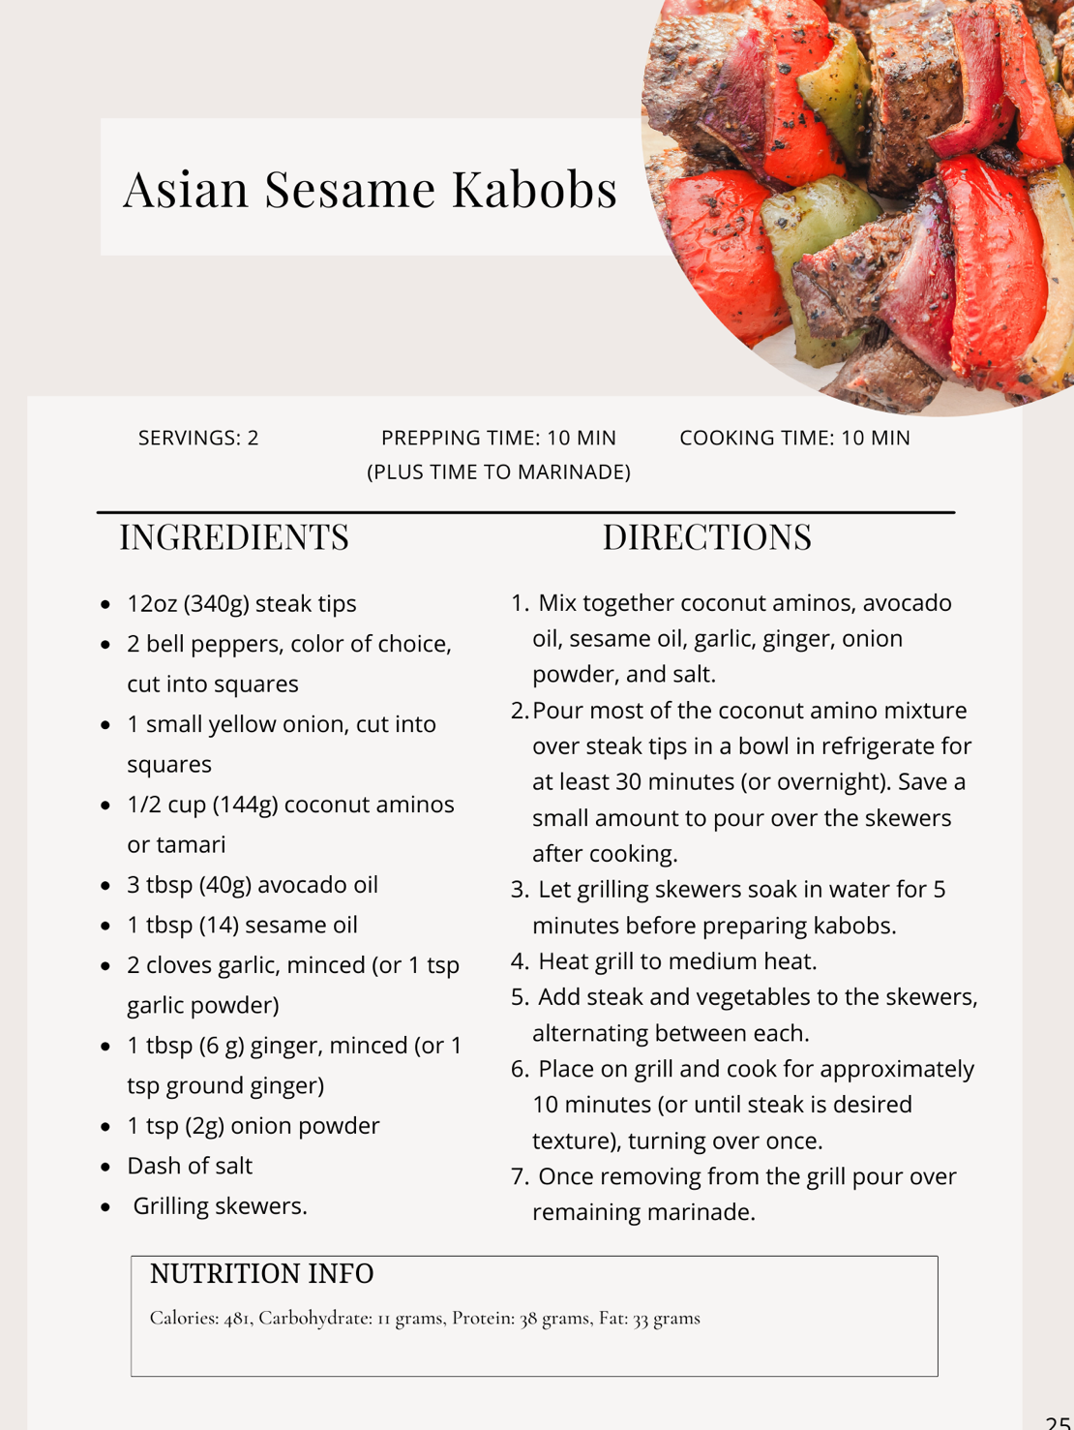
Breakfast (Freeze half for Friday)

Intermittent Fasting :16 hours after your last meal

Self Reflection: What Did I do Well today?
Dinner save some for tomorrows dinner

Day 16
Write down 3 things you are grateful for:

1.

2.

3.

Write with your non-dominant hand today's affirmation Today I let go and have fun !
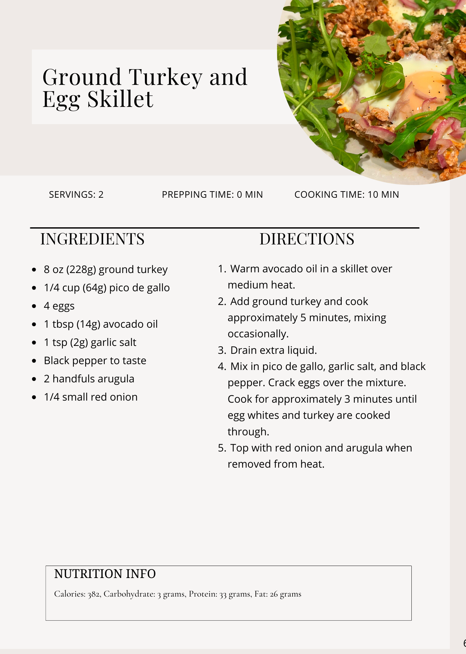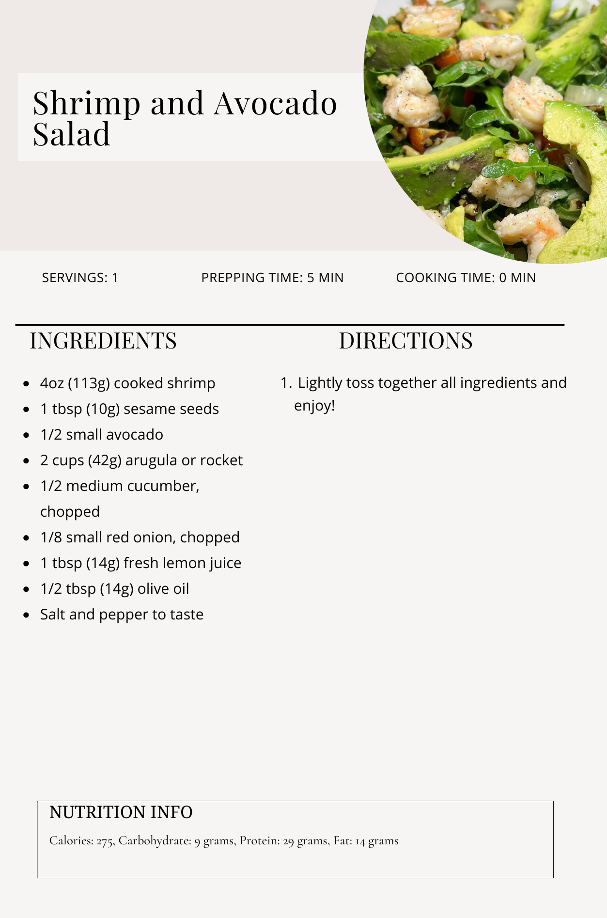
Lunch
Breakfast
Breakfast (save half for tomorrow}
Dinner-Leftovers Intermittent Fasting :16 hours after your last meal
Self Reflection: What Did I do Well today
Day 17
Write down 3 things you are grateful for:

1.

2.

3.

Write with your non-dominant hand today's affirmation Today I create a stress-free world .

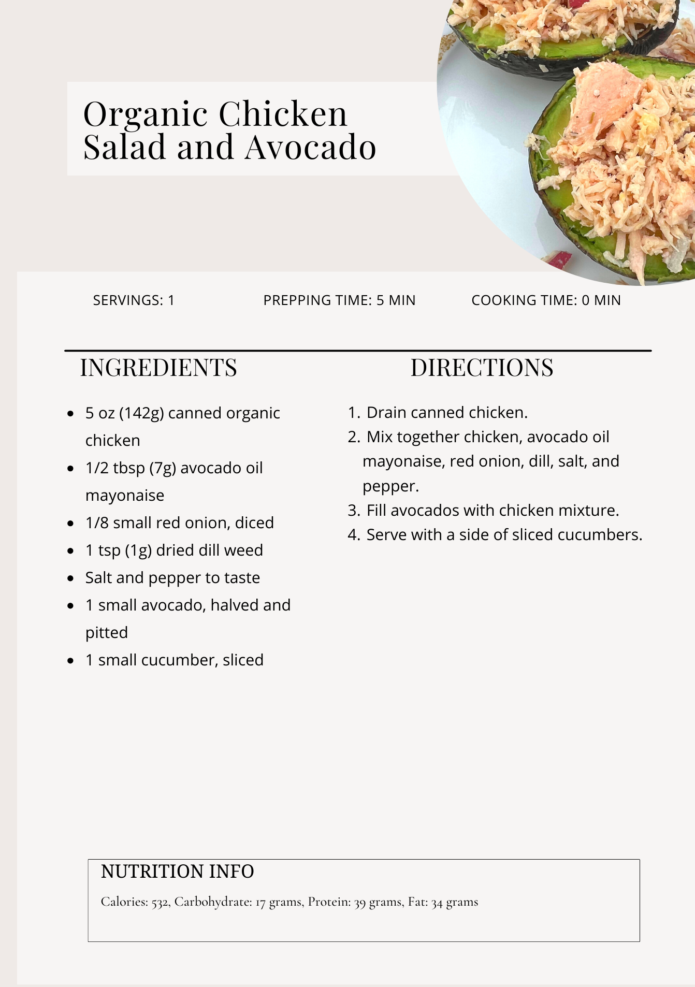
Lunch
Breakfast
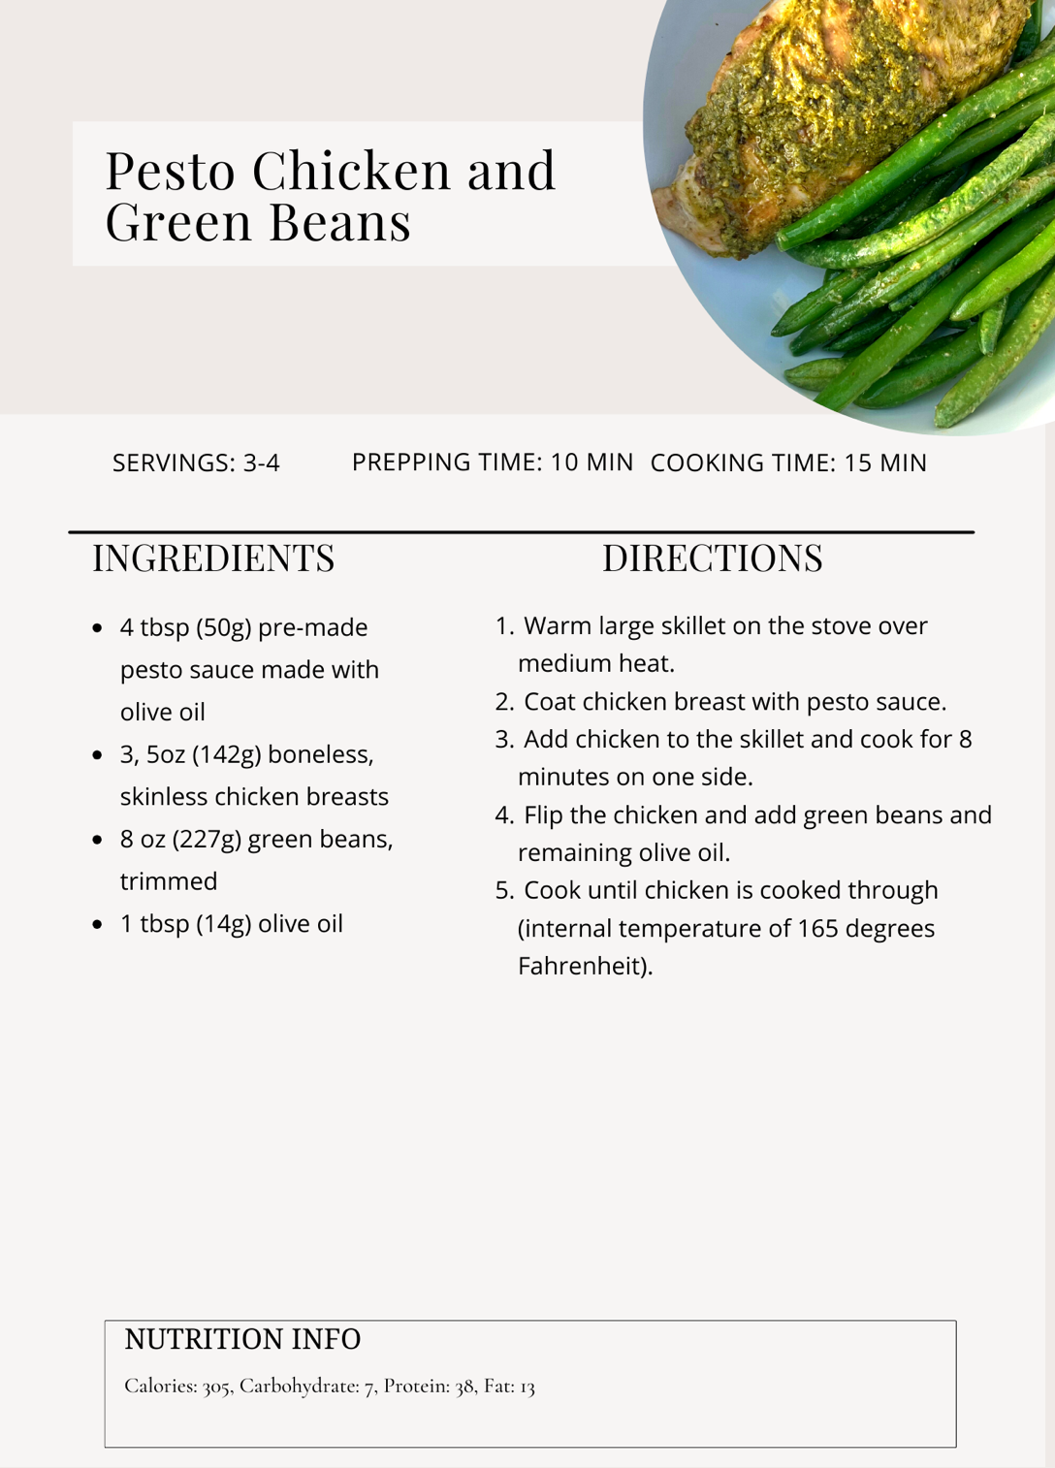
Intermittent Fasting :16 hours after your last meal
Self Reflection: What Did I do Well today?

Dinner-save some for tomorrows dinner

Day 18
Write down 3 things you are grateful for:

1.

2.

3.

Write with your non-dominant hand today's affirmation I want love and acceptance from my family, so I start the ball rolling by loving and accepting them exactly how they are now .

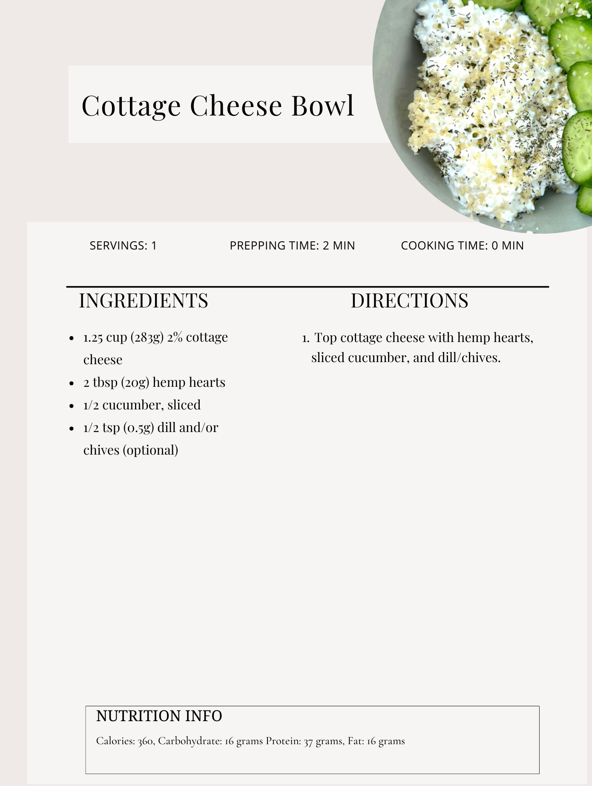
Breakfast
Lunch
Dinner-leftovers Note what time you finish dinner =Intermittent Fasting :16 hours after your last meal
Self Reflection: What Did I do Well today?

Day 19
Write down 3 things you are grateful for:

1.

2.

3.

Write with your non-dominant hand today's affirmation I speak up for myself, secure in my own true worth.

Lunch
Breakfast
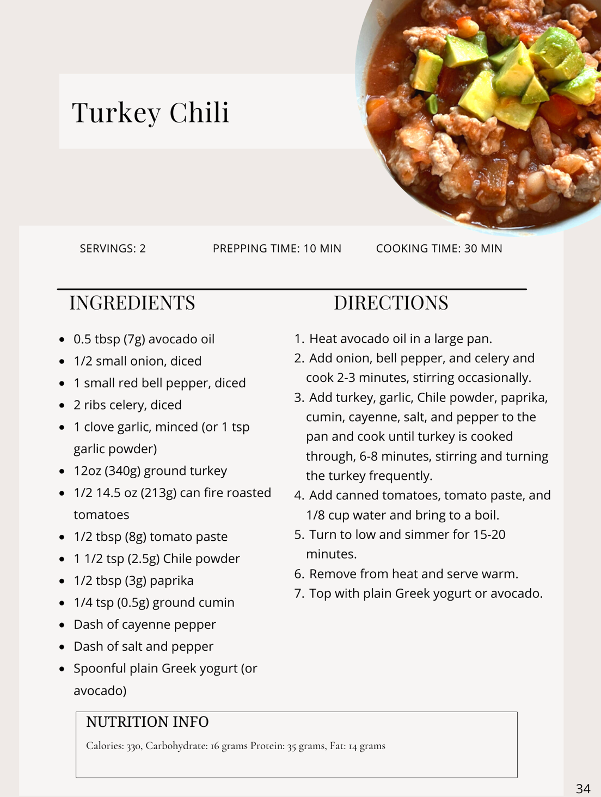
Intermittent Fasting :16 hours after your last meal
Self Reflection: What Did I do Well today?

Dinner save for tomorrows dinner
Dinner

Day 20
Write down 3 things you are grateful for:

1.

2.

3.

Write with your non-dominant hand today's affirmation I am competent and well prepared to handle the tasks before me today.

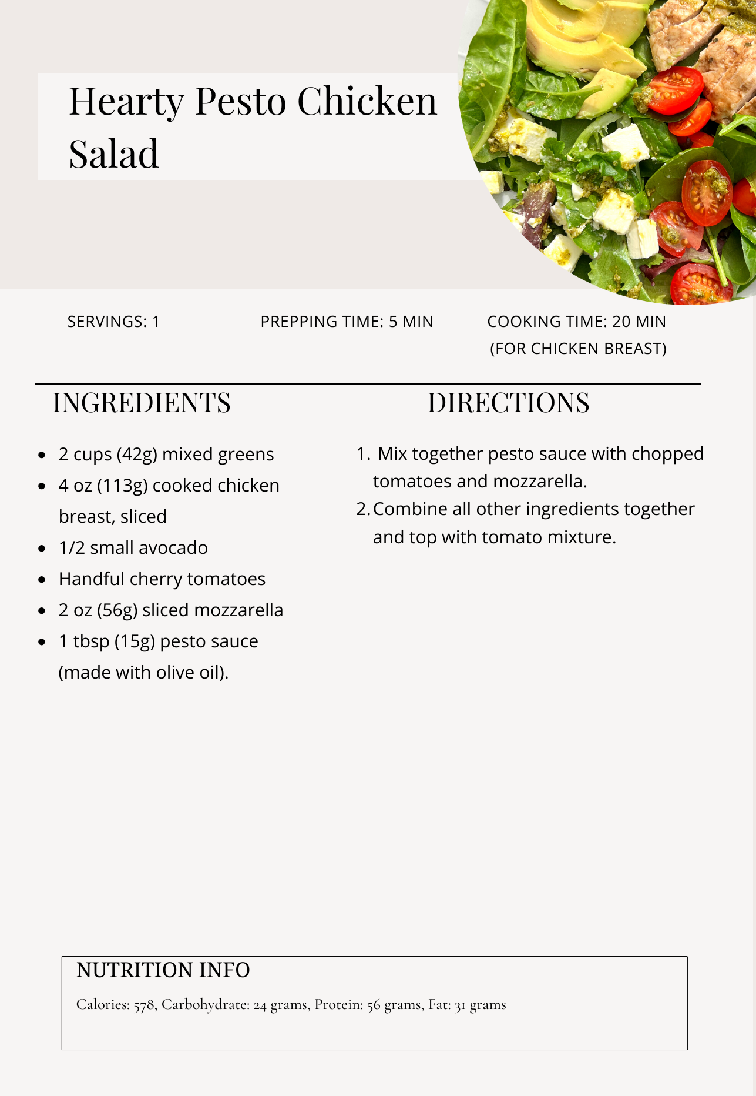
Lunch
Breakfast
Dinner-leftovers from night before Intermittent Fasting :16 hours after your last meal
Day 21-LAST DAY WELL DONE
Write down 3 things you are grateful for:

1.

2.

3.

Write with your non-dominant hand today's affirmation I now allow the genius within me to flow freely
Lunch
Breakfast
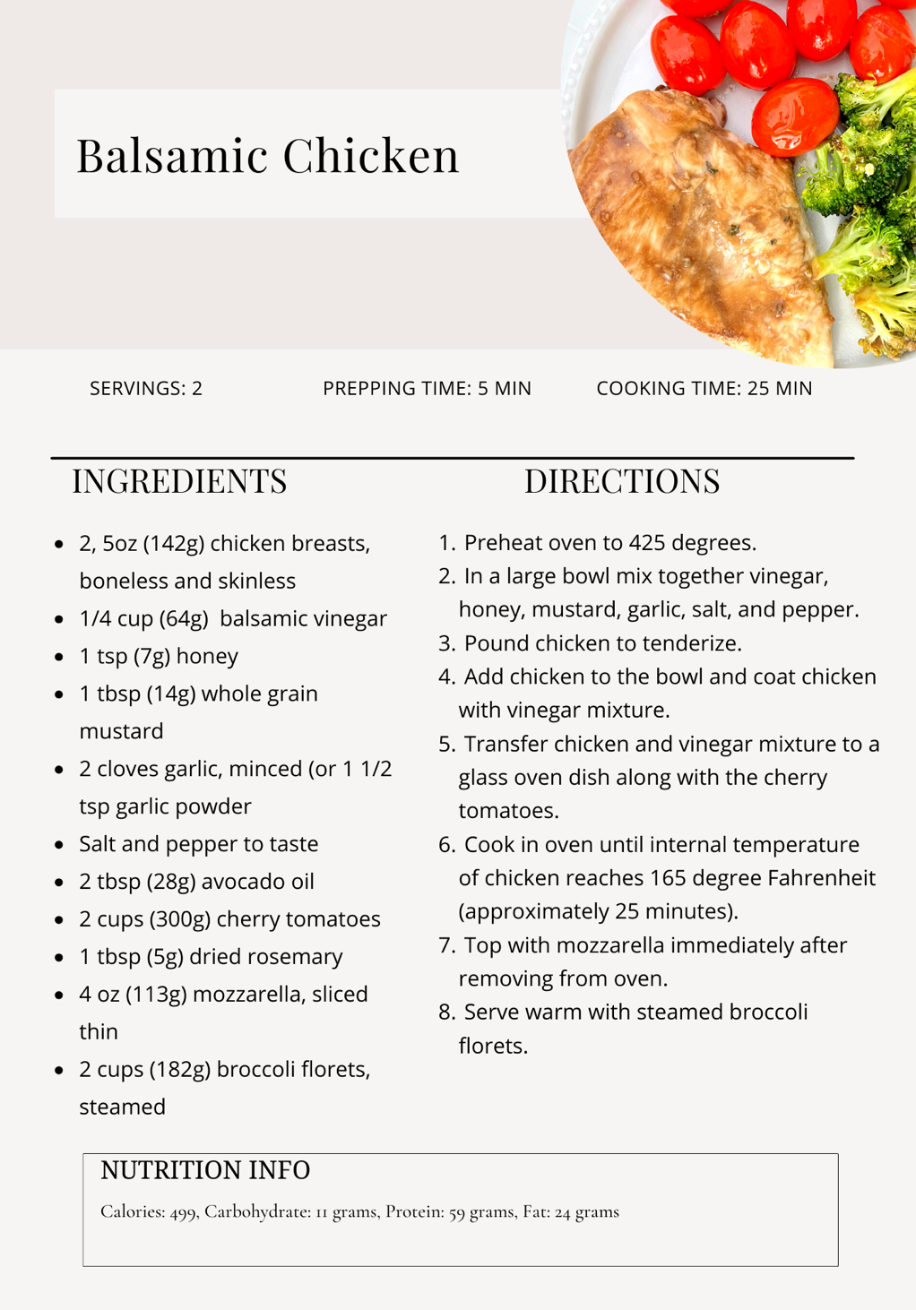
Intermittent Fasting :16 hours after your last meal
Self Reflection: What Did I do Well today?
Dinner

