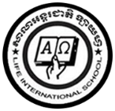

**LIFE INTERNATIONAL SCHOOL**

KHMER SUBJECT FOR KSL

TEACHER : **CHEN SOTHARY**

1. **Let ‘s learn to write your name in Khmer language below .**

Kanishka Paramagura

កានីស្កា ផារ៉ាម៉ាហ្គូរ៉ា

……………………………………………………………………..

………………………………………………………………………

………………………………………………………………………

………………………………………………………………………

………………………………………………………………………