Day 2 & Exercise 2:
Use Your Commute

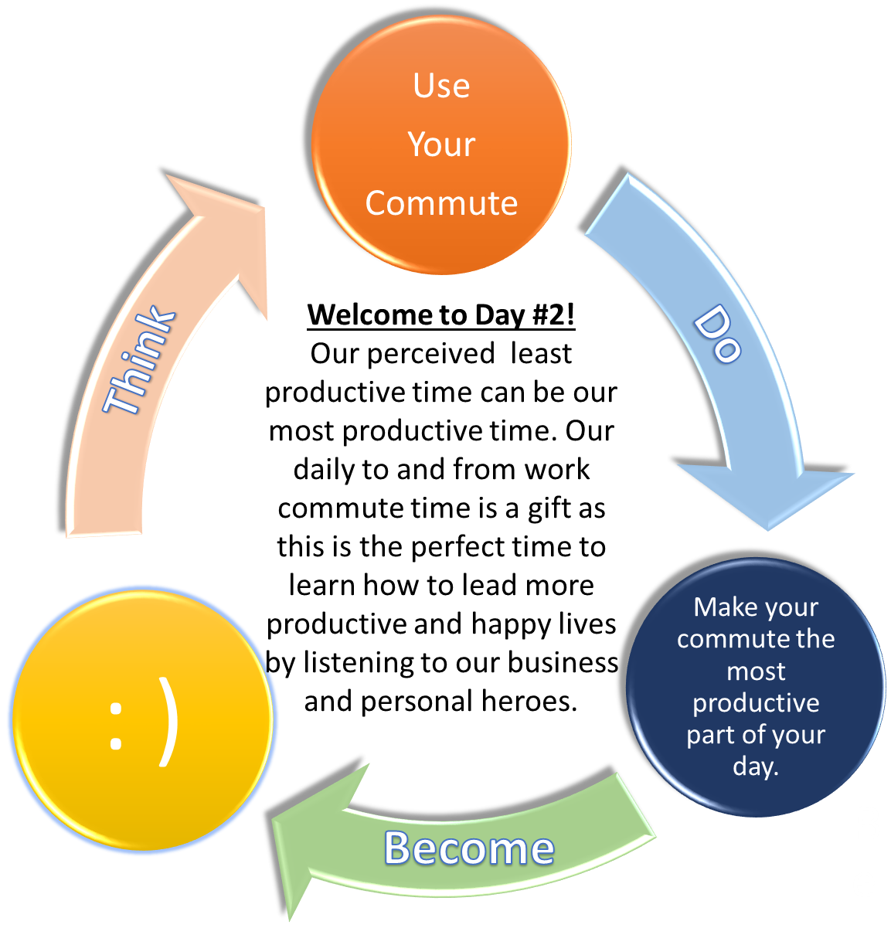
For my entire life, whenever I have had the privilege of meeting someone successful in their office, I always look to see the names of the books on their bookshelves and then I order these books within 5 minutes of leaving their office.
Most of us spend at least an hour commuting to and from work every day. I love this time as I see this as my personal self improvement time. How? I listen to audio books of people that are incredibly successful, happy and productive.
You can download podcasts or audiobooks or even get them for free from your library. I subscribe to www.Audible.com, which is owned by Amazon and has amazing content. The cost of this investment is $15 per month for 1 audiobook per month.
I listen to audio books from people that I admire and then I use what they use in their lives to try to make my life more fulfilling, productive and happy. Recent books that I have listened to that have had a huge impact on me are books written by Sir Richard Branson, Marc Benioff, Bill McDermott, Napoleon Hill and Malcolm Gladwell.
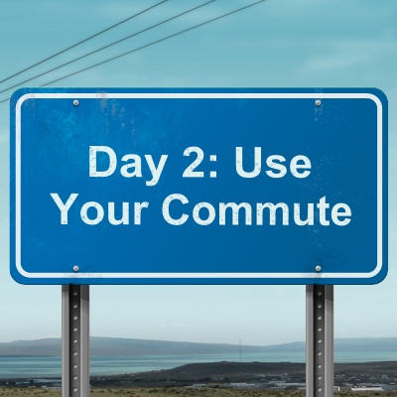
I also love listening to biographies of successful people and companies. What are their recipes of success? Can I use what they did and make my life more successful? Recent books I have listened to were written about the following people and/or companies: Elon Musk, Bill Gates, Google, Amazon, The Bulletproof Diet, The 4 Hour Body, Steve Jobs, Jony Ive and many others.
Many of my largest breakthroughs in my life have been due to listening to audio books during my commute, which is the most productive part of my day. I started out going to my library in Canada in my home town of Mississauga and getting these books on tape for free! It only takes us 30 seconds to download a fountain of life altering knowledge into our smart phones using www.Audible.com or podcasts. Enjoy your commute now as the most productive instead of the least productive part of your day.
: )
Quotes About Learning from & Listening to Successful People:
"Live as if you were to die tomorrow. Learn as if you were to live forever."
– Mahatma Gandhi

"Courage is what it takes to stand up and speak; courage is also what it takes to sit down and listen."
– Winston Churchill

“Listen with the intent to understand, not the intent to reply.”
– Stephen Covey
Today’s Exercise: Please list 1-2 audiobooks to download today from Amazon’s Audible.com service or to pick up from your library (if available) for free written by people that can enhance your quality and success levels in life during your commute:

1: _______________________________________________

2: _______________________________________________

