1. Open Microsoft Outlook 2019 on your device.
2. If you don't have any mailboxes added yet, you will see the Account Information page. Click the + Add Account button there.
If you have mailboxes set up already, go to File tab >> Info >> Account Information and click the + Add Account button:
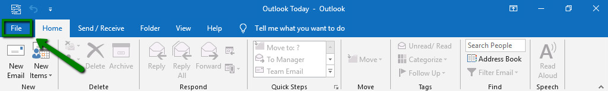
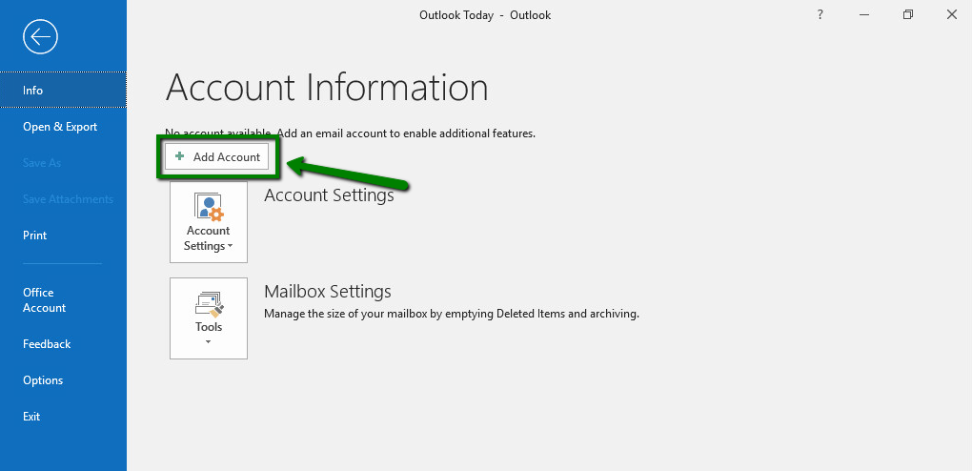
3. Type in your full Private Email address and click Connect:
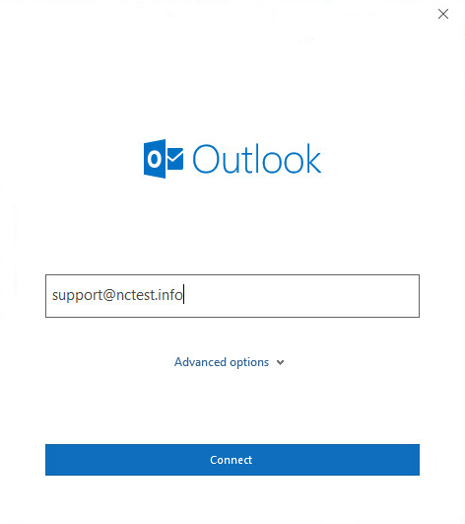

Disregard any warnings that may appear, and proceed to the next step.

4. Type in the password you are using for this email address and click Connect:

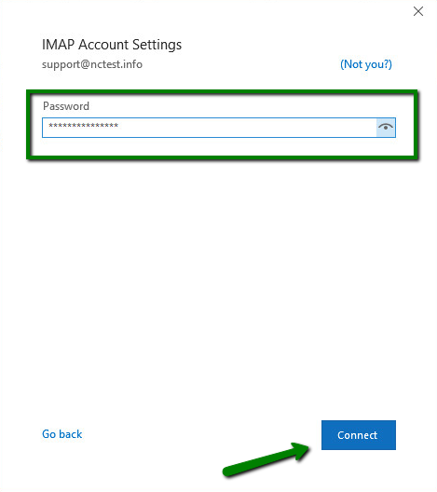

If you are not able to proceed, you may need to repeat the process using the manual setup. The detailed instructions can be found below.
5. Select the Change account settings option and click Next. On the next page, select the POP or IMAP option:
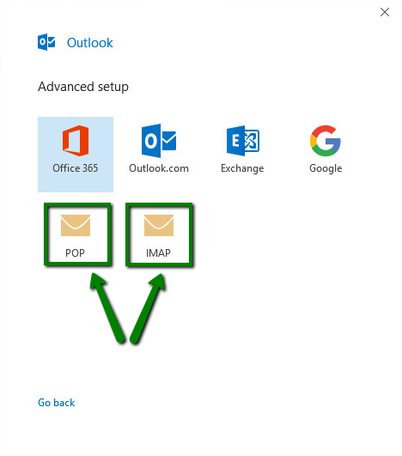
POP3 stands for Post Office Protocol, and was designed as a simple way to access a remote email server. POP works by downloading your emails from your provider's mail server and then marking them for deletion there. This means you can only ever read those email messages in that email client, on that computer. You will not be able to access any previously downloaded emails from any other device, or with any other email client, or through webmail.
IMAP stands for Internet Message Access Protocol, and was designed specifically to eliminate the limitations of POP. IMAP allows you to access your emails from any client, and any device, and webmail login at any time, until you delete them. You can also use different devices and email/webmail clients to access the same mailbox and check, send and receive email, which is not available with POP3 connection.

6. If you choose IMAP account setup, enter the following server details:
- Incoming mail server: mail.privateemail.com (same for all accounts)
- Incoming mail port: 993 (or 143 with STARTTLS)
- Encryption method: SSL/TLS (or STARTTLS if 143 port is used)
- Require logon using Secure Password Authentication (SPA): should be unchecked
- Outgoing mail server: mail.privateemail.com (same for all accounts)
- Outgoing mail port: 465 (or 587 with STARTTLS)
- Encryption method: SSL/TLS (or STARTTLS if 587 port is used)
- Require logon using Secure Password Authentication (SPA): should be unchecked

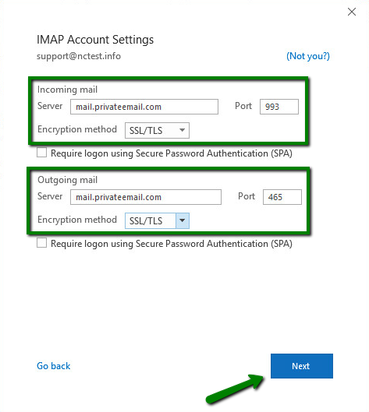
7. If you choose POP account setup, enter the following server details:
- Incoming mail server: mail.privateemail.com (same for all accounts)
- Incoming mail port: 995 (or 110 with STARTTLS)
- This server requires an encrypted connection(SSL/TLS): should be checked
- Require logon using Secure Password Authentication (SPA): should be unchecked
- Outgoing mail server: mail.privateemail.com (same for all accounts)
- Outgoing mail port: 465 (or 587 with STARTTLS)
- Encryption method: SSL/TLS (or STARTTLS if 587 port is used)
- Require logon using Secure Password Authentication (SPA): should be unchecked
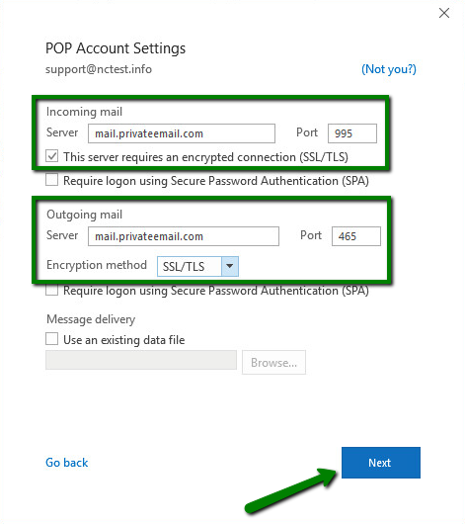
8. Once all the details are filled, click Next.
9. After that, type in your password for this Private Email account and click Connect:
10. If all the settings are correct, you will receive the following message.
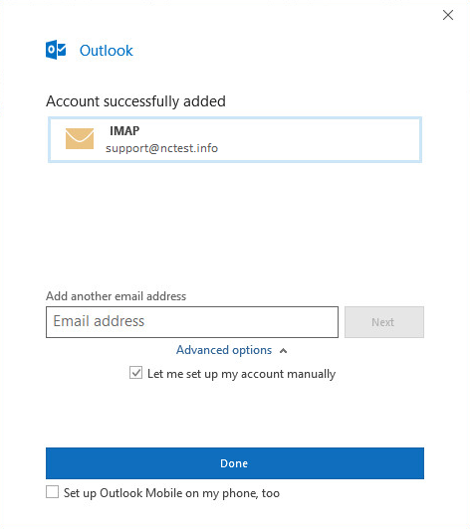
Click Done to complete the setup.
In order to check or update the configuration of an existing email account, follow these steps:
1. Open Microsoft Outlook 2019 on your device.
2. Go to the File tab >> Info >> Account Information page and click on Account Settings:
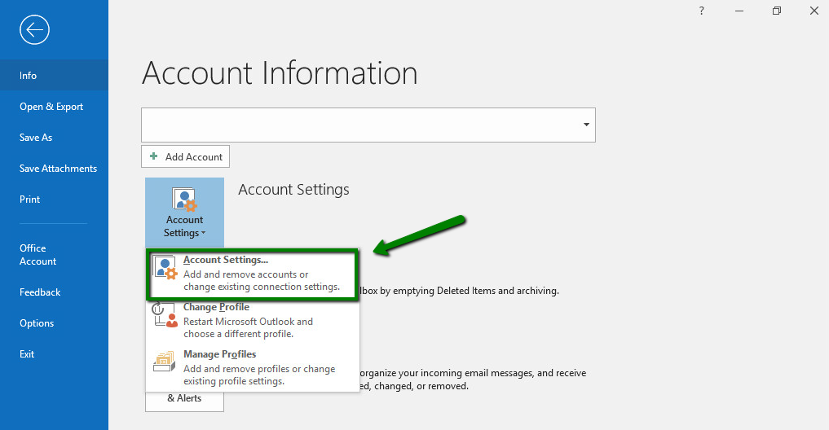
3. Select the mailbox in question and click Repair:
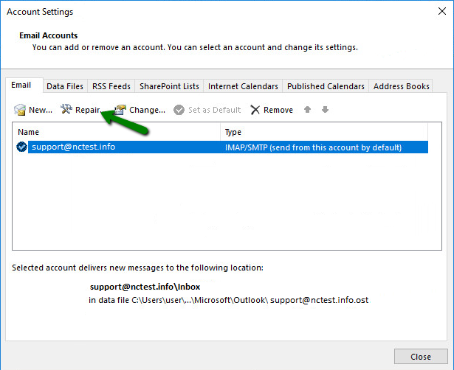
4. In the next window, click on Advanced options, check Let me repair my account manually and click on Repair:
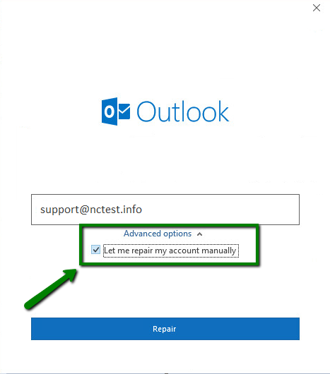
5. On the next page, you will see incoming and outgoing server settings.
Make sure all of them are set properly. If any information is set incorrectly, update it for both Incoming mail and Outgoing mail configurations:
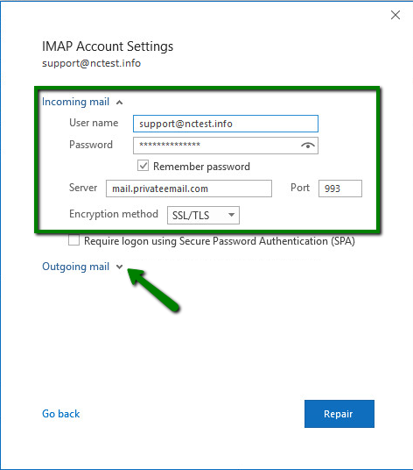
6. Once all details for the outgoing connection are updated, click Repair:
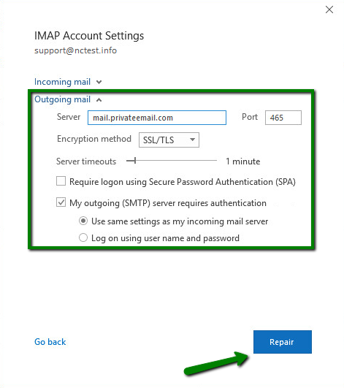
That's it!

