Visibility for Success

- Workbook -

-Mastering Your Messaging -

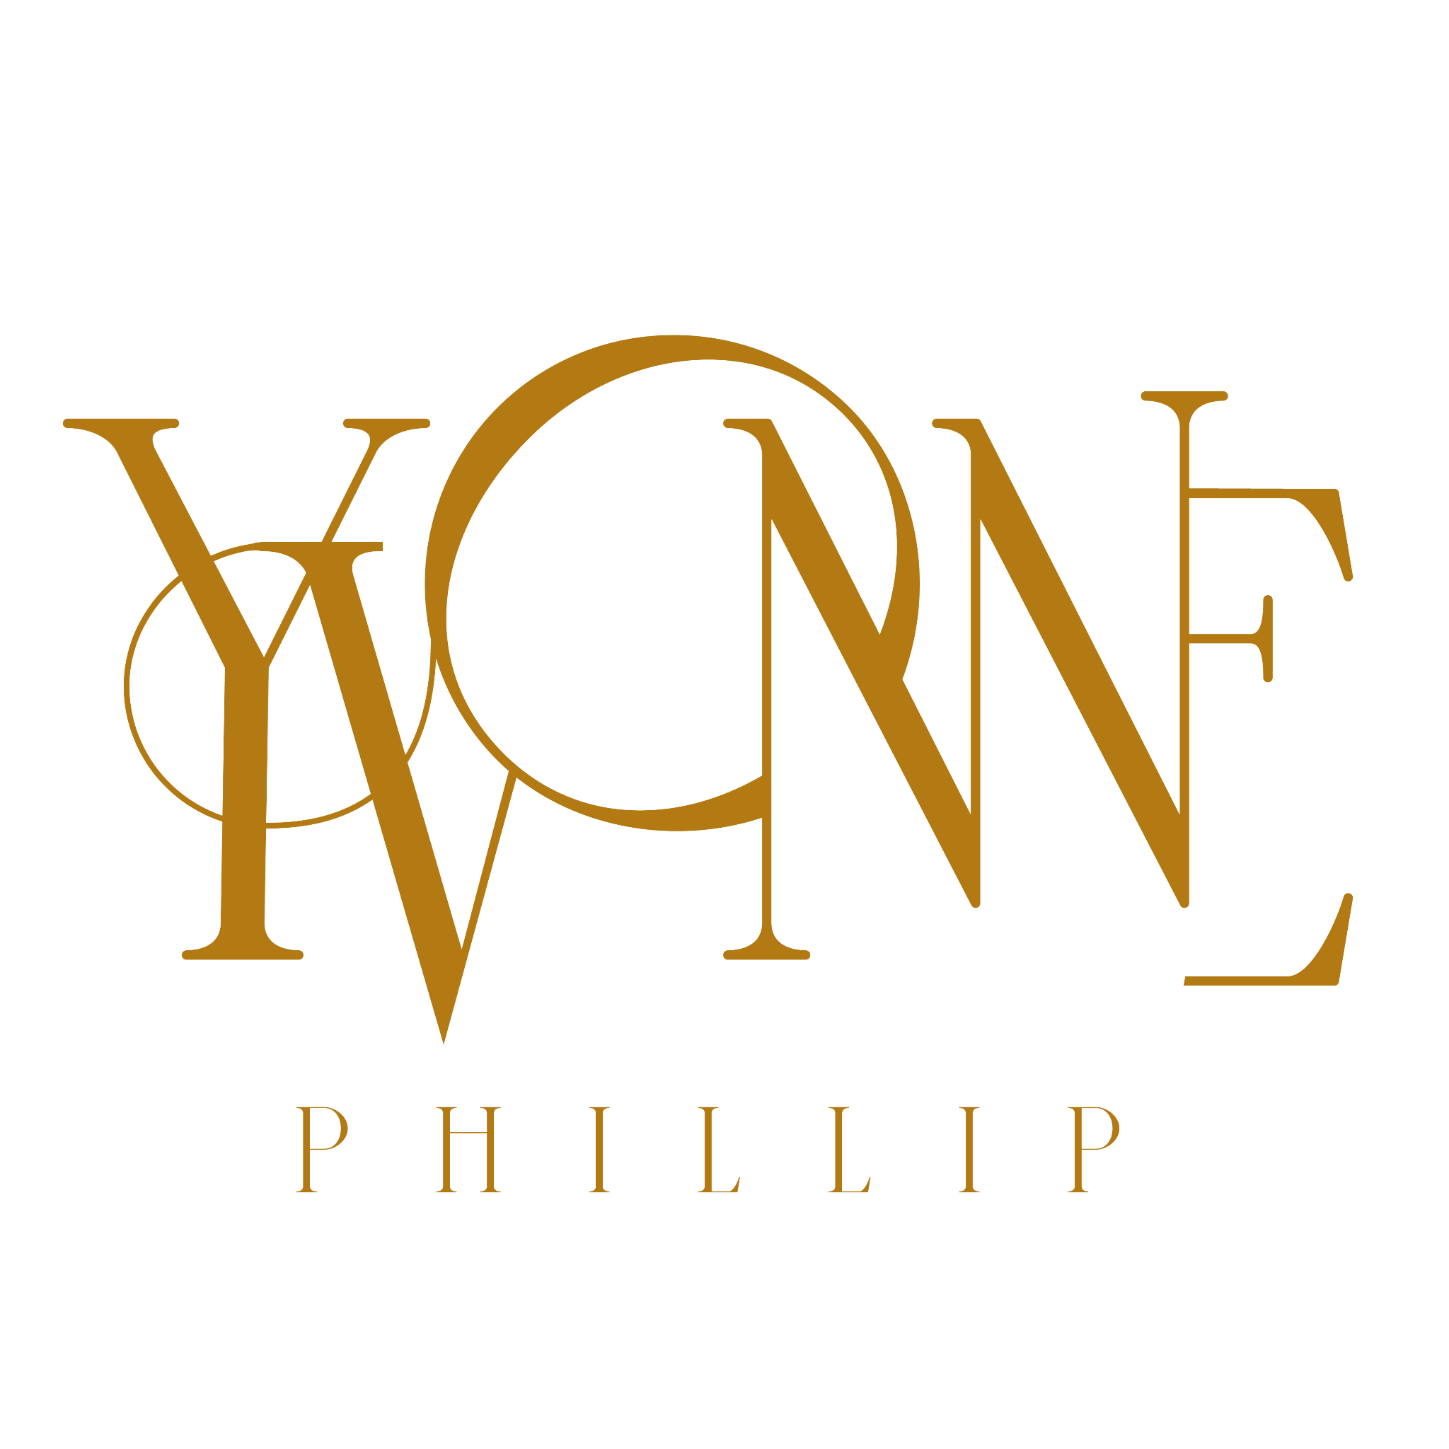

Messaging & your ideal customer

Conducting your interview or producing your questionnaire

Use this template to conduct your avatar interviews to ensure you’re extracting all the necessary information to truly take your messaging to the next level. Ensure that you adapt so that it fits your tone of voice.

Hi and thanks for making some time to chat. [Make small talk — be friendly and build rapport] I’m going to ask you a few questions about your current marketing challenges [relevant focus].

Of course I want to know what you think of [relevant focus], but I’m also very curious about all the events that led you to this current frustration in the first place.

We’ll keep it to 20-30 minutes, does that sound okay? [Wait for response]. Perfect. And just so you know, there are no right or wrong answers. And definitely no sales pitch.

I’m just trying to get your story in your own words. It’s more like a conversation than a survey. At certain times, I may dive in deep and ask detailed questions about a specific situation. Some of the questions might feel a bit repetitive, but I just want to ensure I’m getting all the details. You can think of it sort of like we’re filming a documentary of your current marketing journey . Do you have any questions before we jump in? [await answers)

Questions

Select about 5 - 10 questions for those who have not purchased from you before
- Ask about their business/ life / career/ issue: who it is, serves, type etc.
- What do you sell?
- How do customers buy from you?
- How long have you been marketing your business?
- What type of marketing activities are you currently doing?
- What goal are you hoping to achieve with those efforts?
- What would you say is your biggest marketing challenge/frustration?
- What triggered that initial awareness (when did it happen/where did it happen) – all they way through their decision to actually purchase PASSIVE - ACTIVE - DECIDING - PURCHASING
- Who or what influenced their decision? Where did they go to find trusted information?
- In the last 6 months , what is the most recent purchase you’ve made to help with your marketing challenges?
- How much have you spent on those resources?
- What were you attempting to solve with these solutions? What ‘job’ were you hiring those solutions to get done for you?
- Did you have any concerns about purchasing?
- What anxieties did you have to overcome? Objections?
- What was the #1 reason they chose that product over our solutions?
- What job did you see not getting done with our current offerings that you needed to get done?
- What did you like about the solution? (GAIN)
- What was still missing in the solution for you/didn’t like? (PAIN)
- How did you hope it would make your life better?
- Since purchasing, is there any new goal you want to seek or progress you want to achieve?
- Are you aware of the solutions we offer?
- What has been missing in our solutions that have prevented you from purchasing?

Additional questions for clients that have already purchased from you.
- What triggered them to realize you had a problem?
- What did they want to achieve with a new solution? What job were they wanting to get done?
- How did you find out about our company?
- How did you go about making that decision to purchase from you? (did they talk to anyone etc)
- What alternate solutions have you tried?
- What concerns did you have before purchasing? What specific objections did you have to overcome to purchase?
- How was your life/business better after becoming a customer? Did your offer do the job they hired to get done?
- What new problems are present after purchasing?

You can use the template below for your questions and to note and consolidate the answers.

1.

2.

3.

4.

5

6.

7.

8.

9.

10.

Interviewee Name:
Date:

THINKING - what triggered them to realize they had a problem?
Trigger 1 (passive)

Trigger 2 (active)

Trigger 3 (deciding)

Trigger 4 (purchasing)
PAINS  What pains, frustrations or desires motivated them to seek your solution? | GAINS  What did they want to achieve with new solutions? What did they want to get done? Note the functional, social and emotional.

LOOKING
CHANNELS  Who or what influenced their decision, where do they go to find information? | ALTERNATIVE SOLUTIONS  Did they consider, try or buy any other solutions along the journey.

DECIDING
ANXIETIES  Did they have concerns before buying? Any objections they had to overcome? | DESIRES  How did they hope life would be better? What is their dream outcome?

PURCHASING
WINNING VALUE PROPOSITION
What was top reason they choose this product over others

USING
FRICTION  What don't they like about the product? | DELIGHT  What do they love about the product | WHATS NEXT  What do they want now they have used the product/service

INSIGHTS & IDEAS
What are the key takeaways, ideas, actions for you to take

Creating your Ideal Customer Avatar

Following your avatar interviews, take all of your notes and takeaways and use it to fill in the below ideal customer avatar template, using the exact language used on your interviews! Remember: when you’re creating your ideal customer avatar document keep asking yourself ‘why’ to go deeper in your definition and understanding.

Ideal Customer General Description:

Gender:

Age Range:

Income Range:

Relationship Status:

Children:

Education:

People They Follow & Trust For Information: Note: You can use these pages in the future for ad targeting

Books they Read:

What are their biggest fears they are currently dealing with?

What do they need/want but don’t have?

Ideal Customer Core Problem: (ONE sentence limit. Use language your ideal customer would use talking to their friends)

Ideal Customer Dream Come True: (ONE sentence limit. Use language your ideal customer would use talking to their friends)

Biggest objections to buying your product / offer

Improve Your Messaging and offer

Now you have all of this information, there are a few things you can do with it to ensure your messaging is meeting the needs of your customers.

- Take the exact language from this exercise and bring it into your emails, social media, ad copy and landing pages.
- Take these interviews and list out every problem your audience and prospects are having.
- Take the list of problems, make sure your offers solve every problem even if they are via different products.

Improve Your Messaging Is An Ongoing Process

One of the best ways to use your time is to get to know your ideal customers and fully understand them on a deeper level. Their feelings, their struggles, their dreams and everything in between. Improving your messaging and building a deeper understanding of your ideal customer is something you should be continuously doing. This means carrying out research on an ongoing basis and on an annual basis at a minimum. Make sure you pay attention to what your audience is saying, thinking and asking and then adjust your marketing accordingly.

Now you have this information it's time to craft or improve your message

Crafting Your Message

Having a strong message for your business and brand is a powerful way to connect with your audience and attract clients. It can be a single line, which is none as a tagline. A sentence or paragraph that encapsulates what you and your business stand for and what your customers can expect to receive from your product or service. The emotions and benefits they will receive.

Use the template in your downloadable workbook or on a sheet of paper to answer the following as you know it now about you and your business:

- This transformation matters to the world because

- Who you work with, your ideal customer, be as specific as you can.

- I help this person achieve. The transformation you help your customer or client achieve (what you client thinks they’re buying)

- Once they’ve successfully used my product/ service they feel: list as many feelings associated with that transformation (what your client is actually buying) e.g: proud (less embarrassed) relieved (less stressed, more playful, more happy, more excited to spend together fun time

- The methods I use make the process of achieving this result feel. How your way is better / different / easier /your unique methods / process / approach/ philosophy – overcoming objections about them actually being able to ACHIEVE

- Your offer, the product or service you sell.

- This work / product matters to them because

Ok! Let’s put it together

… I believe (a: why what you do matters to the world) and so I help (b: your who) to (c + d before and after transformation and feelings) through (e: descriptive words about why your methods are easier/better) (F: products + services) that will (G. why it matters to them)

EG: I believe that if a woman sustains herself she can sustain the world but, you have to stand out to fit in. So I help female entrepreneurs who want to get their business visible with the strategy, style and self care to go from stressed, overwhelmed and burnout to a blessed and beautiful business builder. My offers include training, 1:1 services and experiences that give them a step by step process, information, resources and assets to elevate their unique personal brands with clarity, confidence and credibility. Working with me will allow you to step up, show up and stand out from the crowd and get you the success you want, need and deserve with ease and flow. It's time to shine like the star that you are.

Then we shorten: TIME TO COMBINE REPEATING IDEAS & CUT EXTRA WORDS

Then we shorten again: Perfect for an instagram bio (150 characters) you can also use emojis and hashtags

About Yvonne Phillip

Yvonne Phillip aka Yves here, I am a Personal Success Coach and Brand Stylist. I have over 25 years experience of working and running businesses in the corporate, charity and creative sectors. My other current job titles include speaker, trainer, mentor, mother and basketball lover.
​
My mission is to support employees and entrepreneurs to build authentic personal brands that elevate and escalate their success. I achieve this through the provision of customer focused tools, mindset and strategies via 1:1 support, group coaching, online courses and resources .​ To find out more why not get in touch.
​
Connect & join the community:

Facebook Group: @thesuccessstudio
Instagram: @yvonnephillipthesuccessstyle
Linkedin: @yvonnephillip

