Innisfree Housing Association – A Case Study
When the scheme was little known and when, frankly, many Housing Association executives were wary of it, John Delahunty, Chief Executive of Innisfree Housing, saw the power of community sponsorship.
This Irish housing association was established to help Irish migrants to come to London to obtain work and improve the quality of the lives of their families. Acknowledging that history has moved forward and the real need of refugee families from the Syrian warzone to be supported, the housing association made available a 4-bedroom house, to enable the Muswell Hill Methodist Church to welcome a family under the community sponsorship programme.
That family of seven arrived in Tottenham in March 2018 and are now thriving. Having a comfortable and well maintained 4-bedroom house in Tottenham has enabled them to put to one side any concerns about their safety and instead to embrace their new opportunities for education and leaning and to thrive with confidence and smiling faces.
John’s support has been flexible and ever helpful throughout the project, and the group has greatly appreciated his optimism and drive to succeed. On top of this, John has been a strong advocate for community sponsorship within the Housing Association world helping to convince others that this is a scheme that can succeed, and that Housing Associations can safely partner with volunteer groups.
John Delahunty was presented with a Special Judges Award, in recognition of his pioneering and life-changing support
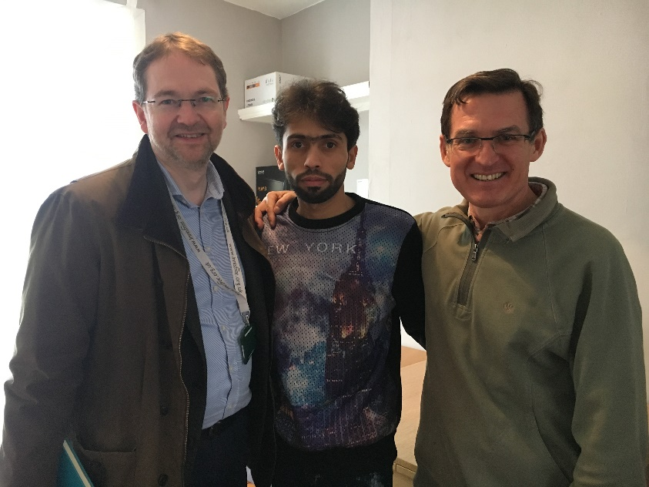
John Delahunty, CEO, Innisfree Housing Association; Naser Ajaj, Syrian refugee; Paul Eedle, interpreter and chair of Muswell Hill Community Sponsorship group. This photo was taken immediately after Naser signed their 2-year tenancy agreement.

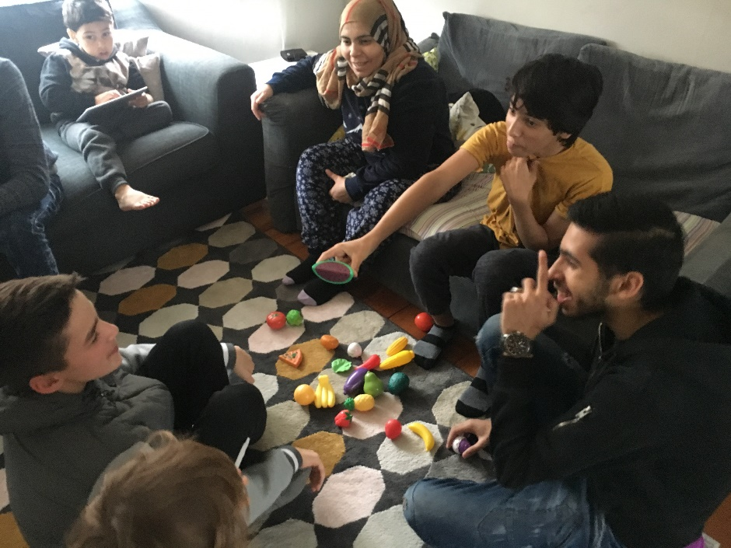
Mouteb is teaching their new best friend, Arun, how to say fruits in Arabic, as he teaches the same in English.

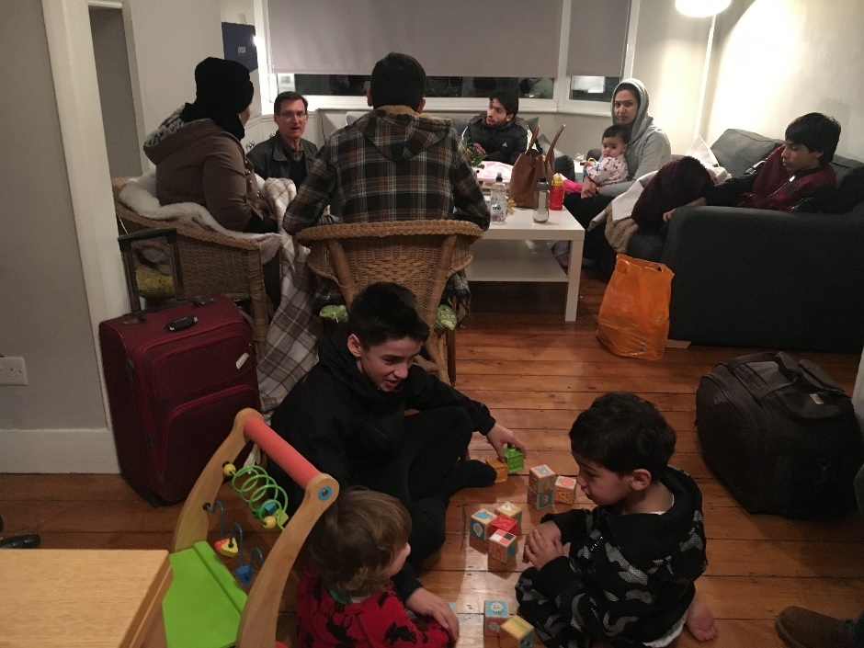
The children play, while the adults discuss their housing contract.

The family on their first UK holiday to North Devon in July
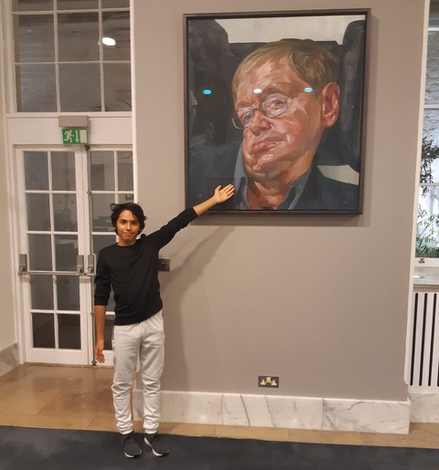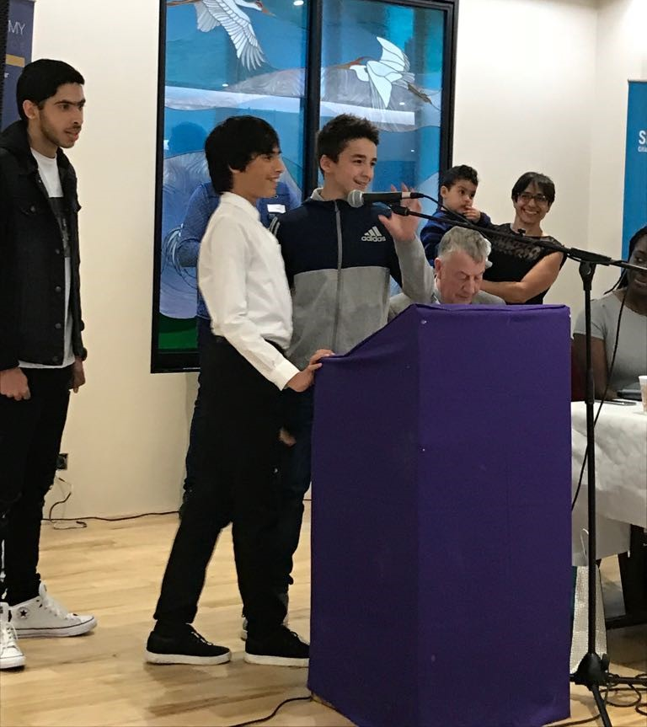
(Left) Mouteb is doing brilliantly in Science and Maths at school. He is first in his family to attend Secondary School. He wants to be "the first Arab Stephen Hawkin".
(Right) Mouteb and Arun spoke in front of hundreds of people at the Citizens UK Assembly, to encourage Haringay council to welcome more refugees in the borough

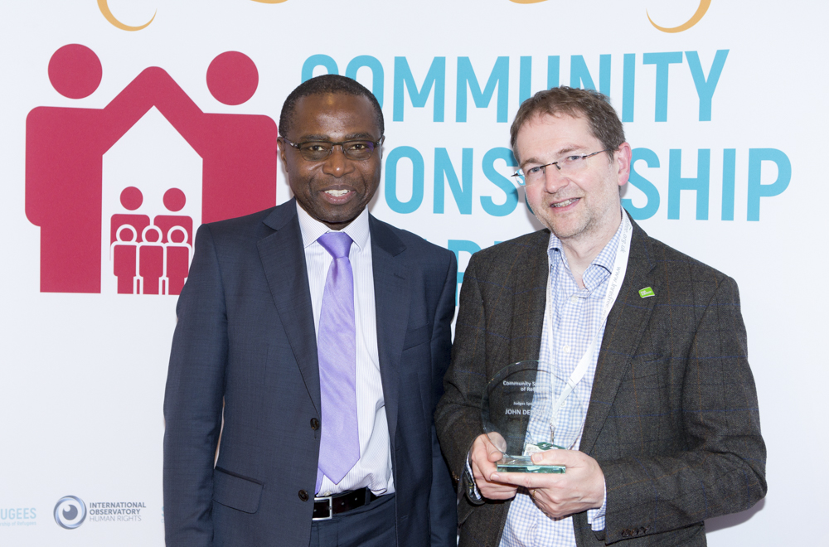
John Delahunty of Innisfree Housing Association won a " Judges Special Award" at Community Sponsorship Awards 2018. This was presented by Cedric Boston, Chief Executive of the Arhag Housing Association in London, who are also supporting refugees to find housing in the capital.

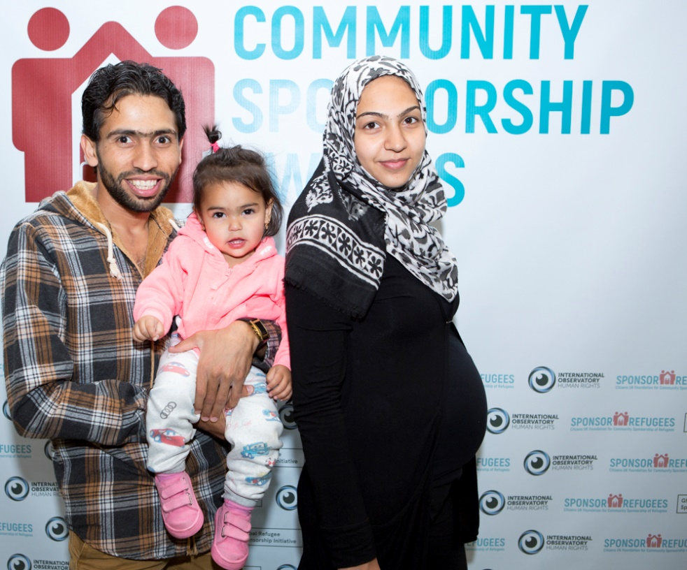
Naser and Marim with daughter Zainab at the Community Sponsorship Awards. Another member of the family on the way!

