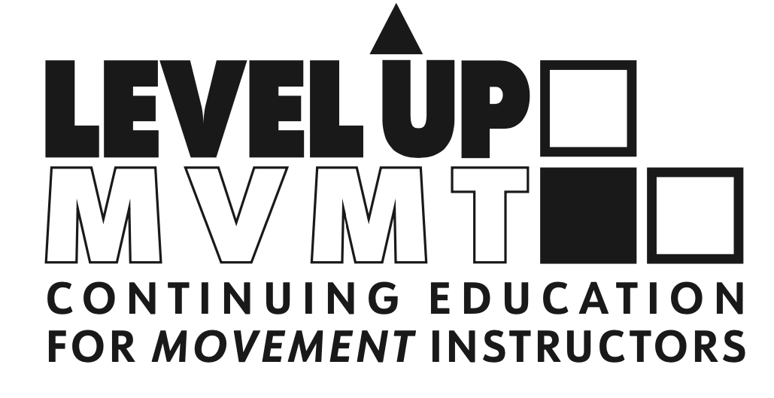
BOLDER NOT OLDER – 2 HOUR LIVESTREAM WORKSHOP
Hi there! I'm so glad you're here. You’re ready to take a livestream workshop with me. AWESOME!
Each workshop is geared towards the movement and Pilates professional and will be tailored to each studios’ individual class and client needs. Livestream workshops are designed to give you a foundation in movement principles, inspire you with new ideas, programming and more + create a deeper connection and camaraderie through our time together.
How it Works:
- You purchase a livestream event through this course.
- You let Erika know when you’d like to schedule this for you and your staff.
- Erika sends you a link to the private Zoom meeting to join along with all materials such as PPT with detail 2 days prior.
- Instructor and attendees can log in approximately 5-10 minutes before class start to get information, chat, prepare and make sure technology is working.
- Class participants are muted periodically so Erika can be main person on screen, but Q&A and chat are turned on at all times.
- Workshop runs for 2-hours.
- A link to the recorded workshop is sent afterwards for review, along with CEC certificate for NCPT.

