- Describe Rule #7 – Modern-Day Application in your own words.

- Please explain each of the three steps for the chart below and the way in which they are critically important for using Rule 7 – Modern-Day Application.

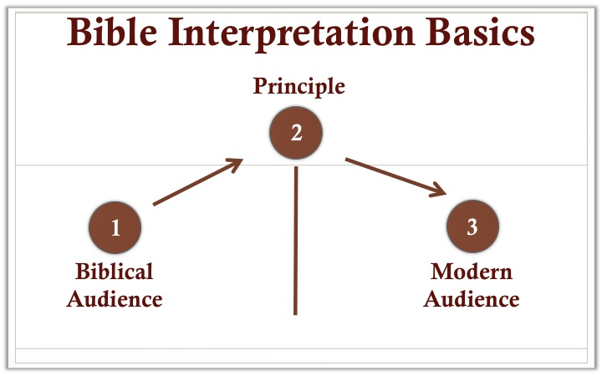

- With respect to a modern-day application, what are the guidelines when it comes to God’s moral commands in the Bible?

- Why is it important to distinguish between a promise and a principle?

- What are some important guidelines when it comes to applying some of the Bible’s promises to Israel, Old Testament believers and New Testament believers.

- What is the general rule when it comes to the central point of a narrative or parable? Why is this important?

- How would we apply Rule #7 – Modern-Day Application to the narratives of unclean foods (Leviticus 11) and Achan’s sin (Joshua 7)?

