Connecting MySQL Workbench to HDP Sandbox MySQL

Launch MySQL WB and click Connect
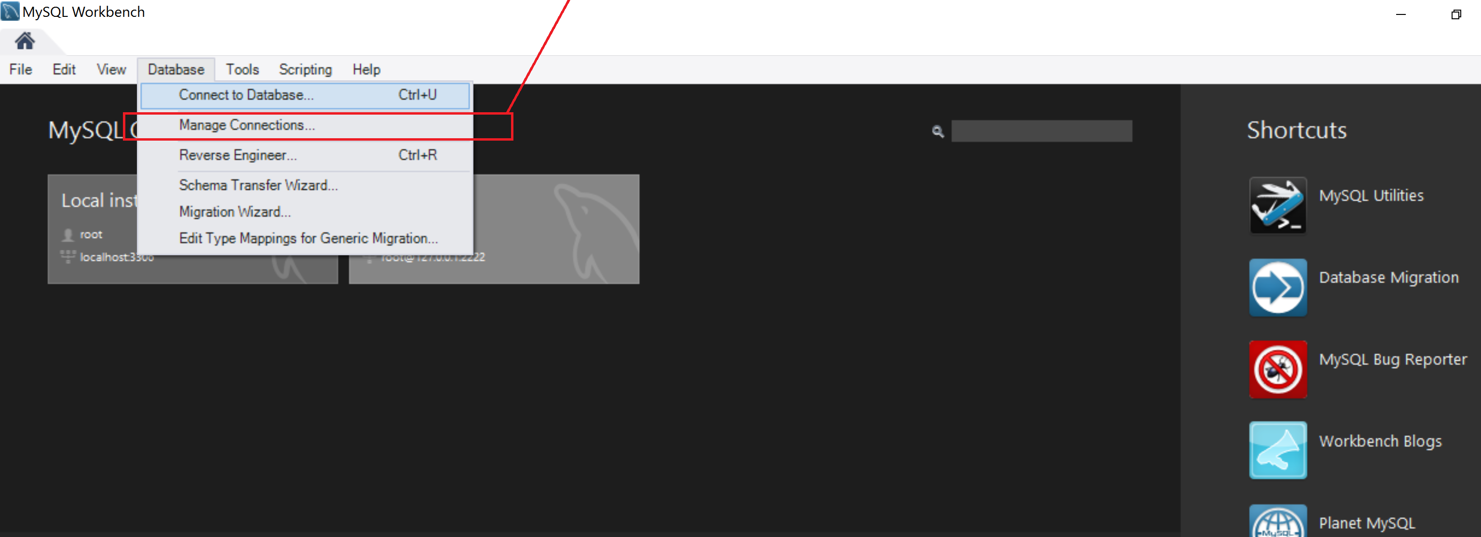
Clicking “Manage Connections” should allow us to create new Database Connection.

Fill in connection Properties
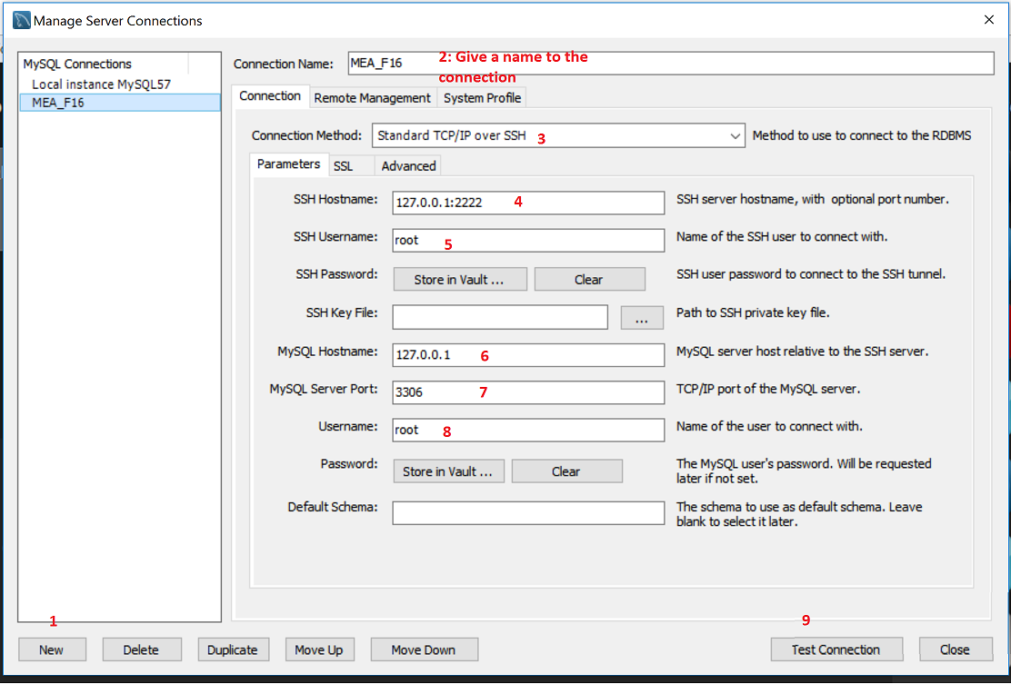

Test Connection Should Be Successful

Connect to Database
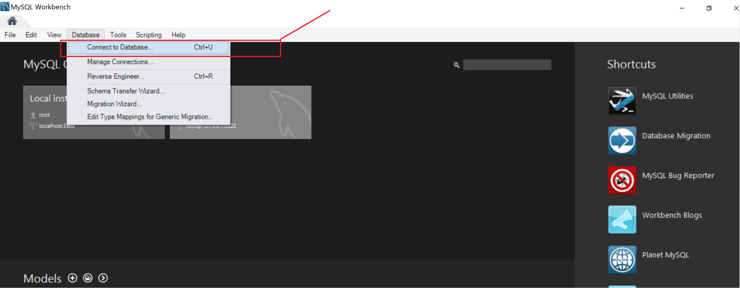

Select the Database Connection Create Above.
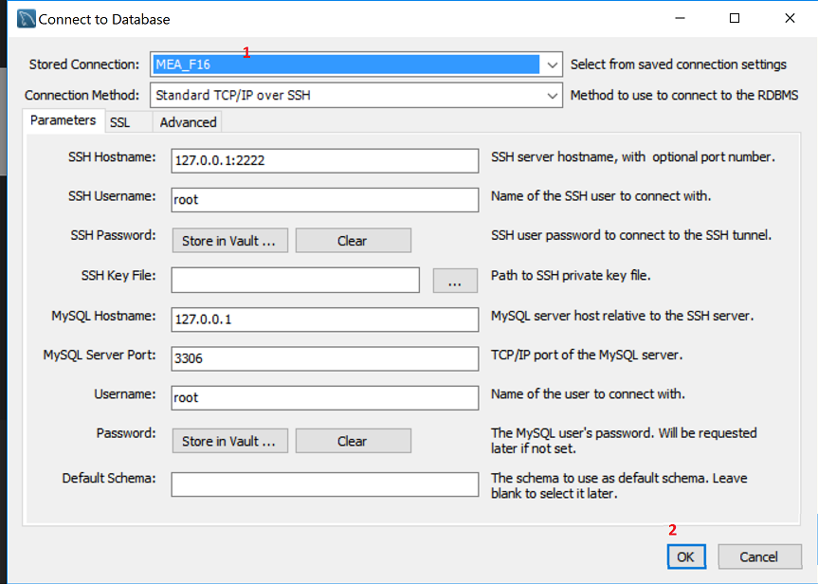

Fill in the password.
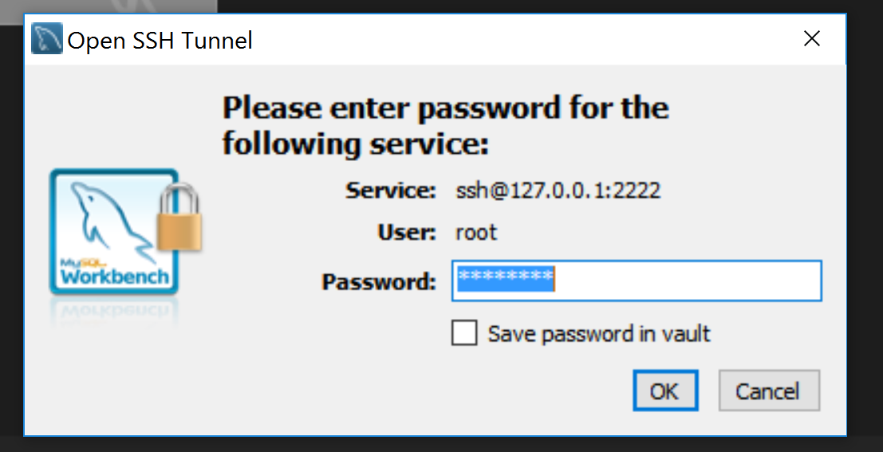

And you are in…
