Origami Dog

Essential Question How do artists show relationships?

Grade Kindergarten

Time 30–60 minutes

Art Concepts Shapes, colors, origami, portrait, background, foreground

Materials 5-inch paper squares, pencil, colored pencils, or crayons

Artwork in Focus Portrait of a Girl with Dog, 1879 by Ernest Narjot

Talking about Art Look at the painting Portrait of a Girl with Dog by Ernest Narjot for 30 seconds. What do you see? What do you notice about this young person? What is she doing? What is she holding? Is the dog small or big? What color is the dog? Why do you think the artist included the dog with the girl? What is their relationship? Do you think the girl and the dog are friends? What do you see that makes you think that? This painting is a portrait. A portrait is a picture of a person, often with items that tell us a story about the person.

The girl, doll, and dog are close to you in the picture. That is called the foreground; it’s the part of the picture that is closest to us. What is going on behind them, in the background?
Ernest Narjot, the artist who painted this portrait, was born in France in 1826. He studied art in Paris, and in 1849 he came to California to join the Gold Rush. He was there for three years but was not successful in mining. However, he did make a living by painting portraits of the miners and other people in the mining camps. He also painted landscapes. Narjot is best known for his portraits and scenes of the Gold Rush and life in California. We do not know who the young girl in the painting was, but we do know, because of her casual clothing, that it may have been an informal family portrait. LACMA’s curators note that the child’s hair and earrings suggest she was probably Hispanic. The artist also included domestic dogs in many of his portraits with children.
Making Art Today we will be making origami dogs inspired by this work of art! We will use simple materials such as paper, pencils, and crayons. We will practice our fine motor skills through the paper-folding process.
Origami is a Japanese word. “Ori” means “fold,” and “gami” means paper. There are four easy rules for making origami the easy way:
- Follow the directions below.
- Leave the paper on the table while you are folding. Do not pick it up.
- Do your best. You do not have to be perfect. And you will get better when you practice.
- Make strong folds.

Directions:

- Put one paper square down on the table.
- Turn the square with your hand until it looks like a diamond shape.
- Pick up the bottom corner with two hands and bring it up to meet the top corner to make a triangle shape. Hold the triangle flat on the table and make a strong fold so the triangle is nice and flat.
- Pick up one bottom corner and fold it up. That will make one ear for the dog.
- Pick up the other corner and fold it up. That’s the other ear. The ears are at the bottom.
- Turn the paper so you see the face. Now the ears are at the top. If the ears are covering the dog’s face, unfold the ears and fold them again, so that they are away from his face. Then you can use your pencil or crayons to add his eyes, nose, and mouth. What else can you draw on his face?
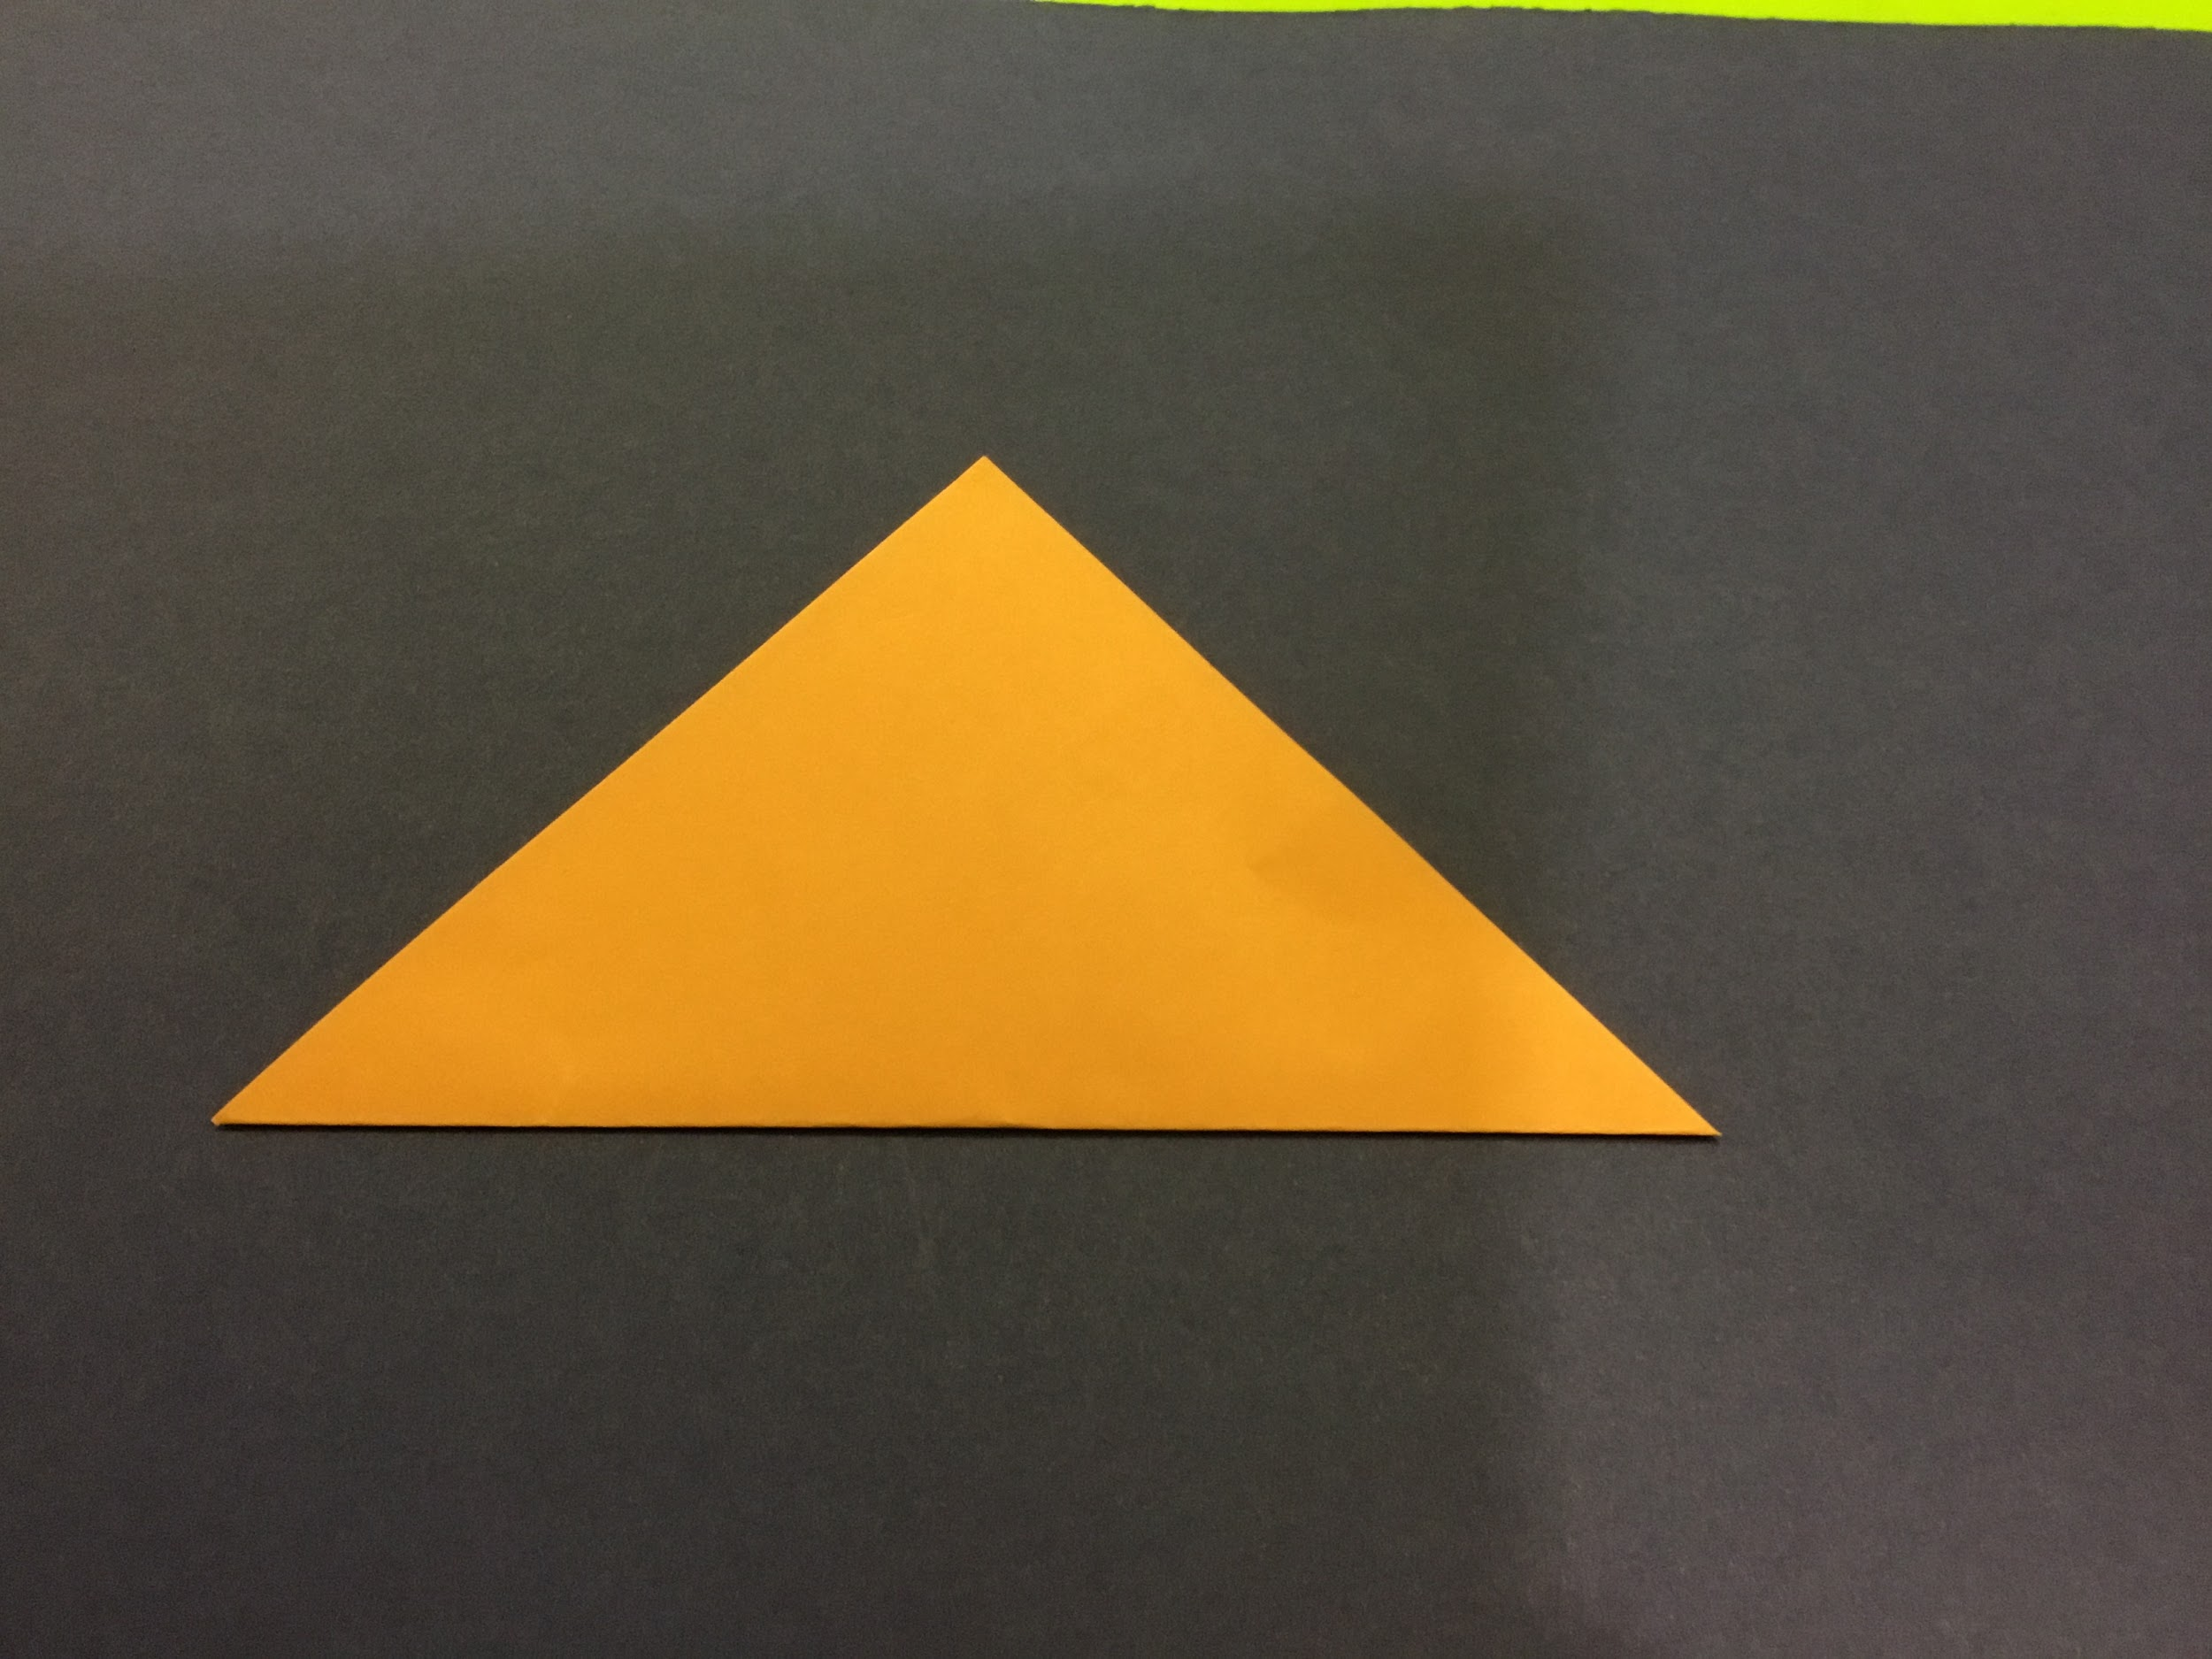

- 2. 3.
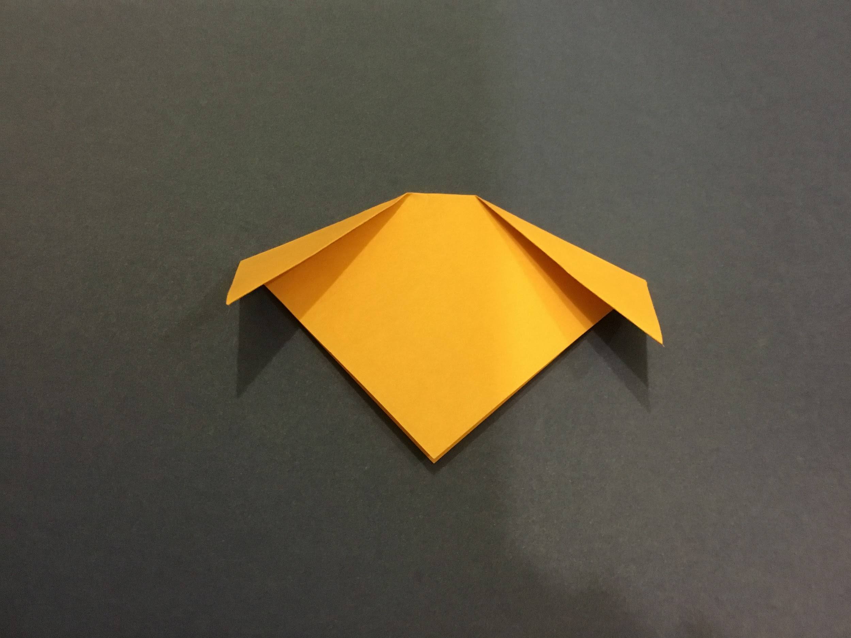
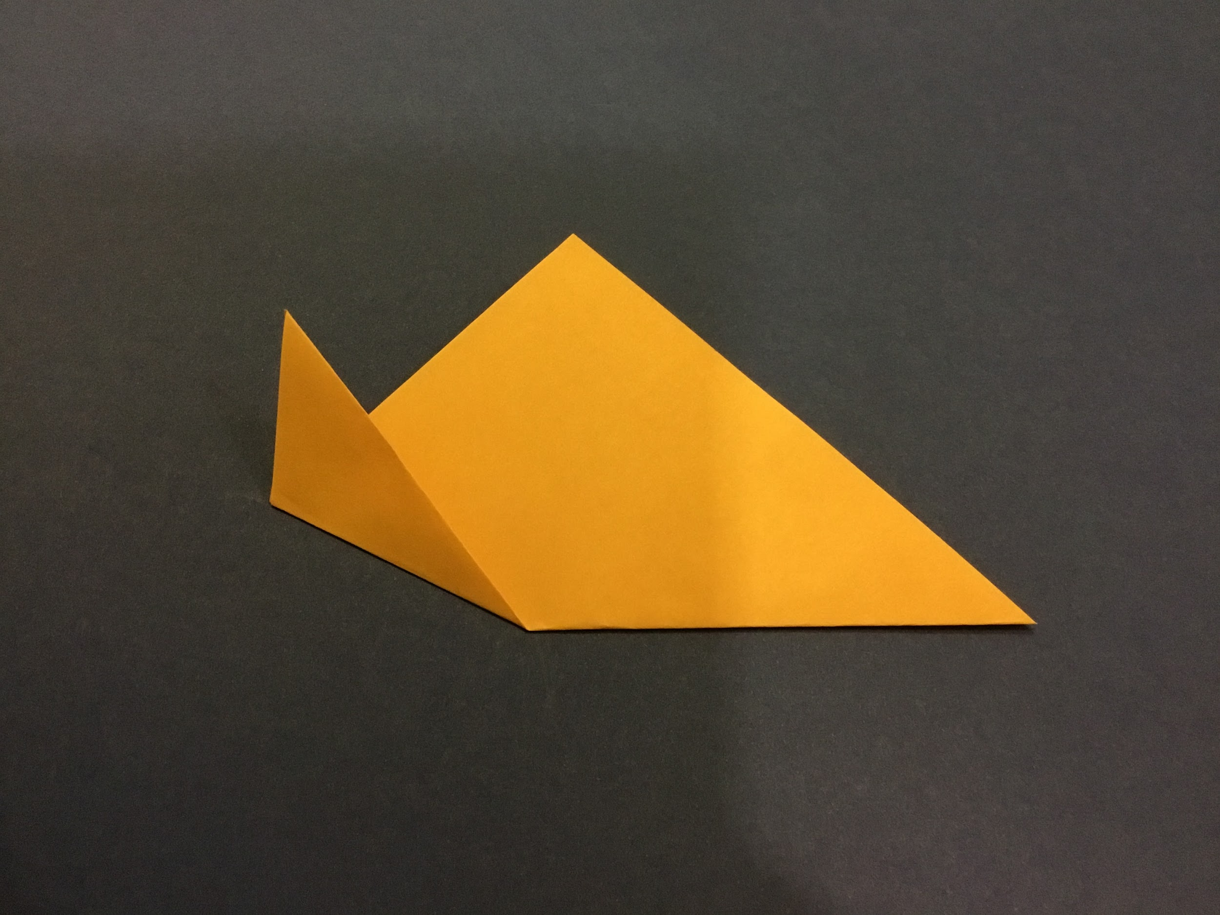
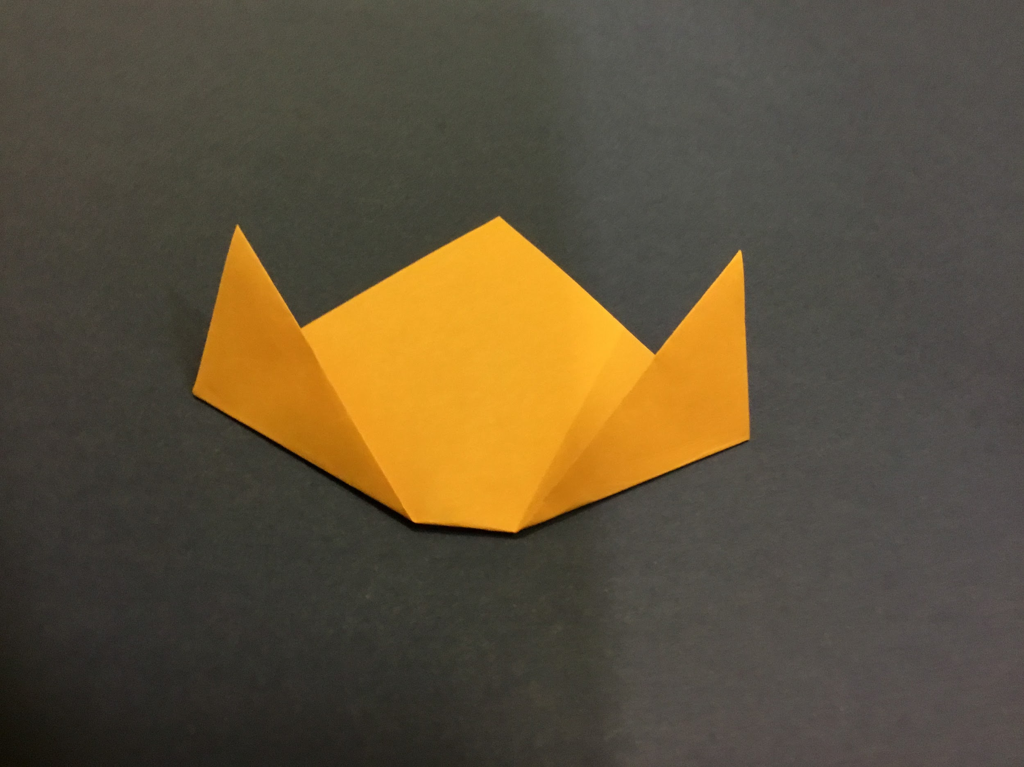

4. 5. 6.

Reflection How can you tell that the girl and the dog are friends? Why do you think she likes the dog?

Why do you think the dog likes her?

Humans take care of their pets. They give them a warm, safe place to live. They feed them. They take care of them when they are sick. This is called compassion—it’s when you care about somebody or something.

Take a look at your origami dog. Think about how you might take care of it. What is his or her name?

Curriculum Connections California Arts Standards for Public Schools—Visual Arts

K.VA:Re8: Interpret art by identifying subject matter and describing relevant details. 1.VA:Cr2.1: Explore uses of materials and tools to create works of art or design.

Prepared by Peggy Hasegawa with the Los Angeles County Museum of Art (LACMA)
Education Department

