Factsheets
Purpose
All Community Sponsor groups must provide a local information factsheet within 3 days of submitting your Property Offer Form to the Local Authority, which can be handed to the families at their UK Cultural Orientation appointments.
Format and Structure
A basic template for these factsheets is found at Appendix A. The template covers the key areas needed in each factsheet which will allow the families to learn about where they are being resettled. As we are trying to ensure that everyone gets consistent information about the areas they are going to, it would be appreciated if you could use the template.
All factsheets need to be in both English and the respective first language of the family that you have indicated in your application that you can support.
Things to put in the factsheet:
- A welcome message to the refugees
- A short introduction to your group and its key members
- A description of the area
- Where it is in the UK – please include a map
- A description of the property including photos
- Distance from nearest city or large town in the case of it being in a rural area
- A description of the types of support your group is offering to the family
- Rail, Bus and Air travel
- Religion (where is the nearest place of worship) – please include all major religions

Good Practice
Good examples of the factsheets are attached at Appendix B. Please ensure that you add appropriate photographs which will give the families an idea of the area they are going to.
Do’s and Don’ts
Do’s | Don’ts
- Keep it simple  - Put in pictures  - Ask already resettled refugees what information they would have liked to see in the factsheets  - Keep your facts pertinent to a refugee coming to an unknown country to resettle | - Don’t focus on historical facts or clubs  - Deviate from the structure of the template  - Don’t do all text with no pictures – remember some of these refugees are not literate and pictures tell them a story

APPENDIX A
FACTSHEET TEMPLATE
Group Name

Welcome from (group name) | Insert pictures of key group members
Where is xxxx?  Xxxx is a (town/village/city) in xxxxx which as you can see on the map is in xxxx part of the UK. We have a population of xxxxxx which is made up of a diverse mix of ethnic groups.  Some of the languages spoken are English, Arabic, xxxx, xxxx, xxxx, and xxxx.  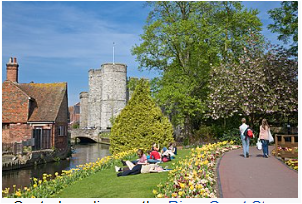 | Location in the UK  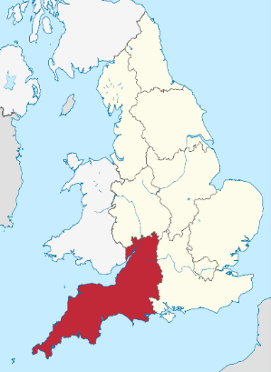  Cornwall the most southern County in the UK  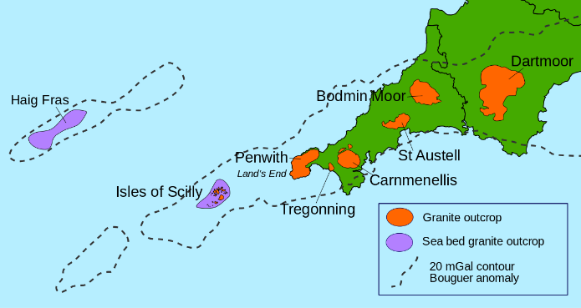
Property details | Property Photos  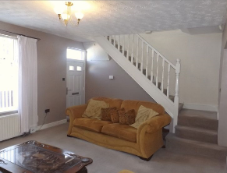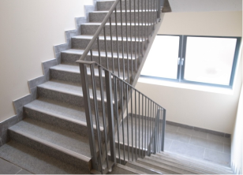  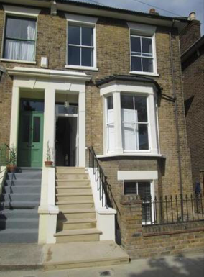
Distance from nearest city or large town in the case of it being in a rural area | Map showing the distances and locations
A description of the types of support your group is offering to the family | Benefit claims  Access to ESOL Lessons etc
Getting about?  Description of transport links available  Airport, train, bus, taxi | 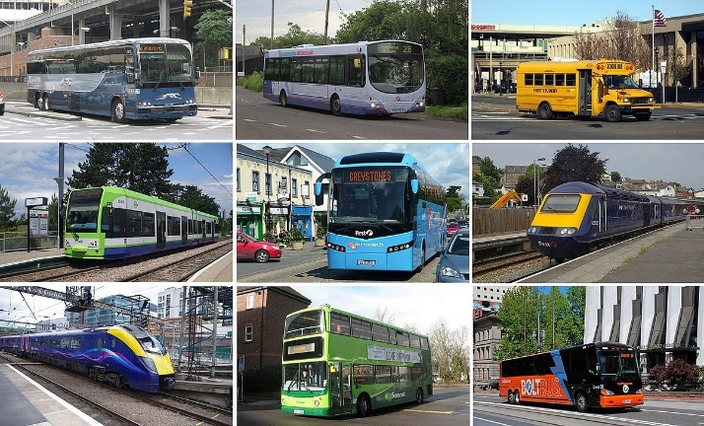
Religion | There are a number of different religions represented in xxxxxxx.  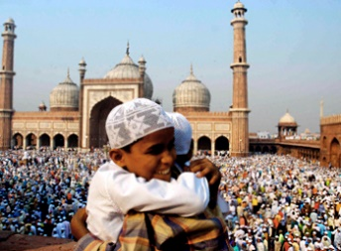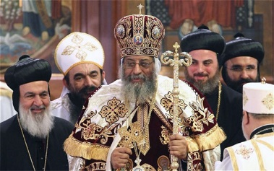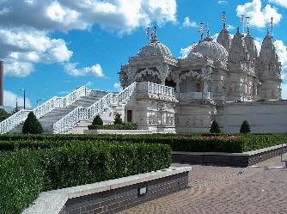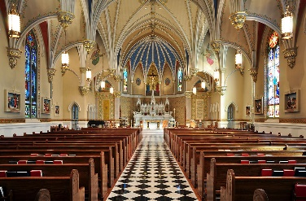

NB- Pictures above are generic for illustration purposes – use more regional specific pictures

Appendix B
