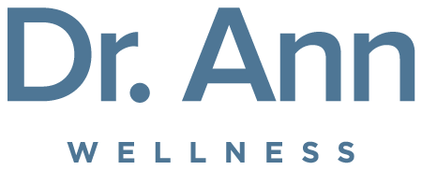
TESTIMONIALS

“Love the energy!” – Mary E.

“Love the positivity.” - Jenine W.

“This course was truly AMAZING!!! I loved it because it was about nourishing our bodies properly and about eating better to feel better. I loved the science and the WHY behind all the nutrition and the benefits. I can now pass this knowledge on to my children in trying to educate them as to why they should eat certain foods. Dr. Ann’s course has truly changed my eating habits!” - Mary M.

“I appreciate that our company is so interested in our
wellbeing.” - Black Hills Energy Employee

“FABULOUS SESSION. Thank you Dr. Ann!” - Angeline T.

“This course was so helpful. Puts everything
in perspective. Thank you!” - Paula S.

“This will be a great way to ensure healthy eating at the start of a new school year!” - Mary S.

“The class was amazing! I learned so much. I now not only understand what, but also why. The “why” and “what happens” is what I have been missing. I can’t thank you enough.” - Moir D., Columbia, SC

“I have already put your words into practice! There is an overwhelming amount of information on healthy eating available. Thank you for making it interesting and manageable. Your books are an excellent resource. The presentation is excellent visually and packed with information. Your enthusiasm, knowledge base, and sincerity made the program more than just an educational experience. It made it a life-changing experience. Thank you... thank you... thank you!” - Karen W.; Dublin, OH

“It was an awesome presentation. Your passion in what you believe transcends to everyone. I’ve made changes and will continue to incorporate more of them into my life for not only my benefit but for those I love.” - Marcia P.; Charleston, SC

“Truly life-changing. Thank you so much for your time and energy.” - Len R.; Wilbraham, MA

“I know I am not alone when I say that these webinars - and all the daily inspiration and education this wonderful woman provides - is invaluable for those of us who want to learn about and maintain a healthy lifestyle. I never let a day go by without checking out her Facebook page and her videos. I own all her books and have made gifts of them to my loved ones. Long may she reign, the Queen of Healthy Living!!!” - Barbara K., Indiana

