BBC Men’s Revelation Bible Study #13 – Jesus Gives Us a New Home
(A Heads Up! This will be material we will cover for our last 2 studies!)

Revelation 20:1 - And I saw an angel coming down out of heaven, having the key to the Abyss and holding in his hand a great chain. ² He seized the dragon, that ancient serpent, who is the devil, or Satan, and bound him for a thousand years. ³ He threw him into the Abyss, and locked and sealed it over him, to keep him from deceiving the nations anymore until the thousand years were ended. After that, he must be set free for a short time.
⁴ I saw thrones on which were seated those who had been given authority to judge. And I saw the souls of those who had been beheaded because of their testimony about Jesus and because of the word of God. They^{[a]} had not worshiped the beast or its image and had not received its mark on their foreheads or their hands. They came to life and reigned with Christ a thousand years. ⁵ (The rest of the dead did not come to life until the thousand years were ended.) This is the first resurrection. ⁶ Blessed and holy are those who share in the first resurrection. The second death has no power over them, but they will be priests of God and of Christ and will reign with him for a thousand years.

A Brief Summary of the Main Views of the Millennium

Pre-Millennial – The 1000 years reign is a literal reign of Jesus on the earth after his second coming. Things will get progressively worse on earth as we get closer to Jesus’ return. After the millennium, final judgment will occur. There are 2 varieties of the Premillennial view: Historic Premil and Dispensational Premil.
Post-Millennial – The 1000 years is a symbolic number and covers the entire period between Jesus’ resurrection and return. Things will get progressively better in the world as the Gospel spreads and the church’s influence on society grows... as we get closer to Jesus’ return.
Amillennial – The 1000 years is a symbolic number and covers the entire period between Jesus’ resurrection and return. History will be marked by a growing contrast between light and darkness. The Gospel will continue to grow in its success among the nations, Christians will have significant influence in the world and various cultures, but the transformation of all things will only happen at Jesus’ return.
Pan-Millennial – Quite literally, it will all “pan-out” in the end! Brothers, we’re not saved by our view of the millennium but by the blood of Jesus! Each of these views has things to commend, and they are all held by those with the highest view of the authority of the Scriptures.

Two helpful articles on the main millennial views. Click on and enjoy.

https://tinyurl.com/5n6nmusb

https://www.dropbox.com/s/cwd3ruxuqfkpnsk/MainViewsMillennium.pdf?dl=0

Our Coming Home: Life in the New Heaven and New Earth

(1) The Joy of living in our world after it has been purified, restored, and brought to glorious completion. (Romans 8). Think of the Garden of Eden on Gospel Steroids!
Revelation 21:1 Then I saw a new heaven and a new earth, for the first heaven and the first earth had passed away, and there was no longer any sea.
(2) The Joy of our completed salvation and fullness of relationship with Jesus
Rev. 21:2 I saw the Holy City, the New Jerusalem, coming down out of heaven from God, prepared as a bride beautifully dressed for her husband.
(3) The Joy of no more brokenness—in anyone, anywhere, ever again.
Rev. 21:3-8 And I heard a loud voice from the throne saying, “Now the dwelling of God is with men, and he will live with them. They will be his people, (literally, “peoples”) and God himself will be with them and be their God. 4 He will wipe every tear from their eyes. There will be no more death or mourning or crying or pain, for the old order of things has passed away.” 5 He who was seated on the throne said, “I am making all things new!” Then he said, “Write this down, for these words are trustworthy and true.”
(4) The Joy of perfect relationships and redeemed stories
Rev. 21:9-21 One of the seven angels who had the seven bowls full of the seven last plagues came and said to me, “Come, I will show you the bride, the wife of the Lamb.” 10 And he carried me away in the Spirit to a mountain great and high, and showed me the Holy City, Jerusalem, coming down out of heaven from God. 11 It shone with the glory of God, and its brilliance was like that of a very precious jewel, like a jasper, clear as crystal. 12 It had a great, high wall with twelve gates, and with twelve angels at the gates. On the gates were written the names of the twelve tribes of Israel. 13 There were three gates on the east, three on the north, three on the south and three on the west. 14 The wall of the city had twelve foundations, and on them were the names of the twelve apostles of the Lamb. 15 The angel who talked with me had a measuring rod of gold to measure the city, its gates and its walls. 16 The city was laid out like a square, as long as it was wide. He measured the city with the rod and found it to be 12,000 stadia a in length, and as wide and high as it is long. 17 He measured its wall and
it was 144 cubits b thick, c by man’s measurement, which the angel was using. 18 The wall was made of jasper, and the city of pure gold, as pure as glass. 19 The foundations of the city walls were decorated with every kind of precious stone. The first foundation was jasper, the second sapphire, the third chalcedony, the fourth emerald, 20 the fifth sardonyx, the sixth carnelian, the seventh chrysolite, the eighth beryl, the ninth topaz, the tenth chrysoprase, the eleventh jacinth, and the twelfth amethyst. d 21 The twelve gates were twelve pearls, each gate made of a single pearl. The great street of the city was of pure gold, like transparent glass.
(5) The Joy of the perfected temple-less worship of God
Rev. 21:22-23 I did not see a temple in the city, because the Lord God Almighty and the Lamb are its temple. 23 The city does not need the sun or the moon to shine on it, for the glory of God gives it light, and the Lamb is its lamp.
(6) The Joy of history redeemed, pan-national culture, and new creation society.
Rev. 21:24-26 The nations will walk by its light, and the kings of the earth will bring their splendor into it. 25 On no day will its gates ever be shut, for there will be no night there. 26 The glory and honor of the nations will be brought into it. (Read Isaiah 60 for the background to this image.)
(7) The Joy of knowing the fall will never happen again
Rev. 21:27 Nothing impure will ever enter it, nor will anyone who does what is shameful or deceitful, but only those whose names are written in the Lamb’s book of life.
(8) The Joy of dynamic life and endless delights
Rev. 22:1-2 Then the angel showed me the river of the water of life, as clear as crystal, flowing from the throne of God and of the Lamb 2 down the middle of the great street of the city. On each side of the river stood the tree of life, bearing twelve crops of fruit, yielding its fruit every month. And the leaves of the tree are for the healing of the nations.
(9) The Joy of shameless intimacy and liberated service of God
Rev. 22:3-4 No longer will there be any curse. The throne of God and of the Lamb will be in the city, and his servants will serve him. 4 They will see his face, and his name will be on their foreheads.
(10) The Joy of filling the new heaven and new earth with God’s glory forever and ever and ever.
Rev. 22:5 There will be no more night. They will not need the light of a lamp or the light of the sun, for the Lord God will give them light. And they will reign forever and ever.
“There are only two days on my calendar—that DAY and this day.” Martin Luther
Questions for Reflection and Conversation
1. Brothers, what had the most impact on you this week in your study, and from Scotty’s teaching today? What was encouraging, “stretching,” and/or hope-fueling?
2. Chat briefly about the joy and freedom of being “pan-millennial”—that is, of remaining committed students of Scripture, but of being at peace about the final fulfillment of all of God’s promises.
3. What’s “pretty cool” about realizing our world won’t be annihilated and replaced, but resurrected, redeemed, and brought to fullness? How might this impact our view of the environment and stewardship of God’s creation?
4. The elimination of all evil and the redeeming of pain behind our tears... how does this impact your heart?
5. What joy do you find in hearing Jesus say, “I am making all things new.” not, “I am making all new things”? What are you most looking forward about the “all new” you? I love this from Joni Tada Erickson. Wow!!! This is what I’M really looking forward to!
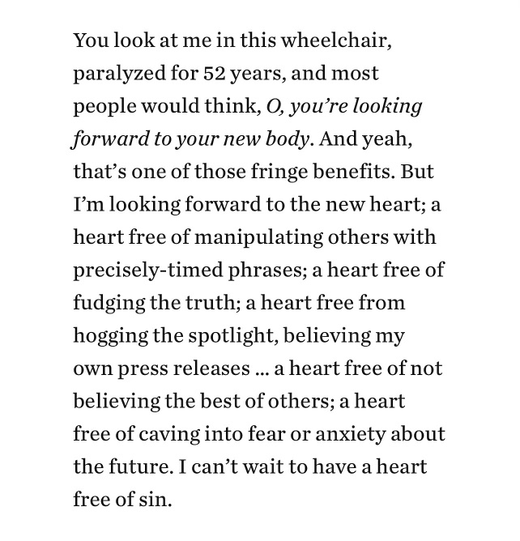
5. Close with a good season of thanksgiving, and prayer for each other!

