Food Dehydrating Made Easy!

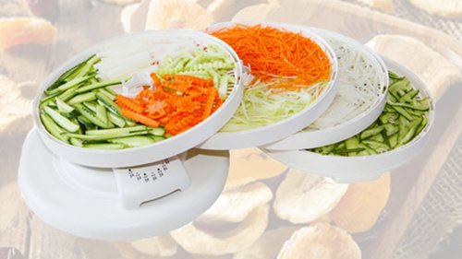

Recipes - so you can print them out…

Along with some links at the end!

Contents

Carrot Soup 3

Cauliflower Soup 4

Potato Bacon Hash 5

Ratatouille 6

Apple Sauce 7

Banana Cinnamon Rolls 8

Chicken Chow Dog Food – Homemade! 9

Extra Information 11

# Carrot Soup



**Carrot Soup Ingredients:**

* 2 tablespoons of olive oil
* 1-3/4 to 2 cups of dehydrated carrots
* 1/4 cup dehydrated onion
* 2 slices dehydrated elephant garlic, crumbled
* 1 teaspoon dried oregano
* 3-1/2 cups of vegetable stock. (I choose to use Better Than Bouillon)
* salt and pepper to taste
* around 1/2 cup of fresh or from-concentrate orange juice, to taste. You should be able to 'detect' the orange juice, but not be overwhelmed by it.

**Here's How to Make It:**

1. Re-hydrate the dehydrated carrots, dehydrated onion, and the dehydrated garlic with clean cold or freshly boiled water.
2. To a good heavy pan, add the olive oil, medium heat.
3. Add the onions and carrots and cook until softened, around 8 minutes or so, then add the garlic and the oregano, and cook some more for a few minutes.
4. Add the vegetable stock and bring to a boil.
5. Simmer for 10 minutes or until the carrots and onions are cooked through.
6. Add the orange juice, stir.
7. Use a blender to mix, in small batches ... allow air to escape from the little hole in the lid so that the heat doesn't cause any explosive problems! Just have your hand over that top little hole to catch any runaway splashes if you don't have a Vitamix (I highly recommend Vitamix blenders). If you have a Vitamix blender, you can leave the small cap on as it has ventilation holes.
8. Blend until smooth, about 45 - 60 seconds.

# Cauliflower Soup

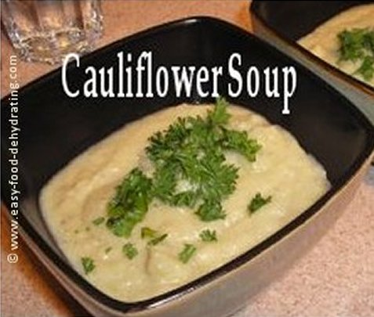

**Cauliflower Soup Ingredients:**

* 2 cups dehydrated cauliflower
* 1/8 cup dehydrated onion
* 1/8 cup dehydrated celery
* 2 slices dehydrated elephant garlic
* 2 cups boiling water (for the dehydrated items)
* 1/8 cup millet, optional - rinse first
* 1/8 cup quinoa, optional - rinse first
* pepper (and salt*) to taste
* 4 cups of vegetable stock (I choose to use Better Than Bouillon)
* Seasonings: 1/2 teaspoon Cumin, 2 tablespoons fresh chopped parsley, and a sprig for garnish!

**Here's What You Do for the best Cauliflower Soup!**

1. Use the freshly boiled water to re-hydrate the dehydrated items above.
2. When they are sufficiently plump, put the veggies into a heavy saucepan (with the optional millet and quinoa -- RINSE the millet and quinoa first in a fine-sieve in the sink to get rid of the bitter taste).
3. Add the chopped parsley, vegetable stock, and cumin, and cook for 15-20 minutes, until the cauliflower is fully cooked/soft.
4. Use a blender to mix, in small batches... allow air to escape from the little hole in the lid so that the heat doesn't cause any explosive problems! Just have your hand over that top little hole to catch any runaway splashes if you don't have a Vitamix (I highly recommend Vitamix blenders). If you have a Vitamix blender, you can leave the small cap on as it has ventilation holes.
5. Blend until smooth, about 45 - 60 seconds. Serve with an added sprig of parsley for garnish!

*IF you need to add salt, do so, BUT be careful NOT to over-salt as the bouillon has salt in it...

# Potato Bacon Hash

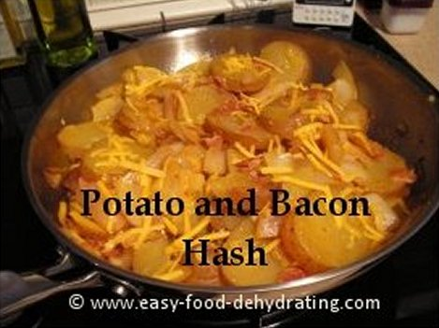

**Potato and Bacon Hash Ingredients:**

* 1-1/2 cups dehydrated sliced potatoes
* 1/4 cup dehydrated onion
* 2 slices dehydrated elephant garlic
* 4 slices bacon (or 2 oz. corned beef, or ham)
* 1 tablespoon plain flour
* 2 tablespoons tomato ketchup
* 1 tablespoon Worcestershire Sauce
* 4 oz. grated cheddar cheese
* 1/4 cup cold water
* salt and pepper to taste

**Here's How to Make This Super Comfort Food!**

1. In a large saucepan, add the dehydrated sliced potatoes, onion, and elephant garlic. Add boiling water to cover them all. Let them re-hydrate in the pan, add more boiling water if necessary.
2. Fry up the bacon!
3. While the bacon is cooking, combine the flour and water in a measuring jug, add the ketchup and Worcestershire sauce and set aside.
4. When the potato mix is sufficiently re-hydrated (and remember, the potatoes are already cooked prior to dehydrating so they only need to be heated through), add the ketchup mix and gently stir and cook a few minutes more.
5. Add the bacon, crumbled (or any other flavorful meat!)
6. Season with salt and pepper to taste.
7. Sprinkle on about 4 oz. grated cheddar cheese, let it melt and serve!

# Ratatouille

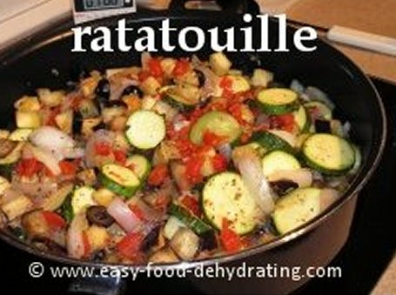

**Ingredients for Ratatouille:**

* 1-1/2 cups dehydrated zucchini
* 1 whole fresh eggplant, cubed (I leave the skin on, so wash well first)
* 1/2 cup dehydrated onion rings
* 1/4 cup dehydrated mushrooms
* 10 black olives, cut in half
* 3 slices dehydrated elephant garlic, crumbled
* boiling water (for dehydrated items)
* 2 tablespoons olive oil
* Salt and pepper to taste
* 1 14.5 oz. can small-diced tomatoes
* 1 cup of vegetable stock (I choose to use Better Than Bouillon)
* seasonings: 1 tablespoon dried Italian Herb blend (more or less, to taste)
* NOTE: Optional Orzo, 1 cup

**Here's How to Make This Fabulous Mediterranean Dish!**

1. Use the freshly boiled water to re-hydrate the dehydrated items above, let sit until they have plumped up.
2. Put oil in a large saucepan, sauté the eggplant.
3. Pour off excess water from dehydrated veggies, and add the veggies carefully to your saucepan as water can spit in hot oil...
4. Add 1 cup of vegetable stock, and add the Italian seasoning.
5. Add the sliced olives and the mushrooms
6. Cook for 15 minutes or until the vegetables are tender.
7. If adding the orzo, add this at step 4. You may need to add a little more boiled water too, if you find the orzo drinks up your stock too soon. Orzo only needs around 10 minutes to cook, half the time of rice. This makes this Ratatouille dish like a risotto, to me!

# Apple Sauce

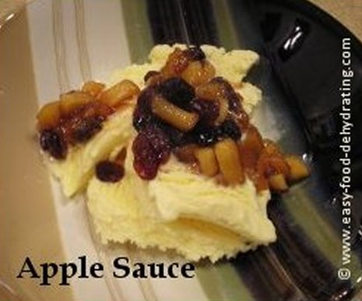

**Apple Sauce Ingredients:**

* 1 apple, peeled and diced
* dash of cinnamon
* 1.5 teaspoons of lemon juice
* tablespoon of water
* handful of dehydrated cranberries
* handful of raisins
* 2 dessertspoons brown sugar
* 1 tablespoon apricot jam

**Here's How To Make It:**

1. Peel the apple, dice into small to medium pieces.
2. Put in a non-stick pan and add the lemon juice, toss.
3. Add the water and cinnamon, stir well.
4. Add the raisins and cranberries, stir and cook about five minutes.
5. Add the brown sugar, stir, heat on low a minute.
6. Add the apricot jam, stir well and serve!

# Banana Cinnamon Rolls

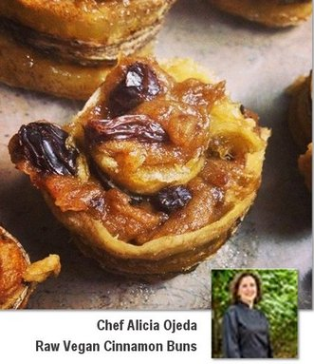

**Banana Cinnamon Rolls Ingredients:**

* 2 ripe bananas, sliced 1/8" thick, chill overnight for easier slicing
* cinnamon powder to taste
* 1/2 cup of raisins
* 1 cup of dates, re-hydrated in good water

**Here's How To Make It:**

1. Re-hydrate the dates overnight in good clean water, preferably distilled.
2. Slice the bananas lengthwise, about 1/8" thick. They slice better chilled. Put on dehydrator trays for about 2 hours to remove some stickiness.
3. When the dates are quite soft, mash them up with a fork in glass bowl and add cinnamon powder to taste. Add raisins too at the end of the date mashing, but don't mash the raisins!
4. Carefully spread the date and raisin mixture onto the slightly dehydrated banana slices. Roll them up.
5. Put the banana cinnamon rolls back on the dehydrator a couple more hours. I had to use my top tray of my Nesco due to the height of the rolls. An Excalibur dehydrator wouldn't have this problem as you can easily remove a tray and have tons of room!

In this recipe, I mentioned [Andrew Perlot](http://www.raw-food-health.net/) and [Brittany Taylor](http://www.simplelivingandtravel.com/) who are both friends of raw food chef [Alicia Ojeda](http://www.rawchefalicia.com/) so I’ve hyperlinked their names so you can go visit them! I have also included links to my Amazon books: [Amazing Un-Processed Raw Food Diet](http://www.amazon.com/Amazing-Un-Processed-Food-Diet-ebook/dp/B0099AID9C) where I initially “went raw” to lose weight (successfully) and now realize it’s a great way of life – though I must admit I’m not 100% raw.

# **Chicken Chow Dog Food – Homemade**!



**Dog Food Chicken Chow Ingredients:**

* 1/4 cup of millet and 1/4 cup of quinoa (rinsed in a fine sieve to remove the bitter taste)
* handful of whole wheat (or plain) egg noodles
* 1/4 cup of orzo
* six boneless, skinless chicken thighs or same amount of beef, or pork (save money by buying on sale and freezing); I currently use two large frozen boneless, skinless chicken breasts

***Followed by***

* 1 cup of chopped fresh carrots (or about a 1/2 cup dehydrated)
* 1/2 cup of sliced celery (two tablespoons dehydrated)
* 1 cup of sweet potato, diced (1/2 cup dehydrated)
* 1 cup of butternut squash, diced (1/2 cup dehydrated) [you can omit butternut squash and double up on sweet potatoes!]
* 2 cups of chicken stock for the millet/quinoa/egg noodle/orzo   
  and
* 2 cups of chicken stock for the chicken and vegetables in the pressure cooker

**Here's How To Make THE BEST Chicken Chow Dog Food!**

1. Put the carrots, celery, sweet potato, and butternut squash aside in some boiled water in a measuring jug for about 5 minutes to re-hydrate then put in the pressure cooker. If using fresh veggies, simply place in the pressure cooker. Add two cups of chicken stock. **Do not** add salt or pepper. Make sure the stock you use is onion-free, because onions are poisonous to dogs.
2. Cook millet, quinoa, egg noodles, and orzo in a separate pan with 2 cups of chicken stock. Watch it to make sure it doesn't stick as it absorbs the stock rapidly! This takes about 20 minutes tops to cook. Add hot water to mix if it dries out too soon.
3. Place six boneless, skinless chicken thighs, (or similar amount of pork, or beef) -- on top of the veggies that are now in the pressure cooker. Make sure the meat pieces are of similar size for even cooking.
4. Cook according to your pressure cooker's directions. Mine only takes around 7 minutes! ... It's a Fagor. Almost felt like singing in Italian there... ALMOST... you know, when the moon hits your eye, like a big-a pizza pie - it's a Fagor!
5. OK... When the pressure cooking is done, remove the meat from the top and let it cool on a chopping board. When it's cooled, chop it into small bite-sized pieces.
6. Then add the vegetable contents from the pressure cooker to your pan of millet, quinoa, orzo, using a slotted spoon so that the majority of liquid (stock) is left behind... you can add some of that stock later IF you think your mixture is too dry.
7. Add the chopped meat to the mix along with four teaspoons of the vitamin mix (see just below for the vitamin mix) and then portion it all out into six or seven containers with lids and then freeze them. Our Min Pin absolutely LOVES this dog food!!!!
8. She’s over eight years old and has never “turned her nose up” at it!
9. NOTE: At our Min Pin’s last mani/pedi at the vets, the vet said “she’s in perfect health”… so I feel VERY good about the Chicken Chow Doggie Food that she’s eating!
10. Make sure that the finished mix is pretty moist; too dry and it falls apart – too wet and it gets too sloppy! There’s no need throw away any left-over stock as it makes a great base for our dehydrated vegetable soup!

**Adding Vitamins to Dog Food for Good Health**

As mentioned above, to the whole pan I've just made I add **four teaspoons** of this powder mixture (below) which are available in individual bottles at health food stores or online:

* 1/2 cup of Alfalfa (powder)
* 1 cup of Bone Meal (powder)
* 1 cup of Brewers Yeast (powder)
* 1/2 cup Kelp (powder)

Mix these four items together -- stir gently! I made a huge vitamin powder cloud in the kitchen first time I stirred this over-ambitiously!!! This vitamin batch lasts for about six to nine months. I keep it in an airtight container (an old CoolWhip tub with the contents and the quantities written on the lid so I don't forget!)

NOTE: If you can’t get Powder, then buy Capsules… I take them apart and dump their contents into the measuring cups. Yes, it’s a finger-aching job, but I’d do it *every day* of the week if I had to, for all the love that little Min Pin gives me!

# Extra Information

If you are interested in having more of my recipes, here is the link to my Amazon eBook: [20 Taste-Tested Easy Recipes Containing Dehydrated Food](http://www.amazon.com/dp/B00COB5HA6) and if you are also interested in beginning a food dehydrating journey and have tons of questions, might I suggest you buy this book, another one of mine also from Amazon: [How to Dehydrate Food… Top 20 Topics …over 225 Questions Answered](http://www.amazon.com/dp/B00RKK45MM)