Satire Project

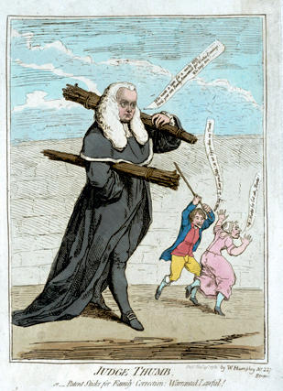

due Wednesday September 24, 2014

Create an essay, script/skit, movie, short story, letter, PowerPoint, or cartoon that attempts to imitate the style and approach of Addison and Steele’s The Spectator and The Tatler. You may also summarize and analyze contemporary satire.

1 - 2 pages double-spaced, 12 font, 1 inch margins, not including header: Name, English IV, period, Satirical Essay (unless creating a skit, cartoon, video, PowerPoint)

Your satire should examine the follies and flaws of human behavior, culture or institutions. As the writer, attempt to comically examine the flaws of society, an individual (or individuals), and the speaker. Attempt to employ the tools of a satirist: juxtaposition, hyperbole, irony, and sarcasm.

The essay may be written on a topic of your choice and may focus on real people or fictional characters (or speaker).

Possible broad topics include: the environment, class, race, taxes, economy, sports, music, holidays, religion, pets, food, politicians, etiquette, school, movies, fashion, gender, journalism, technology, business, and television shows.

Use specifics to support your argument and message.

