***Lesson 49: Choosing a Set of Bagpipes***

Lesson Summary

This video is pretty self explanatory, please refer to the lesson transcript for written version of dialogue.

However, one thing I would like to point out is this:

DO NOT buy pipes that look like this!:

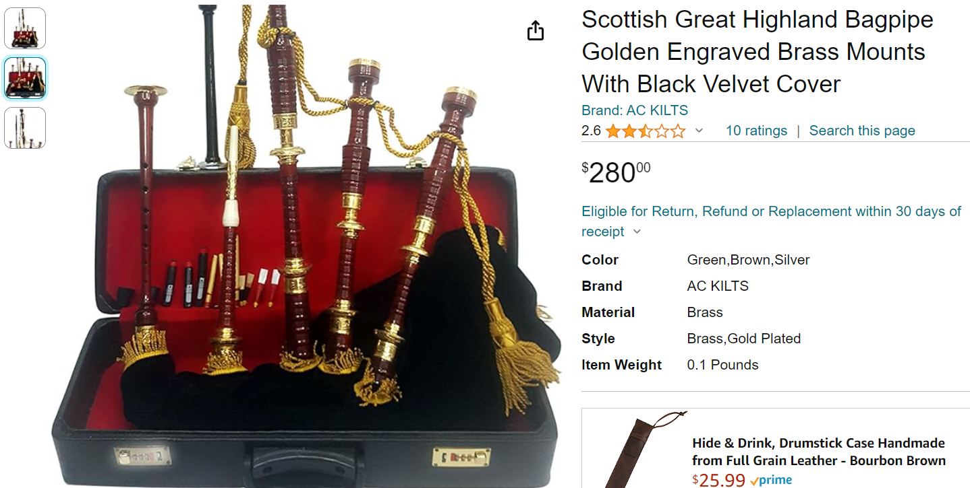

Not only will these pipes not work well, they will not work at ALL, and you will be wasting $300. These products are a scam. I

In general, pipes being sold online for less than $800 are simply not worth buying.

Follow my advice outlined in the video by buying any of the brands listed on Henderson’s and you will be making a wise investment!