The SPARK Method Case Study

Course Title | Flawless Project Management with the SPARK Method
Course Learning Goals | - Know where to start with Project Management, communicate and cooperate effectively.  - Know how to lead a team.
Case Study Name | Construction Business, Leaser Ltd.

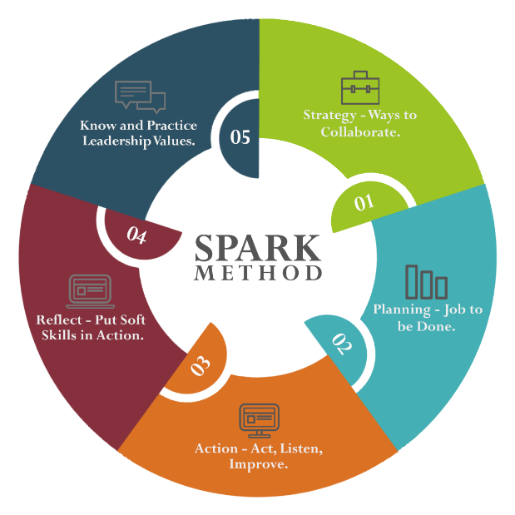

An international Customer (in our Case Study called Leaser Ltd.), provides working spaces for freelancers, small and medium companies and they want to build a new building in Your city.

They are proficient in setting up an IT infrastructure, but they need a construction company to build an office with 800 sitting places according to standards specified for other two buildings they own in other two countries.

Leaser Ltd. wants to concentrate solely on their primary work: leasing working space to freelancers, small and medium businesses and other interested parties. As part of their strategy, they will build relationships with universities, schools and other local market representatives.

Because of that decision, Leaser Ltd. want to outsource everything that is not in their core business to third parties. They do not want to spend their own resources on following areas:

- Construction of the office building, including but not limited to:
  - Parcel purchase, where building will be erected,
  - Agreement with the City government on building standards and administration, including but not limited to:
    - Power supply,
    - Water supply,
    - Sewage system connection,
    - High-speed, optical cable, internet connection etc.
- Building design, including but not limited to:
  - Open Space design,
  - Conference rooms design,
  - Dining room design.
They have two buildings in Poland and India and they are building another one in your city. Leaser Ltd. gives you a creative freedom to build their office in a way you propose while it is inside the business standards accepted and used in construction of two previous office buildings.

For this project Leaser Ltd. dedicated a project team to work on proposal, solution and to cooperate with during the project:
  - Chief Technical Officer (CTO) to whom the whole project team reports and who report directly to Chief Executive Officer (CEO) of the Leaser Ltd.
  - 2 Project Managers in charge for each area: building construction and office design.
  - 1 Network Engineer, 1 Construction Engineer and 1 Marketing representative to consult with you during the project.
  - Leaser Ltd. says that they can invest 5 000 000 USD in this project, but they do not know how much this whole project may cost.
  - Due to new demands, Leaser Ltd. must complete this project in 8 months.
You are part of Flawless Project Management (FPM) Company. Your tasks are to:

  - Lead FPM Project Team and create a Project Plan for Leaser Ltd. Customer.
  - FPM Company has great construction experts, but you will need to cooperate with an Architect Office outside of your company to get modern architecture and building design.
  - You will need to find an appropriate 3rd party company to provide you with those services and cooperate with them.
  - Also, you will need to cooperate with the City to get clarity on all administrative procedures and interfaces to power supply, sewage, internet etc.
  - Inside FPM Company, you will report to your Chief Technical Officer and then to CEO. You will send reports to CTO weekly and to CEO monthly.
  - In your FPM Project Team, you will have 5 Construction Experts.

Now, let’s go through the five SPARK modules and address parts of this Case Study in each of them.
Make sure to:
- Listen to all Educational materials;
- Download all checklists and templates;
- Do all exercises;
- Prepare your own folder for the future project as stated in those Checklists.

