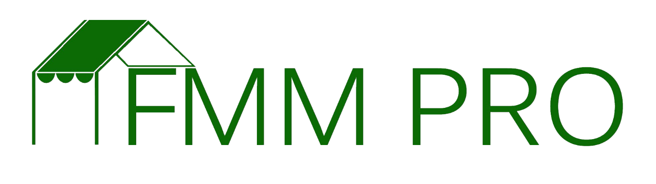

Farmers markets should always be considering their sustainability. One option is to create a fundraising program to support programming, marketing/outreach efforts, or fund operations of the market. Use the template and guiding questions below to craft a sponsorship opportunity from a local business for your farmers’ market.

Step One: Answer these questions:

1. **What is the xyz Farmers Market?**

(Give a description of your market, including the types of activities, number of vendors, customers, etc… This is your short elevator speech about your market)

1. **Why does the Market exist?** --> Remember all that work you just did creating your market’s brand & story? (What is the mission of your market? What types of products do you provide? What is the atmosphere? What is the role of your market in the community? Etc…)
2. **Why are you requesting funds?**(What program, service, etc… are you requesting funds to support? What areas of the market will this support? Activities? Food Demonstrations? Programs? Etc… It is important that you also include a budget here)
3. **How will your request help this business or organization?**(This is where you will need to have a good handle on their mission and values and how they intersect with your market)
4. **What can we do for you?**

(How will you promote the business? Newsletter? FB page? What is your reach in these marketing channels? Booth at the market? Banner? Etc… How many people/families will this reach?

Step Two: Craft the Ask

Utilizing Word, or whatever design program you are most comfortable using, create a sponsorship/donation letter using the information generated above. Remember that you always want to highlight the benefits for the business you are soliciting with partnership at the market. If you have a market logo always include it at the top of the letter.

Make sure to end the ask with a statement like the one below. This demonstrates that you are serious about this request as you will be following up. It also illustrates that you already have some level of marketing and outreach for the market, which a potential sponsor will be interested in – especially if you are asking for help in that area.

*We would love to meet with you to discuss this in person and talk personally about our market, your business, and how we can work together. If you’d like more information about our market, make sure to visit our Facebook page. The link can be found in our signature.*

You also want to remember to make it as easy as possible for them to donate to your market. Letting them know if they can send a check, or if you have a donation set-up through PayPal, or something similar, will also be helpful. Many businesses like to do transactions with credit card as it cuts down on their own internal costs. Here’s an example you can use, or modify for your market:

*Want to send a check today? Make it payable to “XYZ Farmers Market or farmers’ market sponsor” and mail to: address for mail for the farmers market, or you can make a donation online here (insert link).* ***Remember that any donation or sponsorship is tax deductible (if your market (or market sponsor) is a 501©3).***

Thank you and we hope to hear from you soon!

{Market Manager Name}  
Market Manager (or title)  
{Contact Information}  
{Social Media Info/Facebook, Twitter, Instagram}