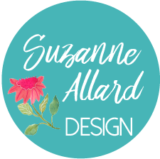 | “Grow Your Creative Practice with Sketchbooks” – Supply List  (clickable links at suzanneallard.com*)

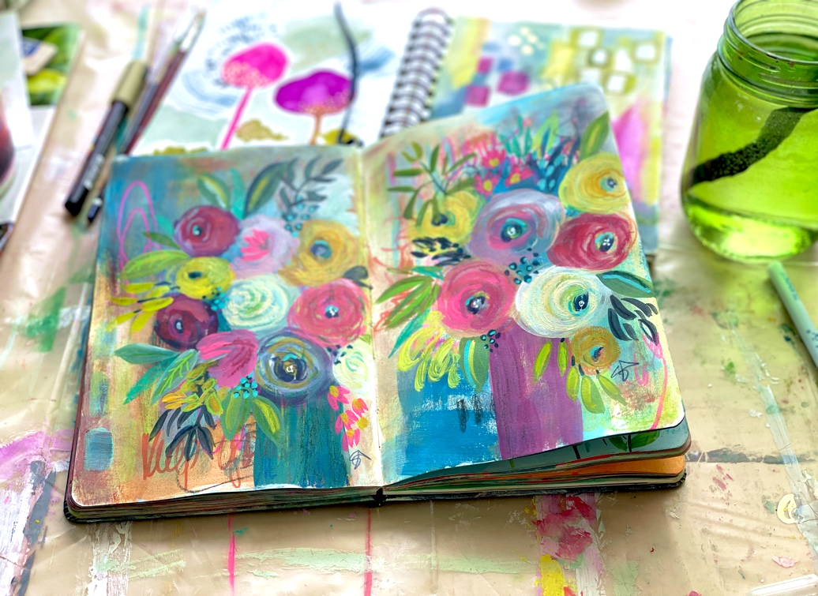

This is a list of what I use in the class, just so you know what they are. YOU DO NOT NEED TO GET ALL THESE SUPPLIES! Just use what you have and get whatever else you want. I just want to list them so you can find what you like and to add to your art supply wishlist . You may want to watch several modules of the class before ordering supplies and then watch them again when your supplies arrive and you’re ready to create.
Sketchbooks Shown in class: (you only need one for the class!) My favorite one is the first one but if you want watercolor paper then choose one of those. I just wanted to list everything I used so you would know.
Not watercolor paper:
- Moleskine Art Journal* (not watercolor paper), 5” x 8.25”
- Reflexions Sketchbook, (drawing paper, has to be gessoed or painted first) 6” x 6”
- Super large Moleskine Art Sketchbook (8.25” x 11.75”)
- Canson Mixed Media Sprial Notebook (various sizes)

Watercolor paper:
- Strathmore Visual Journal* (5” x 8.25”)
- Moleskine Watercolor Journal (5.25” x 8.25”)
- Arteza Watercolor Sketchbook* (8.25” x 8.25”)
- Handbook Journal Co. Journal (5.5” x 8.25”)
- Strathmore 400 series Softcover Art Journal (9.75” x 7.75”)
Paint:
Any paints you have will work as long as you know which ones are water-soluble after drying and which aren’t. The brands I generally use for gouache are Turner and Winsor & Newton. For acryl gouache I use Turner* or Holbein. For acrylic I use a variety, Liquitex, Golden, Nova color. The higher the quality, the more vibrant the color and pure the pigment. The Winsor Newton Cobalt Turquoise Light is amazing. The Opera pink is too but any Opera pink or red will do. Acryl gouache is matte and chalky like gouache but it is not water soluble once it’s dry. Acrylic paint is an option too, watercolor could work but would be more translucent and you can’t paint light over dark. Also, there is no white in watercolors so you have to use more water to lighten colors. You can mix white gouache with watercolors though and get them to be more opaque. You can try mixing anything with anything! I usually find the best prices for paints at JerrysArtarama.com.
White gesso is what I’ve been mixing with paint and using as the first layer on my spreads. I’ve been wanting to try clear gesso too. If you don’t have gesso you can just use acrylic paint as a first layer as well.
Brushes:
Any decent brushes, I like the Princeton Velvetouch* brand, # 4 or 5 round, #10 round and a #6 flat. Also, a number 1 or 2 for fine lines. These Princetons are if you are doing florals and want more control, otherwise cheap brushes are good for scrubbing the paint in on abstracts. A fan brush is great fun.
Various pens, crayons and pencils: (just a couple of these is fine)
- Oil pastels, any brand*
- Neocolor II Water-soluble crayons*
- Woody 3 in 1 pencils*
- CaranD’Ache Supracolor II Soft Pencils*
- Craftsmart metallic gold pen (if you like metallic gold)
- Uni-posca paint pens or any good quality paint marker*
- Any other pencils you have or want
- Any ink you have or want
Palette:
Palette or plastic or glass plate to use as a palette. Or a piece of cardboard covered in sticky plastic wrap works great!
Tools for Mark making:
These all work, you don’t need them all:
Paper clip, chopstick, palette knife, any tools you can find that make a variety of lines or can be used to make a mark.
Varnish or Fixative:
Finishing varnish spray if desired. I like the Krylon Workable Fixative from Amazon if I’m going to keep working on a page or the Liquitex Matt Varnish if I’m not.
Links to many of these supplies can be found in the supplies page at suzanneallard.com.
*Items with links under “Supplies/Resources” at suzanneallard.com

