business analysis process series
Student Workbook

^{v1.0}

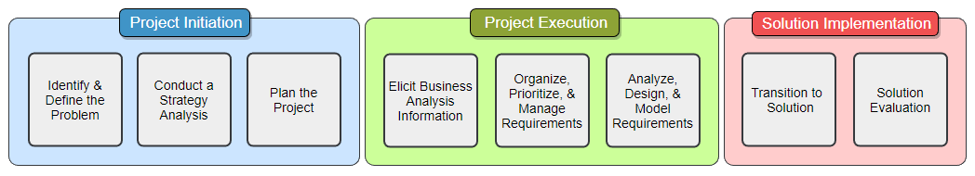
The BA Guide’s Business Analysis Process

Identify and Define the Problem Process

Need =
Project =
Value =

Problem Identification

Most Common Initiators

Organization: Self-Initiated:

Focus on the _________________________, not the _________________________.

Observation Technique

Benefits: Challenges:

Things to remember:

Observation Technique - Additional Notes

Interview Technique

Benefits: Challenges:

Things to remember:

Interview Technique - Additional Notes

Survey Technique

Benefits: Challenges:

Things to remember:

Survey Technique - Additional Notes

Additional Problem Identification Tools

Process Analysis and Modeling: Quick sketch

Pareto Chart: Quick sketch

SWOT Analysis: Quick sketch

Market Analysis:

Choosing a Technique

Step 1: _________________________________________________________________________________________________
Notes:

Step 2: _________________________________________________________________________________________________
Notes:

Step 3: _________________________________________________________________________________________________

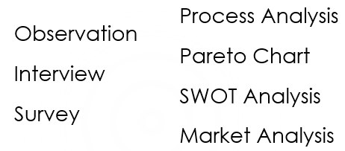
Notes:

Root Cause Analysis Techniques

Five Whys:

Fishbone Diagram: Quick sketch

Choosing a Technique or Tool – Instructions
This activity can also be found on the Udemy platform. It is highly recommended you also complete it there, so you can receive instructor feedback.
For this assignment you will be given a scenario and then you will be asked a series of questions about it. Many of these questions will ask you about what technique or tool would fit well into the situation.
YOUR OPTIONS:
Observation -- Interview -- Survey -- Process Analysis -- Pareto Chart -- SWOT Analysis -- Market Analysis
If you chose interview, observation, or survey, be sure you also provide the additional details pertaining to it.
The 'details' I'm referring to are the items you can find on the top of the corresponding Elicitation Notes template. For this assignment, what is highlighted in yellow is required and the items highlighted in blue are optional.
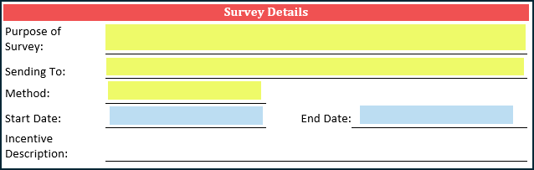
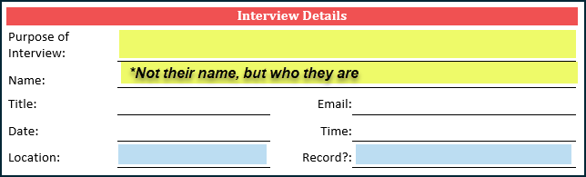
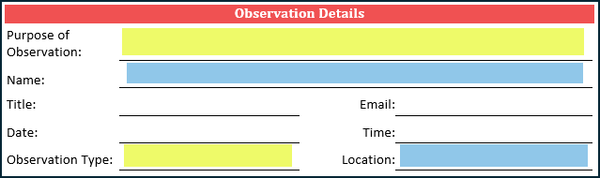

Choosing a Technique or Tool – Test Your Skills

- ABC Company wants you to focus on the internal help desk. They support the company by taking internal calls for things like password resets, hardware fixes/replacements, software installs, etc. While the company has only grown by 1% over the past 12 months, the call volume has skyrocketed (164% increase). They track each call, the prompts selected, the reported problem, the actual problem, and the solution implemented. They want to understand why the volume has gone up, so they can create a project to decrease it.
  - What technique or tool is the best to start this analysis off with? What would you be hoping to learn?
________________________________________________________________________________________________________________________________________________________________________________________________________________________________________________________________________________________________________________________________________________________________________________________________________________________________________
  - After you learn those details, what are your most likely next steps and why? ________________________________________________________________________________________________________________________________________________________________________________________________________________________________________________________________________________________________________________________________________________________________________________________________________________________________________

- Automotive Repair has 25 locations spread across the Midwest. Over the past few years, a competitor (123 Auto) has begun opening locations in and around Automotive Repair’s current territory. Executives at Automotive Repair fear if they don’t differentiate themselves, their sales could decrease sharply.
  - What technique or tool can identify areas of opportunity for Automotive Repair? Why?
________________________________________________________________________________________________________________________________________________________________________________________________________________________________________________________________________________________________________________________________________________________________________________________________________________________________________
  - What technique or tool could be utilized to generate (and later analyze) ideas and thoughts from over 3,000 employees spread across five different states? Why?
________________________________________________________________________________________________________________________________________________________________________________________________________________________________________________________________________________________________________________________________________________________________________________________________________________________________________
  - What technique or tool could be utilized to uncover automotive repair industry best practices? Why?
________________________________________________________________________________________________________________________________________________________________________________________________________________________________________________________________________________________________________________________________________________________________________________________________________________________________________
- Homes-4-You, a non-profit organization, is amid their annual spending audit. These audits are done every year to validate donated money is being spent in places with the highest impact. You were asked to look through the auditing process and identify any potential areas for improvement.
  - What is the best tool to help you lay out and visualize the audit procedure?
________________________________________________________________________________________________________________________________________________________________________________________________________________________________________________________________________________________________________________________________________________________________________________________________________________________________________
  - What two techniques could be utilized to help you gain the necessary information for the selected tool? Be sure to include the technique details in your answer.
________________________________________________________________________________________________________________________________________________________________________________________________________________________________________________________________________________________________________________________________________________________________________________________________________________________________________
________________________________________________________________________________________________________________________________________________________________________________________________________________________________________________________________________________________________________________________________________________________________________________________________________________________________________

Determine Value
Value is when a _______________________ is _____________________.

_________________________________ = something you can see, feel and touch (eg - money)

_________________________________ = something not able to be seen or felt (eg – time, brand awareness)

Value is both ________________________________ sensitive and differs based on ________________________________.

Steps in determining value:
- What is the value?
- Who is the beneficiary?
- How long will it be of value?

Final value validation question: ________________________________________________________________

Project Proposal

Project Proposal (definition)

Section 1: Statement of the Problem or Need

Section 2: Project Deliverables and Value

Section 3: Key Stakeholders

Section 4: Additional Notes

Section 5: Approval Signatures

Additional Notes and Thoughts:

The BA Guide’s Business Analysis Process:

Course Completion Checklist

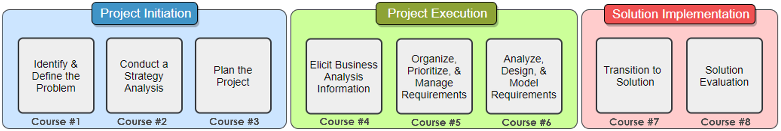

To learn more about this series and receive special discounts, head over to
www.TheBAGuide.com/BASeries

