HERE YOU ARE

Please answer each question as honestly as possible to help find what best suits your needs.

MASLOW PYRAMID

This pyramid helps to define your needs. Please have a look at the pyramid before answering the questions below.

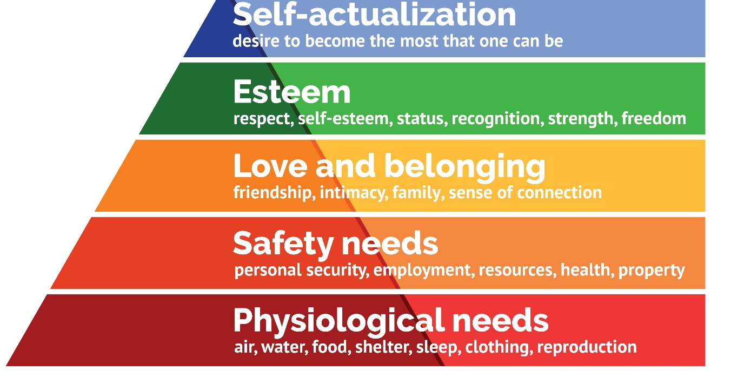
Picture: Maslow´s hierarchy of Needs
- Where are you on the Maslow’s hierarchy of needs? Which needs are covered, which needs are you trying to reach?
_____________________________________________________________________________________________________________________________________________________________________________________________________________________________________________

- What do you think, based on what we know now, where will you be in 6 months?
_____________________________________________________________________________________________________________________________________________________________________________________________________________________________________________

Our life can be divided in 12 Parts.

Character | Am I happy with who I am? Am I the person I aspire to be?
Intellectual Life | Does my life satisfy me intellectually? Can I learn new things on a daily basis? Can I use my creativity at work or somewhere else?
Health & Fitness | Am I satisfied with my level of vitality? Am I in good health? Do I balanced physical activity and nutrition?
Career | Am I satisfied with my career? Am I where I want to be? Does my career still suit me?
Financial Life | Am I making a living that meets my expectations? Am I satisfied with how much time I devote to work?
Quality of Life | Am I happy with my Lifestyle? Am I satisfied with my activities, my free time, my vacations?
Spirituallity | Am I spiritually connected, awake, aware, and fully present?
Love Relationship | Am I happy in a romantic relationship with a wonderful, loving partner?  Do I enjoy the connection with them? Do I have the impression that we are different but work together?
Emotional Life | How do I feel about my frame of mind? Is my emotional state irregular or consistent ? Do I feel my emotions are under control or do my emotions tend to control me?
Social Life | Am I an active member of a wonderful, connected, caring community?  Do I meet people with the same motivations? Does it make me happy?
Parenting | What kind of relationship do I have with my children? Do I have the impression that my parenting mission is going the way I want?
Life Vision | *The life vision is all encompassing.  Is my life moving in the direction I want to go?  Do I feel I am living my life mission? Do I feel like I am living my destiny?

Please rate yourself on the 12 parts of life, on a scale from 1 to 10.
(1: Catastrophic; 10: dream situation, it could not be better)

Now
Emotional Life
Character
Intellectual Life
Health & Fitness
Career
Financial Life
Quality of Life
Spiritual Life
Love Relationship
Social Life
Parenting
Life Vision

Please pick the area of life where you have the highest rating and answer the following question:
Could you explain why you think you are so successful in this life area?
_______________________________________________________________________________________________________________________________________________________________________________________________________________________________________________________________

Please pick the area of life where you have the lowest rating and answer the following question:
Could you explain why you think you struggle the most in this life area?
_______________________________________________________________________________________________________________________________________________________________________________________________________________________________________________________________

If you could change only ONE thing in your life right now, what would it be?
_______________________________________________________________________________________________________________________________________________________________________________________________________________________________________________________________

What would you do to change it?
_______________________________________________________________________________________________________________________________________________________________________________________________________________________________________________________________

Why haven’t you change it before?
_______________________________________________________________________________________________________________________________________________________________________________________________________________________________________________________________

Comment:
________________________________________________________________________________________________________________________________________________________________________________________________________________________________________________________________________________________________________________________________________________________________________________________________________________________________________________________________________________________________________________________________________________________

Well Done. You have done the first step.

Kind Regards
Christelle

