A Complete List of Materials Needed for The Fairy/Art Doll Felting
Course with Online Resources

I put together a kit for the fairy/art doll course. 5 different colour schemes are available. The kit contains most, if not all the material you will need. From head to toe. Or you can buy just wool too. All wool is 18-micron merino wool and is mulesing free.
https://feltfairies.com/craft-supplies/

This is the whole list of all materials and tools needed for 1 Fairy/Art Doll
A list of online shops is added at the end where you can find supplies.
A lot of the tools and materials you probably have in your household already.

- 18 Micron Merino Wool 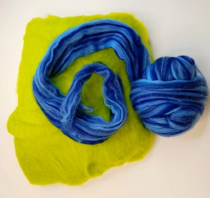

You will need about 20-30 grams of coloured wool of your choice. This is for the fairy’s dress and her hat.
And 15 grams of skin colour wool for the body parts. I am using a light-coloured skin tone wool. The reason for this is, that the makeup that is applied to the fairy’s face does not show on dark wool. Freckles or rosy checks will not be visible on dark wool.
Merino wool is widely available online, but make sure you have the right micron count when you buy it. Micron is the name of the measurement for wool. The lower the number the softer the wool. Throughout the course I use a18 Micron Merino Wool. Other wools will give you a very hairy face and body parts. If you can at all stick to the 18-20 micron or lower.
Can be bought in a felting supply shop. Full list at the end.

If you have a batting or a roving fleece makes no difference. If you do not know the difference in the two, then I would recommend watching the free course "introduction to wet felting". Available here: https://courses.feltfairies.com/
- Core Wool
Not a necessity, but handy if you got it. Core wool is rough wool that is used for stuffing.
It is much cheaper than merino wool and saves money if you plan to make lots of fairies.
You will need 10 grams of core wool for one fairy. Otherwise just order more of the skin-coloured merino wool if you do not want the core wool. This wool will not be visible, so you may have something similar already. But make sure it is pure wool. Any synthetic wool or even a mixture will not felt.
The picture below shows you the difference in the wool micron .
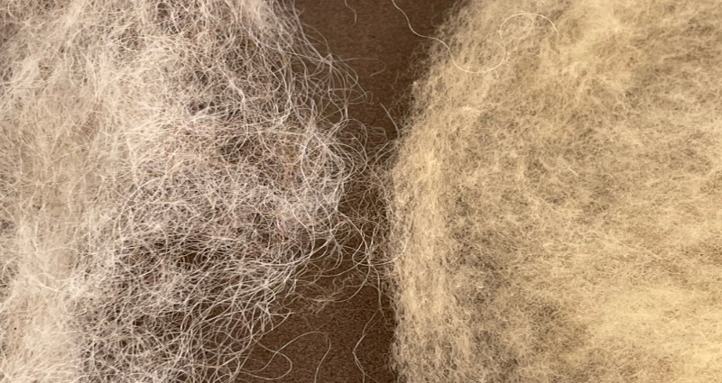
Left is a micron count of ca. 27 or higher. The right wool is merino wool with a micron of 18.
Just to make you aware of the difference. You could use the wool on the left as your core wool.
Can be bought in a felting supply shop
- Silk or Viscose 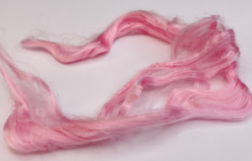
Silks or Viscose make a lovely pattern into felt. You need very little of silk /viscose. Only by the minimum amount. It often comes in bags of 25-50 grams. If you can, buy mixed colours as it will go a long way. Viscose or bamboo fibre is a cheaper alternative to silk.
Can be bought in a felting supply shop
- Locks of Wool 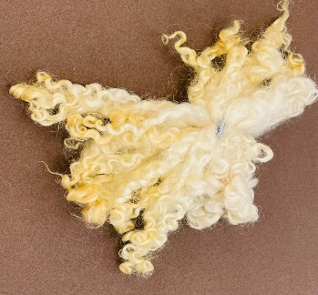
Locks of wool are curly sheep wool. This is a different product and not suitable for wet felting as such. This wool is very coarse and of course curly. Perfect for fairy’s hair. Look out for locks from the Wensleydale sheep, Teeswater sheep and the Valais black nose sheep. There are others too of course but to mention a few. The colour of this wool is mostly white. But you can buy id dyed in many shades. You need about 15-20 grams per fairy.
Best shop for locks is Etsy.com

- Fine Felting Needles 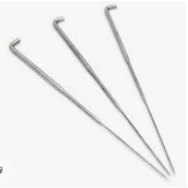
Felting needles come in grades of 32-42 gauge. The higher the number the finer the needle. You will need fine needles. Depending on the shop they either sell it in gauge measurement or fine, medium, or heavy. Felting needles break easy. Buy at least 3 – 5 felting needles
For example: 32 Gauge Heavy
38 Gauge Medium
42 Gauge Fine
Can be bought in a felting supply shop

- Water Sprinkler (Can be as simple as a jug or mug) 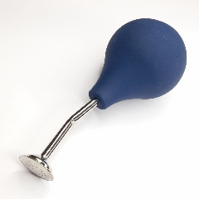
Can be bought in a felting supply shop or garden supplies.
- Pliers 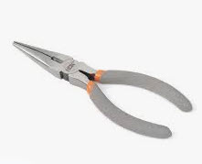 DIY Shops

- Awl 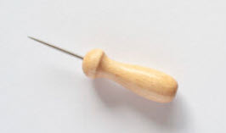 Online craft supplies. ( Rayher)

- 3 mm black beads

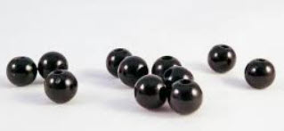 Online craft supplies.

- Florist bind wire paper covered

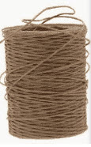 You need very little of this 15 cm is enough. You will get some at a florist shop.

- 6 Pipe cleaners white (minimum) buy proper pipe cleaners for smoking pipes.

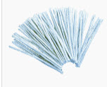 Tabaco Shops

- Felting Math 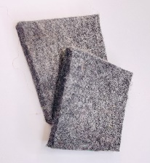 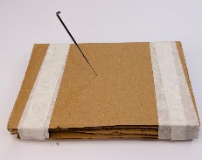

Good thing to have, or you can make your own with a few layers of cardboard or something else that is soft like a sponge.

- Fimo or polymer clay 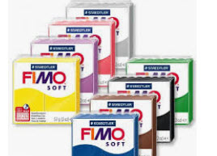For the shoes for fairy.
Craft shops

- Bigger awl or thick knitting needle. 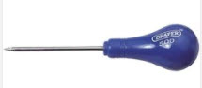
DIY Shops

- Foam board or other strong plastic (Milk bottles or cartons)

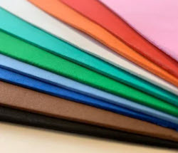 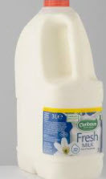This is needed for the resist. I use foam board, but you can make resist from empty cardboard bottles or plastic milk cartons too.
Stationary or craft shops

- Tulle 20 cm x 40cm
Fabric shops

- Pins
Fabric shops

- Measuring Tape
Fabric shops

- Scissors
Fabric shops

- Strong Glue
DIY Shops

- Really strong Thread ( Guetermann 100% polyester skin colour) or fine Fishing line
Fabric shops

- Normal sewing thread (one skin colour and other colour of your choice)
Fabric shops

- Fine sewing needle
Fabric shops

- Bubble wrap A4 size or bigger
DIY Shops and others

- 2 Non-slip maths A4 or bigger or net curtain.
DIY Shops and others like household shops

- 2 basins or bowls to hold water
DIY Shops and others like household shops

- Soap bar (no particular brand)

- Watercolour pencils

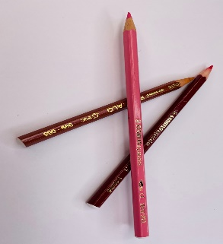

They are great for drawing smaller details like freckles and eyebrows on fairy’s face.
Buy red and brown. Available in art supplies.
- Makeup (blusher or other makeup powder in red) or crayons. 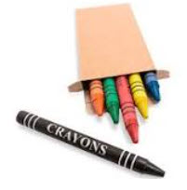

- Vinegar (any brand but clear)

The Following is optional

- Pretty ribbons

- Feathers

Suppliers:
If you know off any other suppliers and I know there must be more, please let me know.

Ireland
https://feltfairies.com/craft-supplies/

England
https://www.worldofwool.co.uk/ ( Not supplying EU countries at present, subject to change)
https://www.gilliangladrag.co.uk/collections/frontpage

USA/CANADA
https://artgusstudio.com/
https://mohairandmore.com/
https://feltingsupplies.livingfelt.com/

Australia
https://www.unicornfibres.com.au/wool-tops-roving/

Russia
https://www.livemaster.com/item/21478783-wool-merino-18-micron-ireland-50-gr

Germany
https://www.wollknoll.eu/shop/wool-891/coloured-wool-in-tops-903/

Italy
https://www.dhgshop.it/item-fibers-tops-slivers-16-merino-wool_0_0_1_1_7.php

Etsy is a good craft supply too. There are lots of small sellers on the platform. Especially for wool locks.
https://www.etsy.com/ie/search?q=teeswater%20locks

Buttinette and Rayher are German crafty supplies. But the website translates to English or other languages too.
https://www.buttinette.com/
https://www.rayher.com/de/

