Concessions
❓What is it❓
It’s a strategic discussion of the main objection to the author’s argument. Writers intentionally include such commentary to disarm the naysayers.

❓Why is concession great for the SAT essay❓
It’s a strong rhetorical device that requires a certain level of mastery to spot and write about. If done correctly, writing about a concession can help you get a higher point on analysis.

❗️Spelling Alert❗️
If you are going to be writing about concessions to appear clever and educated, make sure you spell the word concession correctly. There is a “CESS” embedded in the word conCESSion.

Concession can have THREE different effects in non-fiction writing:
ONE: address objections
TWO: answer objections persuasively
THREE: pave the way for the author’s argument by clearing objections.

Concession helps the WRITER to
- appear more knowledgeable about the issue
- present as someone who has considered the “other side”
- quell the doubts and objections of the reader
- make the reader feel heard

Concession helps the ARGUMENT to
- seem well - rounded
- appear well considered
- address both sides and look more researched
- appeal even to radical opponents

Concession helps the READER to
- feel heard and understood
- weaken the resistance/assuage their opposition
- be willing to hear what the author has to say
- trust the author as he/she did the research on objections

Here is an example from the official SAT Essay (Test 5) prompt:

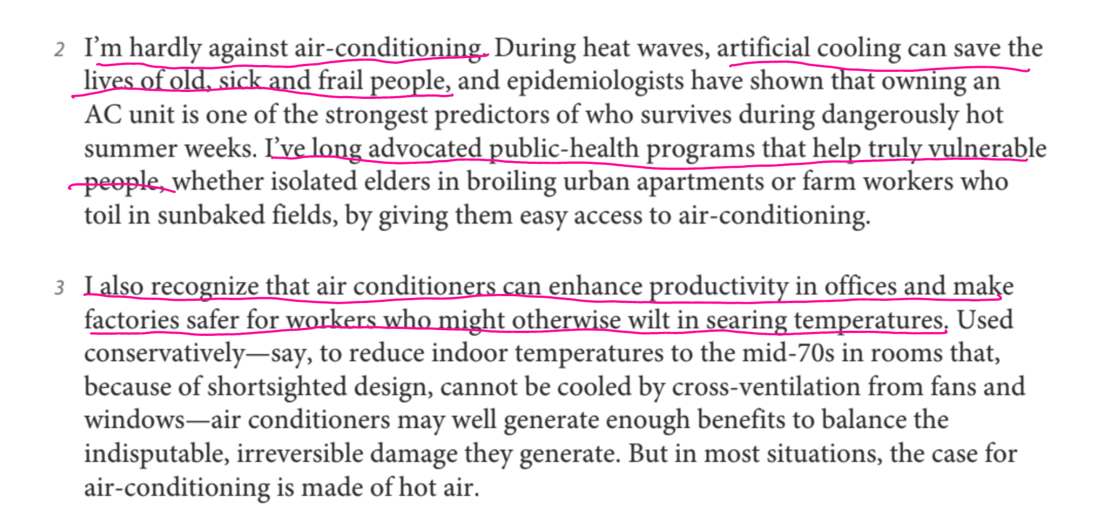

I: Since Eric Klienenberg urges people to cut down on using their well-liked ACs, he must concede to avoid altogether losing the interest of his audience.

Q: He says, “I’m hardly against air - conditioning.” This sentence helps him establish common ground with the majority of his readers. He adds that “ artificial cooling can save lives” as well as “enhances productivity in offices and factories.”

W: Eric Klinenberg concedes that air - conditioning can play a critical role in people’s lives, but he maintains that the use of AC by the masses must be reduced. That way, the author can carve his way past a significant objection to his proposal. In doing so, he frames the argument differently. It is now coming from someone who also enjoys the cool air that ACs generate.

A: As a result, the argument transcends the objections and doubts that many readers may have and becomes more persuasive.

R: Readers feel “heard” and weaken their resistance to the argument. Therefore, readers can now tune into the author’s reasoning instead of getting bogged down in their self-monologues.

