Major Chords

C major
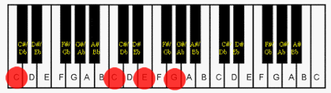

D major
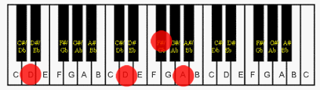

E major
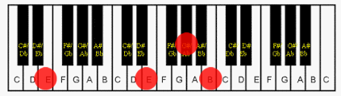

F major
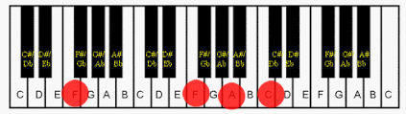

F# major
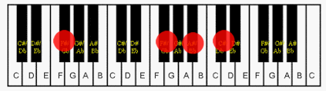

G major
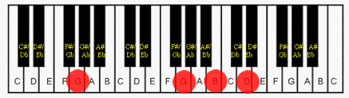

A major
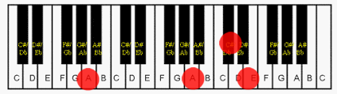

Bb major
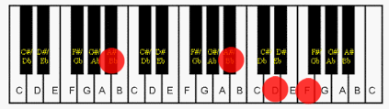

B major
