Abstract Sculptural Forms

Essential Question How do you translate a flat, two-dimensional (2-D) drawing into a three-dimensional (3-D) work of art?
Grade 3rd

Time 50 minutes

Art Concepts Shape, form, abstract, drawing, balance, sculptural tension

Materials Scissors, glue, white paper, cardboard (base), construction paper in various colors

Artwork in Focus Sculpture Study, 1949 by Theodore Roszak

Talking about Art Take a close look at Theodore Roszak’s Sculpture Study. What types of shapes do you see? Can you identify any animals or objects? Does the drawing remind you of anything? If it were transformed into a sculpture, what do you think it would be made out of?

Roszak was born in Poznan, Poland, in 1907. In the 1930s, he worked out of a small studio on Staten Island in New York, making paintings, sculptures, and drawings. At first, he experimented with photographing his work, himself, and models in plaster, a series of freestanding and relief sculptures. Roszak was one of the first artists in his generation to use welded metal as a medium for sculpture.

Drawing was an important part of Roszak’s art-making practice. He discovered that the most important aspect of drawing is what is suggested in the background; often, the next sculpture emerges out of that drawing. Shapes that emerge in the background suggest abstract shapes—that is, shapes that do not match anything in the real world. For Roszak, this method served as a means of releasing any number of ideas that could not be so readily recorded in any other media like sculpture.

Inspired by Roszak’s Sculpture Study, you will create a three-dimensional abstract form using colored construction paper. As you begin to imagine what this sculpture will look like, think about the colors you will use to create it. Will the form stand on its own, or be suspended from a building, a roof, or other structure? A successful sculpture has balance, or a sense of being equally weighted across the space the sculpture occupies. But a sculpture also has strong visual interest when it has sculptural tension, or a feeling that it might move—take flight, fall over, roll.
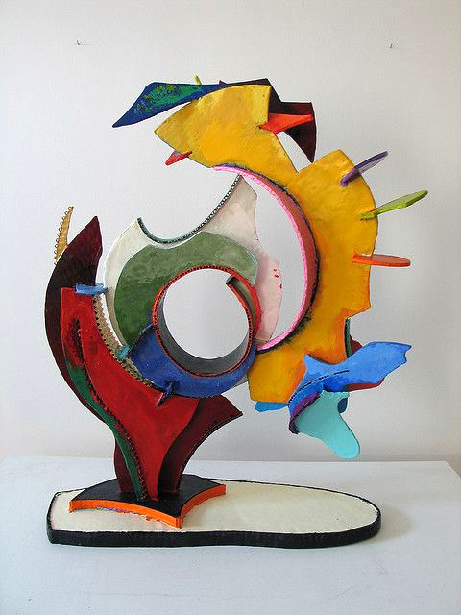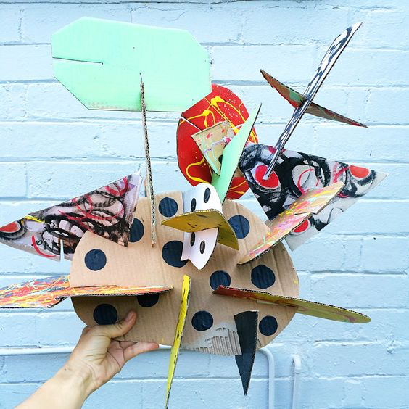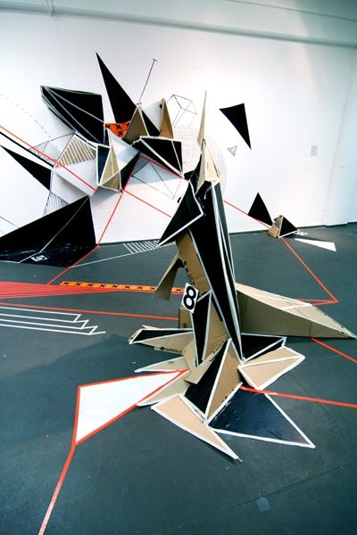

Making Art For this activity, you are going to make a small paper sculpture inspired by Roszak’s Sculptural Study. Before you begin to sculpt with your paper, consider what the form will look like and what color/s you will use to shape it.

- Begin by drawing an abstract form on a sheet of white paper. Make lots of shapes. Let them overlap or share sides.
- Add shading to your drawing and think about the shapes you drew as if they could grow up from the paper into 3-D forms.
- Now, cut different-size shapes out of colored construction paper. The shapes you cut will depend on what you want your form to look like. Let your drawing be your inspiration for the kinds of shapes you cut. Make them big shapes so you can fold them into smaller shapes.
- Fold, wrap, and wrinkle your shapes as you start putting them together. Again, let them overlap and share sides. Let them go through one another, arch over one another. Experiment!
- Once you have a sculpture you like, glue the shapes together and to the paper.

Reflection What does your sculpture look like? How did you decide on the form you wanted? What was your source of inspiration?

What colors did you use? Why did you choose those colors? If you could build your sculpture using another material, what would you use?

Where would you display this form?

Curriculum Connections California Arts Standards for Public Schools—Visual Arts

3.Va:Cr1.1: Elaborate on an imaginative idea. 3.Va:Cr1.2: Apply knowledge of available resources, tools, and technologies to investigate personal ideas through the art-making process.

Prepared by Wenceslao Quiroz with the Los Angeles County Museum of Art (LACMA) Education Department

