- PRE-LISTENING: Let’s look at vocab and expressions from the song.
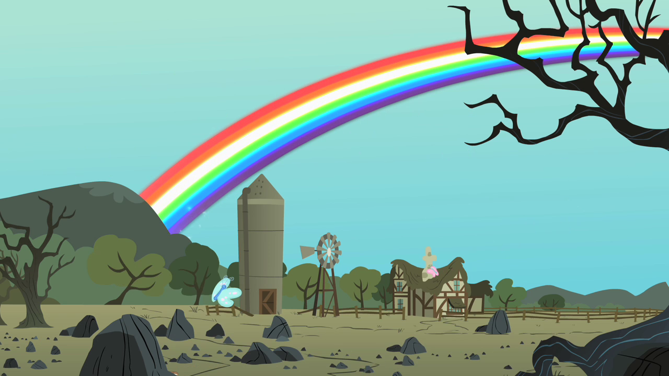
C

E
B

F
A
GA

D

Label the Photo: Write the correct letter from the picture next to the word.

_____ chimney _____ bluebird

_____ rainbow _____ over

_____ trees _____ clouds

_____ sky

PRONUNCIATION TRICKS: Look at the following pronunciation and listen to the teacher pronounce the expressions. Write the words.

- /tha-chu | dree-muhv/
- /that-swear | ih-tiz/
- /wi-sha-po-na-star/
- /wai-can-tai/
- /way-cup/
- /mel-tslike | lem’n-drops/
- /ai-think-t’mai-self/

- LISTENING: Listen to the song as many times as necessary to complete the exercise.
Somewhere over the rainbow, way up high
And the dreams that you dream of,
once in 1_____________.
Listen to the song. Use these words to fill in the blanks in the song.

Word bank:

- that you
- wish upon
- you’ll find me
- that’s where
- shaking hands
- a lullaby
- they’ll learn
- chimney top
- red roses
- wonderful world
- far behind
- wake up
- I like the
- so pretty
- can’t I
Somewhere over the rainbow, bluebirds fly
And the dreams 2____________ dream of,
dreams really do come true
Someday I'll 3________________ a star
Wake up where the clouds are far behind me.
Where trouble melts like lemon drops,
High above the chimney top,
4_______________ you'll find me.
Somewhere over the rainbow, bluebirds fly
And the dream that you dare to
Why, oh why 5 _________?
Well, I see trees of green and 9 ____________ too
I'll watch them bloom for me and you
And I think to myself
What a 10 __________________

Well, I see skies of blue and I see clouds of white
And the brightness of day, 11 _________ dark
And I think to myself what a wonderful world

The colors of the rainbow 12 _________ in the sky
And also on the faces of people passing by
I see friends 13 ________________ saying
‘How do you do?’
They're really saying I, ‘I love you’

I hear babies cry and I watch them grow
14 ______________ much more than we'll know
And I think to myself what a wonderful world
Someday I wish upon a star
Wake up where the clouds are 15 ____________ me
Where trouble melts like lemon drops
High above the chimney top
That's where 16 _______________
Version:
Israel Kamakawiwoʻole

Oh, somewhere over the rainbow
Way up high
And the dreams that you dare to
Why oh, why can't I?

Ooh, ooh
Ooh, ooh

- POST-LISTENING: Reflect on the song
1. How does this song make you feel?
(Ex. “This song makes me feel positive about life.”)
This song makes me | adjective
This song makes me feel | adjective | because…
This song doesn’t make me feel anything.
_________________________________________________________________
- Match the words below with the meaning.

  - Lemon drops 1. Problem
  - Trouble 2. When a flower opens
  - Wake up 3. Get up
  - Lullaby 4. Candy
  - Behind 5. A greeting
  - Bloom 6. A song to help babies sleep
  - How do you do? 7. In back

