Swim Faster & Stronger
We will have our Badu Jet Inspiration water current system installed by mid October for our Stroke Lab.
This will turn our ordinary pool water into an invigorating current; great for exercise and stroke analysis.
Our Badu Swim Jet System will allow you to burn calories, strengthen muscles and soothe body aches by swimming against a gentle or increasingly insistent current.
You will have no impact aquatic exercise while controlling the degree of workout you want.
This swim jet current system allows you to swim in place, ideal for stroke correction and analysis. We are using the Coach's Eye swim stroke analysis software and will be able to provide video feedback with coaching.
Check out the Badu Jet Video below.
https://youtu.be/nFQlazCsPBY
Masters Swim Club

Ages 5+ through adults are welcome to participate. Students must be able to swim the Freestyle and Backstroke well.

Our US Masters Certified Swim Coach will supervise the stroke workshops and stroke development classes.
We utilize the Badu Jet current system for swim conditioning and stroke analysis. We guarantee you will swim faster or we will return your workshop fees.

Swimmers can have training customized for open water and pool events. 60 min Badu Jet pool training sessions.

Max Class Size: 2
$25 per session

Call or email to schedule training.

(Masters Swim Video)
<iframe width="420" height="315" src="// www.youtube.com/embed/SbZJNvhjC-g " frameborder="0" allowfullscreen></iframe>

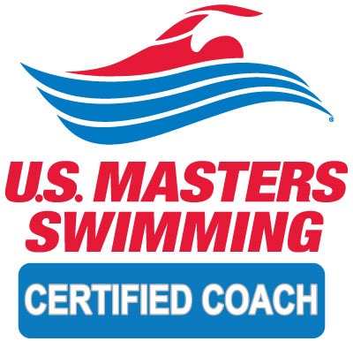

Swim for Fun & Fitness
You can reserve the Badu Jet Water current lane for private swim training at $15 per 30 min session without a coach or $35 with private coaching.
Call or email for available times.
Stroke Analysis Video & Coaching
Using underwater videographer and swim stroke software. We will send you a file highlighting your swim with coaching voiceover.
$20 per session

