Day 3 Workout
EXERCISE | REPS | SETS | REST
A1. Side Walking Plie Squats  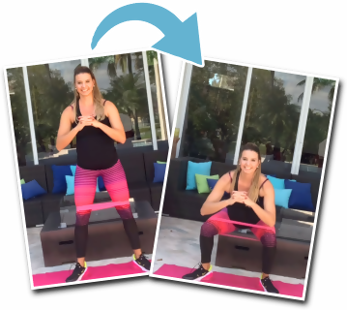 | 10 per side (20 total) | 2-3 | 0
A2. Bent Knee Bank Hip Extension  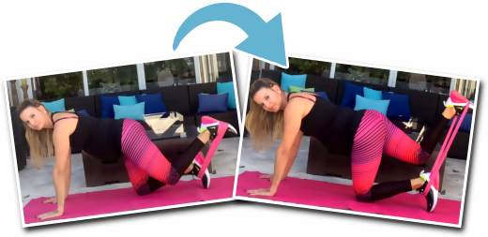 | 20 | 2-3 | 0
A3. Side Lying Side Band Abductions  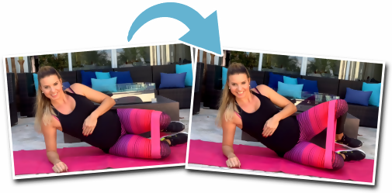 | 20 per side and 20 pulses per side | 2-3 | 0
A4. Flutters  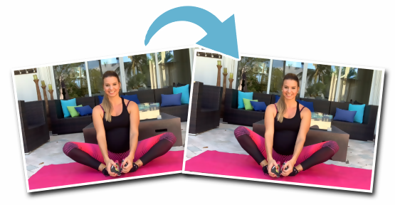 | Alternate Flutters 5 seconds with Hold down 5 seconds | 2-3 | 60-90 Seconds

