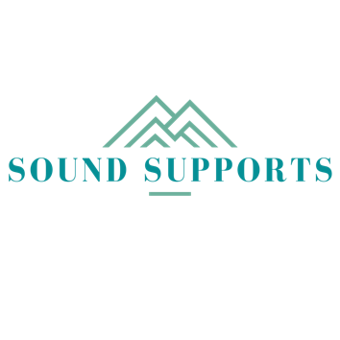

Shoreline Public Schools Professional Development Modules
Supporting Student Learning, Engagement and Well-Being: Implementing Efficient, Effective Tiered Systems of Supports in Secondary Schools (MTSS/PBIS)
Part 1

Instructor: Bridget Walker, PhD bridget@soundsupportsk12.com

Please use these guiding questions as well as the graphic organizer to capture your learning and ideas.

Section 1 Guiding Questions: What is MTSS/PBIS

- Did you recognize some of the work done by your district and school so far?

- What new learning did you gain about these systems and frameworks?

- Do you see relevance of this approach to the development of your school, department and the district? How might you move some of this work forward within your own sphere of influence?

Section 1 Guiding Questions: Building Clear, Shared Expectations

- What new learning or understanding about the importance of clear, concrete expectations emerged for you?

- At what level is your school currently implementing these key practices?

- Do you see ways these practices could be further developed in your school, department and classroom to support the success of EVERY learner in your school and classroom? How might you move some of this work forward within your own sphere of influence?

