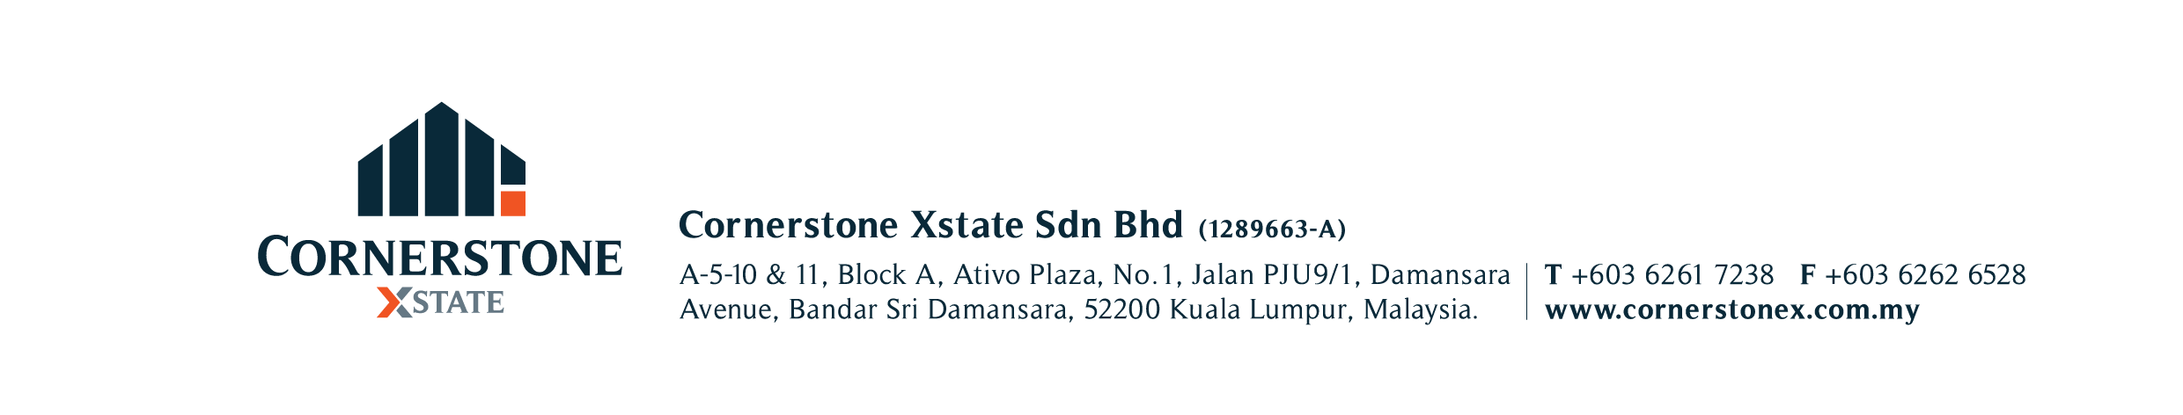

**AGREEMENT TO PURCHASE**  **CSX-P**

PROPERTY ADDRESS :

Type of Property:

1. PURCHASE PRICE : RM (Ringgit Malaysia Only).
2. PAYMENT TERMS : Payment of the Purchase Price shall be made in the following manner: -

(a) Earnest Deposit : RM ( %) payable on signing of this Agreement.

(b) Balance Deposit : RM ( %) payable on signing of the formal Sale & Purchase Agreement (“SPA”).

(c) Balance Purchase : RM ( %) to be paid within ( ) days (“Completion Period”) from

Price

i) The date of SPA *or*

ii) Date of receipt of the relevant consent from the Statutory Body / Developer’s Consent / Developer’s Confirmation / FIC / State Authorities / Extract of LA / Extract of Grant / Extract of the court order for sale, whichever is applicable and later.

(d) Extension : Upon expiry of the Completion Period, an extension of ( ) days will be granted automatically subject to

payment of interest at ( %) per annum calculated on a daily basis on the Balance Purchase Price or any part thereof still outstanding.

1. DELIVERY OF : i) Vacant Possession to be given upon full settlement.

POSSESSION ii) No Vacant Possession to be delivered as the Purchaser shall take over existing tenancy upon full settlement of balance

Purchase Price.

1. EXECUTION OF SPA : (a) Within ( ) working days (“said Period”) from the date of acceptance of this  
    Agreement by the Vendor, the Purchaser shall execute the SPA (provided that there is no delay or fault on the   
    part of the Vendor or Vendor’s lawyer in agreeing to the terms and conditions of SPA), failing which the said   
    Earnest Deposit shall be forfeited. Thereafter this Agreement shall be terminated and be null and void and  
    neither party shall have any right over the other party.

(b) In the event the Vendor fails to execute the SPA within the said Period, the Purchaser shall be entitled to the relief of Specific Performance. Alternatively, the Purchaser may elect for a full refund of the Earnest Deposit together with a sum equivalent to the Earnest Deposit paid to him by the Vendor as damages. Thereafter this Agreement shall be terminated and be null and void and neither party shall have any right over the other party thereafter.

1. SPECIAL CONDITIONS:

1. VENDOR’S : The Vendor hereby declares that he/she/they is/are the registered/beneficial owner(s) of the property and not bankrupts. DECLARATION

7. EFFECTIVE DATE : Notwithstanding the payment and clearance of the cheque for the Earnest Deposit, this Agreement to Purchase   
 shall only be effective from the time that this Agreement is duly signed by the Vendor and the Purchaser.

The Purchaser enclosed herewith the sum of RM ­ (Cash/Cheque No. ) payable to **CORNERSTONE XSTATE** **SDN BHD** as stakeholder/ being the Earnest Deposit towards the purchase of the said Property. In the event the Vendor rejects this offer, the Earnest Deposit shall be refunded to the Purchaser free of interest.

PURCHASER’S SIGNATURE: ) SIGNED IN THE PRESENCE OF:

NAME : )

NRIC NO. : )

ADDRESS : ) NAME :

) NRIC NO.:

EMAIL : ) DATE :

VENDOR’S SIGNATURE: ) SIGNED IN THE PRESENCE OF:

NAME : )

NRIC NO. : )

ADDRESS : ) NAME :

) NRIC NO. :

EMAIL : ) DATE :

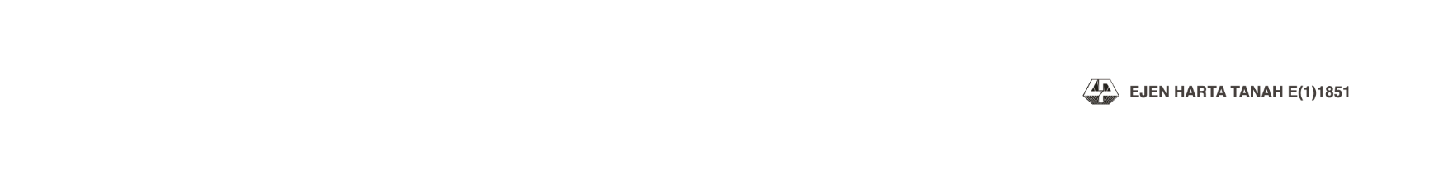NB: ALL PRACTICES WILL BE IN ACCORDANCE TO THE VALUERS, APPRAISERS AND ESTATE AGENTS (AMENDMENT) RULES 20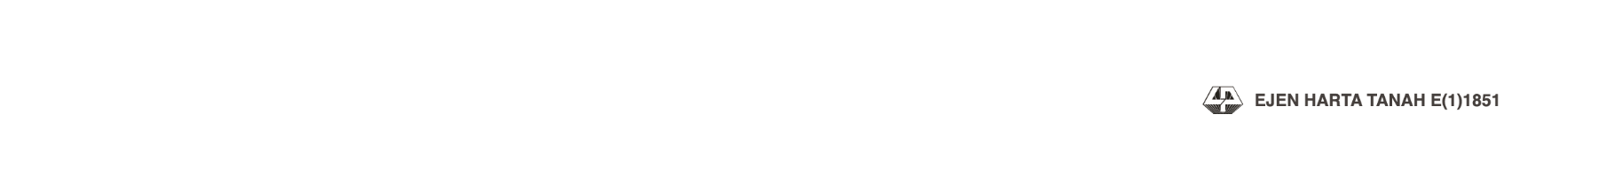02.