Day 3 Workout
EXERCISE | REPS | SETS | REST
A1. Reverse Lunges with Kick  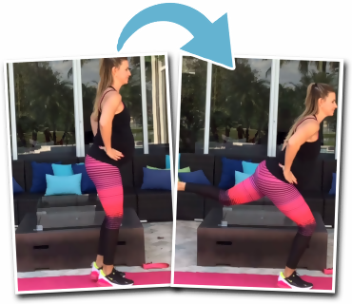 | 20 per side | 2-3 | 0
A2. Butterfly Hip Extensions  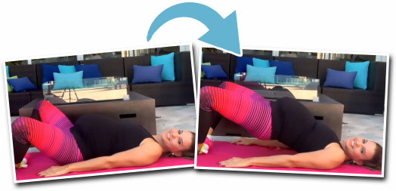 | 20 + 20 pulses | 2-3 | 0
A3. Standing Band Abductions  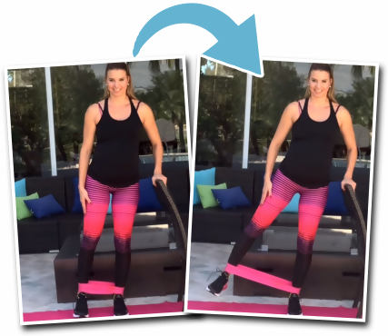 | 20 | 2-3 | 0
A4. Deep Squat Hold  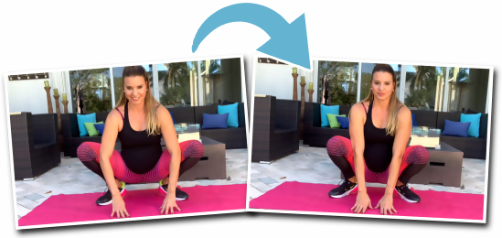 | Stretch -Breathe (Inhale 6 seconds & hold the deep squat position & Exhale 6 seconds while pushing your knees out with your elbows - do this for about 1 minute) | 2-3 | 60-90 Seconds

