Worker Cooperative Development Frameworks
Self-Assessment

Introduction
Worker Cooperative Development can mean different things to different people, encompassing a broad range of activities, and also a range of philosophies and underlying principles. This self-assessment tool helps worker cooperative developers clarify their model, and its assumptions, and consider whether they are organized in a way to achieve the impacts they desire.

A spectrum of low- to high-touch relationships
All worker cooperative developers invest staff time to support the cooperatives they are working with. What we will call a ‘low touch’ developer plays the role of coach to the business and its members, guiding and encouraging them to build a cooperative for themselves. The developer's primary investment at this end of the range is time. ‘High touch’ developers, on the other end of the range, may invest financial capital in the business to buy equipment or property or provide working capital for the startup period. In addition, high touch developers also play a role in the management and/or governance of the startup cooperative. In general they take on greater risk.

For each area of development activity, you’ll be asked to assess your work, or work plan, on a spectrum from low- to high-touch, and then to describe the activities you have in mind. There are no wrong answers.

?
?

Low touch High touch

Three major areas of activity
Worker cooperative development can be broken down into three major areas of activity. All three areas are essential for creating a worker cooperative economy, though each developer's model will focus on the areas differently. This self-assessment looks at each area, and focuses in on question for each. The areas are:

- Developing the cooperative capacity of members to run their businesses together
- Developing strong and viable businesses
- Developing an ecosystem that helps cooperative businesses thrive

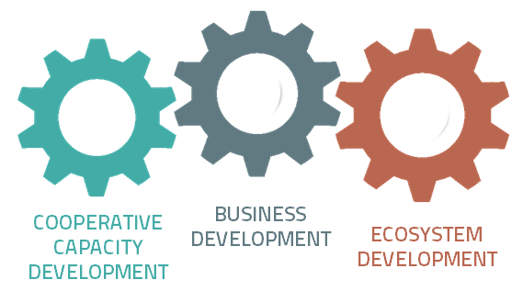
Cooperative Capacity Development
Cooperative capacity development is the work of building cooperative ownership and democratic decision-making structures, and developing cooperative members’ capacity to use these structures to run their business together. This area of activity includes setting up governance, legal, and financial structures to serve the needs of the members. More importantly, it trains members of the cooperative to understand these structures and empowers to use or alter them together.
1
MEMBERSHIP
A low touch developer in this area might help a group of friends become a steering committee.
A high touch developer might hire a group of strangers and train them to work together.

Mark where you see yourself you on the low- to high-touch spectrum in this area

Low High
Describe your development activities in this area:

2
GOVERNANCE
A low touch developer in this area might offer examples of bylaws and train members to serve on the Board.
A high touch developer might write the bylaws, incorporate the cooperative, and serve on the first Board.

Mark where you see yourself you on the low- to high-touch spectrum in this area

Low High
Describe your development activities in this area:

3
TRAINING
A low touch developer in this area might train members in group process and decision-making.
A high touch developer might train members in industry specific skills, business skills, and cooperative skills.

Mark where you see yourself you on the low- to high-touch spectrum in this area

Low High
Describe your development activities in this area:

Business Development
Business development is the work of building successful, strategic, high-functioning businesses. These businesses respond to a clear market need, have adequate capital investment, and operate profitably. Worker cooperatives can meet a human need for high-quality, skill-building, stable jobs, and without success in this area the benefits of cooperative capacity will not last long.
6
4
5
BUSINESS PLAN
A low touch developer in this area might coach members to develop their passion into a business plan.
A high touch developer might research and write a business plan for a target industry.

Mark where you see yourself you on the low- to high-touch spectrum in this area

Low High
Describe your development activities in this area:

FINANCIAL INVESTMENT
A low touch developer in this area might introduce members to lenders.
A high touch developer might raise money and hold an equity share.

Mark where you see yourself you on the low- to high-touch spectrum in this area

Low High
Describe your development activities in this area:

MANAGEMENT
A low touch developer in this area might offer some businesses services as an outside consultant.
A high touch developer might staff a management position in the cooperative during the startup phase.

Mark where you see yourself you on the low- to high-touch spectrum in this area

Low High
Describe your development activities in this area:

Ecosystem Development
Ecosystem development is the work to create conditions of support for the cooperative business. For an individual business, this means finding or creating good customers, suppliers, workers, and sources of capital. Ecosystem developers build strategic relationships to increase all of these. For a community, a regional economy, or an industry's supply chain, this means building community support and a favorable environment. It could encompass policy work, public relations, and movement-building.
7
RELATIONSHIP
A low touch developer in this area might have little relationship to the cooperative after launch.
A high touch developer might have a long-term contract of association built in to the relationship.

Mark where you see yourself you on the low- to high-touch spectrum in this area

Low High
Describe your development activities in this area:

8
POLICY ADVOCACY
A low touch developer in this area might raise public awareness about the benefits of worker cooperatives.
A high touch developer might establish targeted partnerships with industry and government.

Mark where you see yourself you on the low- to high-touch spectrum in this area

Low High
Describe your development activities in this area:

9
MARKET ACCESS
A low touch developer in this area might promote worker cooperatives as preferred suppliers.
A high touch developer might contract with anchor institutions to guarantee a customer base for the cooperative.

Mark where you see yourself you on the low- to high-touch spectrum in this area

Low High
Describe your development activities in this area:

