Dating and Relationships 101:
90 Days To Find Love
Tips - Tools - Inspiration
Interactive Workbook

Created by Jacqueline Nichols

Created by Jacqueline Nichols, Author https://www.jacquelinenichols.com/ https://discoverlovematches.com/ All Rights Reserved. Not For Duplication
Welcome to our amazing daily guidance!
Congratulations on moving forward and taking steps to better understand your personal dating journey. Making time to work through our 90 days of tips, tools, inspiration, challenges and ideas will guide you to success on your love journey. This workbook will give you clarity and direction to understand how you are showing up for dating and relationship opportunities.
It can be tough to keep engaged and motivated so we applaud you for taking the steps to be proactive in your love journey. The more engaged you are in the daily process the greater chances you spark someone's interest!

Let's make the next 90 days an exciting and powerful life changing adventure on your journey to finding love, enjoying love and keeping love! Consistency works best with our workbook. Work the challenges Monday through Friday and take the weekends to catch up, if needed. Allow yourself to work at your own pace.

The steps of this workbook will give you the tools to dig deep within yourself on your search for answers. Allow yourself to truly feel and explore all the insights and emotions that come to the surface as you discover clarity.
When you invest in your own personal journey, you will show up more available and ready for the loving relationship you desire.
Believing in you,

Each day we have new tips, inspirations, challenges and ideas to keep you focused on your journey. We believe in consistency and commitment to attract the love you desire.We celebrate you for showing and investing in what matters most to you!

The more engaged you are in the daily process, stronger the chance of moving closer toward love!

Let's make the next 90 days an exciting and powerful life changing adventure on your journey to finding love, enjoying love and keeping love!

Welcome to your first day of a life changing love journey over the following 90 days.

1st day! DATE: ______________________

Today is the start of a truly new relationship, first with yourself, as you become more clear on this new chapter in your life.

Challenge: Today write five things you have to offer someone when you are in a relationship.

1. ____________________________________________________________________________
2. ____________________________________________________________________________
3. ____________________________________________________________________________
4. ____________________________________________________________________________
5. ____________________________________________________________________________

Let's get some love coming your way.

Time for your 2nd day of receiving a message to keep you focused on your journey. We believe in consistency and commitment to attract the love you desire.

Day #2! DATE: ______________________
Today pick ONE thing new to do with your routine!

1. ____________________________________________________________________________

Changing your predictable patterns starts to open your ability to see more possibilities!

What do you feel you could add to your routine? Maybe take a walk during your lunch break or after dinner. How about making time to meditate? Or putting a little extra time into getting ready for the day so you feel amazing. What about ...?

Select something you want to weave into your daily routine and then applaud yourself as you do it. Even add a daily reminder timer to your phone so you don't forget. It takes time to make something a true routine!

We are cheering you every step of the way!

Day #3! DATE: ______________________
Make an image change for today!

1. ____________________________________________________________________________

Pick one thing you need to refresh your personal look. First impressions are powerful so take a moment to think about just one change you could do to spice your current overall look.

It's amazing how many times I hear people say how excited they are to go on a date for the first time and then the person arrives looking like they didn't really take the time to put themselves together.

I'm sure you look great when getting ready for a date but what is something you could do that would add a little extra? Maybe more color to the clothing choices you make, take time to shave with more detail, personalize your makeup look... the options are full and exciting when you take just a moment to change and refresh your image!

Get excited to discover what your ONE change is today! Have fun with it. Get excited to shake up your usual look to see if anyone noticed.
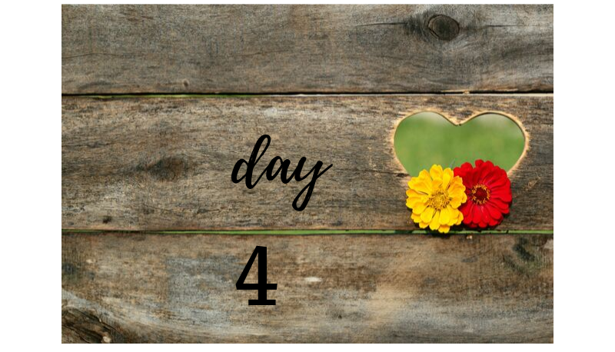

Day #4! DATE: ______________________

Smile! Today is your day to smile a little extra!

As you walk about during your day find three people to share your smile with. See if you get them to smile back.

No words need to be expressed. Just show another person they were noticed! Make their day and it makes your heart smile!

1. ____________________________________________________________________________
2. ____________________________________________________________________________
3. ____________________________________________________________________________

Especially nowadays sharing a true smile is more exciting than ever before. Everyone is looking down at their phone and not even noticing the people around them. When you look up and smile, you might just be pleasantly surprised who appears in your life. Could just be for a moment while you pass by each other or it might be for an unexpected conversation!

Look forward to learning about the THREE people you inspired to smile today!

Day #5! DATE: ______________________
Today is about Gratitude! To truly attract success you need to claim what you are grateful for.

List three things that you are grateful for today!
1.____________________________________________________________________________
2. ____________________________________________________________________________
3. ____________________________________________________________________________

Let yourself allow gratitude of abundance to make you an even more positive person on your love journey!

Think gratitude thoughts and your heart will start noticing more positive things to honor and celebrate. Fill your mind and heart with great words, ideas and optimistic possibilities for you to grow as you move closer toward finding love!

We are here to cheer and inspire you every step of the way!

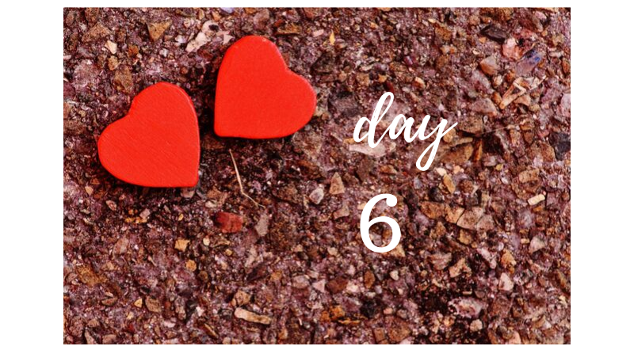

Day #6! DATE: ______________________

Congratulations for getting focused on your journey toward finding love!

Today is a day for research. Make a list of three upcoming events or activities you'd like to check out.

1. ____________________________________________________________________________
2. ____________________________________________________________________________
3. ____________________________________________________________________________

Find out what is going on in your community. Dig in and have fun searching. There are local activities in most any neighborhood or find out what is going on in cities near-by. Searching beyond your local area can expand your possibilities to meet someone new and exciting... or at least make new friends.

What are you looking for on your 7th day?!

Day #7! DATE: ______________________

It's a great day to start your list of what you are looking for in a new relationship.

Focus today on making a list of five personality traits you desire in someone special!

1. ____________________________________________________________________________
2. ____________________________________________________________________________
3. ____________________________________________________________________________
4. ____________________________________________________________________________
5. ____________________________________________________________________________

It's not about physical traits for today, it's about the character style that you are attracted to.

Taking time to really notice and recognize what you are looking for in a relationship will help you welcome someone wonderful when they arrive! People often say they will just "feel" it when the right person appears but sometimes we need to get our "wish list" refreshed in our minds.

Have fun reminding yourself what you desire! What you desire is out there in someone amazing!
For your 8th day you get to begin thinking about how to do things in a fresh new way!

Day #8! DATE: ______________________

Wow, it's a new day and the possibilities are endless! Today my challenge to you is to focus on something you want to do differently on your dating journey. Think about how this time is going to be different in your thoughts and actions.

1. ____________________________________________________________________________
2. ____________________________________________________________________________
3. ____________________________________________________________________________
4. ____________________________________________________________________________

Is it to stop looking for perfection? Or to be more flexible with your schedule?

What is the first change you want to make? Will you be more patient to grow and learn about someone new? How about starting fresh and letting go of past relationship distractions so you can have something new with someone new?

Stretch yourself to think about how this time it's going to be different for you to get better results as you open your heart to love!
For your 9th day it is now time to do fun things for eligible singles to meet you and for you to meet them!
Get ready for day #9! DATE: ______________________

Today you get to start putting the word out that you are single and available... without being too vulnerable! Before we had you look up events to attend. Now we want for you to look up events happening within the next three weeks that are likely to have eligible singles attending too.

Our goal for today is to start looking up events in your area that would be great to attend as a single person. Some cities have local community programs.

List three local singles events that caught your attention
1. ________________________________ Date: ____________________________
2. ________________________________ Date: ____________________________
3. ________________________________ Date: ____________________________

Get excited about all the possibilities to meet someone new! Even if you don't meet the person of your dreams you often can make great friendships. Other people that are single will give you even more ideas of fun ways to get out in your community.

We are here to cheer and inspire you every step of the way!
For your 10th day we are going to Shake It Up a little extra and explore new places! Make time for new experiences and you have a chance to be surprised by what is available.

Get ready for day #10! DATE: ______________________

Get ready for today! It's exploring time! Pick your exploring options based on how much free time you have today. If you have a free day go window shopping in a quaint town nearby and stop in the ice cream shop to meet the locals. If you just have a couple hours available go to the local bookstore and who knows who you might meet! Pick a new place for lunch or pop in somewhere new for happy hour after work. Check out the new coffee shop down the street. Always somewhere new to check out!

Where did you go? Talk with anyone new?
______________________________________________________________________________
______________________________________________________________________________

Exploring gives you opportunities to be in a new space and have reasons to ask questions. You just never know who you could meet or what you could learn when you try out new places that make you smile!

Stretch your comfort zone for possibilities to move forward on attracting wonderful people into your life!
TAKE MORE TIME TO WRITE AND REFLECT HERE:
These daily exercises can trigger lots of feelings and shifts in perspective. Give yourself time release and write down any additional details to keep in mind or even thoughts you want to visit later on your 90 day journey. This process is for you!
__________________________________________________________________________________________________________________________________________________________________________________________________________________________________________________________________________________________________________________________________________________________________________________________________________________________________________________________________________________________________________________________________________________________________________________________________________________________________________________________________________________________________________________________________________________________________________________________________________________________________________________________________________________________
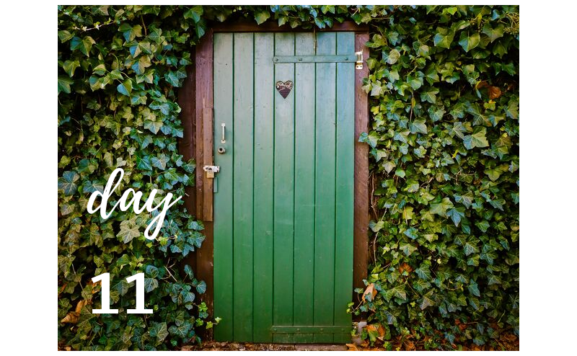
For your 11th day we are going to have you flip the mirror on yourself and see what you offer others. Time to stop, pause and notice your own qualities!.

Get ready for day #11! DATE: ______________________

Our focus for today is to grab time throughout the day to capture details about yourself! Be observant during your day to learn more about the qualities you can offer someone else.

List three details about yourself that someone new might notice right away:

1. ___________________________________________________________________________
2. ___________________________________________________________________________
3. ___________________________________________________________________________

Do you open the door for people? Are you kind to distracted people? Do you notice people that others might pass on by? Do you tip generously? Are you able to slow down and notice life around you or do you zoom through your day?

How do other people notice you?
_____________________________________________________________________________
______________________________________________________________________________
______________________________________________________________________________
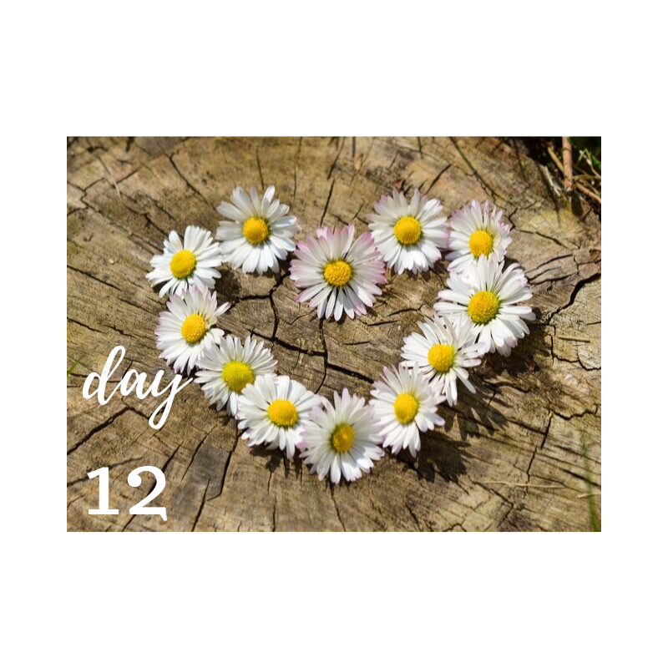

For your 12th day we are focusing on changing up your expected routine and seeing what you can bring new to your life!

Get ready for day #12! DATE: ______________________

Let's keep working on building new routines to your day and life! For today our challenge to you is to pick something new! Try a new coffee shop, listen to a new radio station, do a different workout routine at the gym, ask a new friend to lunch...

1. ____________________________________________________________________________

List your one new activity for today. We are often creatures of habit so shake up your path and try something new. You might be pleasantly surprised to find a new spot for your favorite cup of coffee or make a new friendship!

We are here to cheer and inspire you every step of the way!
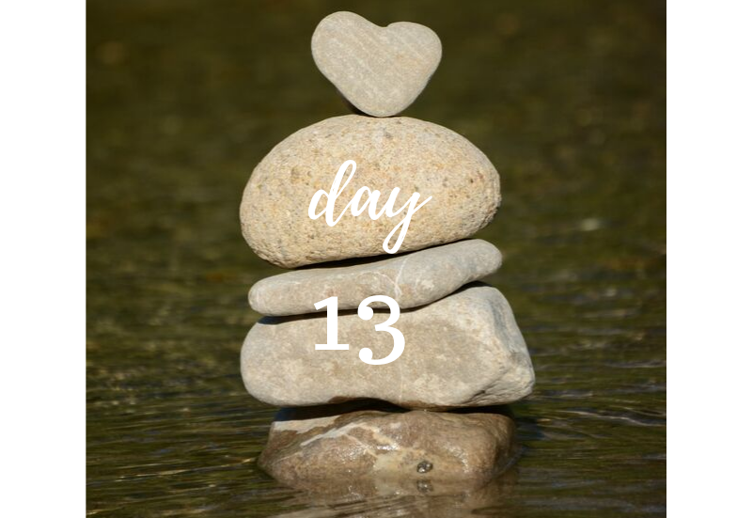

For your 13th day it's time for you to put yourself first! Think about a little extra generosity and give it to yourself. We give so much to others and now it's time to select something that adds a little extra smile to your amazing self.

Get ready for day #13! DATE: ______________________

It's a day for sprucing up your image! I want you to spoil yourself... just a little today! Go out and get yourself a treat! Nothing fancy but something that makes you look and feel a bit more confident. Maybe it's some fun socks or a new scarf! It's not about spending a bunch of money but a chance to say "hey I'm worth it!"

1. __________________________________________________________________________

Excited to see how a little treat for your image can give yourself an extra smile! Enjoy remembering you are worth it. I believe you are worth it. Hope you do too.
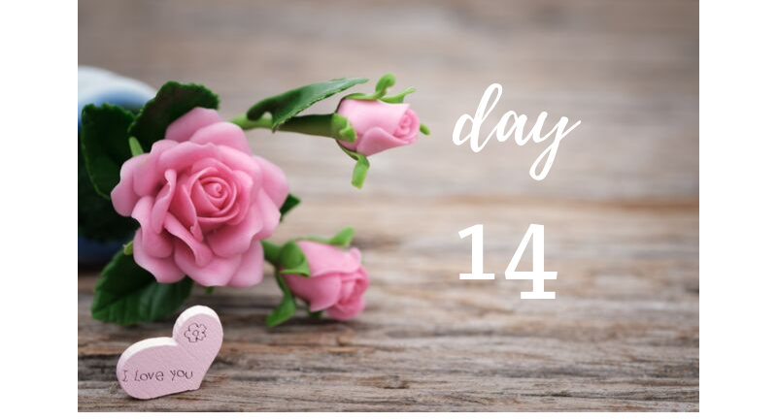
For your 14th day about flirting. Just a little extra eye contact and a soft smile can go a very long way. People want to know if you are noticing them. Look up, look right, look left... look around. Someone wonderful could be very close to you! Your efforts might just make their day. Let yourself enjoy a little flirting fun!

Get ready for day #14! DATE: ______________________

Today is your day to enjoy the fun of flirting again! Flirting is the power of capturing another person's attention to not miss you in a moment that could pass on by. If you have a date today what are you going to do to capture your flirting power? If you are free today, how are you going to send out a signal that you are ready to let your flirt shine on?

1. ___________________________________________________________________________

Write down one thing you did to capture a little extra flirt fun and attraction. Did you touch your dates arm in a kind way that let a spark happen? Did you laugh just a little louder in the grocery store to get someone's attention? Did you notice someone across the room and make eye contact with a smile? How about complimenting someone and seeing their eyes light up?

Have fun Flirting!

Discovering gratitude for your 15th day is powerful. Life can get overwhelming and finding love can feel impossible but when we pause for a moment each day and count our blessings we can refill our spirit. There are so many opportunities to gain a stronger perspective while counting our blessings with true gratitude.

Get ready for day #15! DATE: ______________________

Take a moment and write five things you are grateful for right when you read this message. Without even thinking about it for more than a moment what comes to mind that fills your heart with gratitude?

1. ____________________________________________________________________________
2. ____________________________________________________________________________
3. ____________________________________________________________________________
4. ____________________________________________________________________________
5. ____________________________________________________________________________

Becoming open and aware of what you are grateful for gives you an inner sense of peace as you open your heart to new experiences. Allow yourself to keep in a positive space on your journey.
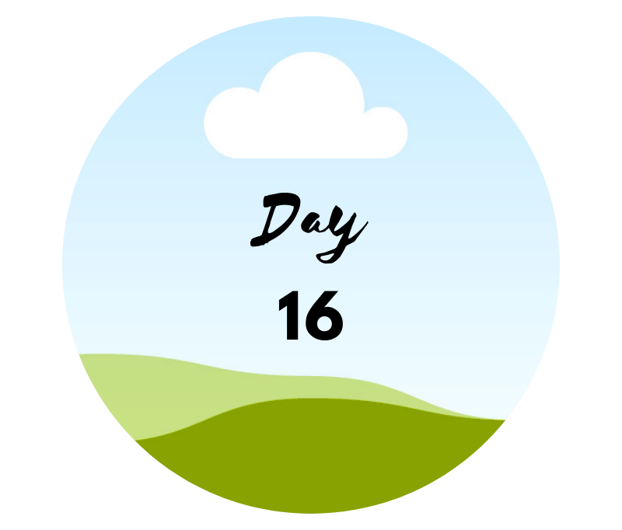
For your 16th day you are preparing for success with something to look forward to doing. Happy Hour is a great chance to enjoy small eats and try out a new place. Plus it's extra fun to go on your own and sit up at the bar to possibly meet someone new sitting on the stool next to you. Lots of people love grabbing a bite or drink after work and would enjoy a fresh conversation. You might just be amazed by who you could meet.

Get ready for day #16! DATE: ______________________

Our challenge for today is to research the best Happy Hour locations in town. There are lots of websites and books about Happy Hour in many communities. Know your options of places you might enjoy going to.

List three restaurants that have a Happy Hour menu you want to check out.

1. ____________________________________________________________________________
2. ____________________________________________________________________________
3. ____________________________________________________________________________
When a dating opportunity comes up you'll be able to have suggestions of places to go and you'll also be excited to check the new spot out! Or you might go with friends to pre-check it out!

For day 17 - gaining clarification in knowing what you desire in the person you are seeking helps fine tune your focus and strengthen your intentions. You will know when you are getting closer to discovering your mystery person, as you recognize traits you desire in someone you meet.

Get ready for day #17! DATE: ______________________
Today is about you! Let's work on your wish list for a relationship.

Think about what you want from the person you are seeking to be in a relationship with and to build a future together. Are looks important? How about personality traits? What about their height or weight? Is their activity level really important to you? Religious views? Living location? Kids or no kids... and so many more important possibilities.

List three details that are important to you when seeking someone new to be with:
1. ____________________________________________________________________________
2. ____________________________________________________________________________
3. ____________________________________________________________________________

For day 18 - This is about you! Today take a break from wondering "what if's" of love and dating! Today don't question your past! Today choose YOU! Yes, it's about YOU!

Get ready for day #18! DATE: ______________________

Today is about picking YOU FIRST! Let's just enjoy your AWESOMENESS for TODAY!

What do you enjoy about being YOU? Even if a past relationship didn't appreciate your late night cravings for cereal, your crazy need to wake up before the sunrises on the weekends or your unique sense of humor... who cares what they didn't appreciate... today is about loving YOU and all your glory! The past people you dated didn't know what they were missing... ! Yep, you are awesome!

List three traits that make YOU FANTASTIC - even if others don't see all your incredible qualities:
1. ____________________________________________________________________________
2. ____________________________________________________________________________
3. ____________________________________________________________________________
It's always so important to not ever lose your individual sense of self! There is someone out there that can and will appreciate all of you. Love being YOU!

For day 19 - Having future date ideas makes you more likely to move forward on your dating journey. When you bring suggestions to the conversation it shows your potential date that you are engaged in the process. It's so much more fun to be excited to go out and do something rather than just waiting for the other person to do all the planning. Be engaged in your dating success!

Get ready for day #19! DATE: ______________________

It's an adventure day! Let's get your creative mind going and start checking out great places to go on a date. Make it like a treasure hunt!

List 3 new spots you would love to check out for a date:
1. ____________________________________________________________________________
2. ____________________________________________________________________________
3. ____________________________________________________________________________

Maybe it's a pottery class, an amusement park, a wine tasting studio or...
Let the creative adventures begin and start exploring!

Get ready for day #20! DATE: ______________________

Today the inspiration is to come from within! I'd love to know you are taking some time out to write down your thoughts about what it will mean to be in a relationship. Think about your day and how it would have been enhanced with someone wonderful to share today with!

Write a few highlights of your day, if your mystery person had already arrived:
______________________________________________________________________________
______________________________________________________________________________
______________________________________________________________________________

Visualizing your life with someone wonderful is very exciting and truly important. Sometimes people forget to stimulate those feelings to keep the heart open for someone wonderful to share life with.

We are here to cheer and inspire you every step of the way!
TAKE MORE TIME TO WRITE AND REFLECT HERE:
These daily exercises can trigger lots of feelings and shifts in perspective. Give yourself time release and write down any additional details to keep in mind or even thoughts you want to visit later on your 90 day journey. This process is for you!
____________________________________________________________________________________________________________________________________________________________________________________________________________________________________________________________________________________________________________________________________________________________________________________________________________________________________________________________________________________________________________________________________________________________________________________________________________________________________________________________________________________________________________________________________________________________________________________________________________________________________________________________________________________________________________________________________________________________

Get ready for day #21! DATE: ______________________

When I think about our clients and all the wonderful traits they have to offer someone new I often wonder if they truly realize how great they are!

List three compliments you received that made you feel great.
1. ____________________________________________________________________________
2. ____________________________________________________________________________
3. ____________________________________________________________________________

It can be that someone noticed you are a great parent, you are in great shape, you made them laugh, you brought a great idea to work and so many other compliments you might have missed but deserve to be noticed.

We are here to cheer and inspire you every step of the way!

Get ready for day #22! DATE: ______________________

Dating means making room both emotionally and physically for someone new. What kind of things do you think you need to work on with your schedule to make more room for someone new? People often think they will adjust once the person arrives but truthfully if you seem "too busy" now it often is a turn off to someone new seeking a relationship.

List three schedule changes you can make for more room to attract love:
1. ____________________________________________________________________________
2. ____________________________________________________________________________
3. ____________________________________________________________________________

Did you decide that you could free up one night to keep open for dating? How about taking more care of keeping your home together so you could enjoy bringing someone by? Maybe taking time each week to plan out your week and become aware when you have free time.

Get ready for day #23! DATE: ______________________

When I think about image and dating I am always amazed at how many people don't really think about the impression they are giving off based on how they put themselves together.

Take a moment and find a full length mirror. What do you see? If you met yourself for the first time what image would your "look" present to a new person?

Describe your look...
______________________________________________________________________________
______________________________________________________________________________
______________________________________________________________________________

Do you look like a soccer mom, a couch potato, a yoga instructor, a model, like you are about to play golf or go to a board room meeting?

First impressions are everything! What is the first impression you leave with new people?

Get ready for day #24! DATE: ______________________

It's time to stretch your flirting! Today we are going to get the attention of someone and keep it long enough for them to say 'Hi' to you!

Of course if you say 'Hi' first then it's even easier but regardless we are going to work on your eye contact!

Where did you go to make eye contact and get a response?
______________________________________________________________________________
______________________________________________________________________________

Flirting is a proactive behavior! You need to stretch your comfort zone and see what happens. One moment of 'Hi" might just turn into a new conversation.

Keep the possibilities open!

Get ready for day #25! DATE: ______________________

One, Two, Three... What are your blessings? Let's count them up and see what you are grateful for today!

Our Gratitude focus for today is to count the blessings around you. Are you thankful for the weather, your neighborhood, your car, your job, your friends and ...

1. ____________________________________________________________________________
2. ____________________________________________________________________________
3. ____________________________________________________________________________

It's about finding gratitude to the world around you! Let's see what you discover! When you walk out the door... You deserve to fill your mind and heart with positive visions and feelings as you begin your day!

Get ready for day #26! DATE: ______________________

Who do you know that is in a great relationship? Maybe it's a family member or a great family friend! Today we want you to do some research to find out what makes other couples successful!

If you can ask them directly that would be a bonus but if not, take time to write what you admire about this great couple.

Write three traits that stand out about this happy couple:

1. ____________________________________________________________________________
2. ____________________________________________________________________________
3. ____________________________________________________________________________

Seeing what represents a happy couple inspires you to find more ways to one day be a part of a great couple!

We are here to cheer and inspire you every step of the way!

Get ready for day #27! DATE: ______________________

Let's create a vision! Grab a magazine or two today!

Life gets busy and we can become distracted. Our desire is to support you daily to keep focused and reminded of what is important to you.

Cut out images that make you smile and inspire your future love relationship. For the next four days we are going to focus on different topics to collect images on.

First is to cut out images that reflect who you are today, in the most positive way.

What did you find?
____________________________________________________________________________________________________________________________________________________________
______________________________________________________________________________
______________________________________________________________________________

Opening a magazine and letting the images and words inspire you can often open more thoughts and ideas to attract the love you desire.

Get ready for day #28! DATE: ______________________

On to our second day of collecting images! The focus for today is to collect images of the life you want to attract as the person you want to be. Many times people think about how they wish they traveled more, lose weight, have a better career, new home etc...

Take time to cut out images of the life you are working towards to gain more clarity of your desire and dreams.

What inspired you?
______________________________________________________________________________
______________________________________________________________________________
______________________________________________________________________________
______________________________________________________________________________

Let yourself dream and believe in what you want. Don't worry about how it's going to happen... just put your desires out there and let the art of manifestation bloom.

Get ready for day #29! DATE: ______________________

For the third day you are going to collect images of your new relationship. Cutting out images of attractive couples in love, words of being in love and images of what makes you think about your new partner. Pictures of weddings or people living together.

Let the images speak to you. If you smile and your heart warms when you see the image then it's good for you to capture that feeling and keep the image.

What made you smile?
______________________________________________________________________________
______________________________________________________________________________
______________________________________________________________________________
______________________________________________________________________________

Visualizing your new relationship helps you build the image so strong in your mind that when it arrives you'll recognize it!

Get ready for day #30! DATE: ______________________

The magic of the fourth day is the powerful impact of your dreams coming together! Today you will collect images of your new life with your new partner! Do you want to have more dinner parties? Do you want to get married? Do you want to have children!

Paint your picture of life with your dreams in motion!

What did you discover?
______________________________________________________________________________
______________________________________________________________________________
______________________________________________________________________________
____________________________________________________________________________________________________________________________________________________________
_____________________________________________________________________________
______________________________________________________________________________
Letting your dreams come full circle is truly life changing! Own your dreams and goals and let them come true!
TAKE MORE TIME TO WRITE AND REFLECT HERE:
These daily exercises can trigger lots of feelings and shifts in perspective. Give yourself time release and write down any additional details to keep in mind or even thoughts you want to visit later on your 90 day journey. This process is for you!
__________________________________________________________________________________________________________________________________________________________________________________________________________________________________________________________________________________________________________________________________________________________________________________________________________________________________________________________________________________________________________________________________________________________________________________________________________________________________________________________________________________________________________________________________________________________________________________________________________________________________________________________________________________________

Get ready for day #31! DATE: ______________________

Now it's time to wrap up all that you collected over the last four days! Grab a blank poster board. Any color that you want. Grab some glue or tape and be ready to assemble your Vision Board!

Assemble direction:
Top right hand corner put your 1st day of images
Top left corner you do the 2nd day
Bottom left corner is for the 3rd day
Bottom right wraps up with the 4th day of images

Let your images flow over to the next day of images. It is a fluid process for you to enjoy and embrace as you let your dreams come clear with words and images that inspire you to keep on course for your love filled life and journey!

We are here to cheer and inspire you every step of the way!
Happiness to you ALWAYS!
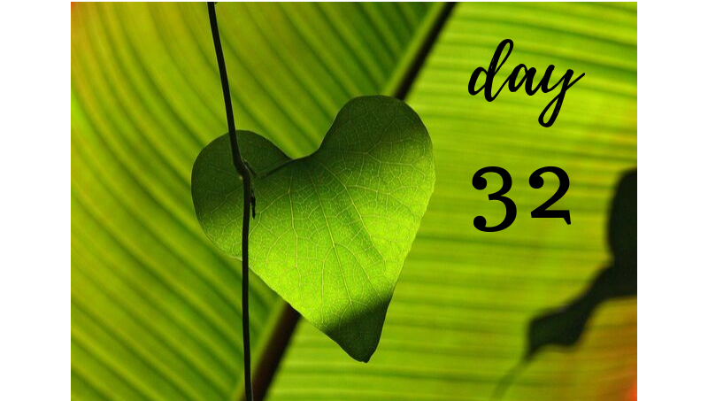
Get ready for day #32! DATE: ______________________

The opposite sex! The forever mystery for many!

Today we are going to focus on writing what you feel confident about with the opposite sex. Our goal is to build up what you feel you know about the opposite sex to making dating more rewarding.

List five things you KNOW about the opposite sex:
1. ____________________________________________________________________________
2. ____________________________________________________________________________
3. ____________________________________________________________________________
4. ____________________________________________________________________________
5. ____________________________________________________________________________

Now let yourself feel good about what you wrote down. Knowing and understanding the opposite sex isn't easy but as confidence builds you'll be more inviting to date!

Get ready for day #33! DATE: ______________________

As you build confidence in dating it's time to keep learning for an even greater understanding.

What are five things you want to learn about the opposite sex? Sometimes it's about conversations and understanding what makes us different, other times it's about learning what makes our dating styles so different.

List your five questions about the opposite sex:
1. ____________________________________________________________________________
2. ____________________________________________________________________________
3. ____________________________________________________________________________
4. ____________________________________________________________________________
5. ____________________________________________________________________________

Being aware of what you don't know helps keep you open to learning new things as you explore your dating journey.

Get ready for day #34! DATE: ______________________

Now we are going to expand to gain more knowledge from other people!

Find someone to give you their opinion on the questions you want to understand about the opposite sex. Ask a man or woman for their thoughts on your ideas and or questions. It's not about their answers being right, as much as it's about you learning other perspectives.

What did you learn?
______________________________________________________________________________
______________________________________________________________________________
______________________________________________________________________________
______________________________________________________________________________
______________________________________________________________________________
______________________________________________________________________________

Developing an awareness of other people's perspective can give you great strength and confidence in dating.

Get ready for day #35! DATE: ______________________

Let's take some time to find gratitude in your journey. Today it's about you and your abundance of positive traits!

As you have worked through your daily journey of finding love we've explored lots of important tools and aspects that will enrich your journey to find love!

Taking time out to refuel your inner spirit with what makes you a great catch, gives you the added inspiration to keep on making yourself available!

What five traits make you awesome to date:
1. ____________________________________________________________________________
2. ____________________________________________________________________________
3. ____________________________________________________________________________
4. ____________________________________________________________________________
5. ____________________________________________________________________________

And yes, you really are wonderful and worth it!

Get ready for day #36! DATE: ______________________

Love and Belief!

What does love mean to you? Today our focus is to write down what love really means to you!

Focusing on different levels of love is important to better understand what type of relationship you are seeking to attract as a love partnership relationship.

What is Love to YOU?
______________________________________________________________________________
______________________________________________________________________________
______________________________________________________________________________
______________________________________________________________________________

Love in a whole is powerful so let's discover what love means to you!
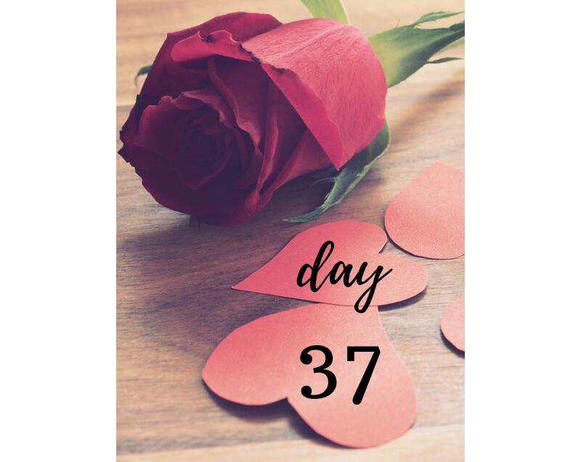

Get ready for day #37! DATE: ______________________

Love of Family!

When we think about LOVE and Family what comes to mind? Do you have fond feelings when you think about the love you have for your family?

Share your thoughts on Love and Family today!
______________________________________________________________________________
______________________________________________________________________________
______________________________________________________________________________
______________________________________________________________________________

Family brings up so many emotions and understanding the difference of love with family compared to love and partnership... It helps gain more clarity on your own Finding Love journey.

Get ready for day #38! DATE: ______________________

Love of Childhood!

Thinking about your childhood. How was love expressed in your family home? Did you grow up hearing lots about love? Did you feel the love? Was their affectionate love?

Describe your memories of love during your childhood...
______________________________________________________________________________
______________________________________________________________________________
______________________________________________________________________________
______________________________________________________________________________

Memories of love when you were young powerfully impact your adult views of love during your life now. Discovering more details is empowering as you attract a new love for your adult life.

Get ready for day #39! DATE: ______________________

Love of friends!

Think about your top three best friendships. They can be current or from years past. What did that love friendship filled relationship mean to you? Do you smile when you think about that endearing connection? What makes it so special for you?

Love of friends... What thoughts and feelings come to mind?
______________________________________________________________________________
______________________________________________________________________________
______________________________________________________________________________
______________________________________________________________________________

Having true friendships is a gift you give yourself and the other person. It's wonderful to have someone that just loves you and is proud to be your friend.

Get ready for day #40! DATE: ______________________

Love of Dreams!

Dreaming is what inspires us to keep going and believing in more. What do you dream about? What is a goal or a wish you always hoped would come true? What motivates you in your dreams? Understanding the power of inspiration from your dreams is life changing!

What do you dream about?
______________________________________________________________________________
______________________________________________________________________________
______________________________________________________________________________
______________________________________________________________________________

Your love with dreams is your motivation for seeking more from your heart and your life!

TAKE MORE TIME TO WRITE AND REFLECT HERE:
These daily exercises can trigger lots of feelings and shifts in perspective. Give yourself time release and write down any additional details to keep in mind or even thoughts you want to visit later on your 90 day journey. This process is for you!
____________________________________________________________________________________________________________________________________________________________________________________________________________________________________________________________________________________________________________________________________________________________________________________________________________________________________________________________________________________________________________________________________________________________________________________________________________________________________________________________________________________________________________________________________________________________________________________________________________________________________________________________________________________________________________________________________________________________

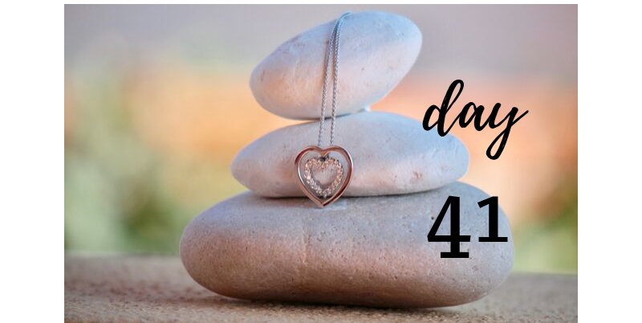

Get ready for day #41! DATE: ______________________

Love of your parents!

The first example we ever have is the one of our parents or family members for how they love. What examples did you witness? Was there lots of affection in your home? Did you feel safe? Did you feel happy with lots of love around? Who were your love role models?

Love and parents... what thoughts does that bring up?
______________________________________________________________________________
______________________________________________________________________________
______________________________________________________________________________
______________________________________________________________________________

Love from the start of your life is the impression that develops examples for your future love relationships.

Get ready for day #42! DATE: ______________________

Love of Animals!

Whether you have your own pets or you know people fond of pets, you know there is a unique type of love that attracts people for love toward animals.

What do you think about when you look at the bond between owner and pet? Do you see people that love their pets with a more relaxed energy or is their pet a motivator to exercise because the pet is so active? What does a pet inspire in it's owner and people around them? Are you drawn to the companionship of a pet in your life now or when you were growing up?

Love of pets, what are the examples you feel?
______________________________________________________________________________
______________________________________________________________________________
______________________________________________________________________________
______________________________________________________________________________
Understanding the bond between pet and owner allows for another powerful understanding of love to be expressed and embraced!
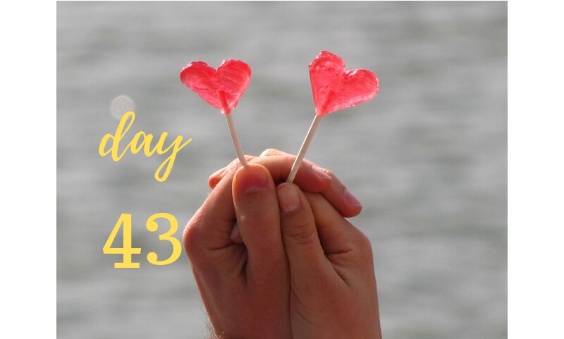
Get ready for day #43! DATE: ______________________

Love examples!

What examples in your personal life, the movies, society, community and life in general that represent love to you?

Did you have amazing affectionate grandparents? Did your favorite school teacher always make you feel valuable and important? Do you have a favorite movie love story?

What are your favorite love stories?
______________________________________________________________________________
______________________________________________________________________________
______________________________________________________________________________
______________________________________________________________________________
Love stories inspire Hallmark cards and warm hearts! May be silly but everyone loves the feeling that true love stories bring!

Get ready for day #44! DATE: ______________________

Love of a Partner!

Now that we've explored many types of love in our life we are going to stop, pause and reflect on what you want the love of your new partner to mean for you!

Will it feel powerful, rewarding, exciting, fun, inspiring, safe....?

Let yourself explore and open up to what love means to you.
______________________________________________________________________________
______________________________________________________________________________
______________________________________________________________________________
______________________________________________________________________________

Love of a partner is a great opportunity to really open up and let yourself feel the love you desire!

Get ready for day #45! DATE: ______________________

Wow can you believe we are at the halfway mark of our 90 days journey?!

Let's take some days to look over where you are on your journey to Find Love!

After working on your assignments for the last 44 days, what new details have you discovered are quality traits to offer someone new?

List four things you've added to your list of what you have to offer someone wonderful!
1. ____________________________________________________________________________
2. ____________________________________________________________________________
3. ____________________________________________________________________________
4. ____________________________________________________________________________

It's always important to remind yourself what you have to offer! Keep a fresh perspective of yourself and enjoy!

Get ready for day #46! DATE: ______________________

As you are making room in your life for someone new ... What have you done differently with your day to day routine?

In order to attract a new life change, you need to change up the current life you live. Now that you are making room for someone wonderful, what has changed in your usual routine?

List two new things you are doing to make your life more attractive for someone new and more exciting for you?

1. ____________________________________________________________________________
2. ____________________________________________________________________________

Do you have more free time? How about going to explore new places? Are you opening yourself to make room for your new partner to have space in your life? Are you putting more effort in getting yourself ready for your day? Any new adventures or opportunities you have opened yourself up to as you move forward on your love journey? Are you saying "YES" more often?
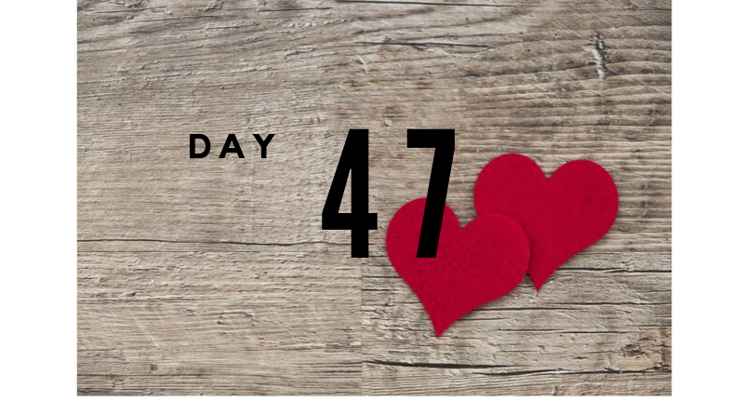

Get ready for day #47! DATE: ______________________

Attraction begins right at the very start! What have you been doing to improve and enhance your image? Did you discover a new hairstyle? How about taking care to get more exercise?

List three things you are doing to improve your image:
1. ____________________________________________________________________________
2. ____________________________________________________________________________
3. ____________________________________________________________________________

Taking added personal care of yourself shows new people that you care about yourself! It's powerful what an impact a little extra TLC can do for your image to others. When you show that you are worth the extra attention... others will notice.

Something very attractive about noticing a person that cares about their appearance in a healthy way. It's not about being high maintenance but showing personal pride.

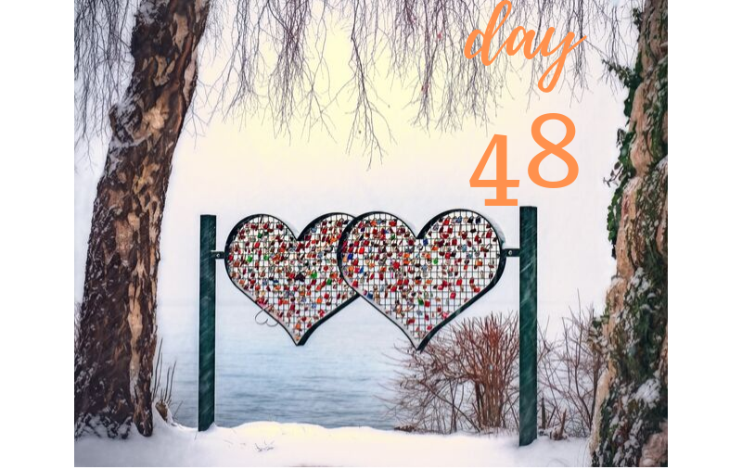

Get ready for day #48! DATE: ______________________

As you are building confidence in attracting the relationship you desire, what flirting techniques have you found to improve over the last six weeks?

The power of quality and effective flirting is amazing at catching the attention of someone you are curious about. It's the first step in allowing someone to be in your space and be open to getting to know you.

List three flirting tools you are utilizing more often as you seek to find love:
1. ____________________________________________________________________________
2. ____________________________________________________________________________
3. ____________________________________________________________________________

Many dates have failed when no flirting happened. Be sure to maximize each opportunity with a little flirting fun to keep your date interested and intrigued. Everyone wants to feel special and flirting has a powerful way of giving someone very focused attention with great smiles to share together.
A little more laughter, soft touch on the hand, warm eye contact... lots of fun and exciting ways to flirt!

Get ready for day #49! DATE: ______________________

Opening up your heart and space to finding love can be a very emotional journey. Let's take some time to reflect and acknowledge the power of gratitude each day.

Over the last 49 days what moments of gratitude have stood out in your mind?

List four moments that you found to be thankful and gracious as you learn through this emotional process:
1. ____________________________________________________________________________
2. ____________________________________________________________________________
3. ____________________________________________________________________________
4. ____________________________________________________________________________

Even in the good and the not so good moments of dating there is always a silver lining. Find your moments to appreciate and grow from, as you keep engaged in your journey to find love. Sometimes it's when a last minute date cancels and you end up making better plans with someone spontaneous. Did you first think a date wouldn't be good but it ended up being great? Have you learned more about yourself and new conversation skills?
Have fun appreciating the process!
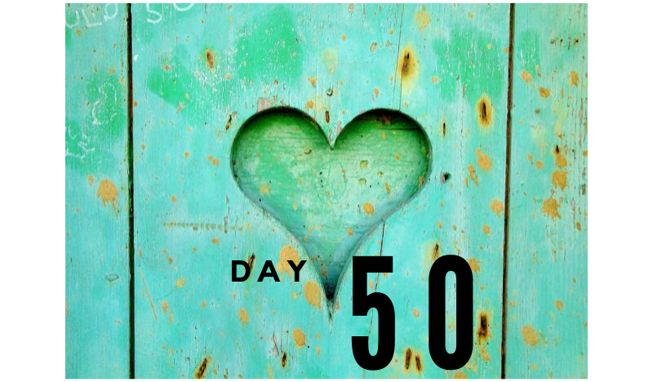
Get ready for day #50! DATE: ______________________

What have you learned about dating at this stage of life? Has it been harder or easier than you thought? Do you wish you could skip past this part or are you enjoying what you've learned and grown from?

Compared to the last time you were in a committed relationship, what is different this time?

Write three things that you have learned about dating now compared to earlier years?
1. ____________________________________________________________________________
2. ____________________________________________________________________________
3. ____________________________________________________________________________

Learning and growing on each stage of this journey is the power of success in motion. Keep yourself open to the changes and applaud yourself when you keep open on your journey. Young love, college love or even a marriage that didn't last can teach you a lot to improve for the next chance love arrives. As life changes through the years, so do our needs to grow and embrace new needs and experiences.

Honoring the journey let's you learn the lessons for a richer and more rewarding relationship when you find real love.

TAKE MORE TIME TO WRITE AND REFLECT HERE:
These daily exercises can trigger lots of feelings and shifts in perspective. Give yourself time release and write down any additional details to keep in mind or even thoughts you want to visit later on your 90 day journey. This process is for you!
____________________________________________________________________________________________________________________________________________________________________________________________________________________________________________________________________________________________________________________________________________________________________________________________________________________________________________________________________________________________________________________________________________________________________________________________________________________________________________________________________________________________________________________________________________________________________________________________________________________________________________________________________________________________________________________________________________________________
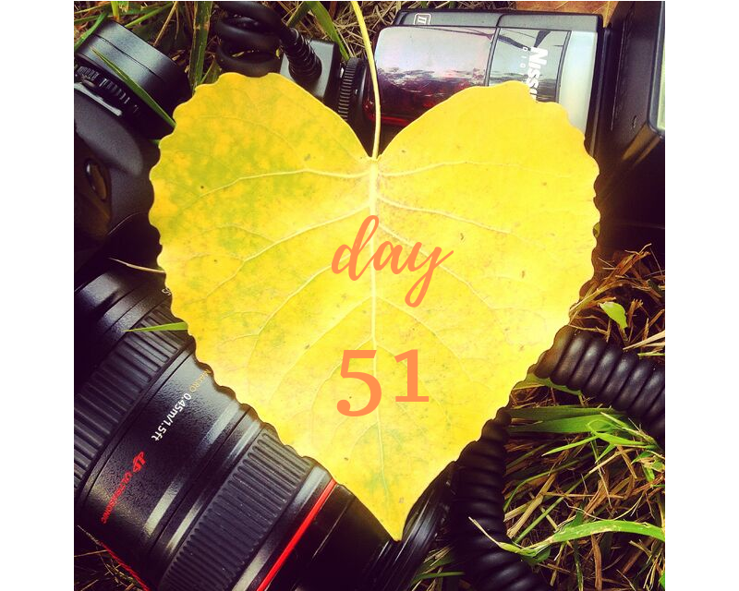
Get ready for day #51! DATE: ______________________

Learning daily tips, inspiration and challenges on your quest to find love has likely brought up many new things about your own personal wish list for your future relationship.

What are new things that you are gaining clarity on as you seek to discover your mystery person. Are you more open to the love you desire or more specific about exactly what you want?

List five traits you have gained more clarity on when you think about what you want with the person you desire:
1. ____________________________________________________________________________
2. ____________________________________________________________________________
3. ____________________________________________________________________________
4. ____________________________________________________________________________
5. ____________________________________________________________________________
Gaining clarity and being open is powerful as you attract and recognize the relationship you desire. It's amazing and exciting to think about the person you want and desire in your life. As you meet more people, while becoming truly engaged in real connections, you'll likely discover a deeper desire for what your heart craves.
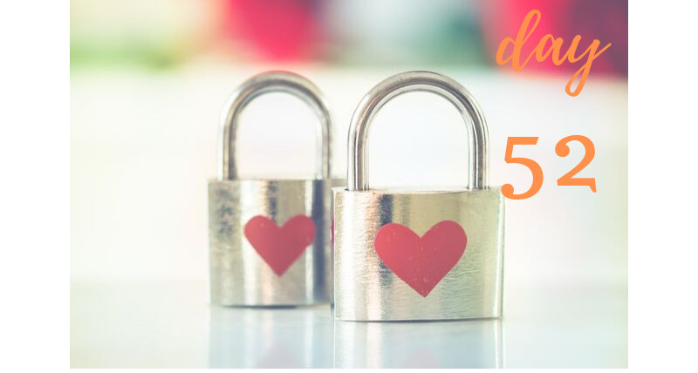
Get ready for day #52! DATE: ______________________

As much as we all have a desire for someone wonderful to be in our lives we have to step back and think how can we improve ourselves too.

People that are lifelong learners and engaged in a healthy lifestyle are very attractive to other empowered eligible singles.

What are you doing to improve yourself? Have you been exercising more? Taking more time to put on a matching outfit and put yourself together for the day? Are you being more patient with dates so you have time to discover one another? Are you more flexible with your schedule so you can accommodate other people's busy lives? Are you taking new classes or going to new events?

List three ways you are improving on yourself:
1. ____________________________________________________________________________
2. ____________________________________________________________________________
3. ____________________________________________________________________________

Even on your journey to find love you will likely get to know yourself better and really enjoy what you discovered!
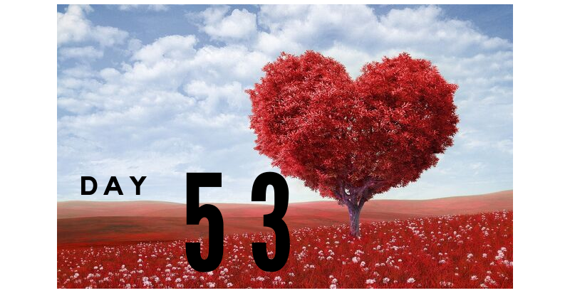
Get ready for day #53! DATE: ______________________

With all your discovery of yourself and the mystery person you seek to meet, what have you learned about events to attend to meet more new people?

Always having a curious eye keeps you aware of what is going on in your community. The greater chances to meet someone happen when you are out exploring, attending events, learning new skills and embracing all the possibilities.

What five new events or activities have you attended in the last 53 days or wish to attend before our 90 day program is complete?
1. ____________________________________________________________________________
2. ____________________________________________________________________________
3. ____________________________________________________________________________
4. ____________________________________________________________________________
5. ____________________________________________________________________________

Many love stories have begun when two people happen to sit at the same park bench, bump into each other in the elevator, attend the same dance class etc...

What are you doing to make sure you meet new people regularly?
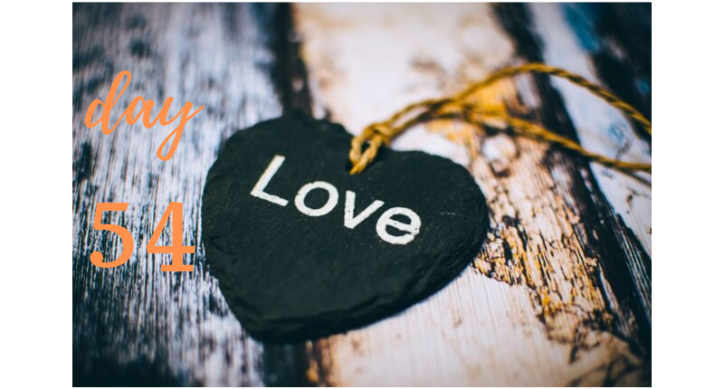
Get ready for day #54! DATE: ______________________

Welcome to day number 54 on your 90 day journey!

What have you learned about your community for dating fun? Did you find a great place to enjoy Happy Hour? How about fun parks to take walks? Oh and did you find some fun concerts to enjoy at local pubs?

List the five new community tips you learned for being engaged in dating success:
1. ____________________________________________________________________________
2. ____________________________________________________________________________
3. ____________________________________________________________________________
4. ____________________________________________________________________________
5. ____________________________________________________________________________

Knowing options for dating fun makes planning dates tons more exciting and easier! Plus it will impress your date that you have great ideas to share!

Whether you are looking for someone to date or you have began dating, it's always good to keep fresh with ideas and enjoy some of your favorites!

Welcome to day number 55! DATE: ______________________

Now that we have talked about various ways to be more date-able... let's work on the type of date you want. What are your thoughts about the expense of a date? Who should pay? Is it best to just go for coffee because it's cheap or is it so the date can be quick?

Thoughts about monies:
________________________________________________________________________________________________________________________________________________________________________________________________________________________________________________________________________________________________________________________

Take some time in advance to think about how money plays in your expectations of dating. Many people have judged a date based on if they paid or offered to pay. There is more to a date than money but it has become the deal breaker for many potential couples.

Some dates over do by having the first date be too fancy or over done to over impress and realize later it was too much. Understanding how money plays into your dating expectations is important. Sometimes when you meet for happy hour it's not about being cheap, as much as it's about light eats and a chance to make it fun in a bar setting. As relationships progress so do the dating and expense opportunities.

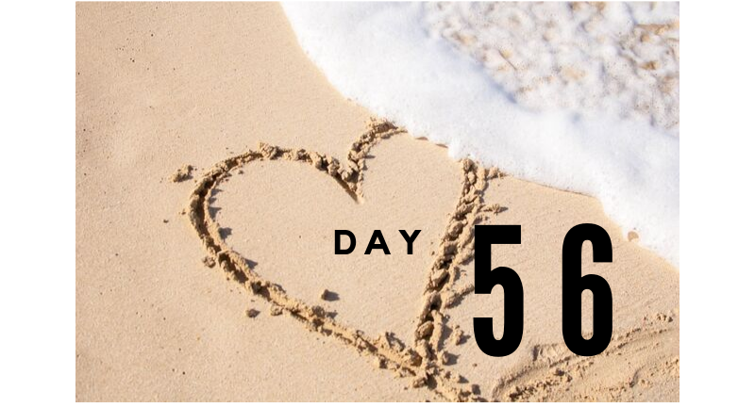
On to day #56! DATE: ______________________

Now that we are talking about money, how do you feel someone's financial status should play in your decision of the quality of match potential?

__________________________________________________________________________________________________________________________________________________________________________________________________________________________________________

I know many people don't want to date because they don't feel they can afford to date, while others won't date someone unless they are at a certain financial level. This is a good time to ask yourself what is most important?

Financial status now or potential future? ____________________________________________________________________________________________________________________________________________________________
______________________________________________________________________________

Money is a top reason people struggle or conflict in a relationship. It is powerful to figure out the power money holds as you are opening yourself to a new relationship.
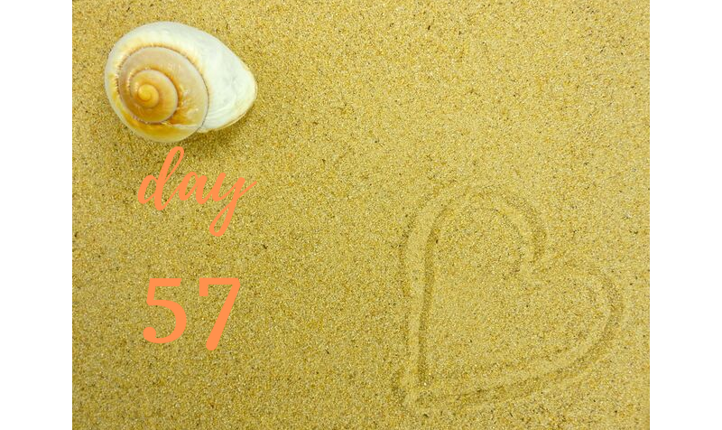

Welcome to day #57! DATE: ______________________

As we talk about money in dating, what thoughts come to mind in how money plays in a relationship?
______________________________________________________________________________
__________________________________________________________________________________________________________________________________________________________________________________________________________________________________________
______________________________________________________________________________
______________________________________________________________________________

Do you want to be in a relationship where you can be the provider or be provided for? Do you want to be financial equals? Do you want to find mutual ways you'll come together as a couple and let the money figure itself out later?

Clearing up your money expectations ahead of time makes more room for real love.
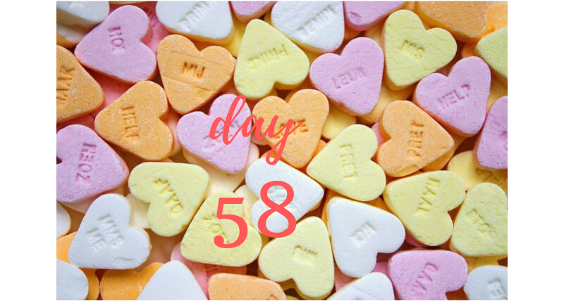

Welcome to day #58! DATE: ______________________

What are your biggest regrets? I ask this question because I don't necessarily believe in really living with regrets but if you could have done something differently in your love world what would it have been?

List a couple situations where you wish you had done things differently?
1. ____________________________________________________________________________
______________________________________________________________________________
______________________________________________________________________________

2. ____________________________________________________________________________
______________________________________________________________________________
______________________________________________________________________________

Sometimes taking pause to look in the “rear-view mirror" can have a greater impact at moving forward.

Welcome to day #59! DATE: ______________________

Now that you have identified some opportunities where different choices could have helped, what would you have done differently?

Situation 1: __________________________________________________________________________________________________________________________________________________________________________________________________________________________________________

Situation 2:
__________________________________________________________________________________________________________________________________________________________________________________________________________________________________________

Learning from your past helps from repeating mistakes in the future!
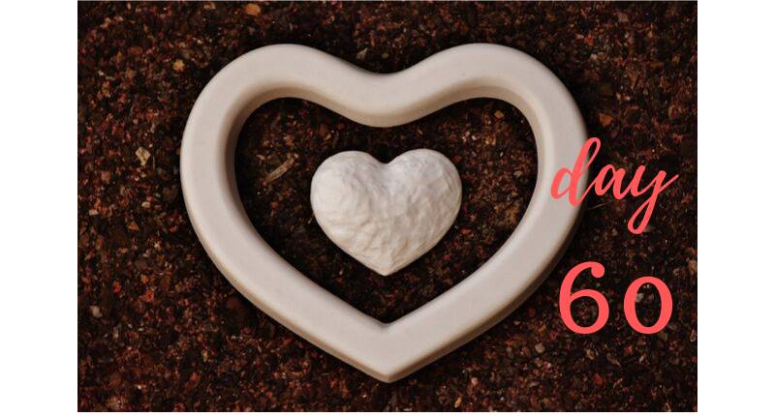

Welcome to day #60! DATE: ______________________

What other lessons have you learned on your dating journey? We are 2/3 of the way through our 90 day series to Find Love. As you grow and learn you are able to learn through reflection and new experiences.

List five new tips that you have been implementing over the last 60 days.

1. ____________________________________________________________________________
2. ____________________________________________________________________________
3. ____________________________________________________________________________
4. ____________________________________________________________________________
5. ____________________________________________________________________________

Gratitude and credit as you move through your journey is powerful to keep going forward!

TAKE MORE TIME TO WRITE AND REFLECT HERE:
These daily exercises can trigger lots of feelings and shifts in perspective. Give yourself time release and write down any additional details to keep in mind or even thoughts you want to visit later on your 90 day journey. This process is for you!
____________________________________________________________________________________________________________________________________________________________________________________________________________________________________________________________________________________________________________________________________________________________________________________________________________________________________________________________________________________________________________________________________________________________________________________________________________________________________________________________________________________________________________________________________________________________________________________________________________________________________________________________________________________________________________________________________________________________

Welcome to day #61! DATE: ______________________

Let's celebrate today!

With your consistent focus toward finding love, you deserve to give yourself a day off and celebrate you!

How can you spoil yourself today? Take time to watch a favorite show, indulge in buying yourself a treat, take a quiet walk or...

What can you come up with to spoil yourself for today?
______________________________________________________________________________
______________________________________________________________________________
______________________________________________________________________________

Yes, you are worth it!

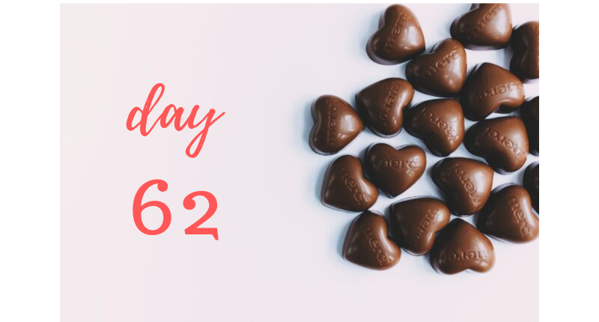

Welcome to day #62! DATE: ______________________

Let's get back to exploring! One of the biggest complaints I see clients having is that the other person didn't offer any suggestions for date ideas. Often people like to feel the other person is engaged in the journey and invested by coming up with new ideas to enhance the dating experience.

Plus with extra ideas it's fun that when date #1 goes well, then you already have something fun in mind for date #2, #3 etc!

What are some new date ideas you have come up with?
_____________________________________________________________________________
______________________________________________________________________________
______________________________________________________________________________

Prepared for dating success is powerful!
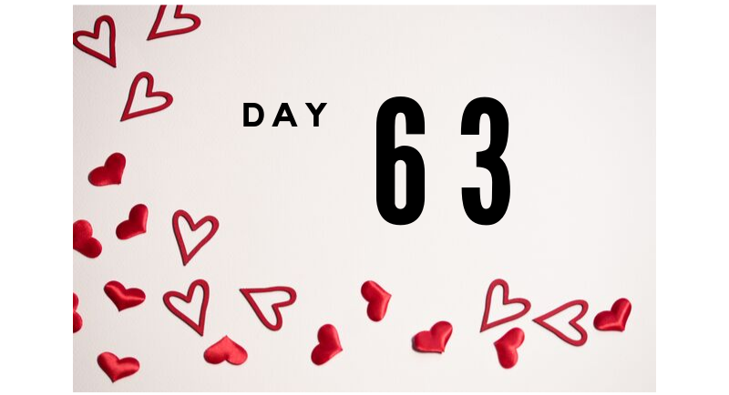

Welcome to day #63! DATE: ______________________

How would people describe you? This isn't as easy as we think!

Take a few moments to write down a description of yourself from a friend's perspective. What new things do you feel you learned about yourself?

______________________________________________________________________________
______________________________________________________________________________
______________________________________________________________________________

Be positive and remind yourself why people enjoy spending time with you!

Loving yourself and all you have to offer is powerful!

Happiness to you ALWAYS!

Welcome to day #64! DATE: ______________________

Send a friend a card letting them know how much you appreciate them! Sending a compliment to another person is powerful at making yourself feel good too!

Who do you feel deserves a little extra attention?
____________________________________________________________________________________________________________________________________________________________
______________________________________________________________________________
______________________________________________________________________________

Why did you pick your friend?
____________________________________________________________________________________________________________________________________________________________
____________________________________________________________________________________________________________________________________________________________

Exciting to make someone's day by letting them know they are valued!
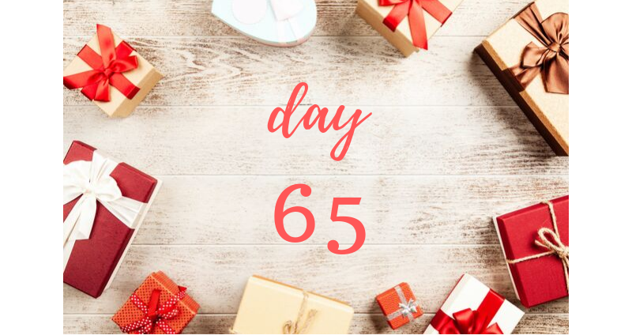

Welcome to day #65! DATE: ______________________

Now is the day to write a letter to someone that broke your heart. This is not a letter to give them but to get feelings out. A chance to reflect, release and own your willingness to move forward.

Who did you pick?
____________________________________________________________________________

Why did you pick them?
_____________________________________________________________________________

How did you feel after you wrote the letter?
______________________________________________________________________________

Giving yourself permission to move on is amazing!

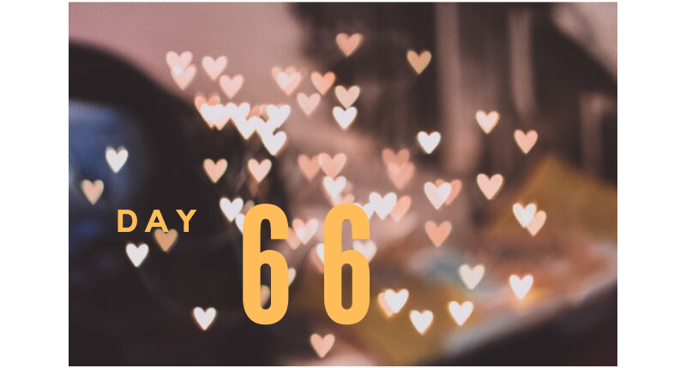

Welcome to day #66! DATE: ______________________

What an exciting day you are being given today! Regardless of what obstacles you have in your way... let it be a day that you jump up and embrace for your dreams to be closer to coming true!

When you woke up today what was your biggest reason to smile?
______________________________________________________________________________
______________________________________________________________________________

What was your biggest worry?
_____________________________________________________________________________
_____________________________________________________________________________

What is something new that you want to do for your day to move past your worries?
______________________________________________________________________________
______________________________________________________________________________

The power of a positive mind is going to change how each day gets more powerful!
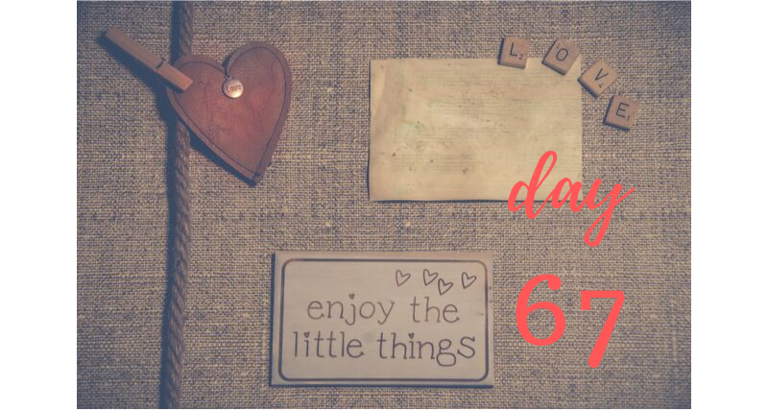

Welcome to day #67! DATE: ______________________

Let's keep working on our Positive Thought process over the next few days!

What lessons of life and love have you learned over the last few months? Even if you have been single for awhile I bet you have taken time to reflect and process about past relationships.

List the three lessons that you feel you learned recently:
1. ____________________________________________________________________________
2. ____________________________________________________________________________
3. ____________________________________________________________________________

Sometimes these lessons are hard to see and other times it feels like they are staring you right in the face!

Learning is powerful! Not always easy but necessary to grow!
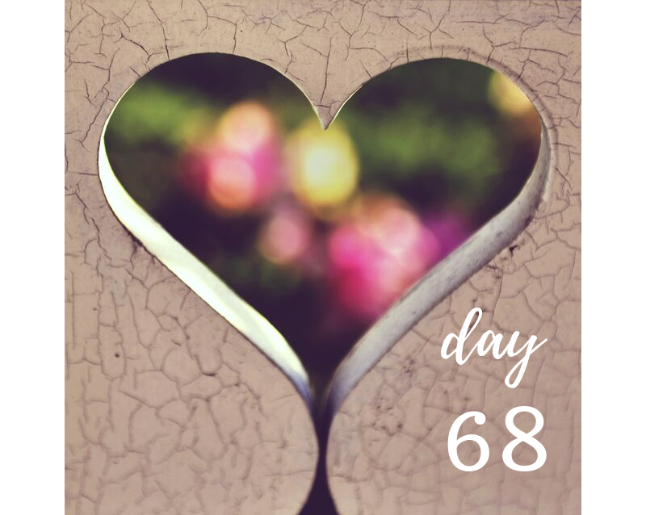

Welcome to day #68! DATE: ______________________

Lessons of past relationships is our Positive Thought for today.

Today the focus is to find something positive from your last relationship(s). What do you feel you have that you can say is positive?

List three positive aspects to past relationship experiences:
1. ____________________________________________________________________________
2. ____________________________________________________________________________
3. ____________________________________________________________________________

Moving forward to find love is exciting and fun but also important healing. Even if your heart was broken at the end of the relationship there must have been something positive that brought you together in the first place. Take a moment and remind yourself of the positive. It's all a valuable part of your journey!
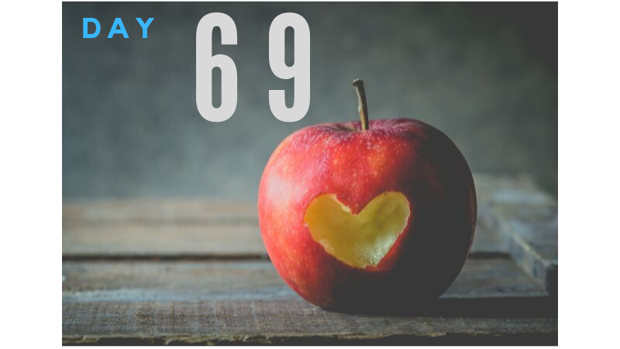

Welcome to day #69! DATE: ______________________

Giggle! Giggle! Giggle!

Yes, I just want you to laugh today! Be one of those people that finds the simplest ways to laugh and be happy!

This might seem odd to just laugh but when you lighten up and have fun you'd be amazed how many things in life can make you laugh!

List four reasons you laughed today!
1. ____________________________________________________________________________
2. ____________________________________________________________________________
3. ____________________________________________________________________________
4. ____________________________________________________________________________

Yes, laughter is the best medicine and it keeps you looking young in heart and spirit! Not to mention people that laugh and enjoy life are simply more attractive!
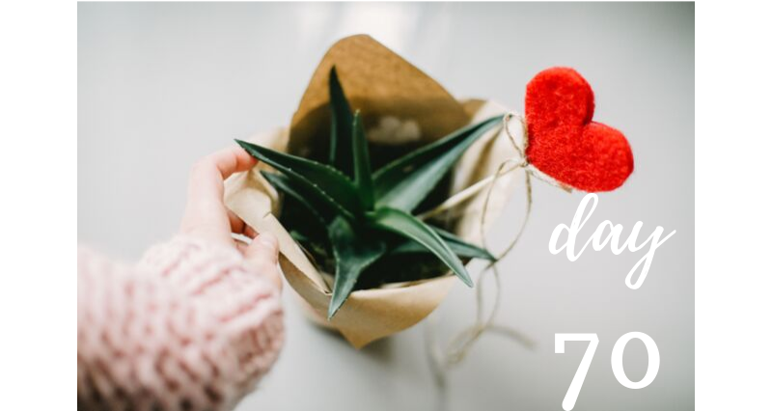

Happy Day #70! DATE: ______________________

Today we are focusing on dreams!

Dreams in love and relationships inspire happy love lives! What do you dream about? What do you desire in a relationship? When you close your eyes and visualize this amazing new person being in your life, what are some thoughts and feelings that come to mind?

Write your feelings and allow yourself to dream:
______________________________________________________________________________
______________________________________________________________________________
______________________________________________________________________________
______________________________________________________________________________

Believe in your dreams again... they really can come true!

TAKE MORE TIME TO WRITE AND REFLECT HERE:
These daily exercises can trigger lots of feelings and shifts in perspective. Give yourself time release and write down any additional details to keep in mind or even thoughts you want to visit later on your 90 day journey. This process is for you!
____________________________________________________________________________________________________________________________________________________________________________________________________________________________________________________________________________________________________________________________________________________________________________________________________________________________________________________________________________________________________________________________________________________________________________________________________________________________________________________________________________________________________________________________________________________________________________________________________________________________________________________________________________________________________________________________________________________________

Happy Day #71! DATE: ______________________

Yesterday you began writing down your dreams of life and relationships. Now that I have you in a positive place to enjoy the possibilities let's think of ways you'd enjoy dating even more.

What would be your dream date?
______________________________________________________________________________________________________________________________________________________________________________________________________________________________________________________________________________________________________________________________________________________________________________________________________________________________________________________________________________________________________________________________________________________________________________________________________________________________________________________________________________________________________________________________
______________________________________________________________________________

Let yourself get creative and fun as you design your dream date! How would you participate? Would you be planning or would your partner surprise you?

Enjoy your dream date ideas!
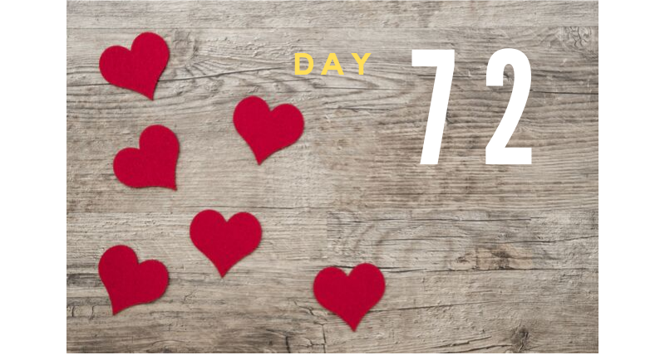

Happy Day #72! DATE: ______________________

Dream life!

What is your dream relationship? When you think in the future five years from now and your relationship has a strong foundation, what comes to mind? Feeling comfortable and in love with your journey is powerful.

Describe your future dreams:
______________________________________________________________________________
______________________________________________________________________________
______________________________________________________________________________
________________________________________________________________________________________________________________________________________________________________________________________________________________________________________________________________________________________________________________________

A wish is what your heart makes! Having dreams let's you know when your wishes come true!
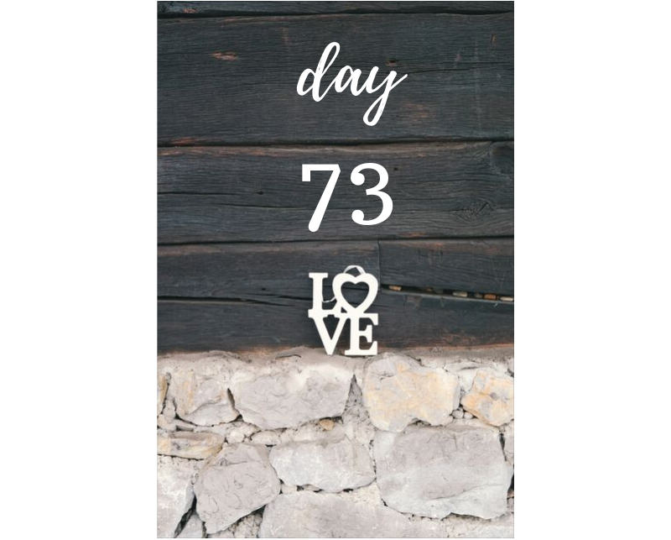

Happy Day #73! DATE: ______________________

As you continue your journey to find love what makes you keep moving forward? Even if you are dating life can throw curve balls and make you question your choices. Today our focus is to remember why you believe Finding Love is important.

List three things that Finding Love will add to your life:
1. ___________________________________________________________________________
2. ___________________________________________________________________________
3. ___________________________________________________________________________

With your dreams and desires for Finding Love reignited in your mind anything and everything can be possible. Sometimes people lose sight of their 'why' and fall off course. Since we've worked on dreams and reconfirmed why you are moving forward lets have some fun along the journey!
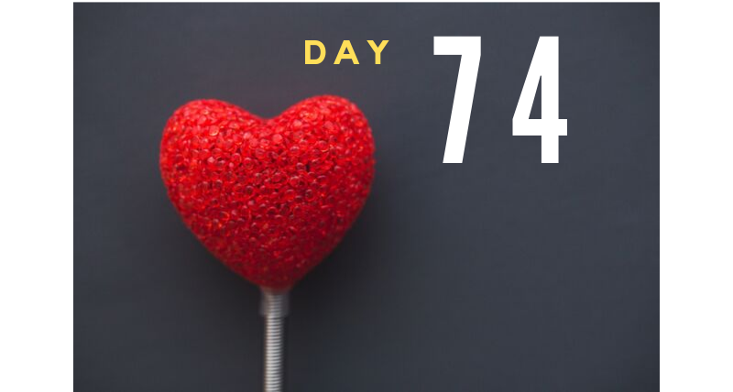

Happy Day #74! DATE: ______________________

Having fun with dating makes all the hard work pays off! For the next few days we are going to focus on different levels of fun!

What could you do today that is totally wild and unique? What would make you smile all day because you finally dared yourself to do something new? What about talking to someone that you have noticed but keep passing by? Or asking someone to join you for Happy Hour just for fun?

What wild and fun new things did you do to push yourself?
______________________________________________________________________________
______________________________________________________________________________
______________________________________________________________________________

Today is YOUR DAY! Embrace it and have FUN!
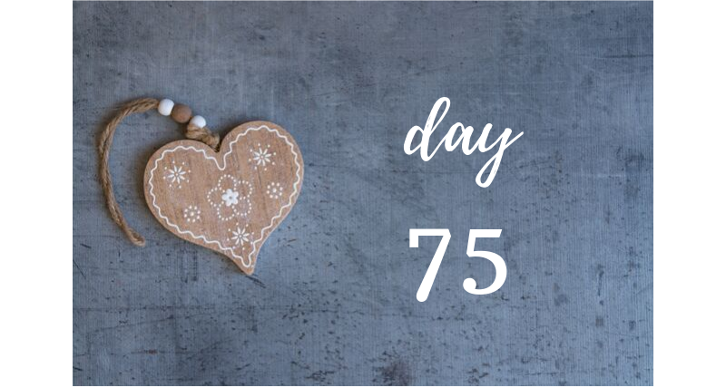
Happy Day #75! DATE: ______________________

Now that I've inspired a little dare filled energy... What else are you inspired to do?

Action takers make a difference in the world and you deserve to see more powerful results in your dreams coming true! I know it isn't easy pushing yourself or trying new things that test your comfort zone but it is ever so important.

This is your life and there is someone wonderful you need and deserve to discover. What is the one ACTION thing you are still not quite ready to do?

______________________________________________________________________________
______________________________________________________________________________
______________________________________________________________________________

Let yourself accept that your actions are what make a difference. Doing nothing is still taking action. It might have a low impact but you are still doing something. Think about what you could do to move yourself forward and be more of a proactive action taker.
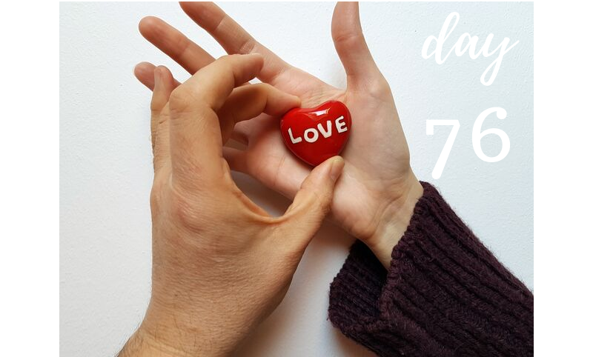

Happy Day #76! DATE: ______________________

As our 90 day series comes to a wrap over the next two weeks I want to use this time to reflect and continue growing with you! This is your time to see how you can maximize all that is possible on the entire 90 days!

Today we'll discover what you have to offer as a person. Yes, we are seeking to enrich who you are as a partner but you can't love anyone until you love yourself.

Take a few moments to write a little paragraph about YOU!
______________________________________________________________________________
______________________________________________________________________________
______________________________________________________________________________

Writing thoughts about yourself is exciting but not always easy!

For an added challenge write it in 3rd person. How would someone else describe you?
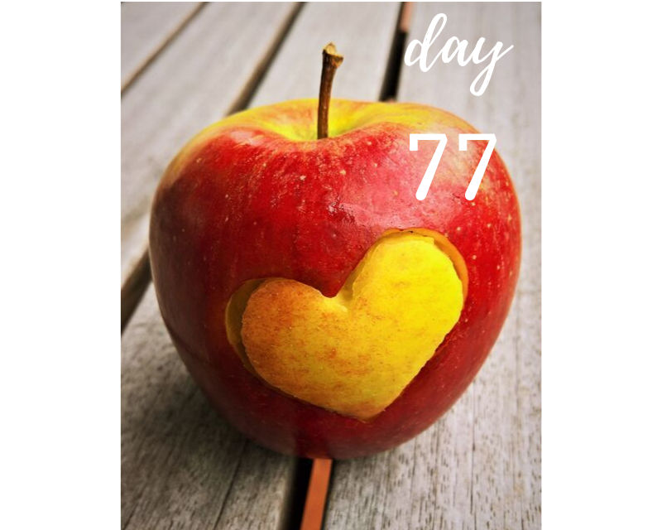

Happy Day #77! DATE: ______________________

The exciting part of finding new love is discovering all the new things life brings you! What we'll focus on for today is finding something new you can bring or have already brought into the routine of your day to day life.

If you are now in a dating relationship or still working toward finding someone wonderful, what is NEW in your life since you began your own journey to FIND LOVE?

__________________________________________________________________________________________________________________________________________________________________________________________________________________________________________
______________________________________________________________________________

List the New moments, things and experiences allows you to keep your eyes open for many new possibilities!
Happy Day #78! DATE: ______________________

Let's take today and think about the image you present. What does your image today say to the world? Just stop and pause right now and look at yourself! Grab a mirror and have a conversation with yourself... the person in the mirror!

What did you say?
______________________________________________________________________________
______________________________________________________________________________
______________________________________________________________________________

Were your words positive? Exciting? Negative? Confused?

Own your expression of your thoughts! It's incredibly important to be very clear on what you express in your image. If you are dressed casual and you like it then rejoice. If you are dressed too casually and you are disappointed then why are you not taking care of yourself like you believe you should?

Make choices to own what you represent! People really don't care what you wear, as much as they care how you feel about what you wear! Own your awesomeness unique style!

Happy Day #79! DATE: ______________________

So how have you improved on flirting and living life a little lighter and happier?

While you have been working through your journey of moving closer each day toward finding love, have you found your outlook on life improving?

The energy through body language and words is the most powerful tool to get someone's attention... and keep it!

What level of confidence is growing inside of you?
______________________________________________________________________________
______________________________________________________________________________
______________________________________________________________________________

Share your thoughts on how you are expressing yourself through fun, flirting and connections with new people and people you continue to spend time with!
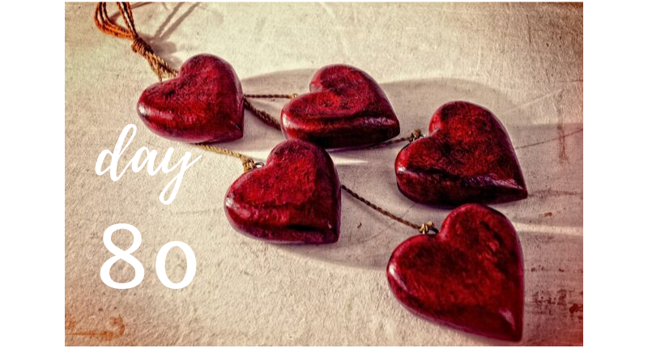

Happy Day #80! DATE: ______________________

Today I want to stop and pause to say THANK YOU FOR YOU! What a blessing it is to have shared the last 80 days with you! Excited for what we'll share for the next 10 days!

Yes, today is about gratitude!

What are you excited about in your life right now! First thought that came to mind...
______________________________________________________________________________

What are you grateful for the lessons, challenges and tips you have worked on since day #1?
______________________________________________________________________________

What dreams and goals are you excited to say your gratitude about... once they come true?
______________________________________________________________________________

Let's celebrate gratitude today... you deserve it!

TAKE MORE TIME TO WRITE AND REFLECT HERE:
These daily exercises can trigger lots of feelings and shifts in perspective. Give yourself time release and write down any additional details to keep in mind or even thoughts you want to visit later on your 90 day journey. This process is for you!
____________________________________________________________________________________________________________________________________________________________________________________________________________________________________________________________________________________________________________________________________________________________________________________________________________________________________________________________________________________________________________________________________________________________________________________________________________________________________________________________________________________________________________________________________________________________________________________________________________________________________________________________________________________________________________________________________________________________

Happy Day #81! DATE: ______________________

What do you feel that you need to improve on in your social graces? Today is discovery day... I want you to research whatever part of your dating / relationship skills seems to be lacking.

This is a time to gain tools and insight to empower yourself with more tools specific to your needs.

Do you want to get more confident on planning a date? Research "great date ideas".

Do you want to gain more confidence in your image? Research image consultants and see what tips they share?

Do you want to get healthier to attract people that live a healthier lifestyle?
Research local places to workout or a new routine you can do at home.

What did you learn? What do you want to learn more about?
____________________________________________________________________________________________________________________________________________________________

Knowledge is powerful! Have fun discovering!
Happy Day #82! DATE: ______________________
What do you want?
______________________________________________________________________________
Do you have a very specific list that your future partner must meet to date you or is your list very vague?

Think about the TOP three things you want in a relationship no matter what?
List the non-negotiable details:
1. ____________________________________________________________________________
2. ____________________________________________________________________________
3. ____________________________________________________________________________

Now list three things you used to have as rules that you learned to let go of recently?
1. ____________________________________________________________________________
2. ____________________________________________________________________________
3. ____________________________________________________________________________

What are three things you always wished for in a relationship but never seem to find?
1. ____________________________________________________________________________
2. ____________________________________________________________________________
3. ____________________________________________________________________________
Gaining inspiration and direction on your wishlist is amazing! Let yourself grow!

Happy Day #83! DATE: ______________________

Over the last 83 days I'm sure you have learned a lot and made many changes.

What jumps out the most in your mind as you improve yourself to attract the person you desire?

List three ways you have improved as a person:
1. ____________________________________________________________________________
2. ____________________________________________________________________________
3. ____________________________________________________________________________

List three ways you want to improve, yet haven't really moved into that new direction yet.
1. ____________________________________________________________________________
2. ____________________________________________________________________________
3. ____________________________________________________________________________

This is where you have your power in life to make choices or what till you are ready! What do you choose?

Happy Day #84! DATE: ______________________

What have you found to be the best ways to meet people? Over the weeks and months you've been moving closer toward finding love I'm sure you've discovered many new ways to meet people.

What are your three favorite ways to meet people?
1. ____________________________________________________________________________
2. ____________________________________________________________________________
3. ____________________________________________________________________________

What are your three least favorite ways to meet people?
1. ____________________________________________________________________________
2. ____________________________________________________________________________
3. ____________________________________________________________________________

There are amazing people everywhere you go... how are you embracing the journey to meet the greatest people?
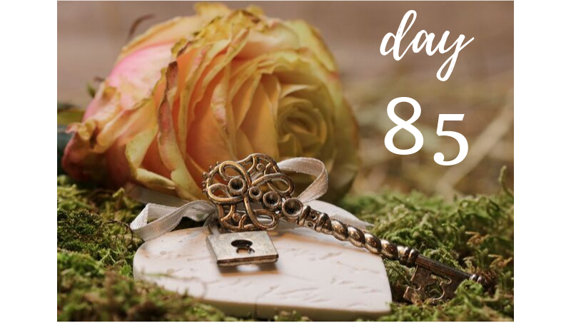

Happy Day #85! DATE: ______________________
Today we are going to take you on an adventure! I want you to drive or bike or walk in a new direction than you have ever gone before!

If you usually go down one street for your favorite restaurant, I want you to go the exact opposite way for a new restaurant.

If you usually travel 15 minutes one way for work, today go the opposite direction 15 minutes to see where you end up.

Today we'll flip your view and perspective around.

What did you find?
_____________________________________________________________________________
How far did you travel?
_____________________________________________________________________________
What did you learn?
_____________________________________________________________________________
New opportunities create New possibilities... What did you attract today?
_____________________________________________________________________________

Happy Day #86! DATE: ______________________

Now it's time to wrap up our 90 day series with reflection.

I want you to look over your notes from day 1-21.

What assignments did you like the best? And why?
______________________________________________________________________________
______________________________________________________________________________

What assignments do you need to still finish? Why did you not get them done?
______________________________________________________________________________
______________________________________________________________________________

What assignments do you want to do again as you could have different answers now that you have grown and experienced so much more?
______________________________________________________________________________
______________________________________________________________________________

Learning, growing and reflecting makes you an amazing person!

Happy Day #87! DATE: ______________________

Let's continue with reflection...

I want you to look over your notes from days 22-39.

What assignments did you like the best? And why?
______________________________________________________________________________
______________________________________________________________________________

What assignments do you need to still finish? Why did you not get them done?
______________________________________________________________________________
______________________________________________________________________________

What assignments do you want to do again as you could have different answers now that you have grown and experienced so much more?
______________________________________________________________________________
______________________________________________________________________________

Each step you move forward is your way of owning your life, your dreams and your self worth!

Happy Day #88! DATE: ______________________

Can you believe we are on our last three days together?

Knowing you are taking time to reflect, pause and acknowledge is how I know I connected with you. Thank you for taking the time to make sure nothing was missed!

Look over your notes from day 40-65.

What assignments did you like the best? And why?
______________________________________________________________________________
______________________________________________________________________________

What assignments do you need to still finish? Why did you not get them done?
______________________________________________________________________________
______________________________________________________________________________

What assignments do you want to do again as you could have different answers now that you have grown and experienced so much more?
______________________________________________________________________________
______________________________________________________________________________
Remember... YOU ARE WORTH IT!!!!
Happy Day #89! DATE: ______________________

Tick-Tock... How can it already be day #89?!

For today look over your notes from day 66-85.

What assignments did you like the best? And why?
______________________________________________________________________________
______________________________________________________________________________

What assignments do you need to still finish? Why did you not get them done?
______________________________________________________________________________
______________________________________________________________________________

What assignments do you want to do again as you could have different answers now that you have grown and experienced so much more?
______________________________________________________________________________
______________________________________________________________________________

Gratitude, smiles, possibilities... love! That is what I think of when I think about how your heart has grown during this journey! Thank you for YOU!

Happy Day #90! DATE: ______________________

It's arrived! Our grand finale day! Bet you can’t believe what you have been able to share and experience over the 90 days.

Thank you for giving me the opportunity to share with you tips and tools I’ve utilized to support my clients on their love journey. Congratulations for caring to do something with the professional guidance and knowledge I gave to you.

May I now ask for a favor?

Write a Testimonial and email it to us at info@jacquelinenichols.com - Your personal work to find love, will continue to inspire others on their own love journey. We want to hear about your journey!

I want to learn from you. I want to grow from your journey too.

You have been a true inspiration! Thank you for being open to growing and discovering more about yourself and entrusting my 90 days of inspiration to move you forward on your most valuable love quest!
WRAP UP YOUR THOUGHTS:
Celebrate YOU!
Congratulations on completing your 90 days challenge of inspiration in support of your love journey! Go out and celebrate! Honor your commitment and follow through. You are AWESOME! I’M PROUD OF YOU!
__________________________________________________________________________________________________________________________________________________________________________________________________________________________________________________________________________________________________________________________________________________________________________________________________________________________________________________________________________________________________________________________________________________________________________________________________________________________________________________________________________________________________________________________________________________________________________________________________________________________________________________________________________________________

About The Author
Love, dating, matchmaking and life guidance expert, Professional Matchmaker Jacqueline Nichols provides a wide range of personal, relationship and love support services. She has more than 20 years of experience supporting women and men to find success in their life, love and relationships. Through her years as a love expert she has matched incredible couples, saved many marriages and officiated multiple weddings.
Over that time she has gained a unique perspective that truly makes a difference when individuals seek to raise their deserve level and enjoy life transforming results. What started as Jacqueline utilizing her spiritual gift to listen to her angels when people wanted to find true love, has now become a very successful purpose driven life. Clients credit Jacqueline’s ongoing support and professional advice for keeping their life, love and personal journey enjoyable, long lasting and truly rewarding.
Jacqueline teaches a new level of success and happiness that you have always deserved and desired. Yes, you are worth it!
To experience additional workbooks in this series go to https://www.jacquelinenichols.com/

