Community Comes Alive!

Essential Question How do you create a work of art that captures what community means to you?
Grade 3rd

Time 50 minutes

Art Concepts Realism, stylized, palette, diorama

Materials Scissors, shoe box or other cardboard box, tape, markers, crayons, ruler, white paper, colored or construction paper, glue stick or liquid glue, strips of stiff cardboard

Artworks in Focus Carlos Almaraz’s Tree of Life, 1987, and Ramiro Gomez’s So Different, So Appealing
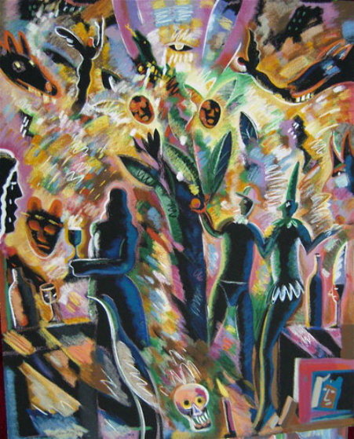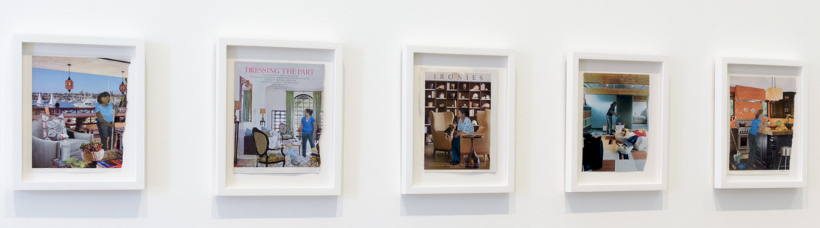

Talking about Art Take a closer look at Carlos Almaraz’s Tree of Life with Ramiro Gomez’s series of photographs showing domestic immigrant workers. Are there any similarities between both the artworks? What do you notice about the colors, shapes, and background of each work? Which of the two artists’ work seems more realistic? What do you see that makes you say that? Before we begin the project, let’s find out more about the artists and their art styles.

Almaraz was a Mexican-born American artist known for his brightly colored murals and paintings. His themes often focused on his Chicano heritage and city life. Almaraz captured the pulse of his subject matter with stylized (or simplified) forms and neon colors. As a prolific painter and printmaker, his work captured the vitality and life of East Los Angeles neighborhoods, and his colorful, expressionistic palette (or choice of colors) usually incorporated bright violets, hot pinks and blood-like red tones.

Gomez was born in 1986 in San Bernardino, California, to undocumented Mexican immigrant parents. He briefly attended the California Institute for the Arts before leaving to take work as a live-in nanny with a West Hollywood family, an experience that did much to inform his artistic practice. Similar to Almaraz’s work, Gomez’s art addresses issues of identity, culture, and immigration, making visible the “invisible” labor forces that keep so many of the pools, homes, and gardens of L.A. in such pristine condition.

Making Art For this art activity, you will be using recycled materials to make a shoebox diorama inspired by both Almaraz’s and Gomez’s work. You work should highlight a part of your community that is personal or important to you.

Let’s start by gathering the materials we will need. Then, think about what is important to you in your neighborhood, or among your community. Your community might be your family, your friends, your school, your neighborhood—whatever you think your community is.

- Take a ruler and measure the size of the bottom of the shoebox.
- Take a sheet of colored or white construction paper and use the measurements to draw a rectangle on the paper the same size as the bottom of the shoebox.
- On the same sheet of construction paper, draw a background for your neighborhood scene and then add color with crayons, colored pencil, or markers.
- Glue this inside the box and set the box on its side so that your drawing forms a background for your diorama.
- Add additional color and details to the sides of the box with markers, crayons, or colored pencils.
- Select a few more sheets of construction paper, in colors that contrast (are not the same as) the background sheet. Draw the shapes of people and other things you would see in your neighborhood (trees, people playing, animals, stores, etc.). These will be silhouettes, like the shadows of the things.
- Cut out the silhouette figures.
- If your figure will be freestanding, create a backing to hold up the figure. You can do this by cutting a piece of cardboard (approximately one inch long and 14 inches wide) and folding it into an “L” shape. Then, tape one part of the shape to the back of the figure and the other to the bottom of the cardboard.
- Locate the area where you would like to place each figure before you glue/tape the figures to the box.
- Adhere your figures inside the box in front of the background to complete your scene.

Reflection By looking closely at the artworks of Almaraz and Gomez, we learned how each artist created works of art that are similar in theme and that focused on concepts of “community” and “identity.” Although each artist has his own particular style, their work informs us that these concepts can be defined in different ways and through a person’s individual experience. For example, your community can mean something different to you than it does to your neighbor, or to an outsider. Were there any particular parts of their work (style, color, technique, etc.) that inspired you to create your neighborhood scene? If so, what elements in their work inspired you? Why did you create this particular scene in your neighborhood? What were some of the challenges in creating the diorama? If you could make this piece life size, what type of community would you create and where would you install it?

Curriculum Connections California Arts Standards for Public Schools—Visual Arts

3.VA:Cr1.1: Elaborate on an imaginative idea. 3.VA:Cr2.1: Create personally satisfying artwork using a variety of artistic processes and materials. 3.VA:Cr2.3: Individually or collaboratively construct representations, diagrams, or maps of places that are part of everyday life.

Prepared by Wenceslao Quiroz with the Los Angeles County Museum of Art (LACMA) Education Department

