Hi!
I just hit send on all the Backerkit surveys, so you should get them at your Kickstarter email address in the next hour or so. Remember, this email will not come from me. It will come from Backerkit, and the subject will look something like this.
Response Needed -- Get your reward for Black Market Heroine
Below, I'm going to again tell you how to download your digital rewards, in case you missed it in the last email.
STEP 1: Log into your email and find your survey confirmation. If you type in survey confirmation Backerkit Russell or survey confirmation Cthulhu, you should be able to find it.
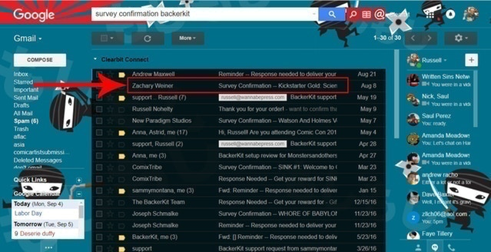
STEP 2: Scroll down.
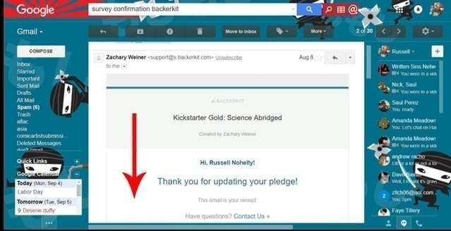
STEP 3: At the bottom, there is a unique link to get back to your survey. Click it.
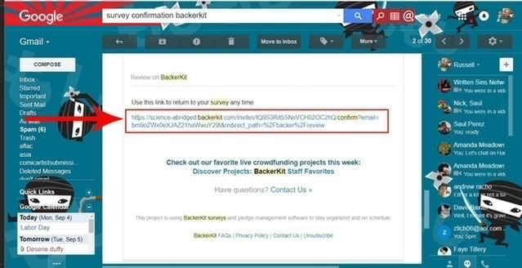
STEP 4: That link will take you to your survey. Once you finish your survey you will be taken to your survey confirmation page.
If you have ALREADY filled out the survey, then you can use the same link to get to your digital rewards.
(FYI: If you need to change your address, you can do it here.)
Once you get to that page, then click the link for digital rewards.
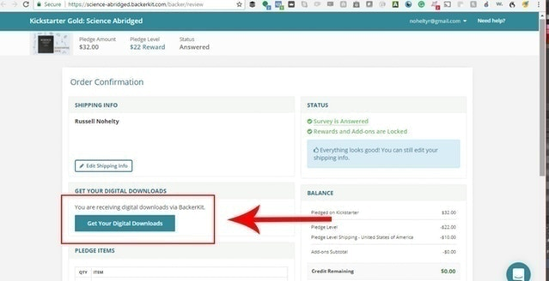
STEP 5: BOOM! There they are.
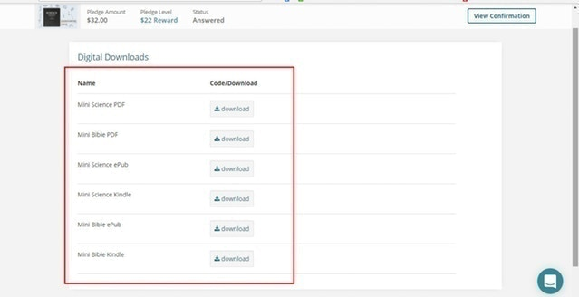
If you have digital rewards only, then this will fulfill your rewards. If you have physical rewards then I hope to get those by the middle of next month and then I will fulfill it hopefully before, or immediately AFTER getting back from my vacation to Cabo.
Hope you enjoy the book(s)!
Russell

