The SPARK Method Case Study

Course Title | Flawless Project Management with the SPARK Method
Course Learning Goals | - Know where to start with Project Management, communicate and cooperate effectively.  - Know how to lead a team.
Case Study Name | IT Infrastructure, Zipper ltd.

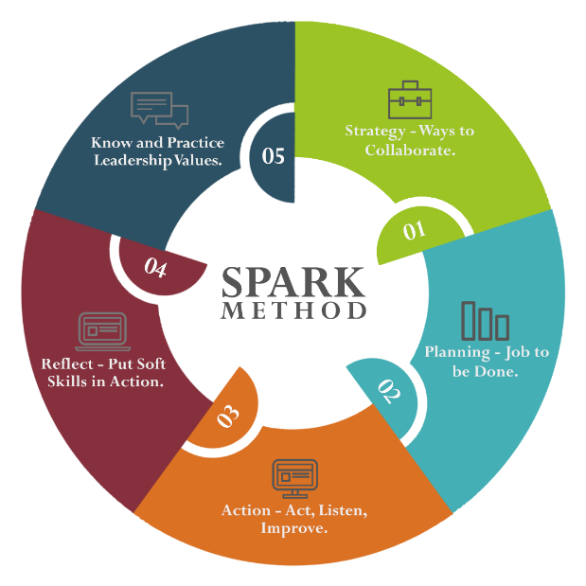

An international Customer (in our Case Study called Zipper Ltd.), is producing high quality leather products (jackets, wallets, belts, shoes and many other articles).

Zipper Ltd. decided to concentrate solely on their primary work: high quality production and client relations and to grow in those core business areas.

Because of that decision, Zipper Ltd. want to outsource everything that is not in their core business to third parties. They do not want to spend their own resources on following areas:

- Internal company IT infrastructure:
  - Cabling between computers,
  - Switching and routing between computers and servers,
  - Web servers (company website and online shop),
  - Internal e-mail and chat services,
  - Database servers,
  - Payment methods and card security;
- Marketing materials production:
  - Photography and video/audio production for marketing purposes,
  - Ads creation,
  - Marketing Funnel creation,
  - Marketing campaigns creation;
- They have three production facilities in:
  - Canada,
  - Poland and
  - India.
- As of now, each of their production facilities have local infrastructure, including servers, and Client would like to unify their governance system. They are opened for proposal on the best way to do that.
- For this project Zipper Ltd. dedicated a project team to work on proposal, solution and to cooperate with during the project:
  - Chief Technical Officer (CTO) to whom the whole project team reports and who report directly to Chief Executive Officer (CEO) of the Zipper Ltd.
  - 3 Project Managers in charge for each location: Zipper Ltd. Canada, Zipper Ltd. Poland and Zipper Ltd. India.
  - 1 Network Engineer and 1 Marketing representative for each target area per location; making in total 1 Project Manager and 2 team members per location, or in total 3 PMs and 6 team members.
  - Zipper ltd says that they can invest 100 000 USD in this project, but they do not know how much this whole project may cost.
  - Due to new regulations and demands, Zipper Ltd. must implement needed changes in the next 4 months.
- Zipper ltd. Has 500 employees in Canada, 400 in Poland and 600 in India. 100 Employees in each location should have a computer directly connected with a cable to the IT network and the rest of the employees have handheld WiFi devices.

You are part of Flawless Project Management (FPM) Company. Your tasks are to:

  - Lead FPM Project Team and find technical solution for Zipper Ltd. Customer.
  - FPM Company has great IT experts, but they do not have experience with Marketing and also, you do not have resources on site to perform cabling activities.
  - You will need to find appropriate 3rd party companies to provide those services and communicate with them.
  - Inside FPM Company, you will report to your Chief Technical Officer and then to CEO. You will send reports to CTO weekly and to CEO monthly.
  - In your FPM Project Team, you will have 5 IT Experts. Their knowledge covers IT area of the project tasks; however, they have only a basic knowledge of Marketing.

Now, let’s go through the five SPARK modules and address parts of this Case Study in each of them.
Make sure to:
- Listen to all Educational materials;
- Download all checklists and templates;
- Do all exercises;
- Prepare your own folder for the future project as stated in those Checklists.

