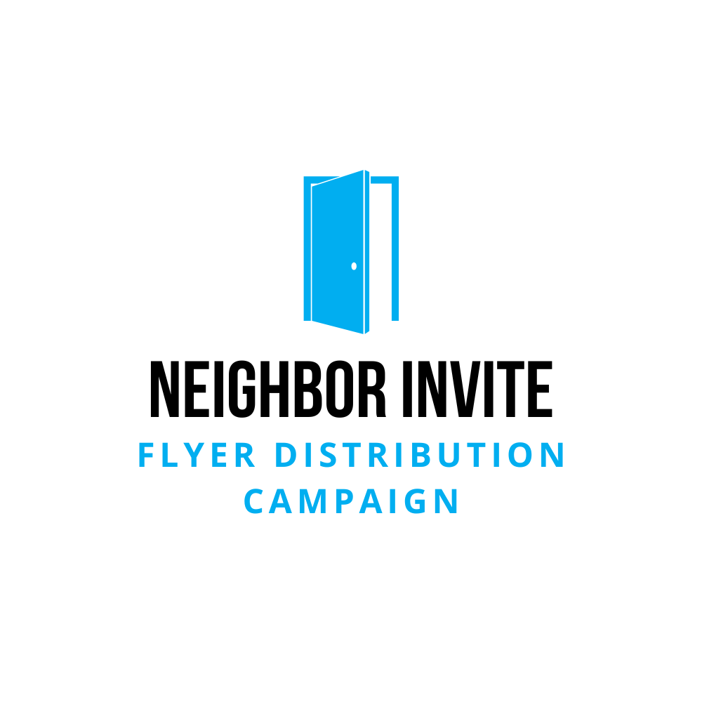 | Editable Emails

Overview
The Neighbor Invite campaign is about more than just delivering flyers—it’s about creating opportunities for our neighbors to experience kindness, connection, and community. Each email in this series is designed to inspire, train, and encourage volunteers and leaders by helping them see the bigger picture: they’re part of a movement that can lead to restored relationships, newfound purpose, and steps toward Jesus.
This email sequence provides clear instructions while casting vision, reminding recipients that their efforts may result in someone finding hope, making a friend, or taking a life-changing next step. Volunteers aren’t just completing a task—they’re helping transform lives and strengthen the community, all while experiencing the joy and purpose that comes from serving others.

Email 1: Team Leader Recruitment
Subject: Let’s help our community together—can we chat?
Body:
Hey [First Name],
I believe you could play a key role in something exciting. Our church is launching the Neighbor Invite campaign—a practical way to extend kindness, community, and hope to those living around us. We’re looking for a few people to help lead and guide this effort, and I think you’d be great.
This isn’t just about distributing flyers. It’s about giving people a chance to experience meaningful connections, find hope, and perhaps take steps toward a stronger sense of purpose. We want leaders who can help others catch that vision.
Could we chat this week? I’d love to share more and hear your thoughts.
Just reply and let me know when you’re free.
Thanks so much,
[Your Name]

Email 2: Volunteer Recruitment (with Ask Video)
Subject: You can help make a difference in our community—here’s how!
Body:
Hey [First Name],
Imagine if a simple act—like inviting someone to church—was the first step toward hope, healing, or new friendships for someone in your neighborhood. That’s what the Neighbor Invite campaign is about, and I’d love for you to be part of it!
We’re looking for volunteers to walk a route and drop off invitation flyers. These aren’t just pieces of paper—they’re opportunities for people to find community and support. You never know how one invitation could impact someone’s life.
I’ve got a quick video that explains how it works:
👉 [Watch the Ask Video Here]
Would you consider walking a route? You can pick up flyers at our weekend services or during the week at the office. Reply and let me know if you’re in!
Thanks in advance for making a difference,
[Your Name]

Email 3: Follow-Up to Volunteer Recruitment
Subject: Still thinking about joining the Neighbor Invite?
Body:
Hey [First Name],
I wanted to check in and see if you’ve had a chance to think about joining the Neighbor Invite campaign. It’s a simple yet powerful way to be part of something that brings hope and connection to our community.
If you haven’t seen it yet, here’s a short video explaining the heart behind the campaign:
👉 [Watch the Ask Video Here]
Taking a walk, delivering flyers—it might seem small, but it can be the beginning of someone finding community or peace in a challenging season. We’d love to have you join us.
Let me know if you’re interested!
Grateful for you,
[Your Name]

Email 4: Volunteer Confirmation & Training Video Invitation
Subject: You’re on the team—here’s how to get ready!
Body:
Hey [First Name],
Thank you for stepping up to be part of the Neighbor Invite campaign! You’re joining a movement of people who believe in extending kindness and building connections in our community.
To help you feel prepared, we’ve put together a short training video with practical tips for your route. Even if this is your first time, you’ll find it super helpful.
👉 [Watch the Training Video Here]
Flyers are available for pickup at weekend services or during the week at the church office—whatever works best for you.
Once you’ve watched the video, just reply and let me know you’re ready.
Excited to have you with us!
[Your Name]

Email 5: Follow-Up to Confirm Training Video Was Watched
Subject: Quick check—did you get a chance to watch the video?
Body:
Hey [First Name],
Just wanted to follow up—have you had a chance to watch the Neighbor Invite training video? It’s short but packed with helpful tips to make your flyer delivery smooth and meaningful.
👉 [Watch the Training Video Here] (if you haven’t yet)
Your role in this campaign matters. You’re helping create opportunities for people to find belonging, community, and maybe even a fresh start. Let me know when you’ve had a chance to watch it—I’m cheering you on!
Thanks,
[Your Name]

Email 6: Route Pickup Reminder
Subject: Your route is ready—pick up your flyers this week!
Body:
Hey [First Name],
Good news—your Neighbor Invite flyers are ready to go! You can pick them up at weekend services or swing by the church office during the week, whichever is easier for you.
This isn’t just about delivering flyers—it’s about opening doors for people to find hope, friendships, and maybe even healing. You get to be part of that. How cool is that?
Let me know if you have any questions.
We’re so grateful you’re part of this!
[Your Name]

Email 7: Distribution Start Reminder
Subject: Ready to go? Your route awaits!
Body:
Hey [First Name],
It’s time! As you head out on your route, remember—you’re doing more than dropping off flyers. You’re extending an invitation that could lead to meaningful change in someone’s life. People find community, new friendships, purpose, and even improved well-being when they connect with a local church.
Here are a few reminders:
✅ Take a moment to pray before you go.
✅ Place flyers in mailboxes (and skip houses with “No Solicitation” signs).
✅ Stay hydrated, smile, and enjoy the walk!
We’d love to hear how it goes—fill out our quick feedback form after your route:
👉 [Fill Out the Feedback Form]
Thank you for being part of something that matters!
[Your Name]

Email 8: Midway Encouragement & Feedback Reminder
Subject: How’s your route going? We’d love to hear!
Body:
Hey [First Name],
You’re out there making a difference—thank you! Walking those routes isn’t just exercise (though that’s a bonus!); you’re giving people a chance to connect, find support, and explore something deeper.
Got a fun story or unexpected moment from your route?
We’d love to hear it! Sharing your experience encourages everyone involved.
👉 [Fill Out the Feedback Form]
Thanks for helping make our community stronger.
You’re a big part of this!
[Your Name]

Email 9: Final Thank You & Story Collection
Subject: You did it—thank you for being part of this!
Body:
Hey [First Name],
You completed your route—and we can’t thank you enough. Every flyer you delivered was more than paper; it was an invitation to hope, community, and a fresh start for someone.
If you have any stories or reflections from the experience, we’d love to hear them! Your feedback inspires us and helps shape future efforts.
👉 [Fill Out the Feedback Form]
Thanks for being part of something bigger than yourself. This community is better because of people like you.
With gratitude,
[Your Name]

