Dancing Sculptures

Essential Question How have artists from different time periods and cultures created sculptures of dancing figures? How can we use simple materials to create a dancing sculpture that stands on its own?

Grade 3rd

Time 50 minutes

Art Concepts Sculpture, geometric, balance, weight

Materials Recycled cardboard (cereal box, side of a thicker cardboard box, unrolled toilet paper or paper-towel roll, etc.), aluminum foil, scissors, tape and/or glue
Optional: recycled materials that can be found around the house (e.g., clothespins, thin wire, sticks or twigs, other small objects)

Artworks in Focus Untitled (Dancing Man), 1981 by Joel Shapiro
Dancing Figurine, Roman Period (30 BCE - 395 CE) or later by unknown artist
Dancing Ganesha, Lord of Obstacles, 16th-17th century by unknown artist
Dance Headdress, circa 1880 by unknown artist

Talking about Art Sculptures are three-dimensional artworks that can often be walked around and viewed from all sides. Look at the sculpture from 1981 made by American artist Joel Shapiro. How would you describe it? Shapiro called this artwork Untitled (Dancing Man). If the sculpture suddenly came to life, what do you think the figure would do first? What do you see that makes you say that? Perhaps the figure might move in one direction or another, or maybe leap to the side and land on his other foot.

Shapiro’s sculptures often represent movement and form. Here, the artist used geometric shapes to create the body of a dancing man. He was inspired by artists from around the world and from all time periods who have used various materials to create sculptures that show humans in movement. These artworks often represent a specific person or sacred entity who is dancing. Scholars believe they were used in spiritual rituals and dances, or were created purely to celebrate the human body, movement, form, and balance.

In all of these different contexts, each artist had to consider the materials they would use to make their sculpture and how they would balance their figure to make it stand up. Let’s look at some examples of dancing figures in LACMA’s collection and consider some of these questions: Is the sculpture standing on one or two legs? How did the artist make the sculpture stand on its own? Is the sculpture attached to a base or to something else? How does the body appear to be balancing itself?

Dancing Figurine was made in Egypt more than 2,000 years ago. Notice how the figure balances on one leg by propelling his body forward with one arm and sticking the other leg out behind him.

Dancing Ganesha, Lord of Obstacles was made in India in the sixteenth or seventeenth century. The act of dancing is spiritually significant in Hinduism, and the Hindu deity Ganesha dances to bring joy to his parents. He is often shown stepping to the right or left with one foot and thrusting the opposite hip outward, creating a strong sense of movement. Also notice that the artist balanced the figure by anchoring him to a base.

The dancing figure on Dance Headdress is part of a larger headdress made in Papua New Guinea during the nineteenth century by the Sulka people. The headdress would have been worn in ceremonial dances that marked important occasions such as births, marriages, and the deaths of important members of society. The artist made the figure and headdress by wrapping bark strips and natural fiber around a wood frame. The figure is strong in its pose because it is balanced on two legs and supported by the rest of the headdress. See how the figure holds on to the arching wood frame above it?

Pose and Balance Movement Activity
- Get up and stand in the same pose as Shapiro’s Dancing Man. Try to hold the pose for a little while. What do you have to do to hold the pose? Where do you feel all the weight of your body?
- What are the forces that push on your body and make you lose your balance? You will have to move your arms slightly to keep your balance, and you should feel all your weight in the leg that is touching the ground.
- Now try to copy the poses of the other dancing figures we discussed. Which pose feels easiest to balance in? Pay close attention to the position of your legs, torso, and arms. Why is it easier to balance and stand in that pose than in others?

Making Art Shapiro said that he "wanted to make work that stood on its own, and wasn't limited by architecture and by the ground and the wall and right angles.” We are going to make a dancing sculpture that stands all by itself!
- Choose materials that you have at home to make your sculpture, such as aluminum foil and cardboard.
- Your sculpture should have a head, torso, arms, and legs. The torso should act like a frame that holds the arms and legs. Your legs can be the part of the sculpture that stands on the ground and holds the body up. The arms of your sculpture should help create balance.
- Position your sculpture to see if it stands on its own. If it doesn’t, adjust the arms, legs, and body until it stands. Remember how you had to adjust your pose to keep your balance?
- Does it stand up now? If not, you might need to anchor your sculpture to a cardboard base, or create an extra “leg” to hold it up.
- When you finish your first sculpture and it successfully stands on its own, try making a second one using different materials. If your first sculpture had both legs on the ground, set yourself a challenge and try to make a sculpture with just one leg on the ground!

Reflection What kinds of materials did you use? Which were easiest to work with? Why do you think they were easier to work with than others?

What techniques did you use to join the different parts of your sculpture together? How did you make it stand up?

How could you make your sculpture stronger next time?

Curriculum Connections California Arts Standards for Public Schools—Visual Arts

3.VA:Cr1.1: Elaborate on an imaginative idea. 4.VA:Cr2.1: Explore and invent art-making techniques and approaches.
3.VA:Re7.1: Speculate about processes an artist uses to create a work of art.

California Arts Standards for Public Schools Dance

3.DA.Cr1 a: Experiment with a variety of self-identified stimuli (e.g., music/sound, text, objects, images, notation, observed dance, experiences) for movement.
Next Generation Science Standards

3–5-ETS1-1: Define a simple design problem reflecting a need or a want that includes specified criteria for success and constraints on materials, time, or cost.
Examples
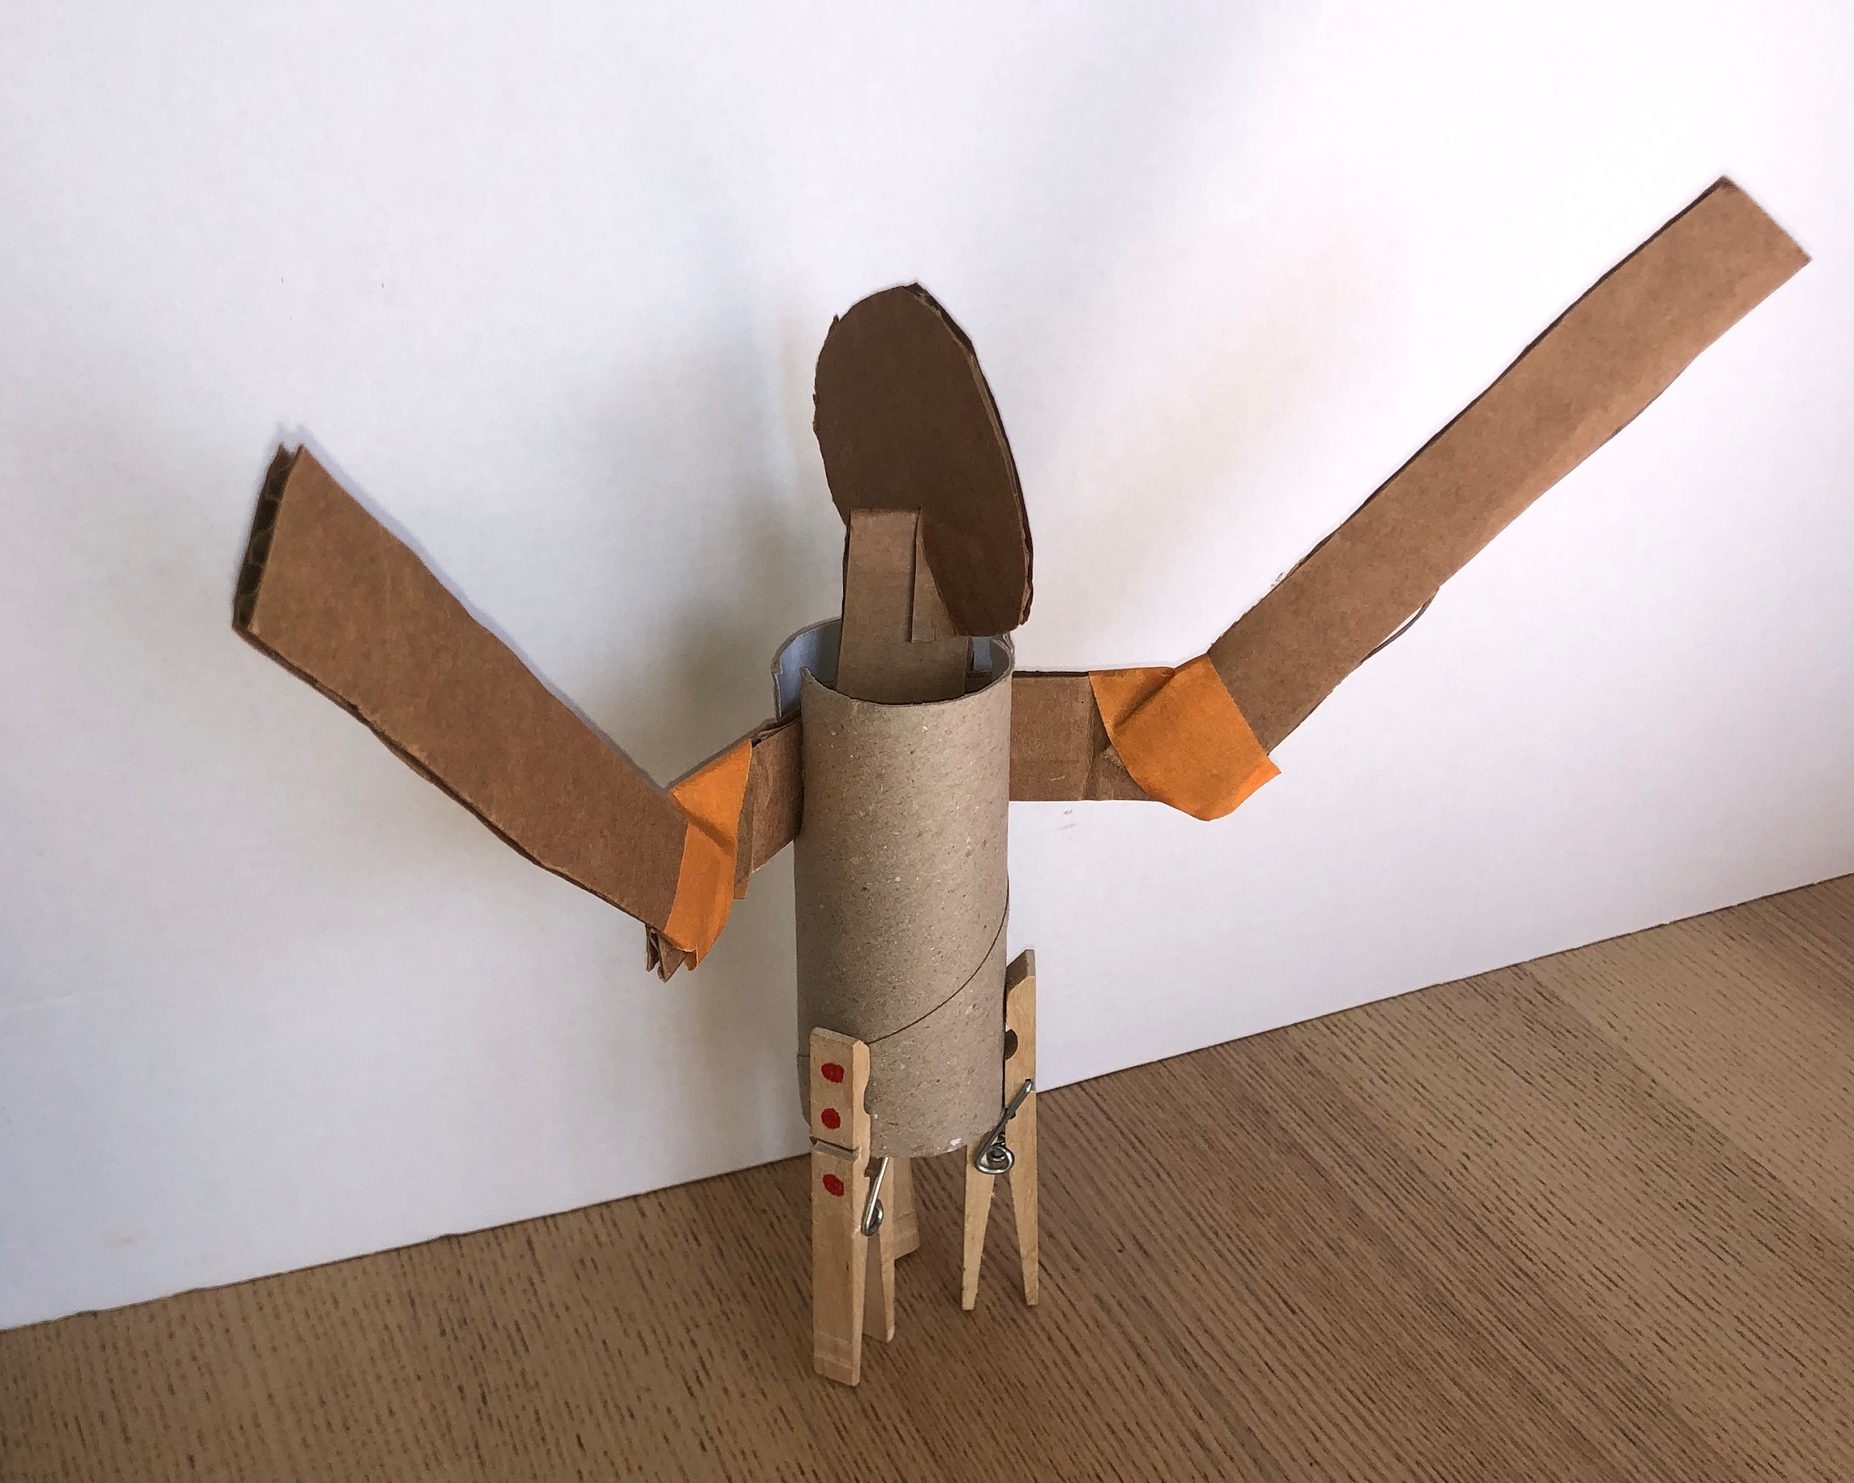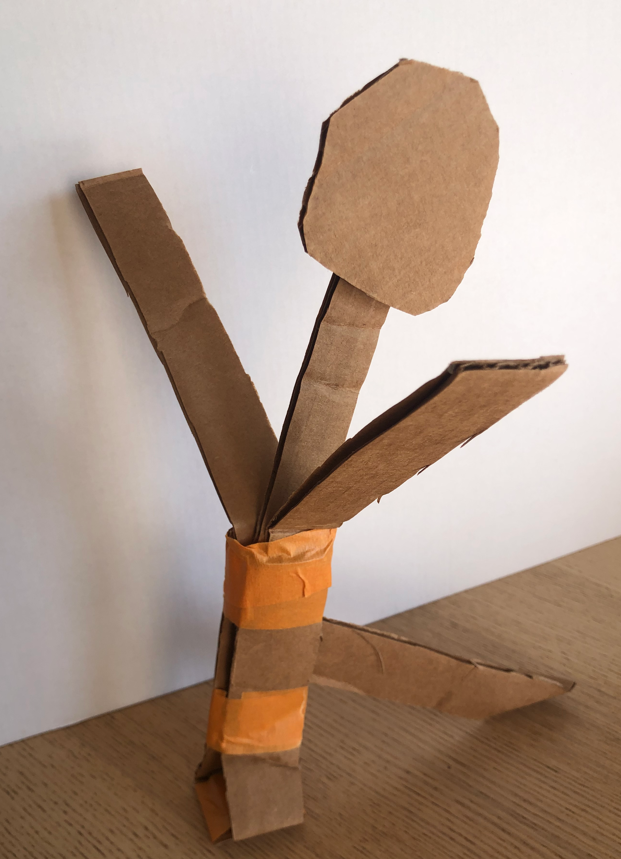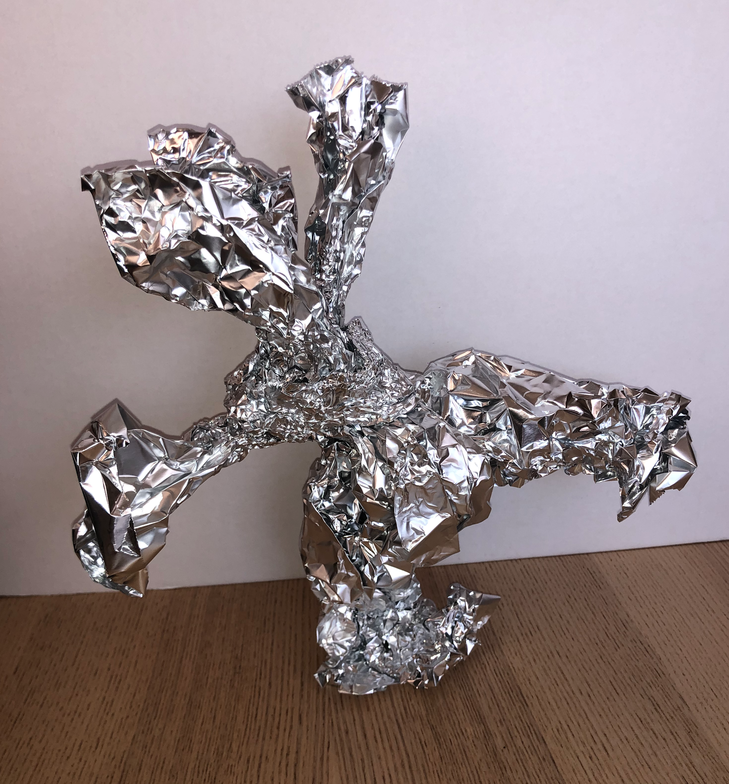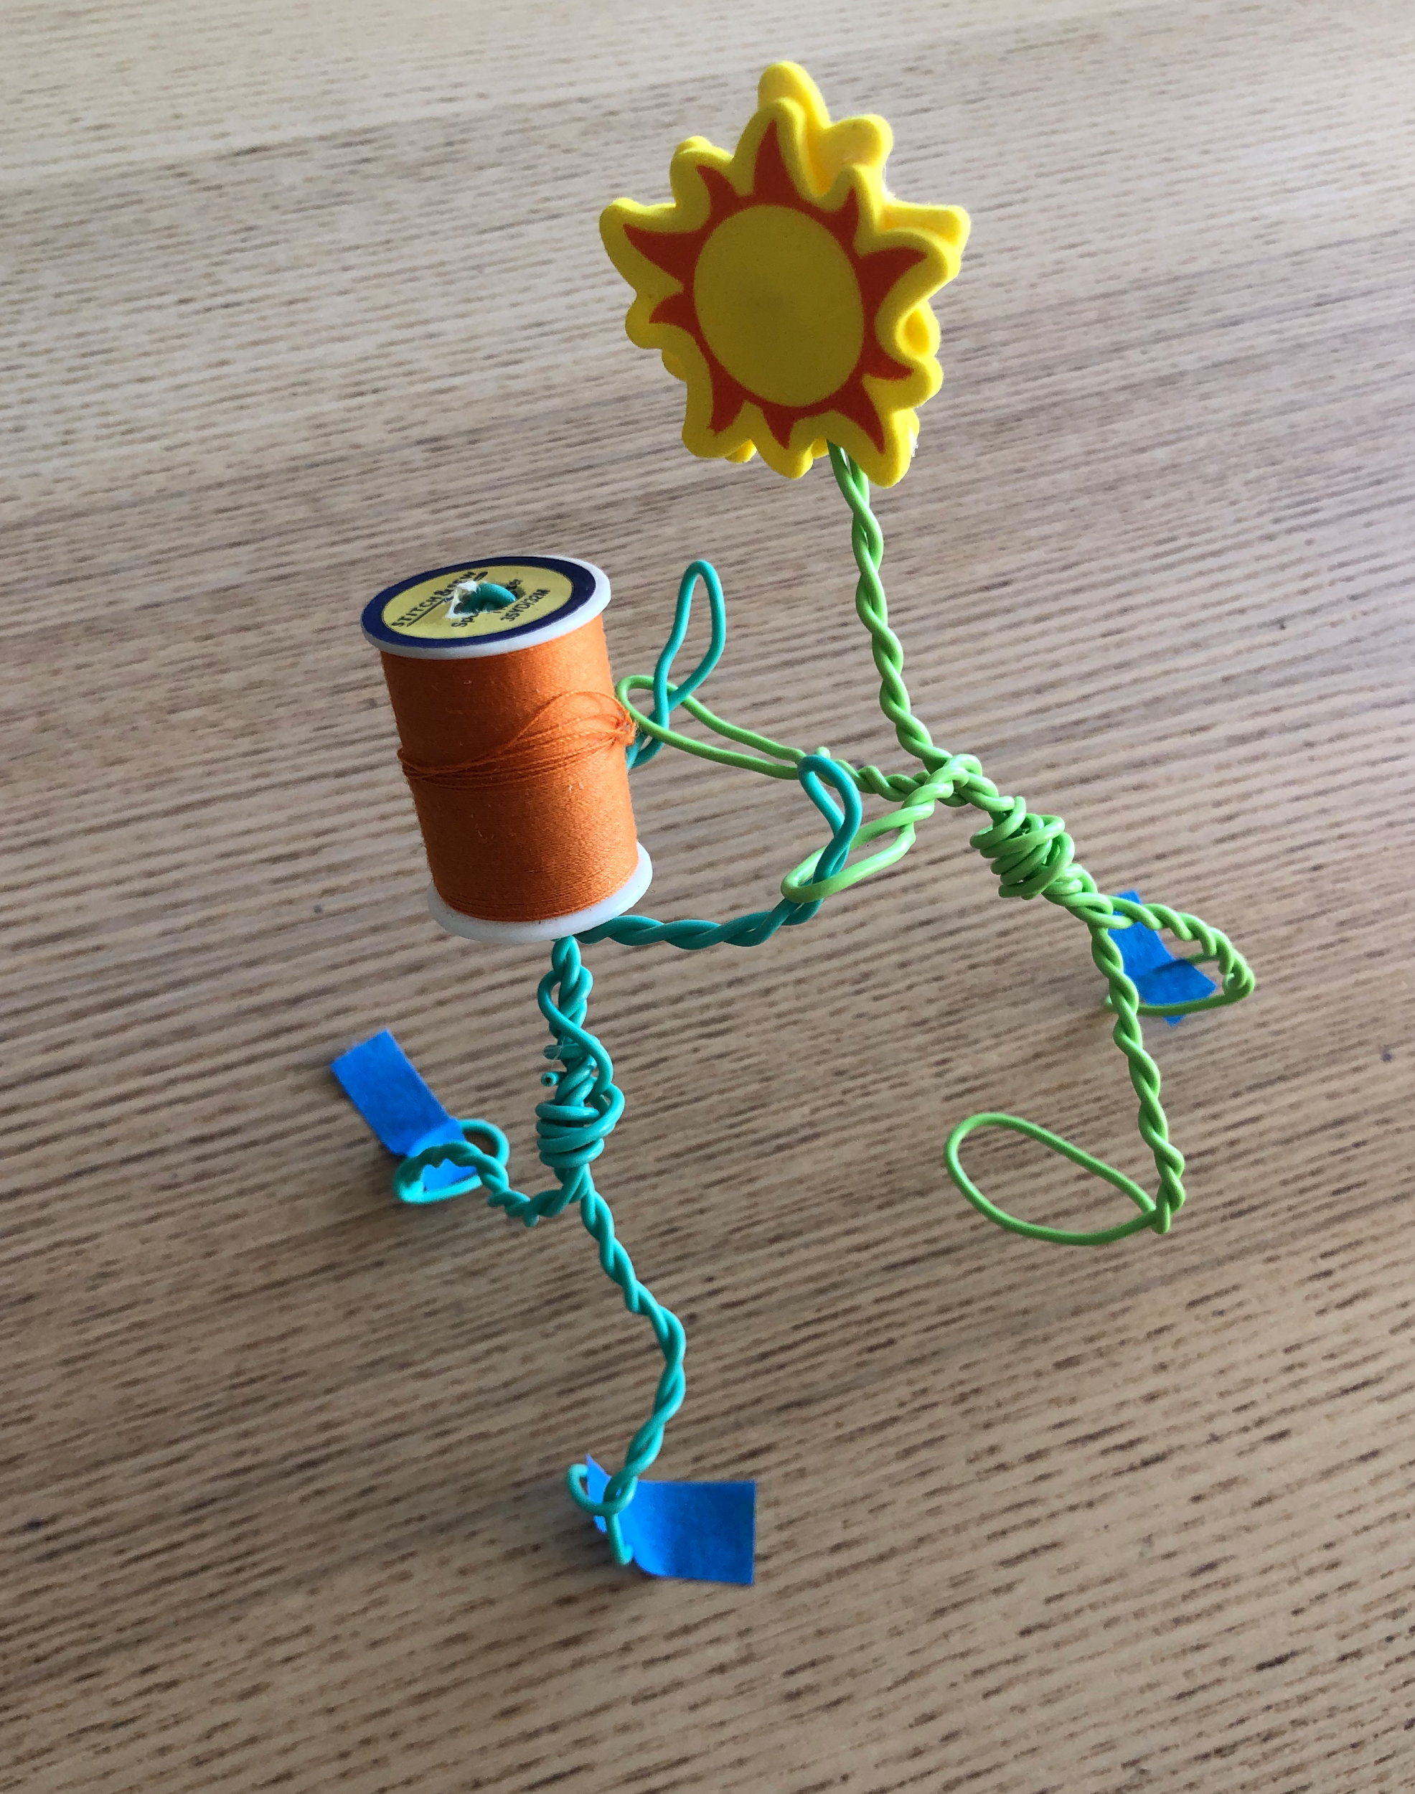
Materials from left to right: 1) cardboard, toilet paper roll, and clothespins; 2) cardboard and tape only; 3) aluminum foil; 4) wire, foam stickers, spool of thread

Prepared by Billie Rae Vinson with the Los Angeles County Museum of Art (LACMA) Education Department

