Date : 4th November 2012
Theme : Biblical values of GOD’s Kingdom
Topic : I will Reproduce leaders of 12 (II)
Key Verse : Luke 12:42, 43
⁴² The Lord answered, “Who then is the faithful and wise manager, whom the master puts in charge of his servants to give them their food allowance at the proper time? ⁴³ It will be good for that servant whom the master finds doing so when he returns.

Review: I will Reproduce leaders of 12 (I)
- Nehemiah’s leadership model
- his concern
- his courage
- his consolidation

I will reproduce leaders of 12 (II)

- What are the Benefits to Reproduce leaders of 12?
- Good to serve as leaders Luke 12:42, 43
- Provide spiritual fathers Philippians 2:22
- Supply labourers Matthew 9:38
- Kingdom of God grows

- How to REPRODUCE leaders?
- The PRODUCT
- shepherds, disciplemakers, all who win, consolidate, disciple, send.

- The PROCESS Acts 2:22; 1 Thessalonians 2:11,12
- strengthening
- encouraging
- charging

- STRENGTHENING (TTT)
- by teaching (truths) 2 Timothy 2:2
(Purpose: produce mindset change to please God)

- by training (habits) Hebrews 5:14
(Purpose: produce Christ-like character)

- by transmitting (Christ’ grace-based DNA) 2 Timothy 2:1
(Purpose: gratitude to God)

- ENCOURAGING (MMM)
- by mentoring (showing how)

- by modeling (example setting)

- by motivating (PPPP)
- progress
- problem
- principles
- prayers

(Purpose: faithfulness, fruit will remain)

- CHARGING Luke 12:44
(Purpose: every one matured in Christ. Colossians 1:29)

Chain of Multiplication in New testament (Adapted from Multiplying Disciples by Waylon. B. Moore)

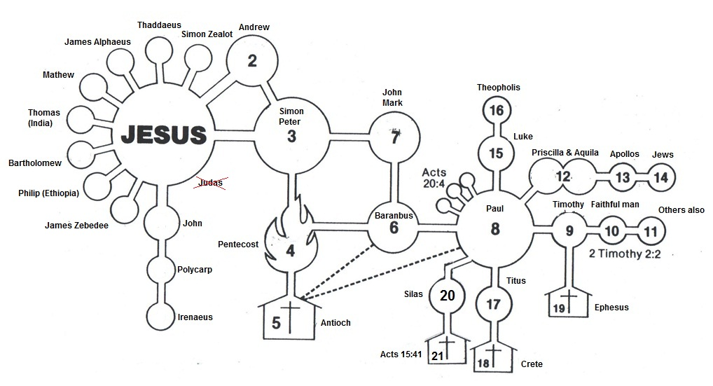
BC Values

- I am caught by the Vision (to be fruitful) 2 Corinthians 4:7
But we have this treasure in jars of clay to show that this all-surpassing power is from God and not from us.

- I am committed to Cell Life Acts 2:42
They devoted themselves to the apostles’ teaching and to the fellowship, to the breaking of bread and to prayer.

- I am a Disciple (& I make Disciples)
Luke 9:23
Then he said to them all: “If anyone would come after me, he must deny himself and take up his cross daily and follow me.

John 15:8
This is to my Father’s glory, that you bear much fruit, showing yourselves to be my disciples.

- I am passionate about Spiritual disciplines
1 Timothy 4:8
For physical training is of some value, but godliness has value for all things, holding promise for both the present life and the life to come.

Isaiah 55:8, 9
⁸“For my thoughts are not your thoughts, neither are your ways my ways,” declares the Lord. ⁹ As the heavens are higher than the earth, so are my ways higher than your ways and my thoughts than your thoughts.

- I am submitted to spiritual Authority 1 Peter 5:5-6
⁵ Young men, in the same way be submissive to those who are older. All of you, clothe yourselves with humility toward one another, because, “God opposes the proud but gives grace to the humble.” ⁶ Humble yourselves, therefore, under God’s mighty hand, that he may lift you up in due time.

- I value life-long Relationships
Ruth 1:16
But Ruth replied, “Don’t urge me to leave you or to turn back from you. Where you go I will go, and where you stay I will stay. Your people will be my people and your God my God.

Mark 3:14
He appointed twelve—designating them apostles—that they might be with him and that he might send them out to preach

- I must be Equipped for battle Ephesians 6:11
Put on the whole armor of God so that you can take your stand against the devil’s schemes.

- I will raise up the next Generation
Isaiah 58:12 (KJV)
And they that shall be of thee shall build the old waste places: thou shalt raise up the foundations of many generations; and thou shalt be called, The repairer of the breach, The restorer of paths to dwell in.

2 Timothy 2:2
And the things you have heard me say in the presence of many witnesses entrust to reliable men who will also be qualified to teach others.

- I will Reproduce leaders of 12 Mark 3:14,15
He appointed twelve — that they might be with him and that he might send them out to preach and to have authority to drive out demons.

