The SPARK Method Case Study

Course Title | Flawless Project Management with the SPARK Method
Course Learning Goals | - Know where to start with Project Management, communicate and cooperate effectively.  - Know how to lead a team.
Case Study Check List Area | - “K” - Know and Practice Leadership Values.

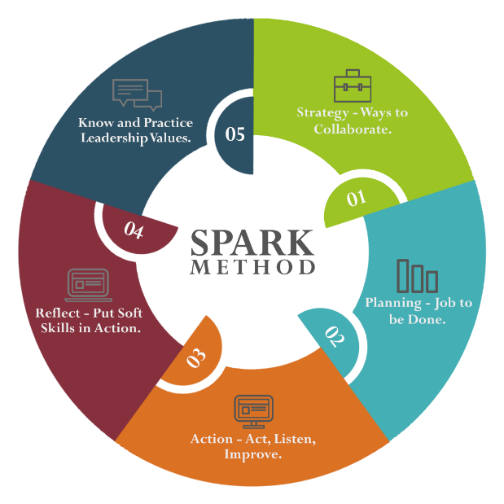
Case Study Section Title | Task Description | Training Lesson Completed | Case Study Task Completed | Tested on a Real Project | Feedback  Gathered | Wrote Comment How It Worked
“K” –  KNOW THE REAL LEADERSHIP VALUES  Live with True Leadership Values Every Day | - Create a Social Contract with your team as one of the basic practices to implement trust in your team.
 | - Download xMind and Excel templates.
 | - Copy it to your folder for the future projects.
 | - Perform Social Contract with your team.
 | - Organize 1-on-1 sessions to:
 | - Provide and get feedback and expectations from your team members.
 | - Practice to speak last. Switch off your own ego!
- Organize at least two, short, 5-10-minute meetings to give immediate positive feedback.
Praise your team members!
- Organize at least two, short, 5-10-minute meetings to give constructive feedback.
Criticize situation not the person! Help to your team members to grow.
 | - Organize retrospective with your team members
 | - Collect answer to the question: “What went well?”
 | - Collect answer to the question: “What didn’t go well?”
 | - Collect answer to the question: “What puzzles us?”
 | - Take actions to your backlog / WBS and make retrospective integral part of your system.
 | - “Values are not only your own, but also VALUES YOU WALK PAST”.
 | - React instantly on gossip and say that that is not something we want to have in our team.
 | - React when someone is treated badly.
 | - React if someone is asking for a help even if it is not in your own team.
 | - Write down your experiences.

