Business Idea to Launch Checklist
DigiArtCandy.com
Facebook.com/digiartcandy
We’ll demonstrate this in the course!

If you’re just setting up your business and need just a bit of help getting started, the list below will be really helpful for you. Those of you already in business might find some of this helpful as well. Here are a few things to remember first:

- Michele Grant created this. She’s from Las Vegas, Nevada, so the information is U.S.-based. Just utilize whatever is helpful for you.

- Copy and paste (or portions of it) into an Asana list, and you’ve got it! In case you need help with that:

  - Copy (PC): CTRL + C. Just select all desired data here first.
  - Paste (PC): CTRL + V.
  - Copy (Mac): Command + C. Just select all desired data here first.
  - Paste (Mac): Command + V.

- Personalize this for YOU! Even if you already have a business, this might be helpful.

- Remember that if the text line ends with a colon, it will become a section header in Asana.

Below is a screenshot from Michele’s Asana showing you how your copy and paste will look in Asana. Time to get it done now!
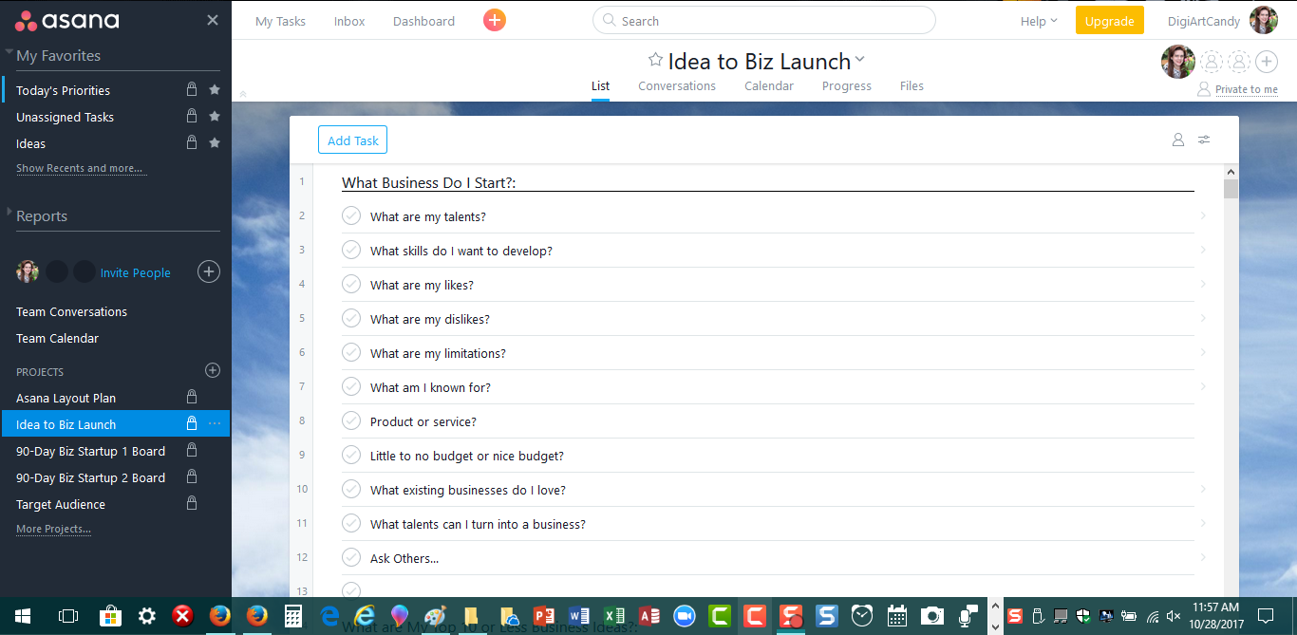

Start copying then pasting into Asana from HERE forward…

What Business Do I Start?:
What are my talents?
What skills do I want to develop?
What are my likes?
What are my dislikes?
What are my limitations?
What am I known for?
Product or service?
Little to no budget or nice budget?
What existing businesses do I love?
What talents can I turn into a business?
Ask Others

What are My Top 10 or Less Business Ideas?:
List my top 10 business ideas.

What are My Top 3 Business Ideas?:
Narrow down to top 3 business ideas.

What is My Final Business Idea?:
Decide on my final business idea.

Who is My Ideal Client?:
What social media pages do they follow?
What Facebook groups are they a part of?
What social media pages have my ideal client following already?
Who is NOT my ideal client? This helps me identify who is.

Determine My Financial Goals for This Year:
How much do I WANT to gross?
Multiply desired gross by 2. This equals how much gross to make.
Divide this total by 12. This equals how much gross to make monthly.
Now price my products or services to make that much gross/month.
This helps me set sales goals!

Set Up My Asana:
Sign up for Asana and personalize.
Gather all of my tasks in any form and put in one place.
Type all of my tasks into a Microsoft Word document.
Create a new list in Asana and name it "Temporary Tasks."
Copy and Paste my Microsoft Word list into Temporary Tasks.
Decide exactly how you plan to work on 1-3 tasks/day in Asana. Create logical categories/Section Headers for my tasks.
Decide if you want a board or list for each section, then create just the titles.
Create your desired dividers in Asana's left sidebar.
Move your projects around in Asana's left sidebar as desired.
Create sections within your projects that work with your Asana use desires.
Start copying/pasting "Temporary Tasks," one at a time, into appropriate projects
Be sure to not delete this temporary folder (you might need it).
Start working on 1-3 major tasks daily.
Be sure daily tasks are assigned to you and have due dates.
Now you can check your calendar at a glance!

--BUSINESS SETUP IDEAS--:
Market Research:
What problem does my business solve?
Do they want it? Check social media (Facebook, YouTube, Quora, etc.)
Who’s my target market?
Where can I find my ideal clients?

Business Setup:
Business name
Legal structure (sole proprietorship, partnership, LLC, Corporation, S-Corporation)
Tagline
Core Values
Mission Statement

Branding:
Logo
Branding Colors
Branding Fonts
Branding Look & Feel

Business Licensing:
Business License (federal, state, other)
Fictitious business name
Federal Employer ID Number (FEIN)
Licensing
Permits
Sales tax permits
Trademarks
Copyrights

Business Planning:
Business Plan
Marketing Plan
Sales Plan
Social Media & Blog Content Schedule
Business loan
Daily, Weekly, Monthly, Quarterly, Annual Goals
Startup costs
Sales forecast
Profit and loss statement
Cash flow statement
Balance sheet

Business Equipment:
Mobile phone
Landline
Fax machine
Computer system
Electronics
Software
Training
Copier
Printer

Website:
Domain name
Domain registration
Web hosting
Web design
Email
SEO

Business Identity:
Business cards
Gmail Email signature
Letterhead
Envelopes
Branded PowerPoint
Forms
Promotional Materials
Media kits
Job order forms
Organizational chart
Packing slip forms
Sales forms
Custom mailing labels
Custom notecards
Proposal templates
Contract templates
Survey forms
Signage
Postcards
Thank you cards
Birthday cards
Custom graphics
Stationery
Shop signage
Uniforms
T-shirts
Press release forms

Business Particulars:
Elevator pitch
About me
About my business

Social Media Profiles:
Facebook
YouTube
Pinterest
Instagram
LinkedIn
Snapchat
Other

Sales:
Blog
Email newsletter
Direct mail
Promotions
Advertising
Cold calls
Other
Sales Venues (Craigslist, Etsy, Facebook, Upwork, etc.)

Finances:
Business Bank Account
Business credit cards
Business checks
Accounting System
Credit Cards
Payment System
Revenue tracking system
Order processing
Invoice processing
Startup expenses
Ongoing expenses
Budget
Financial forecasts

Office Space:
Leasing or Home-based
Office furniture
Computer system
Telephone
Fax
Insurance

Business Help:
Mentors
Legal help
Facebook Groups
Social Media Groups
Online research
Paid Clubs

Employees:
Payroll processing system
Hiring process
Employee exit process
Job advertising
Application form
Job descriptions
Interview Questions
New employee orientation
New hire checklist
Employee handbook
Quarterly review forms
Annual review forms
Meeting agendas
Employee exit form
Disciplinary forms
Expense report forms
Incident reports
Health insurance
Mileage logs
Training
Annual party

Business Systems:
Appointment scheduling system
Calendar system
Databases
Customer Relation Management (CRM) Software
Accounting Software
Time management software
Project management
Anti-virus software
e-Signatures
Landing pages
Email management system
Microsoft Office
Adobe Suite
Social media management tool
Video recording
Image & Graphic Sites
Invoicing & Time Tracking
File sharing
Point of sale systems
Email system

Outsourcing:
Accountant
Attorney
Event Planner
Social Media Help
Virtual Assistant

Education & Organizations:
Trade associations
Chamber of Commerce

Physical Locations:
Find location
Lease or Buy Space

Launching:
Press releases
Social media build-up plan
Webinar plan
Facebook live plan
Advertising plan
Week of opening plan
Opening Day plan

Insurance:
Property insurance
Liability insurance
Worker’s compensation
Life insurance
Disability insurance
Healthcare insurance

