**Linkedin Optimization**

1. **Choose the right profile picture for LinkedIn**
   * Your profile picture is your calling card on LinkedIn. Here are some quick tips to start with: make sure the picture is recent and looks like you, your face should take 60% of the same, long-distance shots don’t stand out, wear what you would like to wear to work, and smile with your eyes!
2. **Add a background photo**
   * Your background photo is the second visual element at the top of your profile page. It grabs people’s attention, sets the context and shows a little more about what matters to you. More than anything, the right background photo helps your page stand out, engage attention and stay memorable.
3. **Make your headline more than just a job title**
   * There’s no rule that says the description at the top of your profile page has to be just a job title. Use the headline field to say a bit more about how you see your role, why you do what you do, and what makes you tick.
4. **Turn your summary into your story**
   * Your summary is your chance to tell your own story – so don’t just use it to list your skills or the job titles you’ve had. Try to bring to life why those skills matter – and the difference they can make to the people you work with.

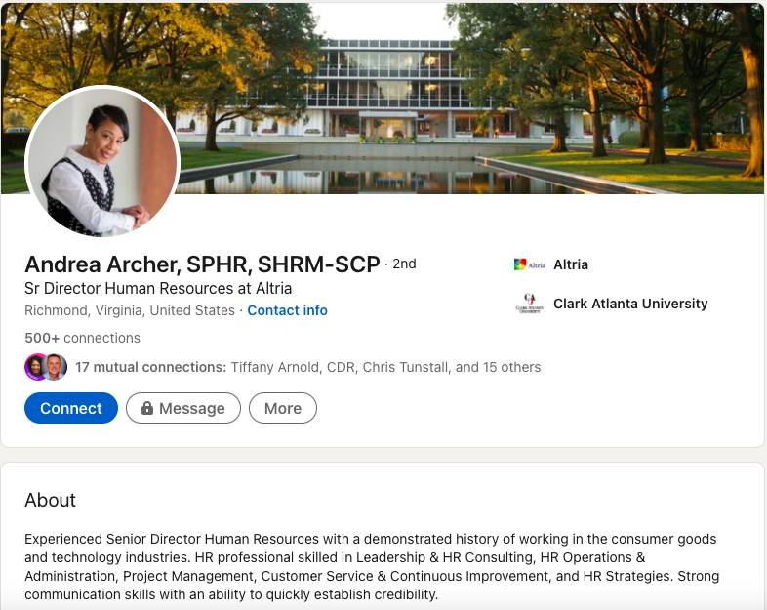

1. **Declare war on buzzwords**
   * Buzzwords are adjectives that are used so often in LinkedIn headlines and summaries that they become almost completely meaningless. Our regular rankings of the most over-used buzzwords include terms like ‘specialized’, ‘leadership’, ‘focused’, ‘strategic’, ‘experienced’, ‘passionate’, ‘expert’, ‘creative’, ‘innovative’ and ‘certified’. Now I’m not saying you can’t describe yourself as these things – or that they don’t matter. However, just using these words won’t convince people that you have these qualities. You need to demonstrate them as well – both in the way you describe yourself, and in the way you use LinkedIn profile features to show what you’re about.
2. **List your relevant skills**
   * It’s one of the quickest of quick wins on LinkedIn – scroll through the list of skills and identify those that are relevant to you. Doing so helps to substantiate the description in your Headline and Summary, and provides a platform for others to endorse you. However, the key here is staying relevant. A long list of skills that aren’t really core to who you are and what you do, can start to feel unwieldy. Take time for a spring clean of your skills list every now and then.

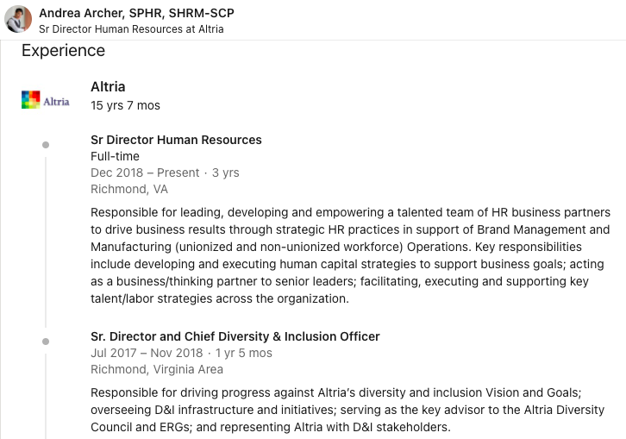

1. **Grow your network**
   * One of the easiest and yet most relevant ways to grow your LinkedIn network is to synch your profile with your email address book. This enables LinkedIn to suggest people you could connect with. It’s amazing how effective this can be at surfacing relevant people for you to reach out to – and no connection requests are sent without your permission, so you can vet all of the potential connections. Beyond this, get into the habit of following up meetings and conversations with LinkedIn connection requests – it’s a great way of keeping your network vibrant and up to date.

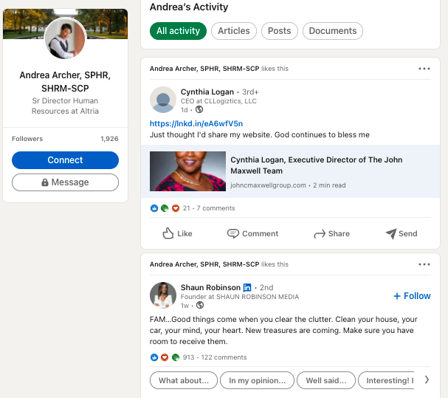

1. **Spread the endorsement love**
   * Endorsements from other members substantiate your skills and increase your credibility. How do you get endorsed on LinkedIn? For starters, go through your network and identify connections who you feel genuinely deserve an endorsement from you – that’s often the trigger for people to return the favor. Don’t be afraid to reach out with a polite message asking for endorsement for a few key skills as well. Remember though – relevance matters. Reach out to people whose endorsement you’d really value.
2. **Manage your endorsements more proactively**
   * Once endorsements start to come in, you might find that they skew the emphasis of your LinkedIn profile in ways that don’t reflect who you are. It could be that your core area of expertise is content marketing for example, but the people who’ve worked with you on events are more enthusiastic endorsers. Be proactive in managing your endorsements list using the edit features in the Skills section of your profile – you can choose which to show, and which to hide.

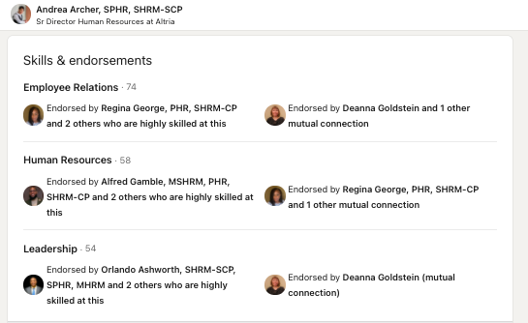

1. **Request recommendations**
   * Endorsements give people viewing your profile a quick, visual sense of what you’re valued for. Recommendations take things a step further. They are personal testimonials written to illustrate the experience of working with you. There’s a handy drop-down menu in the Recommendations section of your profile that makes it easy to reach out to specific contacts and request recommendations. Take the time to think about who you would most value a recommendation from – and personalise your request. It’s worth the extra effort.

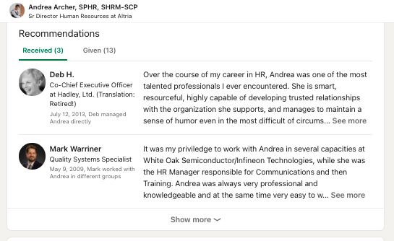

1. **Share relevant content from your LinkedIn feed**
   * It’s one thing to have a network of connections on LinkedIn – it’s far better to have an active role in that network, appearing in your connections’ LinkedIn feeds in a way that adds value for them. Sharing relevant content with your network is one of the most accessible ways of doing this. You can make a start by keeping a close eye on your LinkedIn feed, and sharing content that you find genuinely interesting – and that aligns with your point of view.
2. **Add comments**
   * Sharing is great – but it’s just the starting point. When you add comments to your shares, you give yourself greater prominence within the feed and start to express why you think a particular piece of content matters. Well-expressed comments also enable you to share a broader range of content. It might be that you don’t agree with a point of view but still find it interesting, for example. A comment that can express that viewpoint starts to establish your opinion and thought-leadership. It’s also more likely to draw additional comments, which then raise your profile across LinkedIn. Bear this mind when you’re writing your comment – and make sure you’re saying something you’re happy for people to associate with you.

