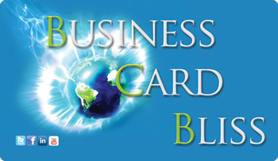

My intention in creating this eBook is to give you the best marketing knowledge possible, to share yourself powerfully, and GORGEOUSLY through your business cards.

I've included space for you to fill in the answers. So invest some time in yourself right now, print this out, grab a good cup of tea and work through it. It's not that long, and you're worth it!

Much Love!


Your business card could be single-handedly the most successful marketing tool for your company.

Most people do business cards HORRIBLY wrong. No offence to Vistaprint, they provide a great service, but the market is now flooded with their cards, and the conscious entrepreneur needs a more authentic offering to really THRIVE.

The object is to create a card that you are CONFIDENT to hand out, and that inspires people to connect with you.

Most cards provide basic contact information, and speak to people in terms of “services offered” I can’t count the cards I’ve seen that say “reiki, massage, hot stone massage etc”. This does NOT make you stand out.
Even if you do exactly the same thing as the lady next door, if you talk about it on your card in language that speaks to the NEED your client has, (in results based language) then you’ll end up with more people interested in your services.
If you bring your unique flair into your card. If you have beautiful writing, why not hand write your card and get copies made, or include samples of your work on one side(moo.com offers a great service for this)
You want to leave a lasting impression, provide relevant information, create a feeling of understanding (of their need), and make clear your ability to answer their need.

We’re going to start with some brainstorming to help get the juices flowing, and then take the best bits and put them on your card!

Ideal Client Profile
The best way to reach your ideal client is to write directly to them. So take the rest of this page to determine WHO your ideal client is. You should describe them in enough detail that you could sit down for coffee with this person. Do they have freckles? How many kids? Etc
When you write to JUST ONE person, you write and market more genuinely, and your message comes over better, even if the person reading ISN’T your ideal client.

What’s your ideal client’s name? Gender? Age? Marriage? Job? What keeps them up at night? What worries them? Where do they have issues, if they were to wave a magic wand, what would they fix in their lives?

RESULTS
Now, move to how you can help them out, you want these to be as results based as possible and specific. Ie, weight loss, specific income level, health level or additional clients. For every “result” you write down, ask yourself “SO WHAT??” at least 5 times, and write them all down.

(you can use the back side too, in fact I recommend it!)

I AM Unique
What is unique about working with ME (vs someone else who does what I do)

Now go back over the last three pages, and highlight or circle the things you wrote down that really feel the most resonant to you!

These first three pages are your “secret formula” to business success and to creating great marketing materials.
If you're thinking this is going to take too much time and you want to just get started, consider this: 15 minutes of freewriting will save you hours and hours of writer's block. It's much easier to start writing when you can visualize a person you're writing to.
If you skipped the first pages. Go back and do it! (if you already know who your ideal client is, it won’t hurt you to write it out again so you can reference it for this workbook)

Now we’re going to use this worksheet to gather all the information you will need to build your best business card!

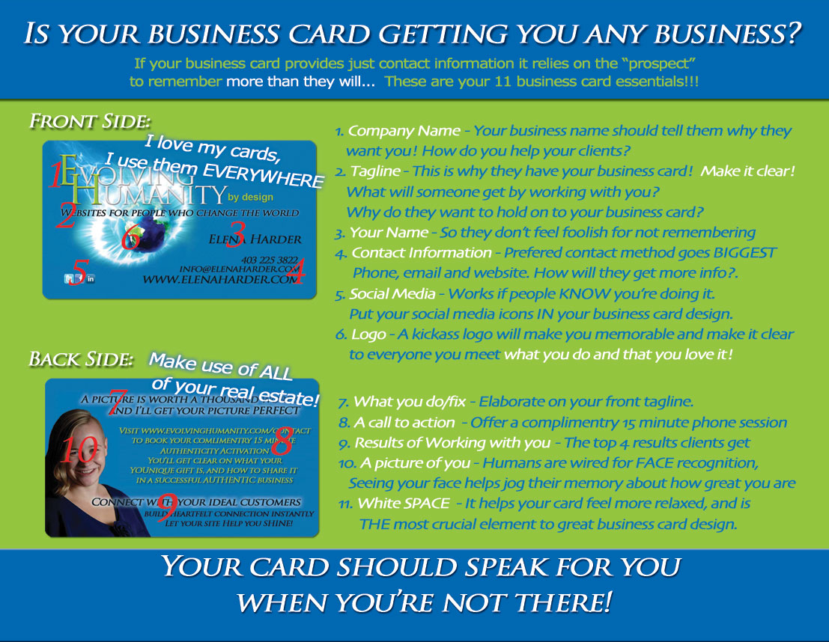
Your Information
Company Name:
What do you do? Your “Tagline” (50 characters or less)
Ie. websites for people who change the world. (34 chars)

Your Name:
Your Logo or a favorite Picture?? (provide the link to it)
A picture of you. Smile, tilt your head a bit, and make eye contact with the camera, it’s proven to make you look more friendly.

Contact Information
Do you have:
- Facebook
- Twitter: Username _______________________
- Linked In
- Youtube: Username _______________________
- Website: What is the Address ______________________
(ie www.MyWebsite.com)
- Email address ______________________
- Phone number ______________________

Which of these would you like listed on your card?
(ie some people don’t want their phone number listed)

Your OFFER
Go back to the first page and pull out the results you wrote down!

Identify what specific problems do you solve for your clients? (sore backs, money troubles, cluttered house, wonky energy, whatever it is)
Then put them in question form. For example.
Release stress becomes “Do you need to relax and release stress?”

This helps your potential clients identify the problems they have that you will help them solve. You then want to offer a simple way of talking with them about this, usually offering a free 15 minute consult with them via phone.

What do you offer to solve that problem?
This is something really actionable, that they can take your card, and book it right now! It is a great idea to use one of these words (Discovery, Breakthrough or Strategy) in the title, as it really makes people feel the transformation that will happen during this call! You want to make sure you HIGHLIGHT this when you give your card to people, so that they remember it, and sometimes you’ll even book them right then and there!!
result + breakthrough/strategy/discovery + session = Your call to action!
Ie. Weight Loss Breakthrough Session, Inner Peace Discovery Session, Money Magnet Strategy Session.

What will they get from this session, again, results based, and YUMMY! You can include some of your unique features here too.

I offer a complimentary ____________________________________session. This session will help you:

How do you want them to contact you to book this session (I recommend website, but if you don’t have your site setup as such yet, you can give a phone number)

Here’s an example of the back of a client’s card:
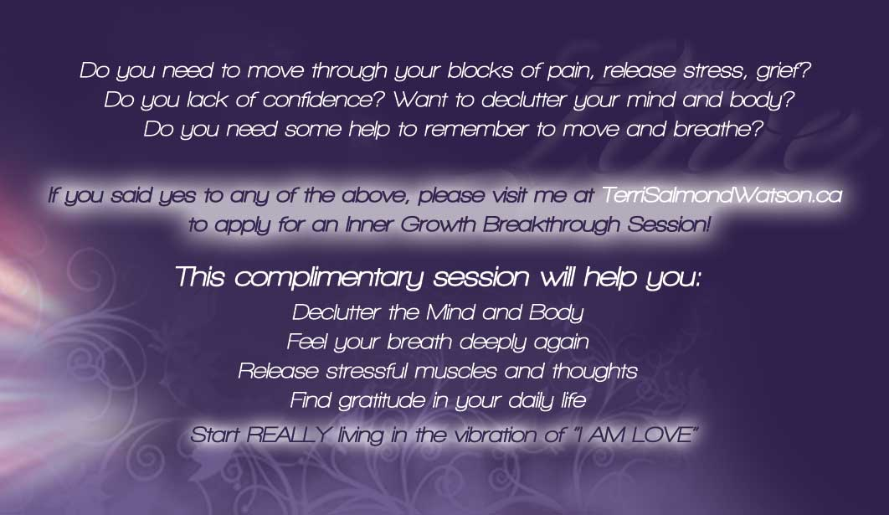

Optional Information

Did you have an inspiration of something really cool that is unique that would make your cards rock? Let me know here!

If people come to your place of business, what is your address? Consider including a Map on the back of your card. (one case study showed that including a map increased client conversion from 8% to 32%)

About The Author

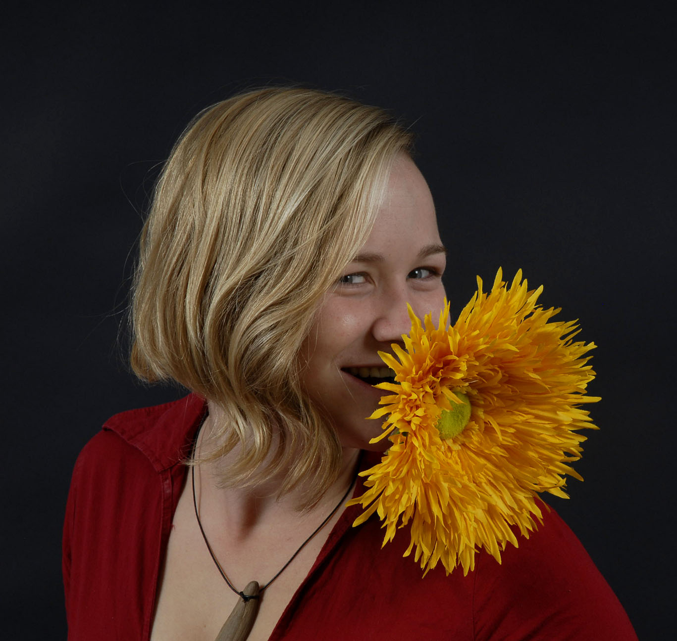

Elena Harder is Loving Visionary, and Authenticity Catalyst at Evolving Humanity by Design. She lives in Sayulita, Mexico.
She hangs out on the beach most of the day with her son and husband, and inbetween works to help conscious entrepreneurs build successful businesses by sharing their authentic gorgeous selves on the web.
She especially loves writing love letters to her clients, and helping them get un-stuck from the fear of sharing themselves really fully with the world.
More information, and get weekly insights at www.evolvinghumanity.com

