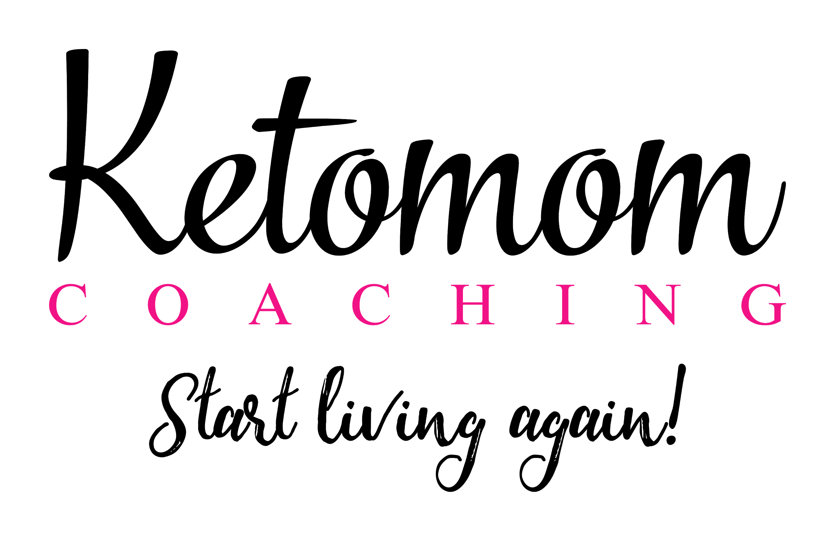

Keto products I won’t live without!
Disclosure: Some of the links below are affiliate links, meaning, at no additional cost to you, I will earn a small commission if you click through and make a purchase. I only recommend products I personally use!

Food Items:

- Almond Flour: https://amzn.to/2VV7ZRl
- Natural Eats Almond Flour: https://amzn.to/2D9HVKM
- Kiss My Keto C8 MCT Oil - Pure MCT Oil C8 Brain Fuel, 32 oz Glass Bottle with Pump, Best MCT Oil Keto for Ketone Diet, Pure C8 Caprylic Acid, Enhance Ketogenic Performance, Get Into Ketosis http://bit.ly/2sTeExT Use Coupon Code KETOMOMKISS
- Lily’s Chocolate Chips: https://amzn.to/2STD4mv (can’t have a cupboard without them)
- Kiss My Keto Protein Powder (chocolate, birthday cake etc) http://bit.ly/2sTeExT Use Coupon Code KETOMOMKISS
- Smart Coffee: https://elevacity.com/ketomom6803

- Keto Cre: https://elevacity.com/ketomom6803 (bake, fat-bombs, and coffee)

- Jordan's Skinny Syrup Dessert Collection - Caramel Creme Cheesecake, Chocolate Coconut Macaron, Iced Cinnamon Roll https://amzn.to/2RYpwtz

- Organic Coconut Flour (4lb) by Anthony's, https://amzn.to/2T12dLK
- Kiss My Keto Exogenous Ketones Powder Drink, Muliple Flavors Available, GoBHB® Salts, Ketogenic Supplement, Beta Hydroxybutyrate, Burn Fat, Increase Energy, Get Into Ketosis (Pink Lemonade) http://bit.ly/2sTeExT Use Coupon Code KETOMOMKISS
- Viva Naturals Organic Extra Virgin Coconut Oil, 16 Ounce https://amzn.to/2CjZ2bd
- 100% Pure Avocado Oil 1 L, Non-GMO, for High-Heat Cooking, https://amzn.to/2AVCair
- Paleovalley: 100% Grass Fed Beef Sticks (10 Count) - Original Flavor - 100% Grass-Fed/Finished Beef - https://amzn.to/2SPfZB3 (very handy to have for travel)

- Creamy Almond Butter, 27 Ounce - 2 Jars: https://amzn.to/2ssJcX0

- Mauna Loa Macadamias, Dry Roasted with Sea Salt, 11-oz. https://amzn.to/2SUIgGq

- Mauna Loa Dry Roasted & Salted Macadamia Nuts, 0.5-Ounce Triangle Pack (Pack Of 24) https://amzn.to/2VStVfL

- Swerve Sweetener, Bakers Bundle, 12Oz Granular and Confectioners pack of 2: https://amzn.to/2CiLWuF

- Swerve Granular Sweetener (48 oz): The Ultimate Sugar Replacement: https://amzn.to/2CkDWt3

- Swerve Sweetener, Brown, 12 ounces https://amzn.to/2VSfrwp

- NOW Foods Erythritol,2.5-Pound: https://amzn.to/2FuQGR0

- Xanthan Gum 1lb (16 Ounce) Packed in the USA, by Anthony's, Gluten-Free https://amzn.to/2Mg5IM9

- PUR Gum 8 Flavor Assortment Spearmint, Peppermint, Pomegranate Mint, Wintergreen, Cinnamon, Coolmint, Chocolate & Bubblegum: https://amzn.to/2VUah2L

- Certified Organic Cacao Powder from Superior Criollo Beans, 1 LB Bag, https://amzn.to/2STziJL

- Now Foods 100% MCT Oil, 32 Ounce, https://amzn.to/2D8NPeV

- Utz Pork Rinds, Original Flavor https://amzn.to/2VUnyIF

- Whisps Cheese Crisps (2.12 ounce) 100% (5 Pack) https://amzn.to/2SPtrFc

Supplements

- Dr. Berg’s Keto Kit (with Bonus Meal Maker): https://amzn.to/2TktnNQ

- Nature Made High Potency Magnesium Softgels: https://amzn.to/2SS1Hjd
- Collagen Peptides Powder (tasteless): https://amzn.to/2STm13T (put in my coffee)
- Great Lakes Gelatin - Collagen Hydrolysate Kosher: https://amzn.to/2MdBYQ0
- Perfect Keto Chocolate Protein Powder: Collagen Peptides Grassfed Low Carb Keto Drink Supplement with MCT Oil Powder. Best as Keto Drink Creamer or Added to Ketogenic Diet Snacks. Paleo & Gluten Free https://amzn.to/2Mg4vo5
- Dr. Berg's Electrolyte Powder, High Energy, Replenish & Rejuvenate Your Cells, 45 Servings, NO Maltodextrin or Sugar, Amazing Raspberry Lemon Flavor (Solo Pack) https://amzn.to/2CT24n7
- Dr. Berg’s Gallbladder Formula Contains Purified Bile Salts, 90 capsules, Enzymes to Reduce Bloating, Indigestion & Abdominal Swelling - Better Digestion, Improved Absorption of Nutrients & More Satisfied After Meals https://amzn.to/2WlAFmF

Health Tools

- KETO-MOJO Blood Ketone and Glucose Testing Meter Kit, Monitor Your ketogenic Diet, 1 Lancet Device, 10 Lancets, 10 Ketone Test Strips, Carrying Case. Does NOT Include Glucose Strips :http://bit.ly/2Rmy6wT (You get a 15% discount using this link at Checkout!!!)

Kitchen Tools
- Bagel tins:https://amzn.to/2VSsOgb
- Magic Bullet Blender: https://amzn.to/2SUfyFI
- Ninja Blender: https://amzn.to/2FBf3fQ
- Simple Chef Air Fryer: https://amzn.to/2VPcY5Q
- Perfect Hard Boiled Egg cooker: https://amzn.to/2D9SEos
- Instapot: https://amzn.to/2srKP7l
- Cuisinart ICE-21R Frozen Yogurt, Ice Cream & Sorbet Maker, Red: https://amzn.to/2CN5849

Books
- Lies My Doctor Told Me: Medical Myths That Can Harm Your Health, Dr. Ken Berry: https://amzn.to/2D6szGI
- Cholesterol Clarity: What The HDL Is Wrong With My Numbers? https://amzn.to/2M7D8MR
- Keto Clarity: Your Definitive Guide to the Benefits of a Low-Carb, High-Fat Diet: https://amzn.to/2M9J2gm
- The Obesity Code: Unlocking the Secrets of Weight Loss: https://amzn.to/2CmA0YY
- Keto Instant Pot: 130+ Healthy Low-Carb Recipes for Your Electric Pressure Cooker or Slow Cooker https://amzn.to/2SQLI4Y
- Keto Comfort Foods: Family Favorite Recipes Made Low-Carb and Healthy https://amzn.to/2ClUalI
- Ketotarian: The (Mostly) Plant-Based Plan to Burn Fat, Boost Your Energy, Crush Your Cravings, and Calm Inflammationhttps://amzn.to/ 2TigIuR

Legal Disclaimer
“We are a participant in the Amazon Services LLC Associates Program, an affiliate advertising program designed to provide a means for us to earn fees by linking to Amazon.com and affiliated sites.”

