The SPARK Method Case Study

Course Title | Flawless Project Management with the SPARK Method
Course Learning Goals | - Know where to start with Project Management, communicate and cooperate effectively.  - Know how to lead a team.
Case Study Check List Area | - Conclusion

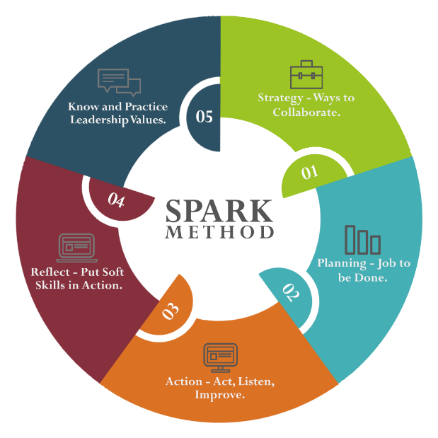
Case Study Section Title | Task Description | Training Lesson Completed | Case Study Task Completed | Tested on a Real Project | Feedback  Gathered | Wrote Comment How It Worked
CONCLUSION | - Get comfortable with the system you have created.
 | - Create a system that fits to You.
 | - Improve and correct Your system as you learn and listen.
 | - Prepare for the next steps and learning.
 | - Understand the main methodologies.
 | - Learn basics about PMI and Agile.
 | - PRACTICE, PRACTICE, PRACTICE!!!

